Early Holladay/Cottonwood History and the George W. Smith Family
Compiled by his Great Grandson
Brent N. Smith
2013

The primary purpose of this history is to enlighten and strengthen the lives of the descendants of this great man, George W. Smith and his wife, Catherine Wootton. The contents have come from multiple resources including photographs in the possession of the Smith Family and stories both written and oral from Smith Family members. I have drawn upon several well documented histories of Holladay and the LDS Church; a reference list of which in included within. Opinions, assumptions, and commentary are those of the author alone. If there are errors and or omissions please bring them to my attention. This is a work in process as more information comes to light in this digital age. 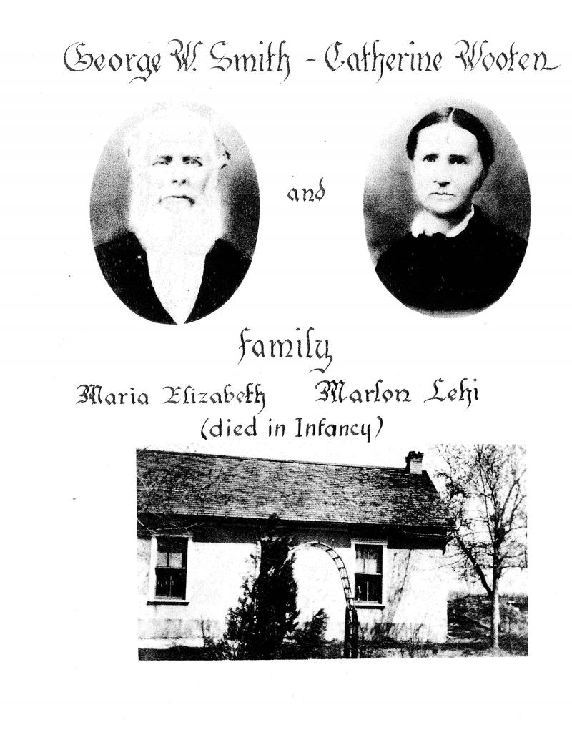

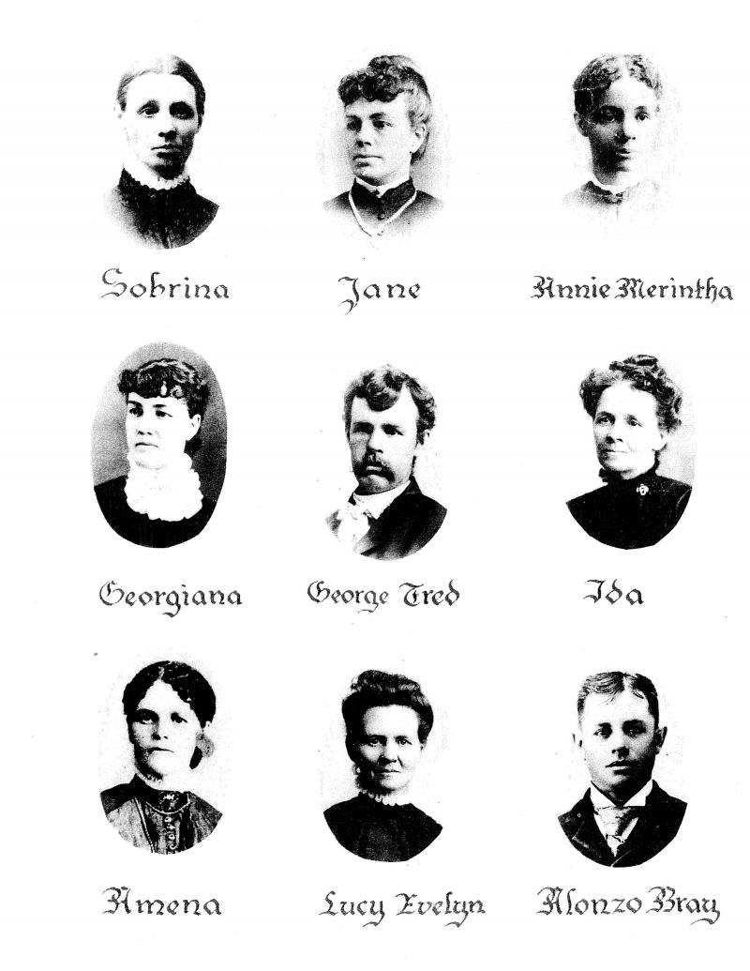

Contents

Why this interest in Holladay/Cottonwood? 5
How did our Smiths get to the Holladay/Cottonwood Area? 6
Settling in Utah 12
Trip to the “Muddy” 15
The Move to Holladay/Cottonwood 19
Finally a Home in Cottonwood 40
The Church in Cottonwood 50
The Children of George W. and Catherine Wootton Smith 62
References 67

Early Holladay/Cottonwood History and the George W. Smith Family
by Brent N. Smith
2013

Why this interest in Holladay/Cottonwood?

I have felt for some time that it would be an interesting and important project to understand and present the history of the early Holladay/Cottonwood area and the Southeastern Great Salt Lake Valley area. This understanding would help me know what went into the decision to settle in this area. This is where I grew up and where my parents grew up and where their parents grew up and it is where both George W. and Catherine Wootton Smith spend the last years of their life; I have a personal interest in and love for this area. In doing so I present no new facts or information regarding the settlements themselves but rather I try to place our family members into this well documented area and relate how they were impacted by and helped impact this beautiful part of the Salt Lake Valley.

My project draws upon several well researched and well written histories of this key area in early Utah and LDS Church history. I will provide references and give credit to those that have written these histories if, in fact, references are known. I want to give credit up front and acknowledge two works that I referred to extensively while putting this project together.
Carr, Stephen L. Holladay – Cottonwood Places and Faces Holladay. Holladay – Cottonwood Heritage Committee 1976
Todd, Jay M. A Historical Walking Tour of Holladay. Holladay 1996

As I have said, as members of the George W. Smith family we have particular interest in this area because George W., his wife, Catherine Wootton Smith and most of their children lived in this area at one time or another and many of their descendants live in this area today. George and Catherine and many of their descendants are buried in the Murray City Cemetery in this area. In addition to our Smiths, Catherine’s father, William Wootton and her brothers also lived and died in this area. Many other prominent families also lived here.

How did our Smiths get to the Holladay/Cottonwood Area?

In 1854 George W. Smith and his family were in Eaton Bray, England and 16 years later they are in the Holladay/Cottonwood area of Utah in the United States of America. Here is what we know happened between those years.

Eaton Bray, England was then, and is today, a small rural village whose boundaries are mostly made by streams.

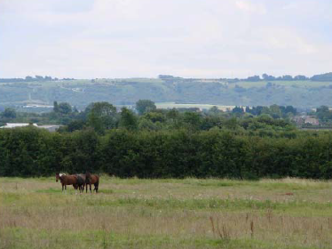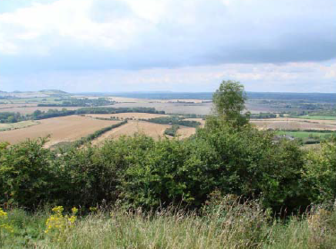
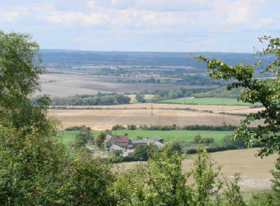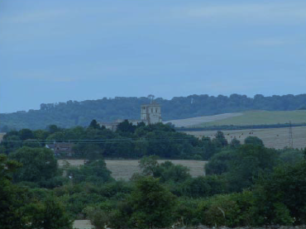

It is still quite pastoral even today and seeing what a beautiful place it appears to be today it makes me wonder why George W. Smith and his wife, Catherine Wootton and their two young daughters left such a place. I say that and yet I know why they did; the Holy Ghost converted them to the Gospel of Jesus Christ and they followed the council of their new Church’s leaders and came to America to join the Saints in Utah. America also held the promise of land ownership and independence as well.

George W. Smith married Catherine Wootton December 21, 1845 in Eaton Bray. Catherine was just 17 and George W. was 22. Their first child, Sabrina was born April 29, 1847 in Eaton Bray. There was a great LDS missionary effort underway in the British Isles at this time. The first seven Mormon missionaries landed in Liverpool England on July 19, 1837. In less than two years there were more than 1500 converts as a result of their missionary efforts. By 1851 there were 24,199 LDS converts in England. We know that George and Catherine received the missionaries and joined the Church in 1848. George W. was baptized on 29 October 1848. Catherine was baptized 15 December 1848 after recovering from the birth to their second child, Jane, born 04 October 1848. They were both baptized by Elder John Mead. George’s younger brother, Thomas X Smith joined the Church a few months later being baptized on 17 April 1849.
Thomas’s future wife, Margaret Gurney, had joined the Church six months earlier on 08 October 1848. George W.’s older brother, Reuben, was baptized on 16 May 1849 but it appears his wife, Betsy Duncomb did not join and they did not immigrate to America. None of the remainder of the George Smith family joined the Church as far as we know. Throughout these early years of missionary work in England there was great opposition to the movement. Other Churches openly preached against the “Mormons”. Those individuals that joined the LDS Church were often “disowned” by the remaining members of the family. It has been recorded that the remaining members of the George Smith family had little or nothing more to do with those that accepted the Gospel. On the other hand, all of Catherine Wootton’s family joined the Church around this same time. In fact, her father and mother, William Wootton and Deborah Roe, were baptized the same day as George W., October 29, 1848. It would be interesting to know the nature of the missionary effort going on at this time in Eaton Bray. Did the Woottons, Smiths and Gurneys influence each other? The Smiths and the Woottons were related through marriage at this time. And these families lived in close proximity of each other. Almost all of these folks were straw plaiters and possibly they all worked in the same neighborhood shop. We are just happy they were influenced by the missionaries and the Holy Ghost and joined the Church when they did.

The Church had encouraged their converts to immigrate to America and strengthen the main body of the Church in Utah. The vast majority of those that joined the LDS faith were considered poor. Many had no jobs and few prospects. Likely, none of these converts own land in England. So, while Eaton Bray and other parts of England may have been beautiful our family members had little or no opportunity to own property or improve their situation in life. From 1847 to 1869 more than 32,000 British and Irish converts left their homeland for a new life in pioneer America. Thomas X. and Margaret Gurney Smith, their daughter Lucy (born 1853), Catherine’s father, William Wootton and her brothers Frederick (born 1844) and Charles (born 1847) and brother, Jessie Milton (born 1830) and his wife, Margaret Gates (born 1836) all left Eaton Bray to be with the Saints in Utah. Catherine’s mother, Deborah, died in Eaton Bray in 1857 and the young age of 50.

George and Catherine left beautiful Eaton Bray, family, and two children in graves to come to America. Catherine and George had two additional children while still in Eaton Bray. Their third child, Maria Elizabeth was born 18 September 1852 but she lived only a few days. Her death is recorded as 01 October 1852. Their fourth child, and first son, Marlon Lehi, was born 08 March 1854 but he died the same day. On 24 April 1954 George W. 30, Catherine 25, and their daughters, Sabrina 6, and Jane 5 sailed from Liverpool, England for America aboard a large three deck vessel, the Clara Wheeler. This was not a “regular organized company of Saints” and as such there were only 29 Mormon passengers on board. It was the practice of the Church to get a large company of converts together and then charter an entire ship. As evidence, the next time the Clara Wheeler set sail for America in November of that same year it was an “organized” voyage and there were 422 Mormons on board. Perhaps our Smiths felt they had waited long enough to start their new life in America. My personal opinion of George W. is this; I think he was a very thoughtful, cautious, and conservative man. He did not borrow money from the Perpetual Immigration Fund as many converts did, including his brother, Thomas X. “Of all the grand designs devised by President Young and others to aid the immigration, perhaps the most effective and best known was the Perpetual Emigrating Fund (PEF). This revolving fund helped more than 100,000 Saints migrate to Zion during its 38-year history, from 1849 to 1887. Of this number, some 40,000 to 50,000 received financial assistance from the PEF.” 1

Below is a partial view of a page from the Passenger List from the Clara Wheeler’s voyage leaving from Liverpool, England on 24 April 1854 arriving in New Orleans, Louisiana, United States on 03 July 1854 that show George W. Smith, wife Catherine, and daughters, Sabrina and Jane. George W. is listed as 30 years old and his occupation as Straw/Manuf.

As an aside, it took George’s brother, Thomas X, many years to gather enough cash money to pay back the $57.00 he borrowed to get his family to America. George W. likely stayed in England until he could afford to buy passage to America for his family. They were 70 days at sea and arrived in New Orleans 3 July 1954. From New Orleans they would have traveled up the Mississippi River by riverboat. In 1854 the Church had chosen Westport, Missouri for a departure point to the West. All of the “regularly organized companies” would have gone to Westport during that year. It is not clear in anything we can find where our Smiths went. Because they were “on their own” they were most likely not prepared to continue on to Utah that season. Again, they could have borrowed money from the Church but George apparently decided not to do that. It is likely they spend a year in Iowa or Missouri preparing themselves financially for the 1200 mile trek to the West. It appears that they got themselves outfitted and made their way to Mormon Grove, Kansas in time to connect up with the Milo Andrus Company that left Mormon Grove, near Atchison, Kansas on August 4, 1855. This was a company of 50 wagons and 461 individuals and it is quite well documented. George W. and his family are clearly registered with this company. This was a late in the season departure and it is a miracle that only two deaths were reported during the journey to Utah although they lost several oxen and other animals along the way.
Adding to the difficulty of the 1200 mile, late in the season journey, Catherine was seven months pregnant when they left Kansas and she gave birth to her fifth child, Anne Merintha, on 28 September 1855 while on the trail. Records indicate the Milo Andrus Company was at Devil’s Gate on that date. They would be about another month getting to Utah and after encountering snow and cold weather the Company arrived in the Salt Lake Valley on 24 October 1855. Below you will find a partial listing of the Milo Andrus Company that includes our Smiths and their new born daughter, Anne Merintha.

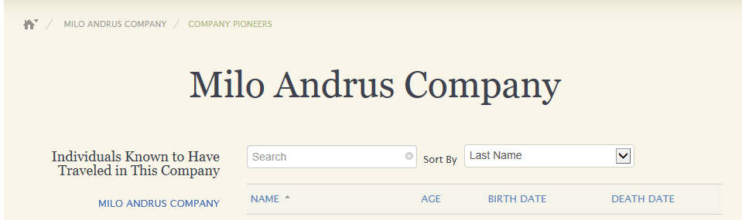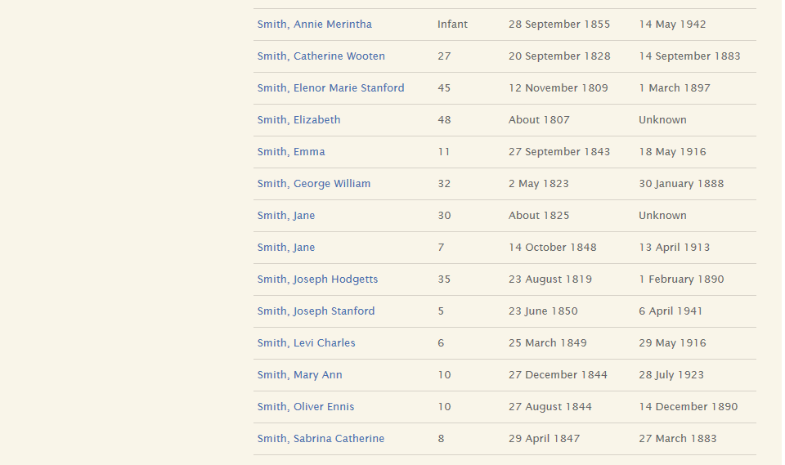

Settling in Utah

After their arrival they moved to Farmington to join George W.’s brother, Thomas X. and his family who had arrived two years earlier. We know that George’s younger brother, Thomas X., and his young family had come to America two years earlier and settled in Farmington. They probably moved onto an adjoining lot. One record mentioned the two brothers being 40 rods (660 feet) apart. It is not surprising to find George W. and Catherine joined up with Thomas X and his family. Records indicate that some 400 people lived in Farmington around the time George W. brought his family to the area. George W. had never farmed in his life. Now he probably had an acre lot and was expected to provide food for his family and trade. Even though Farmington was an excellent agricultural area George W. was not a farmer. He had a difficult time even plowing a straight furrow. Records indicate he often had one of his children ride atop the oxen that were attached to the plow to guide them while George W. tried to man the plow.

George W. and Catherine had six more children while living in Farmington. They were:
Georgiana, born 21 January 1858
George Fred, born 28 December 1859
Ida, born 15 September 1862
Amenia, born 20 January 1864
Lucy Evelyn, 09 born July 1866
And Alonzo Bray, born 18 May 1868
This made 11 children in total with Maria Elizabeth and Marlon Lehi having died in their infancy in Eaton Bray.
Check out the censuses listed below. It appears that George continued to plait straw and make straw hats after arriving in Utah because in both the 1860 and 1870 US Census George listed his profession as “Hatter”. He could apparently make better hats than he could make straight rows in his garden. More likely is the fact that he actually received cash money for his hats or was able to trade for needful things for his family.

Copy of the 1860 US Federal Census taken in Farmington, Utah 20 June 1860

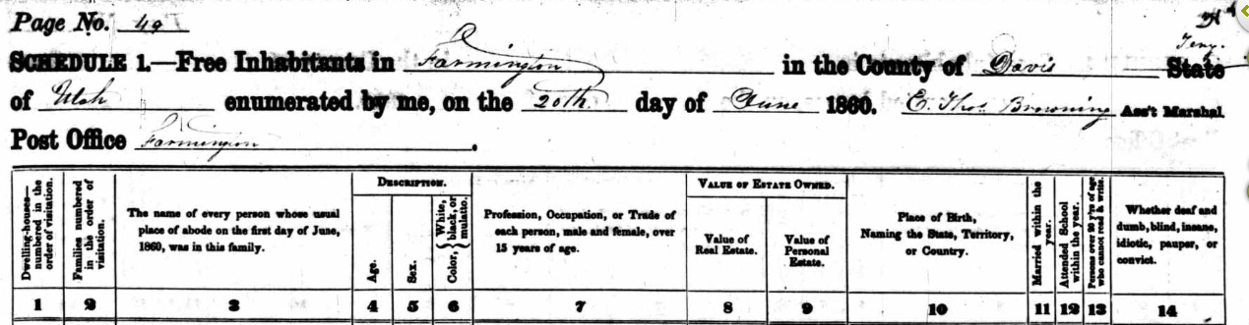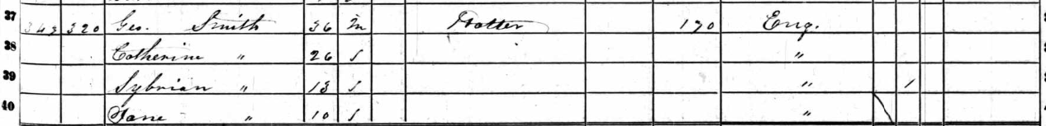
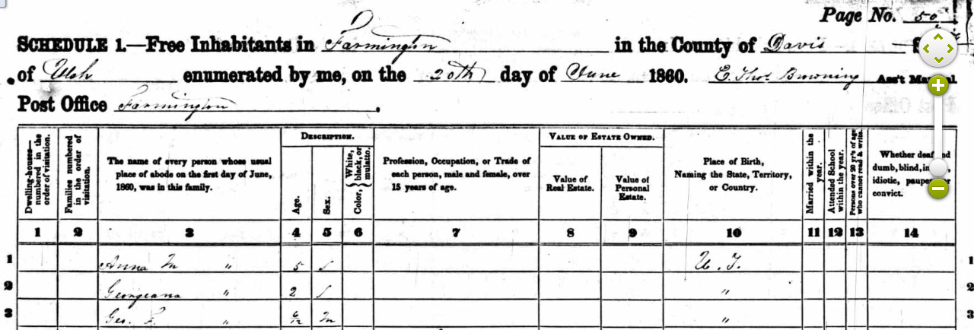

Copy of the 1870 US Federal Census taken in Farmington, Utah 29 July 1870
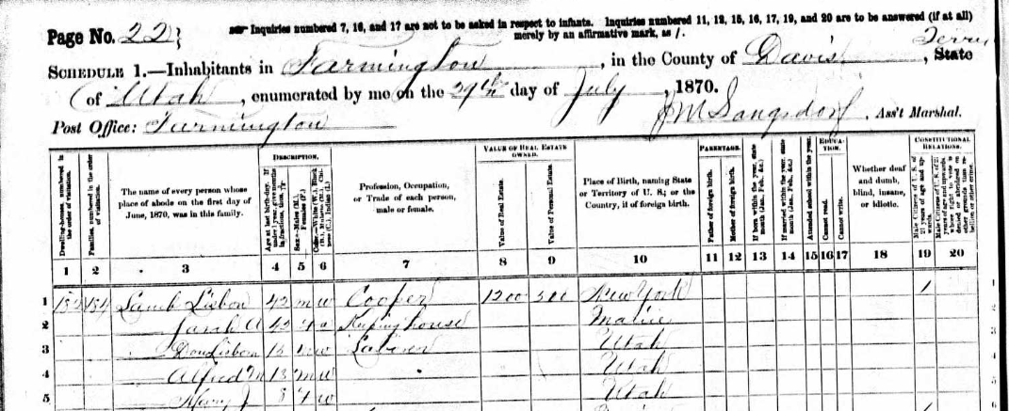
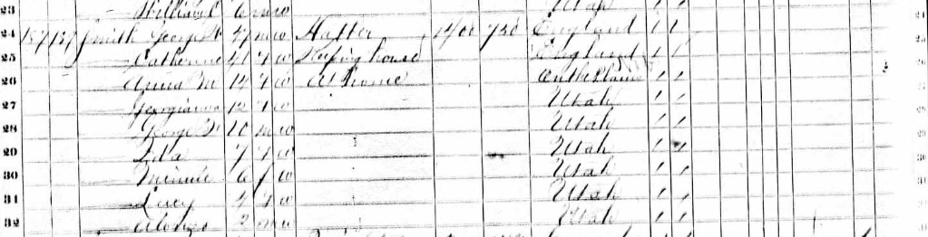

The George W. Smith family spent fifteen years in Farmington and yet we know very little about their time there. So what things do we know from these Censuses? As already mentioned, George considered himself a “Hatter” rather than a “Farmer”. George did not own any real estate or at least did not value it in 1860 and his personal estate was valued at $170. Ten years later he valued his real estate at $1400 and his personal estate at $750. His daughters, Sabrina and Jane are not listed at home in the 1870 Census. We know that Sabrina married Lisbon Lamb as his second wife in polygamy on 03 February 1866 at age 18. Jane did not marry until around 1872 but she is still missing from the 1870 Census. You will note that Lisbon Lamb and his family are shown at the top of the 1870 Census page and George W. and his family are about 20 lines below on that same page. They were obviously fairly close neighbors. Sabrina was not listed with Lisbon Lamb but I guess that was pretty common in that day. It is hoped someday a longer history will be made of their time spent in this area.

It is amazing to me to realize that while George W. and his family were farming a little piece of land in Farmington and Brigham Young and the Church were trying to colonize the Utah Territory the United States was in the mist of the deadliest battles of the Civil War. The Civil War lasted from 1861 to 1865 and over 620,000 Americans died.

Trip to the “Muddy”

During the 1864 October Conference of the Church President Brigham Young called 183 missionaries and their families to leave their homes and settle the territory 90 miles Southwest of Saint George. Thomas S. Smith (no relation to our Smiths) led this group of missionaries and settled what became known as St. Thomas (in honor of their leader Thomas S. Smith) in the Moapa Valley southwest of St. George. Thomas arrived in the area on January 8, 1865 with 11 men and three women. This settlement was about 2 ½ miles from the junction of the Muddy and Virgin Rivers. By May 28, 1965 it was reported that there were 50 families living in St. Thomas and a Ward was established with Thomas S. Smith named Bishop of that ward. These early settlers planted and harvested cotton, wheat and melons. They planted Cottonwood trees for shade and made humble homes from Adobe and they began to prosper somewhat in this difficult area. Another 160 families were called during the 1867 General Conference to strengthen the Muddy Mission.

I don’t know what prompted George and his family to pull up roots in Farmington and go to the “Muddy” when they did. His brother, Thomas X. had moved with his family to Logan in September of 1859 so George W. no longer had that family tie in Farmington. He was not called by Brigham Young in 1870 as some of our histories have indicated. He may have been called in 1865 or 1867 when other calls were extended and was simply not in a position to go at the time. Perhaps they had friends willing to go with them at this time. Whatever the reason George W. and his family gathered all their critical earthly possessions and headed for the “Muddy” sometime after July 29, 1870. As we saw they were still in Farmington when the US Census was taken on their street on that date.

We don’t know what George W. did with the real property he owned. My guess is that he sold his lot prior to leaving since he never returned to Farmington. They would have loaded a wagon with all their earthly belonging and what provisions they would need for the trip and attach that wagon to a pair of oxen. The youngest child, Alonzo, would have been less than two years old and probably got to ride in the wagon much of the way but the reminder of the family would have walked the approximate 405 miles. They possibly got to take turns in the wagon but mostly they just walked. It was not a great privilege to ride in one of those old wagons since they did not had springs or “shocks” so every bump and rut would have jarred and bounced anyone riding the wagon. The wagon was mostly for carrying their supplies such as they were.

This past June my wife and I drove through Las Vegas on our way to a vacation in Arizona. I commented to her at the time we were nearing the Valley of Fire that I just could not imagine my great grandfather and his family walking through this area in August or September of 1870. We were in our air conditioned car traveling at 75 miles an hour while the outside temperature measured 105 degrees. They walked 400 miles in maybe six weeks (if they averaged 10 miles a day) in temperatures sure to be in triple digits much of the time. Our early pioneer ancestors had faith and strength beyond our ability to comprehend.

Brigham Young made his first and last personal visit to the Muddy Mission in March of 1870 and he was not happy with the conditions he found there. Building had been difficult, the heat was intense, and the Indians were stealing grain and livestock. A new United States geological survey put the area they had settled in Nevada rather than Arizona or Utah. The settlers had paid taxes to Arizona and Utah and in 1870 Nevada demanded two years of back taxes be paid to them in gold and their taxes where 5 times higher than Utah’s. When Brigham Young returned to Salt Lake City he wrote a letter dated 14 Dec 1870 to the leaders of the “Muddy” recommending that the Saints abandon the mission and return to their previous homes if they still had a home or settle in Long Valley. These settlers, upon receipt of Brigham’s letter voted 123 “for” and 5 “against” to abandon their homes and crops. Only one family remained in the “Muddy” after the spring of 1871.

George W’s timing was poor at best. Brigham Young’s letter probably arrived just weeks after George W. and his family arrived in the area. He and his family had walked to the “Muddy” from Farmington, spend the winter there, and then they had to walk back when the “Muddy” was abandon the next spring.

While most of those who abandoned the “Muddy” stayed in the south and settled in Long Valley (now Orderville and Mount Carmel, Utah), George W. and his family decided to return to the North. It appears they spend from the spring of 1871 to the spring of 1873 somewhere in Southern Utah, likely St. George. While in Southern Utah the family gathered straw where they could and George plaited the straw and Catherine shaped the plaited straw into hats that were then sold. This was likely their only source of income while living in the South. They finally arrived back in the Salt Lake Valley in the spring of 1873.

The photograph below is not of our Smiths returning from the “Muddy” but if they were lucky enough they might have had a conveyance as nice as this one with four oxen and a horse or donkey to ease their travels over 800 miles to and from the “Muddy”. We can only imagine what it would be like to walk hundreds of miles with all our earthy belongings in one small wagon.

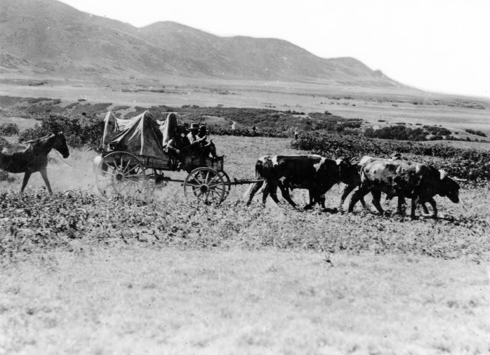

The Move to Holladay/Cottonwood

We have finally gotten to what I really wanted to write about. George W. and his family, for some reason, did not return to Farmington but rather chose to settle in the Holladay/Cottonwood area near 2300 East and about 4600 South. George likely left no real property in Farmington when his family went to the “Muddy” but his daughter, Sabrina, was still living in that area. As mentioned, Sabrina had married Lisbon Lamb in 1866 and she had 4 children under the age of six when George and his family returned to the Salt Lake Valley and settled in Holladay in 1873. Having grandchildren in Farmington would seem like a good reason to return to Farmington but they did not. The truth is we don’t know for sure why our Smiths made Holladay/Cottonwood their home at this time. We don’t know why they went to the “Muddy” in 1870 for that matter. Wouldn’t it have been great if George or Catherine kept a journal? Is there a lesson here for us?

I want to go back several years, at this point, and talk about how Holladay came to be and who settled there and when. Maybe this will shed some light on why our Smith family ended up here.

Everyone knows that the pioneers entered the Salt Lake Valley on 24 July 1847, right? Actually, a Vanguard group from Brigham Young’s Wagon train entered the Salt Lake Valley on 22 July 1847. This initial group included Orson Pratt and Erastus Snow. They explored much of the Salt Lake Valley finding many fresh springs and even some hot springs. On July 23 Orson Pratt dedicated the Great Salt Lake Valley to the Lord. They also dug ditched for irrigation and planted potatoes and turnips. Brigham Young, who was behind this first group and sick with the Mountain Fever, saw the Great Salt Lake Valley for the first time with his mortal eyes on July 24. He had, however, seen the Great Salt Lake Valley in vision much earlier.

As an aside, when Brigham Young said, “This is the right place”, this “place” belonged to Mexico. The United States was in the mist of their war with Mexico at the time and Utah did not become a United States Territory until the treaty with Mexico was signed on 02 February 1848.

After his arrival Brigham Young and others continued to scout out the Valley for possible locations for settlements. Brigham had a concept of land ownership that is foreign to us in our day. It was his intent to populate the territory as rapidly as possible, and he declared on 25 July 1847 that "no man should buy any land ... but every man should [have] his land measured off to him for city and farming purposes, what he could till. He might till it as he pleased, but he should be industrious and take care of it." Farm plots were about 5 or 10 acres in size. There were no real estate developers to be found, no speculators monopolizing access to streams, wood, or timber. The water master, often a bishop, regulated the use of irrigation water. It was an orderly system that placed a premium on community cooperation. 2

Until such time as they would receive their land allotments, the pioneers settled themselves in temporary dwellings and farmed in communal fields. For shelter and protection from the Indians, the settlers quickly began building a fort where Pioneer Park is today. This was a 10 acre fort consisting of adobe-and-log cabins linked together to form a stockade. 3

There were some 1611 pioneers that spent that first winter of 1847/48 in the Salt Lake Valley. More than half of them were under the age of 19 and 25 % were under the age of 8 years.

On August 2, 1847, Orson Pratt and Henry G. Sherwood began the survey of Great Salt Lake City, beginning at the southeast corner of Temple Square. By August 20 the survey of Plat A was completed. It included 114 ten-acre blocks, each containing 8 lots. Lots were 10 by 20 rods or 165 by 330 feet (1 1/4 acres) in size. Each block alternated in the way the lots were divided and the houses faced. Only one house was permitted on each lot and had to be 20 feet off the street. Streets were 8 rods (132 feet) wide. The Apostles selected a number of lots surrounding Temple Square, but general distribution was not made until Brigham Young and Heber C. Kimball were chosen to do so on 24 September 1847. Each applicant was assigned property by Heber C. Kimball and Thomas Bullock. Bullock maintained a record of the land distribution. A fee of $1.50 was paid for each lot acquired ($1.00 to cover surveying expenses, and $.50 as a filing fee). Each person's receipt for the land became his deed for the purposes of maintaining his claim and the conveyance of the land in the future. Interestingly enough, unmarried men were not given an allotment, but polygamists were entitled to receive one for each family.

Within days the lots in Plat A had been distributed. The desire for land not satisfied, Plat B containing 63 additional blocks east of Plat A was surveyed and readied for distribution during 1848. Plat C was soon added to Plats A and B. In February 1849, the three Plats were divided into 19 ecclesiastical wards, a bishop presiding over each ward. Under the supervision of each bishop, fences and irrigation ditches were constructed for the benefit of all ward members. (All wards in the Salt Lake Valley were part of the Salt Lake Stake. Before the stake was divided on 28 Jan 1900, to create the Jordan and Granite Stakes, the Salt Lake Stake was composed of 51 wards. Angus M. Cannon served as Stake President for 28 years, from 1876-1904. 4

As mentioned previously, on 02 February 1848, the Treaty of Guadalupe Hidalgo gave to the United States an extensive area that included the Great Basin, where Brigham Young and our Mormon pioneers had begun settlement six months earlier. Even before the treaty was signed, Mormon Church leaders began discussing petitioning the U.S. government for recognition as a state or asking for territorial privileges. In July 1849 a committee wrote a Constitution and requested that the state be named “Deseret” and that the boundaries be Oregon on the north, the Green River on the east, Mexico on the south, and the Sierra Nevada on the west, including a portion of the Southern California seacoast. "Deseret", a word from the Book of Mormon, means "honeybee" (Ether 2:3) and is symbolic of work and industry. A slate of officers was approved, with Brigham Young as governor. Almon W. Babbitt, appointed representative to Congress, was instructed to carry the plea for statehood to Washington, D.C.

On 09 September 1850, U.S. President Millard Fillmore signed an act to create a much smaller Utah Territory and appointed Brigham Young the first territorial governor. After word of the creation of the territory reached Utah, the tentative state of Deseret was dissolved on 28 March 1851. 5

Below is a map of the State of Deseret (outlined in dark) as proposed in 1849. Also shown is the Utah Territory as created in 1850 defined by the dotted line.
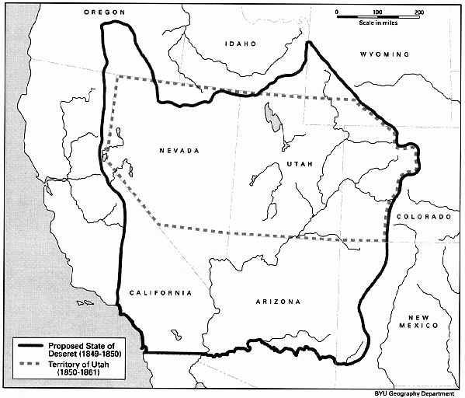
Map of the Proposed State of Deseret (1849-1850)

I am getting ahead of myself so let’s return our attention to the Holladay area. The name of Holladay comes from a South Carolinian, John Holladay. John was born in 1798 and joined the LDS Church in 1844. In 1846, at the urging of their Church leaders, his family and others began working their way to the Salt Lake Valley. They joined up with another group of Southern Saints working their way west to form the Mississippi Company under the direction of John Brown. It was their intent to join up with Brigham Young and the first group of Saints before they reached the Salt Lake Valley. The Mississippi Company actually got ahead of Brigham Young’s company and they wintered over 1846/47 in Pueblo, Colorado while Brigham stayed at Winter’s Quarters, Nebraska. Fortuitously, the Mississippi Saints were able to build cabins and shelters near Pueblo which were used to house many sick members of the Mormon Battalion and most of the women who originally started out with that Battalion but could not continue. John Holladay and many of the Mississippi Company entered the Great Salt Lake Valley just a few days after Brigham Young on July 29.

By the Fall of 1847, John Holladay who, as a captain of 10 pioneering families, most from the Mississippi Company, by lot "drew . . . a high bench" location "six miles southeast" of Great Salt Lake City. Subsequently he "asked permission . . . to locate three miles further south at a large spring" tributary known as Spring Creek, the historical geographical center of the village of Holladay. 6

While most of those original 10 families returned to the fort in Great Salt Lake to spend the winter of 1847/48, two or three men built dugouts along Spring Creek and wintered over. Thus, this became the first village established away from Great Salt Lake City itself. Holladay could actually be considered the oldest continuously inhabited settlement in Utah, since Brigham Young ordered the Saints to abandon the Great Salt Lake City before Johnson’s Army entered the valley in June of 1858. These dugouts were made by digging a 12-ft.-square area about 4 ft. deep in the sloping Spring Creek bank. Corner poles 8 ft. long were set upright; secured to them was wall siding of split logs. Wood slabs, willows, and sod formed the roof, canvas or rawhide became the door. The site of these dugouts is documented by the Holladay Historical Marker shown below.
. 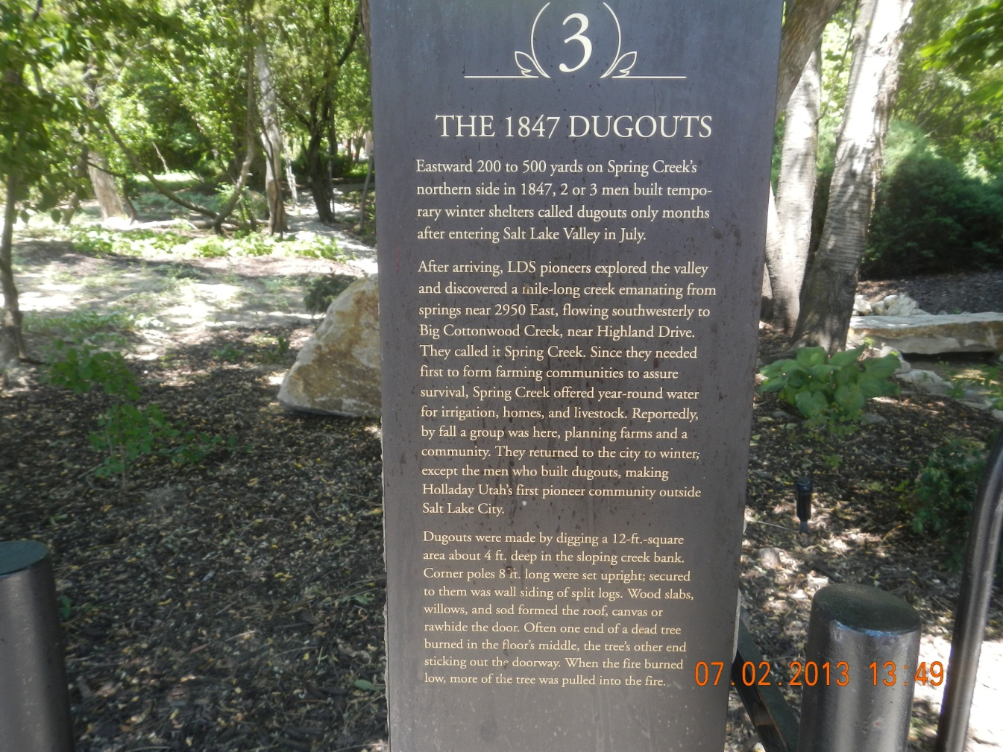

In the early spring of 1848, a number of families returned to their settlement to build homes and tame the land. These houses, forming a close village for mutual help and protection, were rough log cabins, oblong in shape with a 3 ft to 4 ft wide stone fireplace on one side of a single room and openings for windows and doors covered with cloth or rawhide. The drawing below is what a typical log home in Holladay in 1848 likely looked like. It would have been a drafty, dirt floor, one room structure at best.
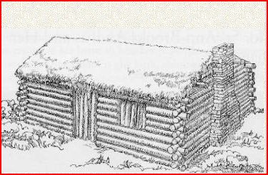

“There were numerous springs and ponds in the area and grasses and wild flowers were abundant, making this a most desirable area for settlement. These early pioneers called the settlement Spring Creek because they settled along that creek and formed a small cohesive village around Spring Creek. This was a group of Saints that had travelled across the United States together, for the most part, and had become good friends. It was right that they created their own settlement within the Great Salt Lake Valley.” 7

In 1849, when John Holladay was named as the branch president (or Presiding Elder) of the Big Cottonwood Branch (later became the Big Cottonwood Ward), the village took upon itself the names of Holladay’s Settlement, Holladay Field, and Holladay’s Burgh. They had called themselves the Mississippi Ward and the Spring Ward prior to this time. In 1911 the settlement was formally and officially named Holladay. It is interesting that the name of Holladay stuck since its name sake; John Holladay moved to California in 1851 to help the Church establish a stronghold in San Bernardino and never returned to this area. Ezekiel Lee was appointed to act as Bishop in John Holladay’s stead. Bishop Lee presided for 5 ½ years. In October of 1853 there were 161 souls living in Holladay.

This Holladay/Cottonwood area of the Great Salt Lake Valley received the ecclesiastical name of the Big Cottonwood and was bounded by today’s 3900 South on the North and 6200 South on the South and from the Wasatch foothills on the East to 1300 East on the West. This area was considered the “Country” part of Great Salt Lake City. From within the Big Cottonwood area the “Holladay” area plat was first surveyed on February 23, 1849. It roughly included the area enclosed today by Highland Drive on the west, 4800 South on the north, Holladay Boulevard on the east and a line going generally west from Holladay Boulevard at Cottonwood Lane to the intersection of Highland Drive on the south.

The Plaque below furnished by the National Society Sons of Utah Pioneers depicts the first plat of the “Holladay Field” surveyed in 1849. Eighteen plats of land were issued to the settlers ranging from 1.6 acres to twenty-eight acres.
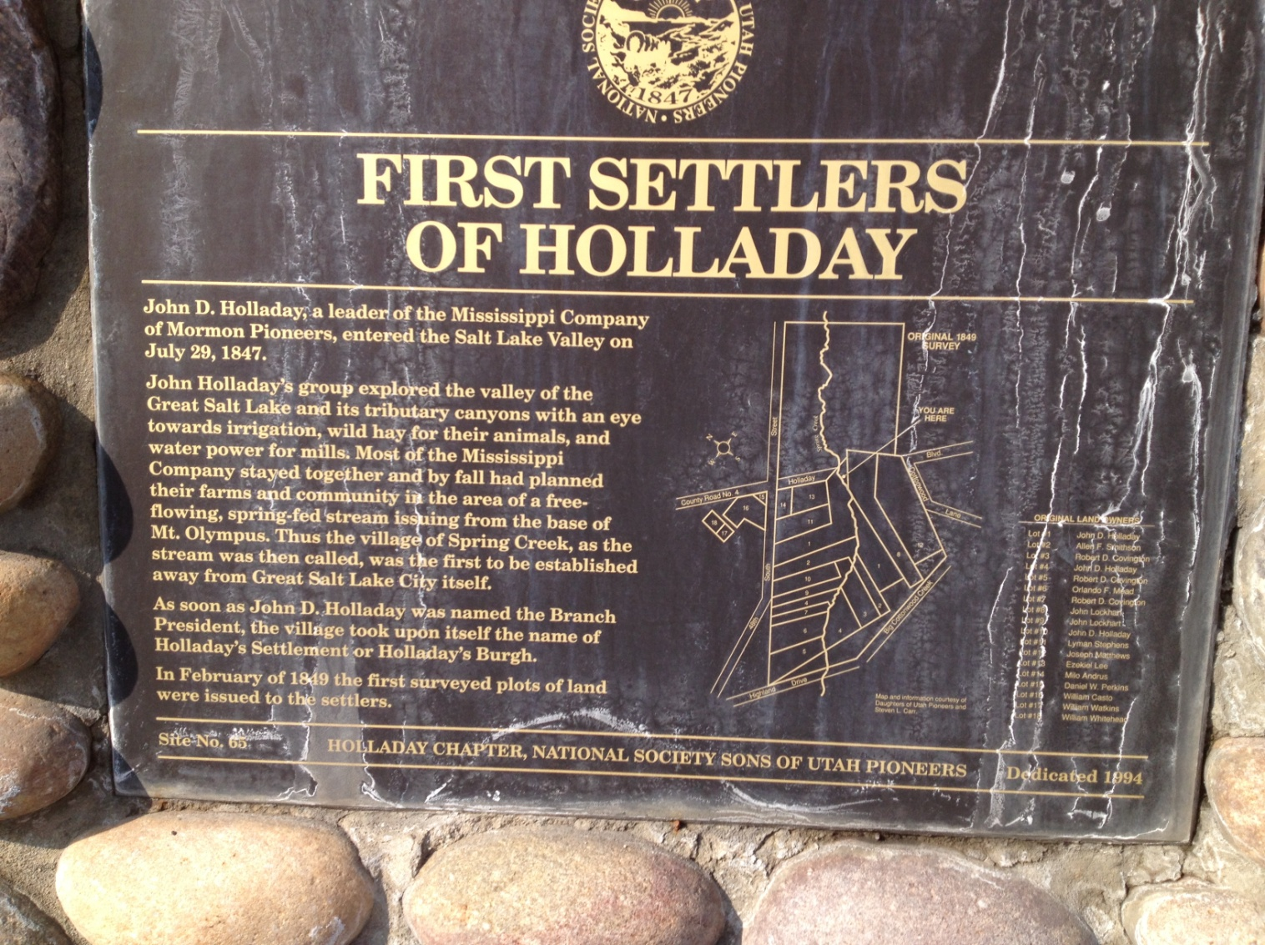

The Google map below shows the rough boundaries of what was considered Big Cottonwood outlined in Red. Within the Big Cottonwood boundaries are the boundaries of what was considered Holladay outlined in pink.

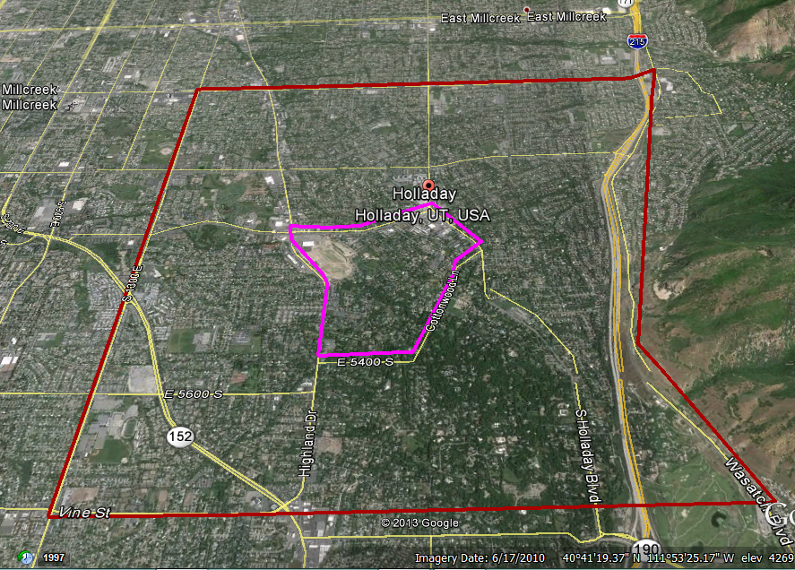
Furthermore, both sides of Big Cottonwood Creek were identified at this time as part of a general area known as Big Cottonwood. Yet, inasmuch as there were two powerful creeks of similar name - Big Cottonwood Creek and, five miles farther south, Little Cottonwood Creek - the whole area between them was called from the beginning "the Cottonwoods." Thus, the term "Cottonwood" or "the Cottonwoods" was used to refer generically to almost anything within that big space as well as specifically to an area stretching several miles South of Big Cottonwood Creek. But in this whole geographical area, it was the concept of a tightly compacted village built on Spring Creek in the spring of 1848 that formed the "town-ness" of Holladay. Elsewhere settlers spread out and took advantage of the abundant land for settling and establishing their farms.

The first school and church building was built near 1966 East Holladay-Murray Road (today’s address) in 1849. This building was approximately 14 feet square and was built out of logs (according to some, it was made of adobe). The roof was logs, brush, and dirt. There was a long log slab along one side and a fireplace on another side. The log slab was used as a desk where the students could do their writing assignments sitting on tree stumps for chairs. Most students only attended school when there was not farm work to do at home. Parents of students would pay the teacher $1.00 per student per month. These payments were often in trade such as food and produce items or building materials. Community activities and socials also took place here. 8

The plaque below can be found on the site of this first church and school building.
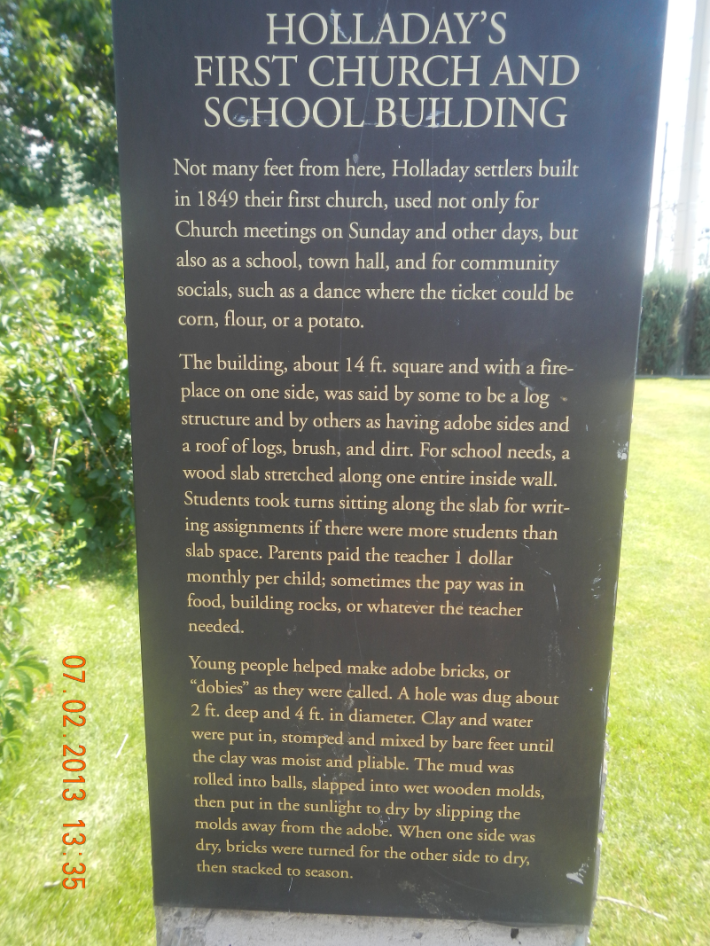
By 1853 there were 161 people established in permanent homes in this area and a fort had been started covering about 4 acres. In the fall of 1853 there were half a dozen Indian attacks in Central Utah. The walls were made of adobe and 5 or 6 feet high and 18 inches thick at the base. At least one home and possibly another was a part of the Eastern wall of the fort. It appears the fort was never completed as the Indians in this area were friendly and fear of the Indians subsided. The families in the area were invited to move within the fort walls but few did so. The 1849 school and church building was abandoned and an existing log home within the walls of the fort was expanded and became the schoolhouse and the Big Cottonwood Ward meeting house. This building was 14 feet by 30 feet providing much more room for students, church and social activities. Most historians feel that this building stood where the northeastern portion of the current Olympus Junior High auditorium stands today. The 14 foot by 30 foot log structure was replaced with the large adobe structure in 1861.

The plaque below can be found on the exterior of the current Olympus Jr. High School near the Southeast entrance to that building.
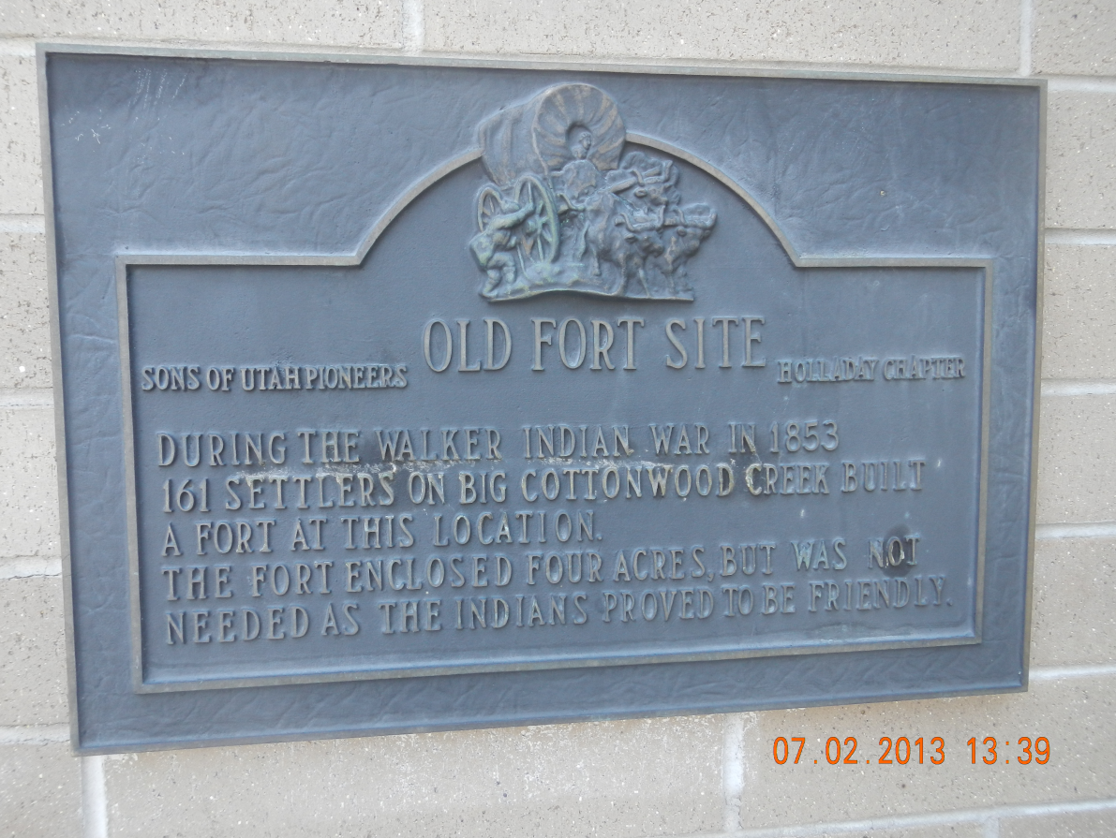
On November 15, 1856, David Brinton was ordained Bishop of the Big Cottonwood Ward. Milo Andrus was called to be his first Councilor (the same Milo Andrus that led the company of saints west to Utah in 1856 that included George W. and his family). In 1857 Bishop Brinton was called on a mission to the United States and during his absence Councilor Milo Andrus had charge of the ward as acting Bishop. After Bishop Brinton returned from his mission a meeting was held on February 6, 1859 where Milo Andrus tendered his resignation as First Councilor. On March 6th Albert Miles, his second Councilor also tendered his resignation. Bishop Brinton served another mission, this time to England, in 1870. He returned from this mission in the summer of 1872 and continued to serve as Bishop until 1873 when he was replaced by Elder B. B. Bitner who was acting Bishop for about a year until William G. Young was appointed Bishop.

Near the site of the fort was located the "tithing yard" - a barn, corral, scales for weighing hay and grain, and a storehouse for home produce and products. LDS pioneers who founded Holladay followed Church teachings of donating one-tenth of their annual increase to the Church; because cash was scarce, many members donated at market value their tithing in animals, chickens, eggs, vegetables, and goods made at home. Other persons donated 1 day of work in 10 to church work projects such as community canals, roads, and church and school buildings.

A Holladay family might donate livestock, perhaps resulting in an overpayment of tithing, and receive credit for surplus goods that were in the storehouse or yard. For years the LDS Church printed tithing scrip, which was an important currency in the 1850s and thereafter. Holladay’s tithing yard and storehouse met many community product exchange needs and, with tithing yards elsewhere, provided LDS Church headquarters with food and supplies for persons employed on its public work projects and generated income to pay its creditors. During George W.’s time in Holladay almost all tithing donations were in livestock and produce or labor. By 1900, when Holladay's tithing yard and storehouse were cleared away, two-thirds of such donations were in currency.

Within a few years after the first settlers arrived in the Salt Lake Valley a short-cut of sorts was established from the mouth of Big Cottonwood Canyon to Salt Lake City. A portion of that route, County Road (Highland Drive), crossed the bed of Cottonwood Creek where it fanned out creating a natural stream crossing for horse and wagons. Here the route intersected the main east-west route from Murray to the settlement of Holladay (Murray-Holladay Road) on the banks of Spring Creek. This intersection became a natural business center. In 1851 or 1852, 36-year-old David Brinton established Holladay's first business enterprise, a blacksmith shop on the southeast corner, causing this locale to be known as Brinton's Corner. North of Big Cottonwood Creek (today rerouted farther south) was Brinton's house, leaving ample room for his shop, horses, carriages, and customers. This essential business was where metal tools, plows, wagon wheels, hinges, chains, were made and repaired, etc. Below are photographs of Brinton’s Blacksmith Shop and a photograph of David Brinton taken around 1860’s.

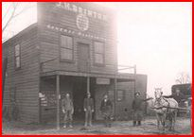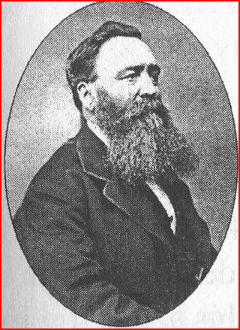
David Brinton also headed an association that built the first general store in the area on the northwest corner of this same intersection in 1869; it was called The Big Cottonwood Cooperative. Here and elsewhere, local LDS-related retail cooperatives were owned by stockholders but regulated by Church policy for the communities' good. This new coop reduced the need to travel to Salt Lake City or Murray for supplies. In 1871 David’s son, David Branson Brinton, was named the county postmaster and the store served as the community post office as well. In 1880 a second larger store was built just south of the first. No doubt our Smiths made frequent use of both the Blacksmith shop and the general store. David Brinton had died prior to the completion of the larger store on 17 May 1878. Below are two markers than can be found on the Historic Walking Tour of Holladay. I took these two photographs this past summer as I researched this presentation.

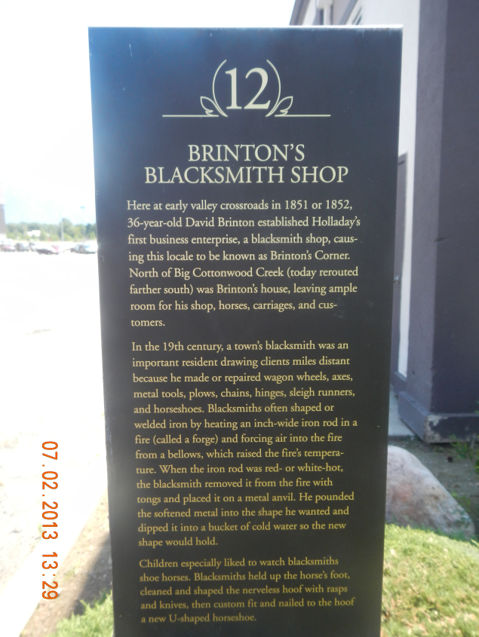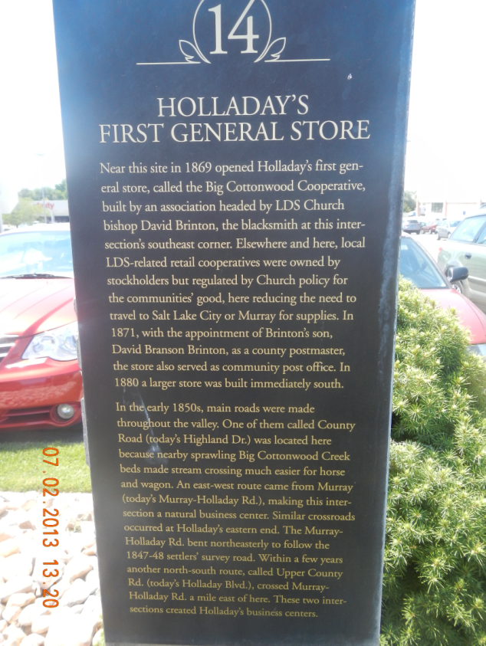

In 1873 it was decided to build a separate church meeting house near the same location as the existing church at 4800 South and 2225 East. This meeting house was build out of Adobe brick. School and civic functions continued in the old schoolhouse building.

This is a great photograph of a new District 28 schoolhouse taken in 1876 with the students that attended that year.

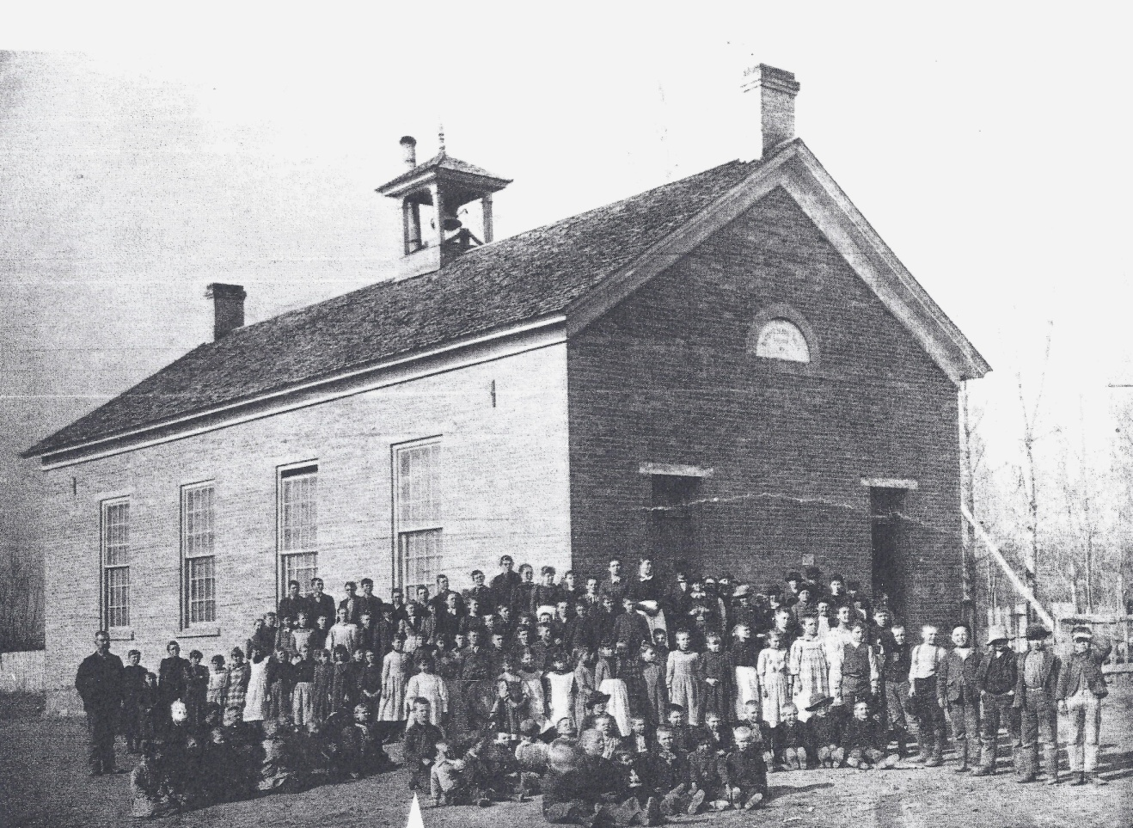

In 1895 yet another new District 28 Schoolhouse was built just south of the 1876 building. This was a much bigger two story brick building and was actually connected to the 1876 building by a hallway and the existing building was turned into a gymnasium sometime later.

Below is another great photograph taken around 1900 showing both the new Big
Cottonwood Ward Chapel built in 1873 and the new bigger District 28 school house in
the distance.
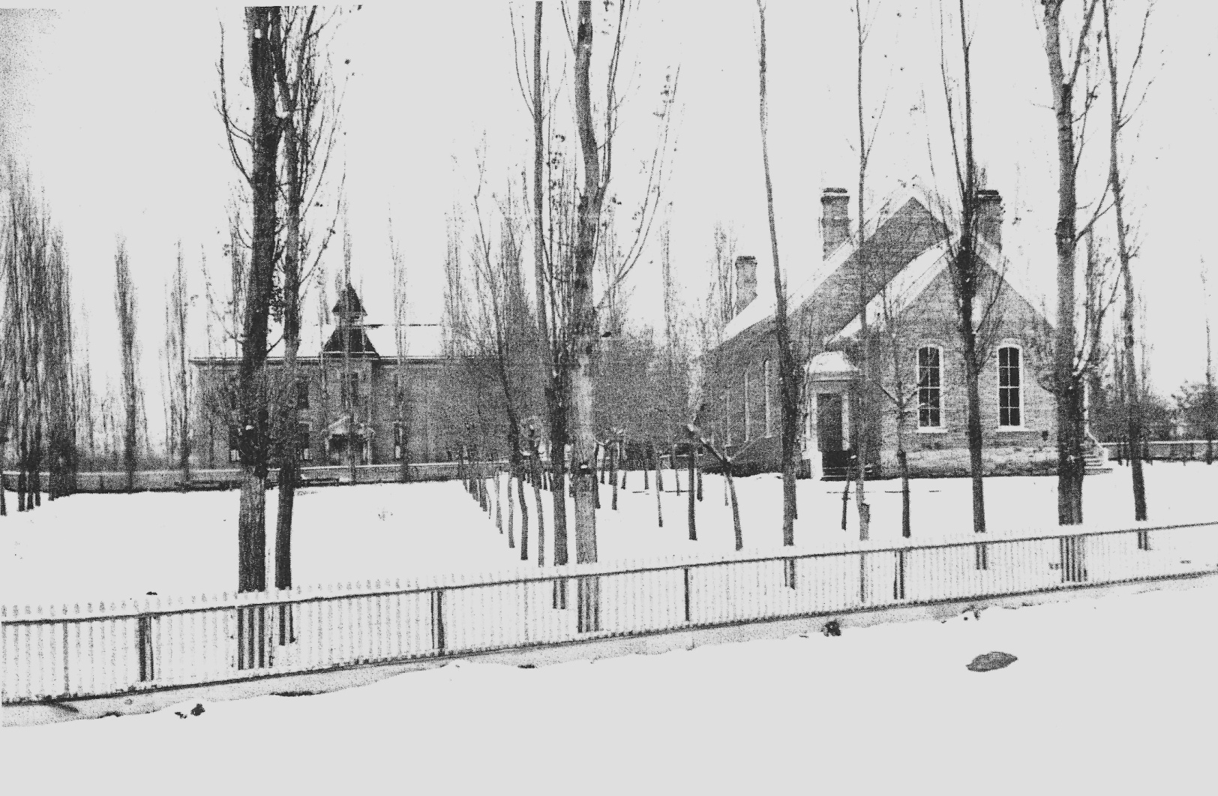

So this Holladay of the 1870’s had a Blacksmith shop, a General Store, Church, School buildings close by and streams and rivers to meet the needs of culinary and irrigation water. Good farm land was readily available. However we still need more information to understand why our Smith’s settle here rather than return to Farmington where their daughter, Sabrina, and her four children lived? In 1873 I suspect Holladay and Farmington looked very much the same. Both areas had the same climate and both were great farming areas. Both had been settled about the same time. I think it is possible that Catherine was the one that made the decision to settle in Holladay. Catherine’s father, William Wootton, had also come to Utah after the death of his wife, Deborah Roe, on 18 Oct 1857 and eventually settled in the Cottonwoods. William Wootton and his wife had both joined the Church and were baptized the same day as George W. Smith, 29 October 1848. In LDS New Family Search William is recorded to have been a Branch President in the Eaton Bray, Bedfordshire, English Conference. After the passing of his wife, Deborah, William, and two of his sons, Frederick (17) and Charles (13) left England 16 Apr 1861 on the ship Manchester and arrived in New York 14 May 1861. They traveled by rail to Florence, Nebraska and trekked across the plains arriving in the Salt Lake Valley on 12 Sept 1861. William and his sons initially spent some time in Farmington; no doubt William wanted to be near his daughter, Catherine, and her family upon his arrival in Utah. In 1862 or 1863, however, William and his sons moved to just south of the Holladay area in what became known as Butlerville. Another son, Jesse Milton Wootton and his wife, Margaret Gates, joined his father and brothers in 1868. They left Liverpool 30 Jun 1868 on the steam ship, Minnesota and arrived in New York 12 July 1868. Another Daughter, Ann Wootton, married William T. Gadbury and came to America as well. Records show she died in Stockton, California 12 December 1873.

Sometime in 1862 William Wootton married Elizabeth George Labrum. There is reference to this marriage from the Mill Creek Ward dated 20 November 1852. This would be an error since both William and Elizabeth were still in England at that time and married to other spouses, for that matter. It is likely that the date was actually 20 November 1862 and was recorded incorrectly. Elizabeth had also joined the LDS faith in England in 1949. She had married Thomas Labrum in 1837 and they had seven children together. In March of 1851 Elizabeth, Thomas and their 5 living children left England for America aboard the sailing ship, “Olympus”. Thomas was converted to the Gospel and was baptized in route. They arrived in St. Louis where Thomas died in May of 1851. Elizabeth and her five living children actually spent some time in the poor house after Thomas’ death. She married Thomas James in 1853 and had one more child, Hyrum, by him. Mr. James also passed away a few years later leaving Elizabeth alone once again. Elizabeth finally came to Utah with the Joseph Hornes’ Company in 1862 and shortly after her arrival in Utah she married William Wootton. As an aside, Elizabeth also outlived William Wootton who died in 1891. She married again in 1895 to William Cornwall. She died in Cottonwood at the age of 90 and is buried in the Murray City Cemetery in the Wootton Family Burial plot. 9

William and his family had apparently acquired a large amount of land in the Holladay/Cottonwood area by 1870. I feel certain that George W. and his family would have visited with the Woottons on their way to the “Muddy” in 1870. Catherine probably had not seen her father and brothers since they had left Farmington around 1862. They would have no doubt stopped to visit with them upon their return to the Salt Lake Valley as well. I think being close to these family members helped them make the decision to stay in the Holladay/Cottonwood area.

For whatever the reason, George W. and his family settled within a mile of the District 28 schoolhouse in the heart of Holladay. Even with a schoolhouse so close by attending public school was a hit and miss proposition. In this early pioneer period children attended school only when they were not needed at home or on the farm. Catherine would have schooled the children at home as time and circumstances permitted in addition to whatever formal schooling they received. They were also taught along the trail to and from the Muddy as conditions allowed. The approximate age of George W. and Catherine’s children at the time the settled in Holladay is as follows:

Annie Merintha 17
Georgiana 15
George Fred 13
Ida 10
Amenia 9
Lucy 6
Alonzo Bray 5

Surely these children would have attended some formal school in the 1861 building and at least the four younger ones would have attended for a short time in the newer, larger, two room schoolhouse build in 1876 as mentioned previously. A family history indicates that Lucy started attending formal school at 8 or 9 and attending for four or five years. She and some of her siblings are likely in the 1873 photograph of the new schoolhouse and students shown above. If our family histories are accurate, my grandfather, George Fred Smith’s formal education ended when he was around fifteen when he finished with the third grade reader.

Finally a Home in Cottonwood
David Brinton’s son, David Bronson Brinton, was Bishop of the Big Cottonwood Ward from 1877 to 1900. He would have been the Bishop when George W. and Catherine purchased a 10 and 45/100 acre piece of property of a William Adamson for the sum of $163.75 in lawful US money. This property was 355 feet wide and 1320 feet long and fronted what is now 6400 South at 1700 East. He purchased this property 02 May 1876 but was not recorded before the Justice of the Peace until 06 Apr 1878. This was an Indenture Contract which I suppose meant it was a promise to pay the amount listed. This 10 plus acre piece of property was the first significant real property actually “owned” by our Smiths. Here they built a small two room house making their own adobe bricks the way it was done in the “Muddy” mission. Young people helped make adobe bricks, or "dobies" as they were called. A hole was dug about 2 ft. deep and 4 ft. in diameter. Clay and water were put in, stomped and mixed by bare feet until the clay was moist and pliable. The mud was rolled into balls, slapped into wet wooden molds, and then put in the sunlight to dry by slipping the molds away from the adobe. When one side was dry, bricks were turned for the other side to dry, and then stacked to season. Up until just recently you could see the remains of the Smith’s adobe pit in what was the front yard on the old farm house. The photo below is of George W. Smith’s two room adobe farm house. I don’t know the date of this early photograph unfortunately.
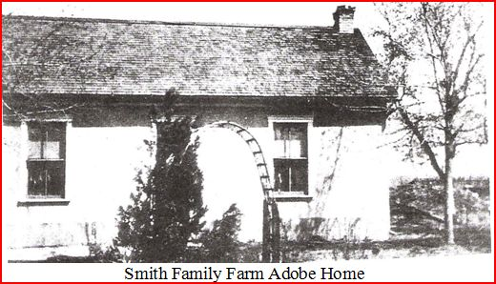
This second photograph of the George W. Smith farm house was taken after a few remodels and before it was torn down around 1990 to make room for larger estate homes.
]
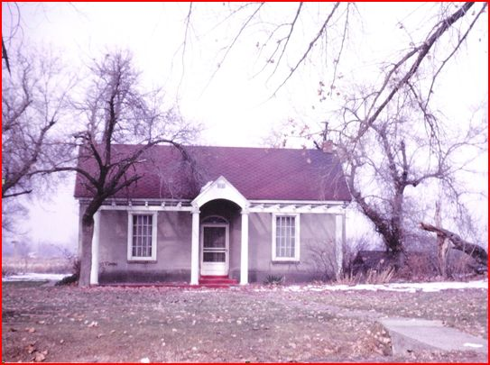

This 2 room adobe building would most certainly have been their first real house they built for themselves and it actually had a wood floor; no more dirt floors. George W. and his family were well settled in their new home and farm when the US Census was taken in their area on June 11, 1880. George W., Catherine, and three children are listed in that census, George Fred (20), Amenia “Minnie” (16), and Alonzo Bray (12). Lucy should have been listed since she was only 14 at the time of that census. Also not listed was Ida (16) and Georgiana (22) both unmarried at the time of the census. It is interesting to note that while these unmarried children were not listed on this census their daughter Jane was!

Time for another short aside; you will recall that Jane was not listed with her parents in 1870 when the US Census was taken in Farmington. Jane apparently moved to Salt Lake or Sandy either before or after marrying Joseph Livsey around 1872 and had two children with him. Annie Viola was born 21 Feb 1873 and Josephine May was born 06 May 1875. Her husband Joseph died in Salt Lake on 24 Sept 1874 after being struck by lightning. With two small children and no substantial means of support Jane gave her oldest daughter, Annie Viola, to her uncle, Catherine’s brother Frederick Wootton and his wife, Sarah. Annie Viola is listed as Frederick’s daughter (age 7) in the 1880 Census taken in South Cottonwood. See the copy of the Census below.

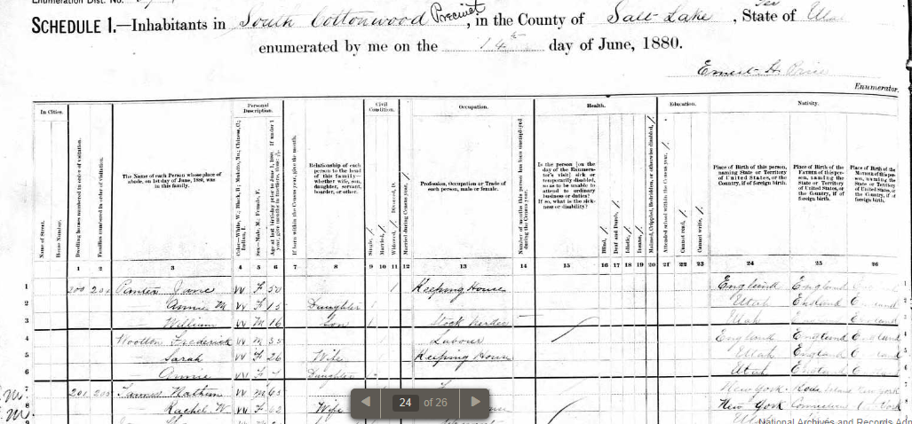

According to some reports, Jane worked for a while cleaning saloons in the area and met a Mr. Clemens. Jane had another daughter, Beatrice, with him in 1878 and we don’t know at this point if she was married to him. Sometime between 1878 and the US Census taken in June of 1880 Jane married Thomas Markham. This bring us back to the 1880 census where Jane (Jennie 31, wife, keeping house), Thomas Markham (49, Head, traveling agent), Josephine (5, Daughter), and Beatrice (2, Daughter) are all listed living with George W. in their little two room adobe farm house. Here, then, is yet another possible reason for our Smiths to settle in the Holladay/Cottonwood area. Jane and her husband, Joseph Livsey and daughter Viola were living in this same area in 1873. Catherine was probably instrumental in helping Jane place her daughter, Annie Viola, with her brother and his wife. By the way, Jane had another daughter, Georgie Irene, with Thomas Markham in 1880 after the census was taken and later moved to San Francisco with the new baby Georgie and Beatrice. Again, Jane left the oldest daughter, Josephine May, age 5, with a family named, Hudson, who raised her as their own. Jane died in San Francisco 13 April 1913.

Below is a copy of the 1880 US Census taken 11 June 1880 in the South Cottonwood Precinct. It shows both George W. Smith and his family and Thomas Markham and his family living in dwelling #173.
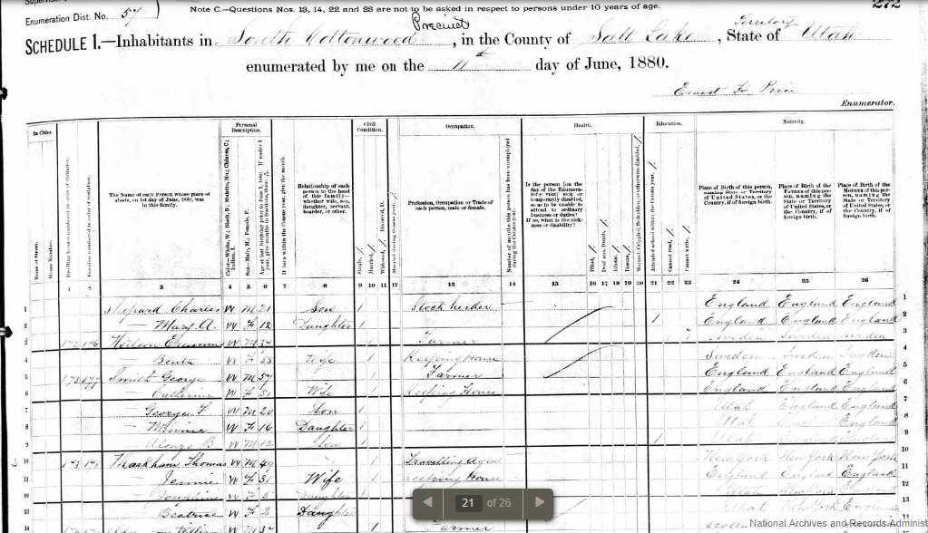

George W. finally listed his profession as “farmer” in this 1880 census; he was longer a hatter. Now that he had his own 10 acres to farm he could not deny any longer that he was a “farmer”. In fact, I found another Indenture Contract where George W. purchased another 5 48/100 acres from a William Turner on 15 Mar 1880 for a sum of $14.46. Furthermore, sometime before March of 1886 he bought yet another 6 ½ acres approximately (I have not been able to find that transaction as of yet). His farm would have been 22 plus acres at this time.

It was probably fortunate that three of George W. and Catherine’s children got married not too long after moving into their 2 room home.

Ida married Charles Albert Wilkins on 16 February 1881 in South Cottonwood.
George Fred married Elizabeth Ann Newman on 28 October 1881 in Murray, Utah.
Georgiana married Charles John Higson on 08 November 1882 in Salt Lake City.

Unfortunately, all of the hardships of trekking across the plains, walking back and forth from the “Muddy” Mission, bearing 11 children, and pioneer life in general took its toll on Catherine and after living in her new two room house for only three or four years she died 14 Feb 1883 at the age of 55. She was buried in the South Cottonwood Ward Cemetery (Murray City Cemetery). Living only 55 years seems short to us in our day but that was about the life expectancy of a woman born in the 1820’s. Our pioneer mothers worked hard and sacrificed much for their loved ones and their Church.

George W. and his son, Alonzo Bray would have continued to work his 22 acre farm pretty much alone after his wife died. Lucy is said to have kept house for his father after her mother died. Amenia was probably at home for a while as well since she did not marry until 1885. I suspect that George Fred helped with his father’s farm along with his own as he had time. George Fred Smith had settled into a small 2 room log cabin with a dirt floor on property owned by his new wife’s grandfather, James Payne. He had married Elizabeth Ann Newman on 28 October 1881. This property owned by James Payne actually adjoined George W.’s farm along the north side. This small log cabin was on the north side of Vine Street (6100 South) and 1725 East. Vine Street got its name because this road was the shortest level route the teamsters used while hauling huge granite blocks from the quarry in Little Cottonwood Canyon to build the Salt Lake temple. George Fred Smith had built a large (for the day) five room brick home in front of the original log home by 1892. This home, whose foundation was built from granite blocks discarded from the larger blocks used to build the temple is still standing today and is lived in by a great granddaughter of George W. Smith. Below is a photo of George Fred’s brick home probably taken around the turn of the century. You can still see the ruts in the dirt road (Vine Street).

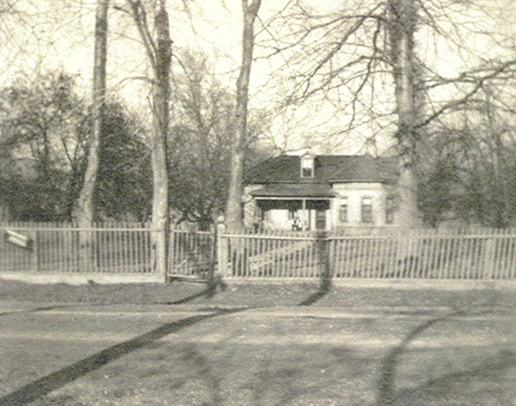
In 1886 on March 30, George W. sold his son, George Fred those 12 additional acres he had acquired after his original 10 acres for $700. George W. probably had big plans for his 22 acre farm but after the death of his wife in 1883 and his oldest son, George Fred married with a farm of his own it made sense to add these 12 acres to his son’s farm. Those 12 acres were farmed for years by George Fred Smith and then it passed on to his son, Raymont Fred Smith. During the 1940’s to the 1970’s these 12 acres were a very productive apple orchard. I personally spent many years working in this orchard as did all my brothers and sisters.

After working his original 10 acre farm with his son, Alonzo Bray, another few years George W. left this mortal existence on 30 June 1888 at the age of 65. George W. Smith was buried alongside his wife, Catherine Wootton, in the South Cottonwood Ward Cemetery (Now the Murray City Cemetery). Shown below is the newly placed Gravestone for George and Catherine. This gravestone was set in place in 2011 and was provided by donations from members of the Thomas X. and George W. Smith Organization. You will notice Wootton is spelled “Wooten” which unfortunately is not correct based on all US Census records as well as immigration records. This incorrect spelling does show up in some of our written histories and on genealogy sites.

This is a good time to add more pioneer history of this area. Beginning in the fall of 1848 settlers from Holladay and Great Salt Lake City began to spread across the southern valley and some made their homes in what is now known as Murray City. Near what is today the corner of 5600 South and Vine Street was a strip of high bench land that was completely surrounded by low land. The low land had water and good grazing grass while the high bench was dry and considered almost worthless by these early settlers. The settlers agreed that no one person should take title to this high ground but that it should be set aside and considered as belonging to the newly formed South Cottonwood Ward. This high ground was used by the teamsters mentioned previously who were hauling granite blocks from Little Cottonwood Canyon to the Salt Lake Temple grounds for the construction of the temple as a half way camp site. They could water and feed their teams in the surrounding low lands before continuing their journey to and from the quarry. The Settlers built a meeting house on this high ground on the East side of Vine Street in 1856. In 1870 the United States government started issuing 160 acre land patents across the Salt Lake Valley to the majority land owner of each 160 acre parcel. Our William Wootton must have been such a land owner because he received the patent on 160 acres going north from 5600 South on both sides of Vine Street. It was established as a legal and moral obligation that the person receiving such a land patent would in turn give deeds to the smaller land owners within “his” 160 acres. William, who was having a dispute with the Bishop of the South Cottonwood Ward at the time, deeded the land west of Vine Street to the Relief Society of that ward. In 1872 it was decided to use this high ground West of Vine Street and North of 5600 South as a Cemetery. Men were called to clear off the sagebrush and to level the ground and fence it. Each man was given a receipt for a family burial lot one rod square in size (16.5 feet square) for $3.00, paid for in labor or cash. This cemetery was called the South Cottonwood Ward Cemetery for years. The name was later changed to the Murray City Cemetery. William Wootton died on 11 March 1891 at the age of 82 and is buried in this cemetery that was once his property. You will remember that William’s first wife, Deborah Roe died in Eaton Bray and is buried there. The taller marker on the right side of William’s gravestone in the second photograph below is for Elizabeth George Labrum. William and Elizabeth were married for the nearly 30 years they lived in the Cottonwood area.

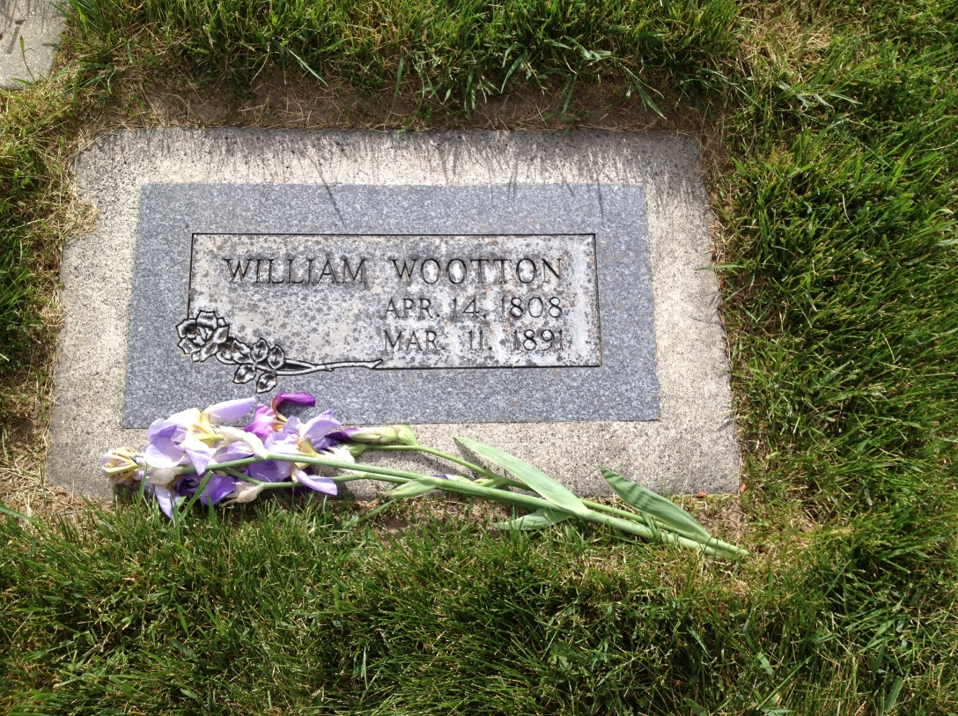
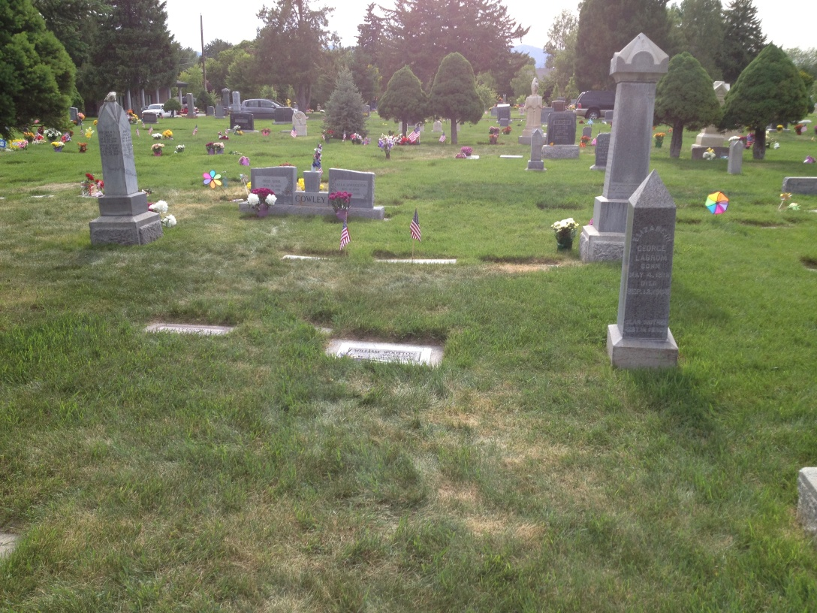

Not long after George W died his daughter, Lucy married Marcus Bennion on 27 December 1888 leaving only Alonzo Bray alone on the family farm just short of his 20th birthday. Alonzo Bray stayed on the 10 acre family farm after the death of his father and their family home stood for at least another 100 years after George’s death. Descendents of Alonzo Bray lived in the home until the pressures of modern home development took its toll and the home was demolished to make way for large estate homes. There is monument on the property showing where the home once stood. This monument is shown below.

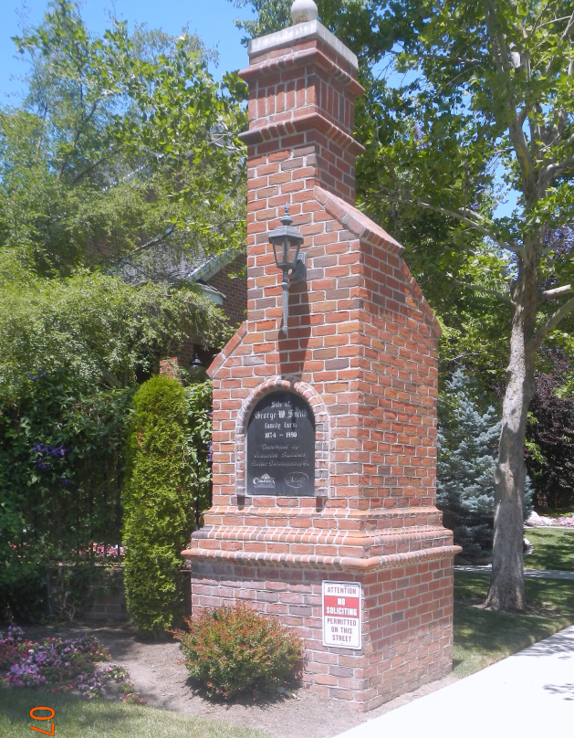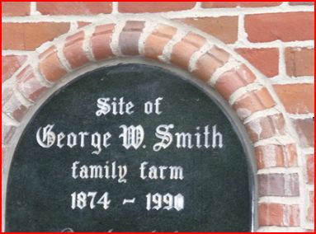

The Church in Cottonwood

This might be another good place for some additional pioneer Church history. It was mentioned earlier that the Big Cottonwood Ward would have been the Ward the Smith’s belonged to after returning from the “Muddy” in the spring of 1873.
This Big Cottonwood Ward was part of the Salt Lake Stake until 1900; twelve years after the death of George W. Smith. At that time the 59 wards comprising that stake were split into three separate stakes. All wards North of 1300 South stayed in the Salt Lake Stake. The “Country” Wards became the Granite Stake and encompassed the area between 1300 South and 6600 South across the entire width of the Valley. The Jordan Stake comprised all the wards south of 6600 South. I have placed approximate boundary lines for the Granite Stake between 1300 South and 6600 South across the Google map of the Salt Lake Valley below.
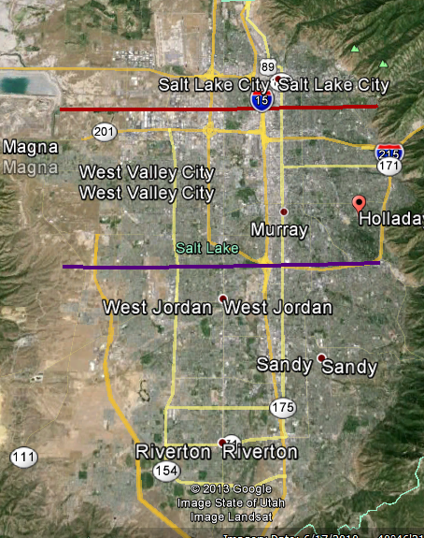
There were 10 Wards and one Branch that originally formed the new Granite Stake in 1900. These Wards are listed below:
Big Cottonwood
South Cottonwood
Mill Creek
East Mill Creek
Farmers
Forest Dale
Granger
Hunter
North Jordan (Taylorsville)
Sugar House
Mountain Dell Branch (a small town up Parley’s Canyon)

Of particular interest to us is, of course, the Big Cottonwood Ward. The Big Cottonwood Ward met in their new building (started in 1873) at 4800 South and 2225 East. On 11 October 1885 a branch of the Big Cottonwood Ward was formed and attended by those to the south having difficulty getting to the Big Cottonwood Ward building because of swollen creeks and the Big Cottonwood Creek in particular. Distance also became a factor as settlers expanded further southward. Branch members met in homes initially and then in 1890 met in the first log schoolhouse in this Southern area at the corner of Spring Lane and the County Road (Highland Drive). In 1894 Church members and school children started attending in a one room log schoolhouse called the District 37 School at 5815 South Highland Drive (present address). This is the location of the current Oakwood Elementary School.

On 11 February 1911 the Big Cottonwood Ward officially split into the Holladay Ward and the Brinton Ward. The wards were split along the Big Cottonwood Creek with the Holladay Ward comprising families living on the North side of the Creek and the Brinton Ward comprised families living on the South side of Big Cottonwood Creek. The Holladay Ward continued to meet in their building and the new Brinton Ward continued to meet in the District 37 School house. Luckily in 1896 a new, much larger, two room red brick school building had been built behind the log school and the log school was removed. It is this red brick building that was used as the Brinton Ward meeting house until a new chapel could be built.

Even though George W. and Catherine had passed on prior to this ward split and the move to the District 37 school house, his sons, George Fred and his family, and Alonzo Bray and his family, would have attended church in this building.

The District 37 school house was less than a mile from George Fred Smith’s home and less than 2 miles from the George W. farm where Alonzo and his family lived. All of George Fred’s children would have attended this school. It consisted of two large rooms, separated by a long hall. There was a big pot belly stove in each room. At the turn of the century one room was used for the first and second grades and the other room was used for all other grades. All of the local social functions were also held in this school building and our family members would have attended parties, dances, shows, etc. there until the new Brinton Ward building was finished.

I show a photograph below of the District 37 red brick school house and students as it looked in 1906. My father, Raymont Fred Smith would have been 10 at the time of this photograph and his sister, Alila Esther would have been 8. Both are likely in this photograph but the quality is too poor to make them out. The photograph comes from the collection of Afton Pulver Weaver.
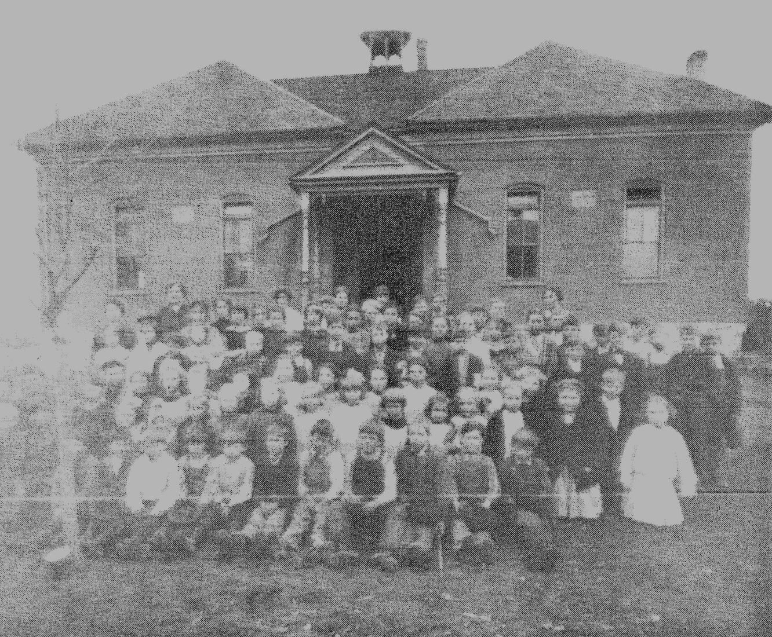

Below is another photograph taken in 1919 showing the newly built Oakwood Elementary school with the old District 37 school house still standing in the background. As an aside, Oakwood Elementary School got its’ name because of a stand of beautiful Black Oak trees along the North side of the school. These oaks belonged to Isaac Ferguson who owned the land next to the school. The old building was not torn down until 1931 when the PTA and the local community undertook a major cleanup and landscape project of the area. For those 12 years between 1919 and 1931 the school looked pretty much like it did in this photograph. There was no grass or sidewalks and the grounds were becoming quite an eye sore as well as a hazard to the students. The Granite School District actually won a national first place beautification award for their efforts, given by Better Homes and Garden magazine. Some of George Fred’s grandchildren participated in planting part of the landscape.

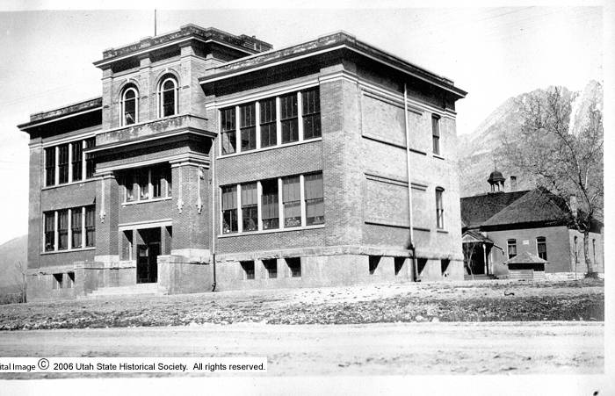

This 1919 version of Oakwood Elementary School (District 37 School) underwent remodels and additions until in 2012 the new Oakwood Elementary School was completed where the original red brick school house had been. This new school building pictured below is quite a step up from the little red brick school house my ancestors attended.

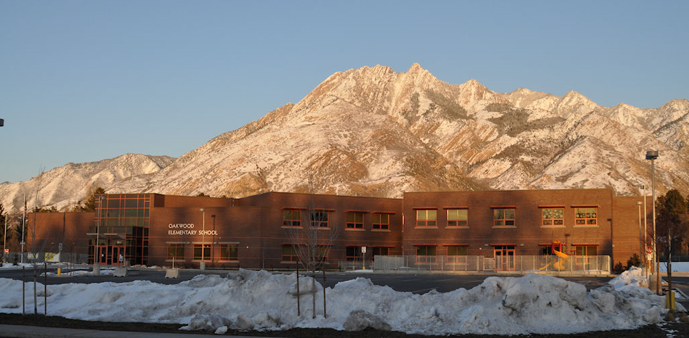

When the Big Cottonwood Ward split in 1911 the newly formed Brinton Ward members began construction of their own Chapel a few hundred feet south of the District 37 School house at the corner or Highland Drive and Fardown Avenue. Fardown Avenue was also called “Danish Alley” and “Druehl Lane”. People said that Fardown Avenue was a winding dirt road that was frozen in the winter, dusty in the summer and otherwise muddy. The land for this new Chapel was donated by John Woodruff and the construction of the building was under the direction of his brother, Ensign Woodruff. Both John and Ensign were sons of LDS Church President Wilford Woodruff. The entire construction work on their chapel was done by the members of the Ward. There is a Utah Historical Marker located on the Northwest corner of Highland Drive and Fardown Avenue. This marker commemorates the settlement of Cottonwood and the construction of the Brinton Ward building. There is a quote on the plaque from Ensign Woodruff’s journal of interest to us, “I was the contractor… With Fred Smith’s team and my plow, we broke ground… My brother, John, donated the ground…” Of course, Fred Smith is our George Fred Smith, son of George W. Smith. I am sure George Fred contributed time working on this building as would have his son, Raymont Fred (15) and possibly, Glenn Taubman (9). These ages are based on their age at the time construction began in 1911. Below is a great photograph of the Brinton Chapel under construction. Ensign Woodruff is the fellow near the far left with the white carpenter’s apron on. The photographer would have been standing on the North West Corner where this Marker is located today facing slightly south of east. This photograph comes from the collection of LeNore Woodruff Turnbow.
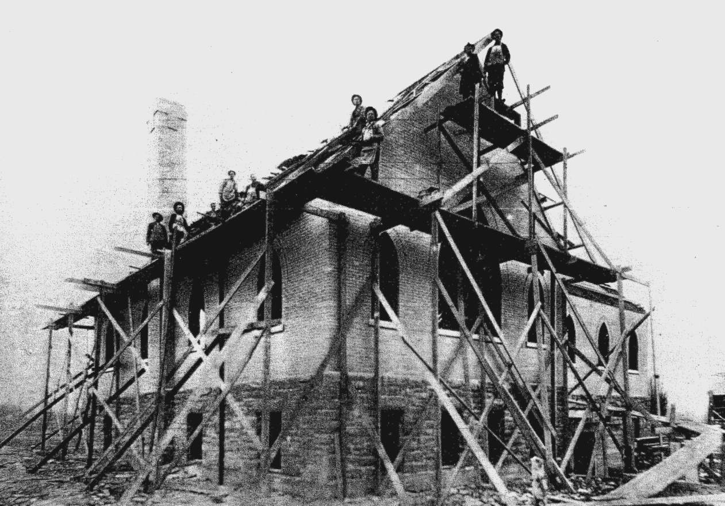
There are actually two significant plaques on this church property. Below is the one I mentioned earlier honoring the Cottonwood Settlement placed by the Daughters of Utah Pioneers.
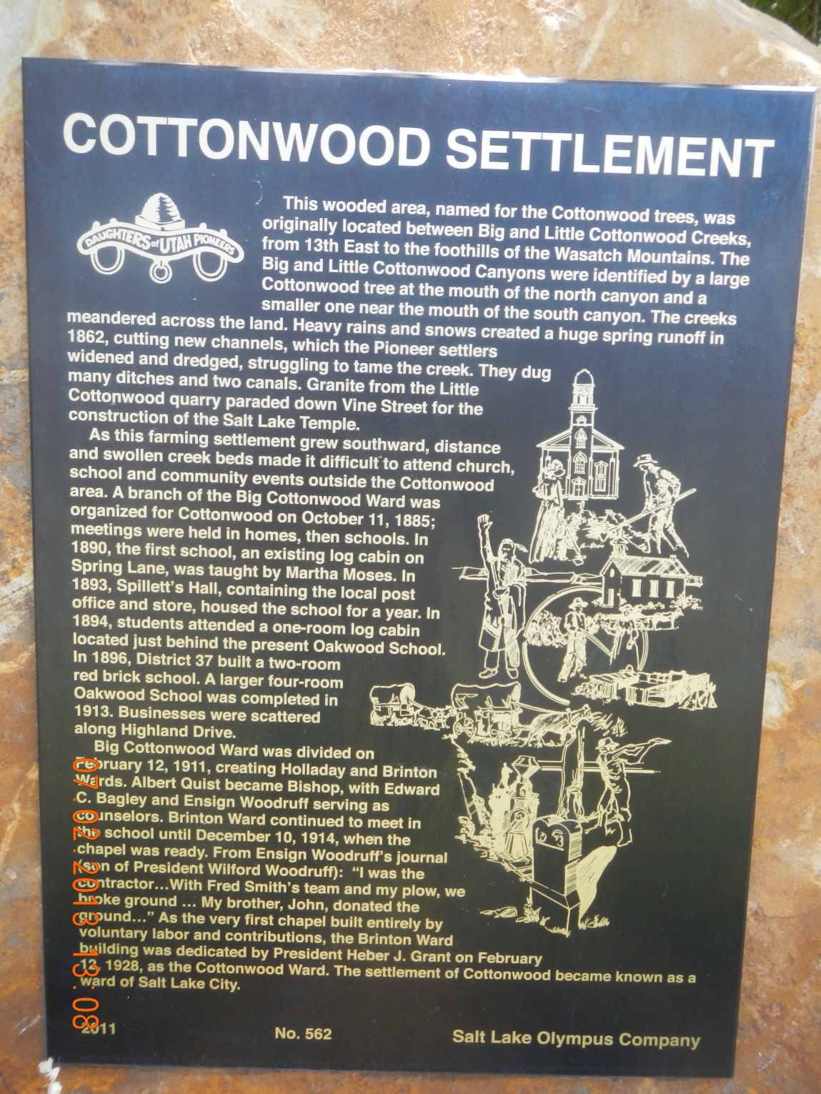

The first Sacrament Meeting was held in the new Brinton Ward building on December 20 1914; just three years after beginning construction. This Chapel is believed to be the first in the Church to have been built entirely by Ward member contributions and labor. The building was not completely finished for another 15 years when it was dedicated by LDS Church President Heber J. Grant on 12 February 1928. The Brinton Ward was reorganized a month prior to this dedication and the name of the ward was changed to The Cottonwood Ward.

The second monument and plaque was placed in 1997 by members of the Cottonwood 5th and 9th Ward occupying this building at that time.
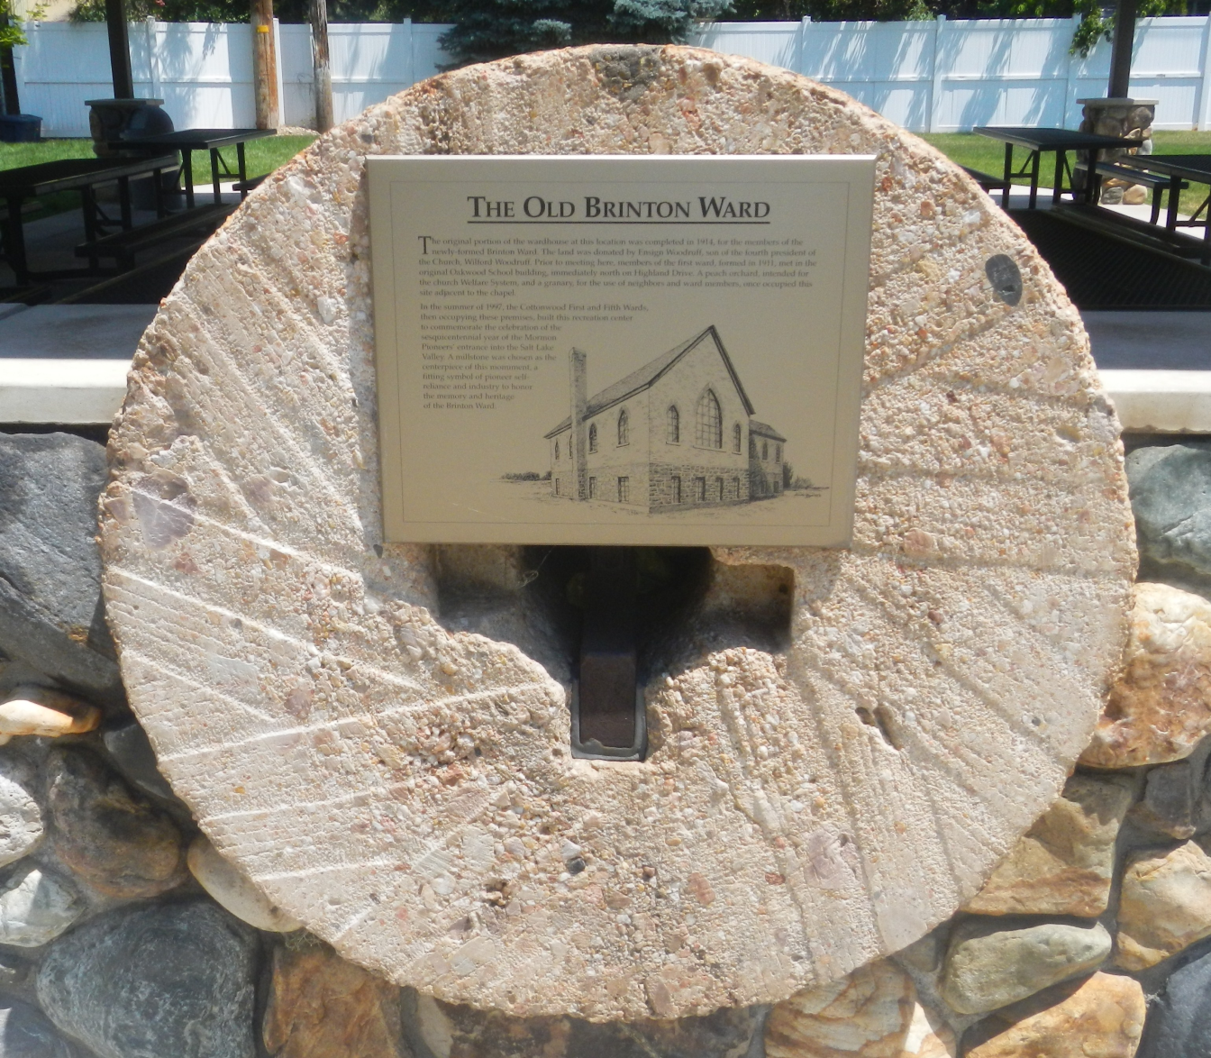

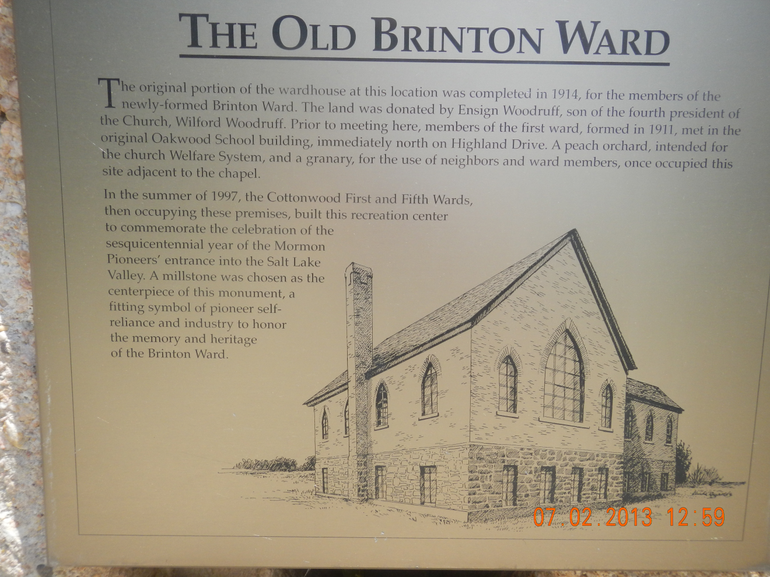

The photograph below was taken in 1931. It is shown here because this would have been how the building looked at the time it was dedicated on 12 February 1928 by President Heber J. Grant. The Ward was reorganized at this time and the ward name was changed to the Cottonwood Ward. The photographer took this picture looking to the east. You can see the thin outline of Mount Olympus in the background. My earliest memories of this Chapel would be about 1951 and it looked exactly as depicted in this photograph with a more mature landscape.

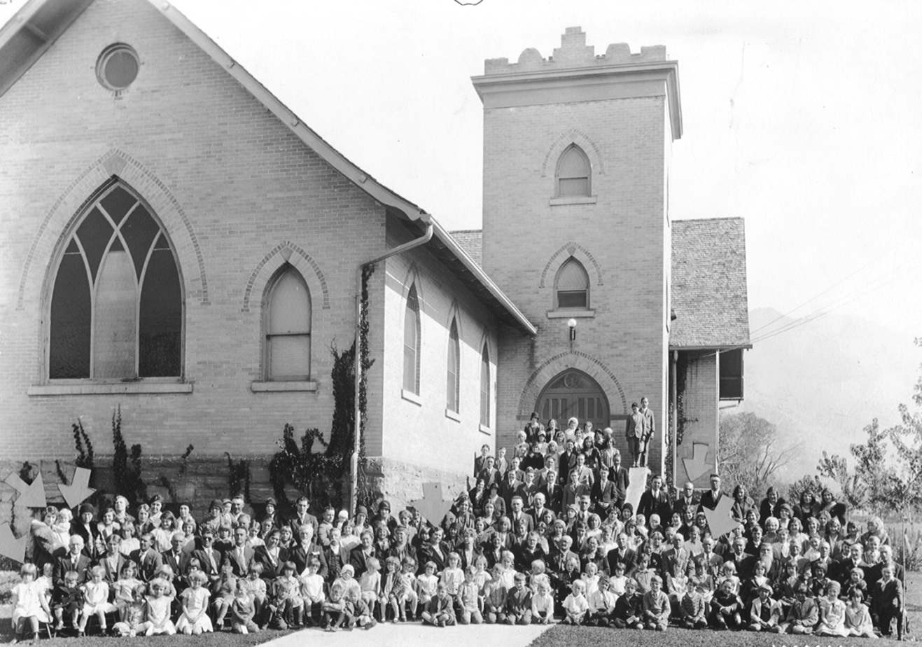

George Fred Smith is pictured in this photo and can be identified by the arrow on the far right side. His son, and my father, Raymont Fred Smith, is identified by the next arrow to the left. In the middle of the photo is George Fred’s wife, Mary Elizabeth Taubman Smith. On the far left of the photograph is my mother, Ethel Naylor Smith, holding her daughter Shirley Dean Smith (Woody). The last person identified with an arrow on the far left is another daughter, Donna Jeanne Smith (Snarr).

This is probably the point I wanted to get to with this project. It was difficult to stay on task with so much general Church and pioneer history to discuss. There is nothing definitive telling us why George W. Smith and his family settled in this area after returning from the “Muddy Mission”. In my mind, however, there were some influencing factors:
- Catherine’s father and brothers and their family were settled here.
- Their daughter, Jane, was living here and had just given birth to her first child, Annie Viola perhaps only weeks before George W. and family arrived.
- Holladay was an established town with schools and a Church meeting house.
- There was a blacksmith shop and general store close by.
- There was good farm land available.

We will probably never know for sure why George W. and his family settled in Holladay-Cottonwood but I, for one, am pleased that they chose this area as a final home. I started this project by saying that I had a personal interest in this area. My family home is standing on Vine Street just two houses west of George Fred Smith’s home. I have wonderful memories of the house, the yard, the farm, the orchard, the school and the Church building. One of my sisters lives in that family home today and another sister lives directly behind our family home.

I attended Church in the Brinton Ward building (Cottonwood First Ward growing up); I walked along Vine Street every school day to attend Oakwood Elementary School as did all my brothers and sisters before me. Cottonwood was a wonderful place to grow up and I couldn’t be more thankful that my great grandfather and great grandmother decided to spend the last years of their life in this area.

The Children of George W. and Catherine Wootton Smith

- Sabrina Smith Lamb was born in Eaton Bray, England 29 April 1847. She immigrated to America in 1854. She was baptized 27 April 1856 in Farmington, Utah. She married Lisbon Lamb on 03 February 1866 in Farmington. She had six children with Lisbon:
George Francis Lamb born 1867
Anna Maria Lamb born 1868
Lucy Jane Lamb born 1870
Charles William Lamb born 1872
Catherine Lamb born 1874
Alonzo Bray Lamb born 1876
Brigham Frederick Lamb born 1878
Sabrina died 18 March 1897 in Farmington, Utah at the age of 49. She is buried in the Farmington City Cemetery.
- Jane Smith Livsey Markham was born in Eaton Bray, England on 14 October 1848. She immigrated to America in 1854. She was baptized on 27 April 1854 in Farmington, Utah. She married Joseph Livsey date unknown. Jane had two children with Joseph.
Annie Viola Livsey Wootton born 1873
Josephine May Livsey born 1875
Jane married a Mr. Clemens in 1877 (not verified) in Utah. Jane had one child with him.
Beatrice Clemens born 1878
Jane married Thomas Markham in 1879 in Salt Lake City, Utah. Jane had one child with him.
Georgie Irene Markham born 1880
Jane died 13 April 1913 in San Francisco, California at the age of 64.
- Maria Elizabeth Smith was born in Eaton Bray, England on 18 September 1852 and died two weeks later on 1 October 1852.
- Marion Lehi Smith was born in Eaton Bray, England on 08 March 1854 but died the same day.
- Annie Merintha Smith Hitch was born near Devils Gate, Wyoming while her parents were crossing the plains on their way to Utah on 24 September 1855. She was baptized 21 April 1867 in Farmington. She married Samuel Palmer Hitch in 1877. Annie had two daughters with Samuel.
Effie Palmer Hitch born 1877
Lucy Frances Hitch born 1879
- Georgiana Smith Higgins was born in Farmington on 21 January 1858. She was baptized on the same day as her sister, Annie, on 21 April 1867 in Farmington. She married Charles John Higgins on 08 November 1882 in Salt Lake City. Georgiana had three children with Charles.
Charles Roy Higson born 1883
Earl Kidgell Higson born 1885
Georgiana Higson born 1890
Georgiana died on 14 May 1927 in Salt Lake City at the age of 69.
- George Fred Smith was born in Farmington on 28 December 1859. He was baptized on 29 October 1868 in Salt Lake City. He married Elizabeth Ann Newman on 28 October 1881. They had seven children together.
Orson James Smith born 1882
Thomas Ruben Smith born 1884
Florence Elizabeth Smith Bringhurst born 1886
Hazel Smith born 1888
Catherine Debora Smith Gilbert born 1889
Nellie Ann Smith born 1892
Elizabeth Ann Newman Smith died 01 February 1895 and is buried in the Murray City Cemetery. George Fred married Mary Elizabeth Taubman on 31 January 1896 in Murray, Utah. George and Mary also had seven children together.
Raymont Fred Smith born 1896
Alila Smith Mitchener born 1898
Ernest J. Smith born 1900
Glen Taubman Smith born 1902
Mary Chelta Smith Quick born 1908
Anita Smith Vanderende born 1910
Janice Marjory Smith born 1916
George Fred died in Cottonwood on 14 May 1942 at the age of 82. He is buried in the Murray City Cemetery.
- Ida Smith Wilkins was born on 15 September 1862 in Farmington. She was baptized on 30 June 1900. She married Charles Albert Wilkins on 16 February 1881 in Salt Lake City. Ida and Charles had 10 children together.
Etta Belle Wilkins born 1881
Charles Claude Wilkins born 1883
Seth Wilkins born 1885
Anne Lenore Wilkins born 1888
Francis Albert Wilkins born 1891
Ida Amanda Wilkins born 1892
Elwood Wilkins born 1895
Rueben Caleb Wilkins born 1897
Gladys Wilkins born 1899
Rodney Wilkins born 1902
Ida died on 19 February 1952 in Hunter, Utah at the age of 89. She is buried in the Murray City Cemetery.

- Amenia Gertrude Smith Park was born on 20 January 1864 in Farmington. She was baptized 20 April 1884. She married William Hill Park on 2 December 1885 in Logan Temple in Logan, Utah. She and William had 5 children together.
Catherine Park born 1886
John Smith Park born 1887
George Thaddius Park born 1890
Elizabeth Park born 1892
William Edwin (Ted) Park born 1895
Amenia died on 20 January 1898 in Granger, Utah at the age of 34. She is buried in the Murray City Cemetery.
- Lucy Evelyn Smith Bennion was born on 09 July 1866 in Farmington. She was baptized on 08 September 1878. She married Marcus Bennion on 27 December 1888 in Salt Lake City. Lucy and Marcus had 7 children together.
Hilda Bennion born 1889
Ivy Bennion born 1890
Marcus Leslie Bennion born 1892
Edna Bennion born 1896
Roy Bennion born 1899
Leo Bennion born 1902
Lucy died on 23 April 1937 in Granger, Utah at the age of 70. She is buried in Taylorsville, Utah.
- Alonzo Bray Smith was born in Farmington on 18 May 1868. He was baptized on 08 September 1878. He married Nellie Josephine Johnson on 21 November 1894 in the Salt Lake City Temple. Alonzo and Nellie had four children together.
Amanda Nellie Smith born 1895
Melvin Alonzo Smith born 1897
George Jonas Smith born 1899
Mark Smith born 1902
Alonzo died on 21 June 1921 in Cottonwood, Utah and is buried in the Murray City Cemetery.

References

- Hartley, Ensign, Oct. 1997, 16.
- Dean L. May, Utah: A People’s History (1987), 61.
- Bagley, Will, A Great Wall once Circled Salt Lake City, 2001.
- Anderson, Ron, Historical Salt Lake City Walking Tour, 1998
- Crawley, Peter. "The Constitution of the State of Deseret." BYU Studies 29 (Fall 1989):7-22. Also see History of the Church, 1844-1877
- Carter, Kate B., Our Pioneer Heritage, 1959, 2:443.
- Todd, Jay M., The Founders of Holladay: A Historical Context 1966, 15
- Todd, Jay M., The Founders of Holladay: A Historical Context 1966, 36
- Elizabeth George’s Obituary 1908, Utah Millennial Star

