The tHOMAS x AND GEORGE w. smITH fAMILY oRGANIZATION
The “Other” Children of George Smith and Patience Timson
And the economic conditions in 1850 Eaton Bray
Brent N. Smith - great grandson of George W. Smith
7/22/2019

This history primarily deals with the parents and siblings of Thomas X and George W. Smith who stayed in England after they left for America in the 1850’s. The economic conditions and occupations are discussed with particular emphasis on Straw Plaiting (there primary occupation). Photocopies of actual birth, marriage and death records of these individuals, their spouses and children are included.

Table of Contents
Who are these “Other” Children? 2
What of Eaton Bray? 13
1850’s English Currency and Occupations in Eaton Bray 18
Straw Plaiting 20
Straw Plaiting schools 25
The Economics of Straw Plaiting 28
Cost of living 29
The Siblings Left Behind in England 33
Caleb Smith 38
Reuben 59
James: 88
George W. 89
John 91
Thomas X 107
Mary Ann and Esther 110
Noted contradictions 119
The Next Chapters in the Story 120

Appendix A: Chart showing siblings, wives, children and status of records documenting each 121
Appendix B: List of issues to resolve or Missing Records 125
Appendix C: Map and narrative showing where each of the siblings lived when the 1841, 1851, and 1861 Census’ were taken. 128

Who are these “Other” Children?
We, being descendants of George W. Smith and Thomas X Smith, have written histories on these two men and their posterity over the last several years. And rightly so, since we are part of that great posterity. On the other hand, their parents, George and Patience, had several other children so it is important to find out what we can about them and their posterity.
Probably the first step in this history, and not an easy one, is to determine exactly how many children George and Patience had.
My sister, Donna Jeanne Smith (Snarr) and another unidentified relative, made a genealogical expedition to England back in the 1970’s and while at various locations she saw firsthand records of important events in the life of George and Patience and their children. From the research they did it was determined that George and Patience had eight children. From her findings she completed page after page of Family Group sheets and Pedigree Charts. Once home these sheets and charts were typed and copies were made. She gave copies of these family Group sheets and Pedigree Charts to each of her six siblings. I still refer back to the sheets given to me when I find discrepancies in the FamilySearch tree and on other genealogical sites. I have often made changes to the FamilySearch tree to bring it back in line with my sister’s original research. In our day many of those original records have now been “Indexed” and are searchable on line at several genealogical sites. But none have disputed what she found in her research over 45 years ago.

Below is a photo of the Family Group Sheet she typed up about 45 years ago for the George Smith and Patience Timson family.

You can see that their first six children were boys and their last two children were girls. When I started this history back in November of 2018 the FamilySearch tree showed that George and Patience had 11 children rather than 8. Which is correct? Eight or eleven or some other number?
It must be understood that the tree in FamilySearch.org is one WORLD tree. In other words, everyone contributes to, edits, and deletes names from a single tree. We often like to think of the portion of that tree where we find our relatives as “Our Tree” but in reality anyone who has an account in FamilySearch can modify tomorrow what we add to “our” tree today. With that understanding let’s look at our Smith family as it appeared in Family Search at the end of November 2018.

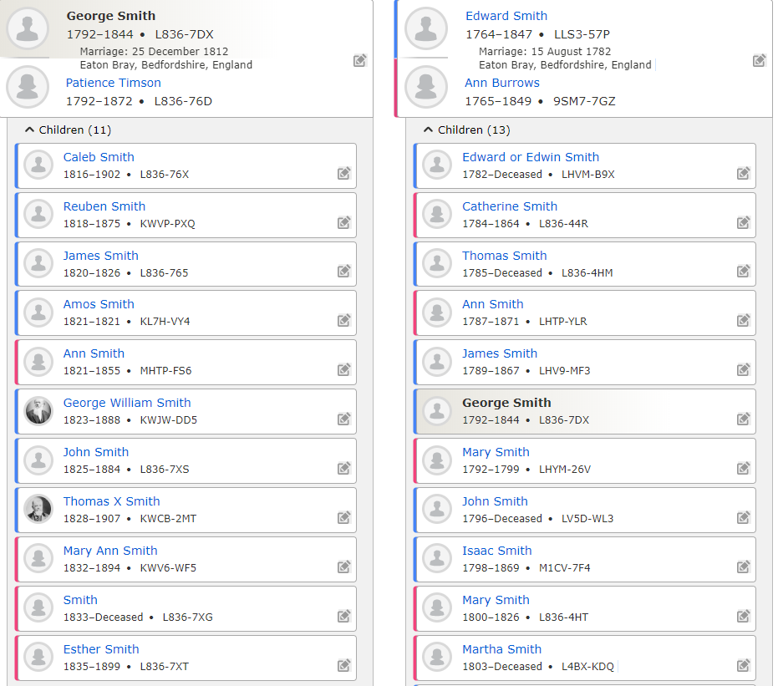

Let’s simplify this screen by just showing George, Patience, and their children:
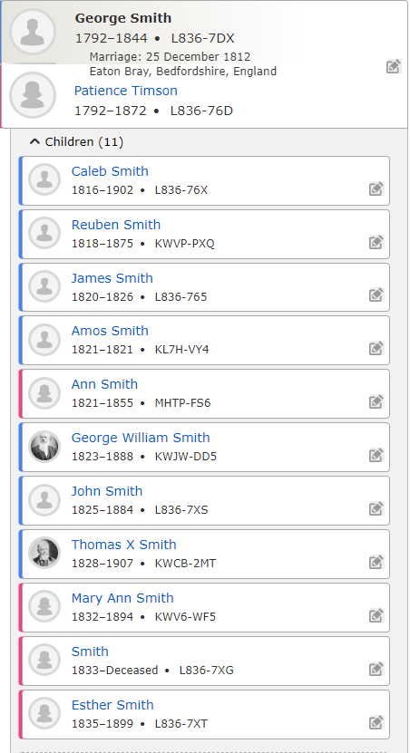
I have circled the three children not found in the original research from fifty years ago.
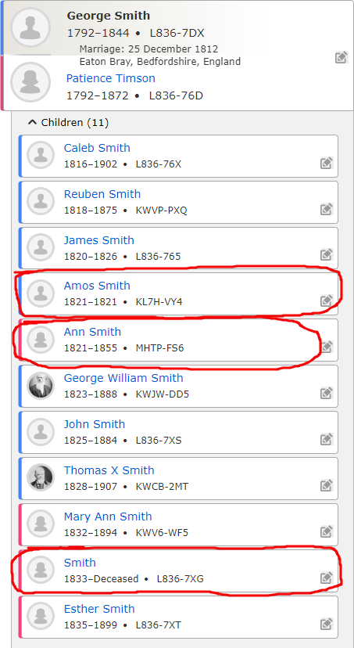

The three additional children are:
Amos Smith, Ann Smith and simply “Smith”. Let’s take a closer look at all three.
Amos Smith is shown with a birth date and death date of about 1821. There is only one source shown for Amos and it comes from Legacy NFS and it lists the death of an Amos Smith about 1821 in Eaton Bray, Bedfordshire, England. No parents are listed nor is any addition helpful information. Does he or does he not belong to George and Patience? Either way, Amos was sealed to George and Patience on March 12, 1853 in the Salt Lake Temple. We have not been able to find any record that prove or disprove Amos is a son of George and Patience. Our research continues.

Thomas X’s daughter, Lucy Smith Cardon, in her written history of Thomas wrote the following:
LIFE HISTORY OF THOMAS X SMITH by his daughter – Lucy Smith Cardon
“Thomas X Smith was born the 25th of December, 1828, at Eaton Bray, Bedfordshire, England. He was the seventh son in the family of nine born to George Smith and Patience Timpson. His father was an agricultural laborer and his mother was a school mistress. While still a young man he learned the profession of braiding straw for making fine hats. He joined the L.D.S. Church 19 March 1849 in Eaton Bray, Bedfordshire, England. After that his family, neighbors, and friends would not have anything to do with him.
They lived on High Street in Eaton Bray. He married Margaret Gurney the 2 January 1851. One year later on the 5th of January, 1852, their eldest daughter Lucy, was born. In March of 1853 they left all behind to come to America. They were only able to take a few necessities of their earthly possessions. They came in a sailing vessel and had a hard, rough, trip on the water three months. They signed a note to the church for their passage and paid it in full. …”.
So Lucy obviously thought or was told that there were nine total children and not eight. That would add credence to another son being born to George and Patience before Thomas X was born in 1828; but is it Amos or another son or did Lucy get the number wrong? I’ll have more to say about other things she mentions in that paragraph later in this history. As I have said, research continues.
Here is some more food for thought regarding another child. It was three and seven months after George and Patience were married on Christmas day 1812 that Caleb was born on July 17, 1816. It is certainly possible a son could have been born during those first few years. It is also possible that “Amos” could have been born and died in 1821 between the birth of James on December 31, 1820 and the birth of George W. on May 2, 1823 but this possibility is much less likely based on the timing of James’ birth being the end of 1820. There is another two and a half year gap between George’s birth and John’s birth on November 25, 1825. And, finally there is three year gap between John’s birth and Thomas X’s birth on Christmas day in 1828.
So the birth of another boy who died in infancy is a real possibility and research will continue.
The other two children shown in the FamilySearch tree are much less likely to belong to George and Patience.
Ann Smith is shown with a birth date of 1821 also. But her birth location is listed as Catton, Humbershire, England. Which, by the way, is 190 miles North of Eaton Bray. There are also five sources shown for Ann. However, none tie her to George or Patience. One is a marriage record of her to her husband, George Kelsey in 1840 in York, York, England which is also about 190 miles north of Eaton Bray. Here is the kicker, that same marriage source shows Ann’s father as Danial Smith of York, York, England. She clearly is not a daughter of George and Patience. Below is a photo of that source.
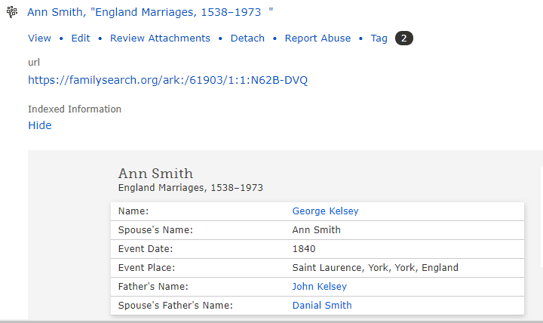
So, the search is on to find Ann’s true parents before we remove George and Patience as her parents. By the way, she was also sealed to George and Patience back in 1992.
There is an update to Ann Smith as of March 13, 2019. We located her spouse and family members and as a result she has been removed from the George and Patience family.
That brings us to “Smith”. She is shown as a baby girl born about 1833 with no sources for birth, christening or death. Without any sources and no reason for her to be associated with our Smith family I doubt if she belongs with George and Patience. But she too has been sealed to them on April 18, 2013 in the Draper Temple.
I have not removed “Smith” for George and Patience even though there is little change she belongs to them.
For now, we will focus only on the eight children as shown on the Family Group sheet from the 1970’s.

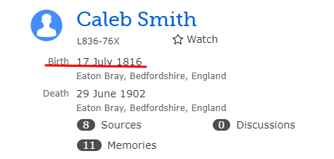
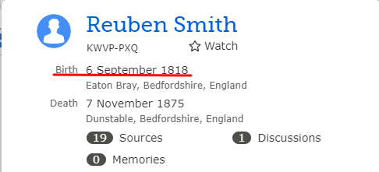

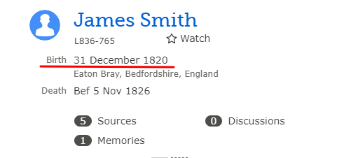
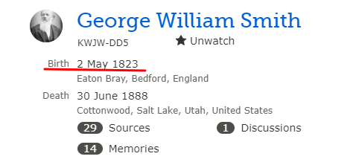
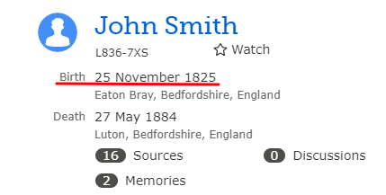
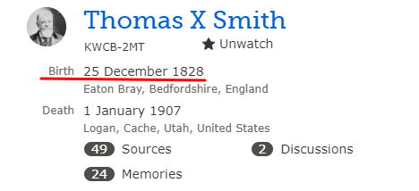
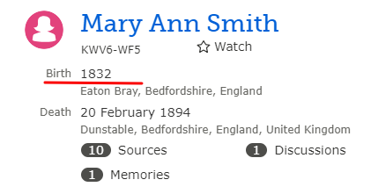
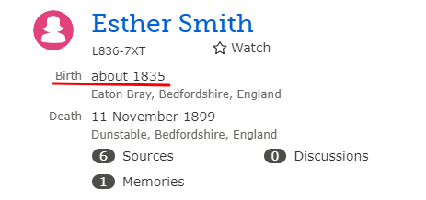

While searching for source material for the siblings I found an Eaton Bray Parish record of the marriage between George and Patience on Christmas day in 1812. I have noticed quite a few marriages having occurred on Christmas Day among our ancestors. One might be thinking that they had a romantic or spiritual reason for marrying on Christmas Day but it was most likely a matter of practicality. Christmas Day and Boxing Day were often the only days of the year that a working person could be guaranteed a day off. If one did not work one did not get paid. George was an Agricultural worker and Patience was a Straw Plaiter when they got married so a day off of work would have truly been rare.
That record is shown below:
.
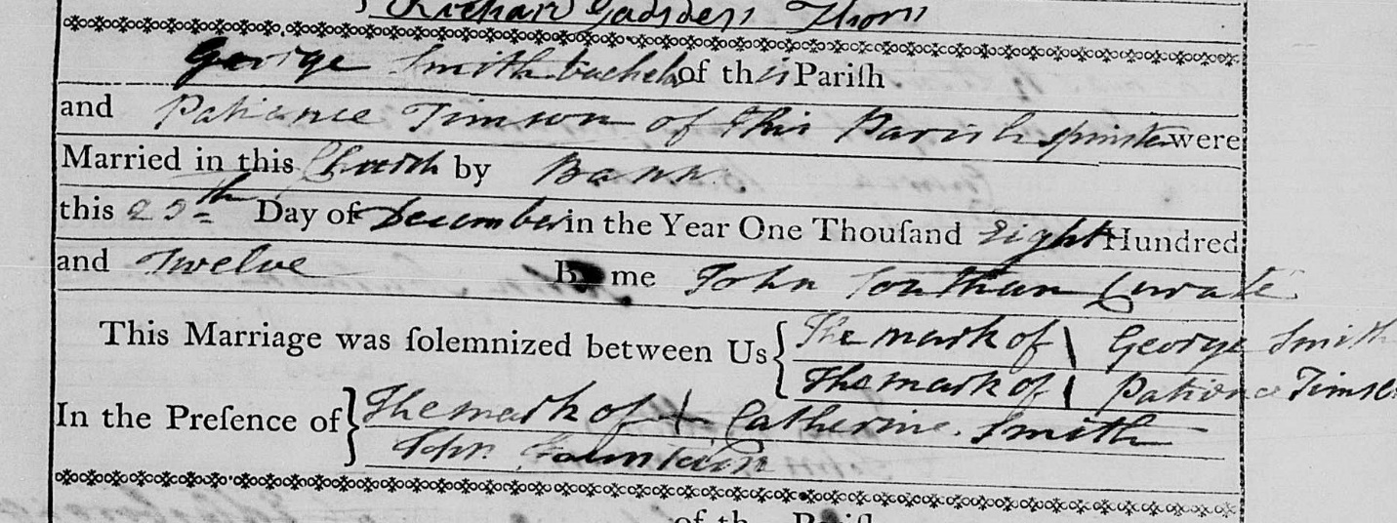

George and Patience appear to both have been about 20 years old when they were married. George was christened in Saint Mary’s Church in Eaton Bray on 10 February 1793 and Patience was christened at Marsworth, Buckinghamshire on 10 June 1792. By the way, Marsworth is only about 7 miles away from Eaton Bray.
It is interesting to note that, apparently neither George nor Patience could write at the time of their marriage since both simply made their mark on the record. The same is true of the witness to the marriage, Catherine Smith, who was probably George’s older sister. I suspect that neither George nor Patience had any formal schooling growing up. They were very likely working long hours from a very early age. Formal education was very much the exception for the working class in 1820 rural England.
Before I get to the details of each sibling let’s look at Eaton Bray and the living conditions, labor and wages situation in this area around the 1850’s in hopes of getting a better insight into our Smith ancestors and in particular Thomas X and George W. and their siblings.

What of Eaton Bray?
Let’s try to understand better what it was like to live in Eaton Bray and the surrounding area during the 1840s through the 1880s. We’ll start with a few maps and descriptions so we can get a feel of where Eaton Bray is in relation to more familiar locations. Most of our Smith ancestors lived and died in or near Eaton Bray, Bedfordshire, England. Bedfordshire in one of the smaller Counties in England and Eaton Bray is a parish within Bedfordshire. London is about 45 miles South of Eaton Bray. And Liverpool is about 190 miles to the Northwest. The first map is of all of England. The second focuses in on Eaton Bray and the surrounding towns. The third shows Eaton Bray in more detail.

England

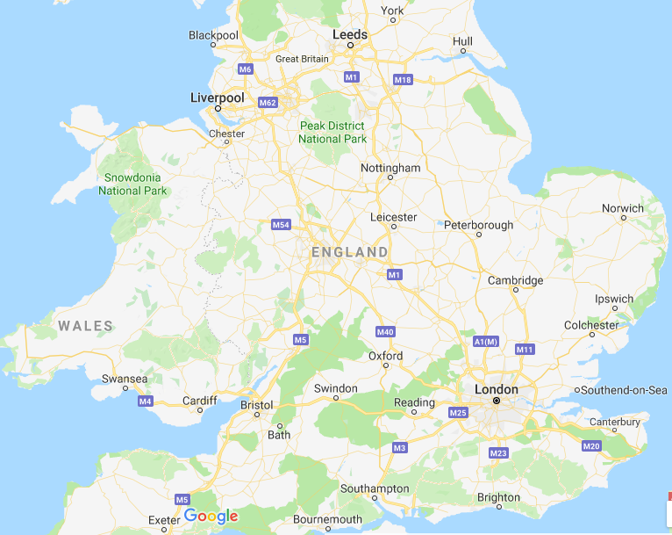

Eaton Bray and Surrounding Area

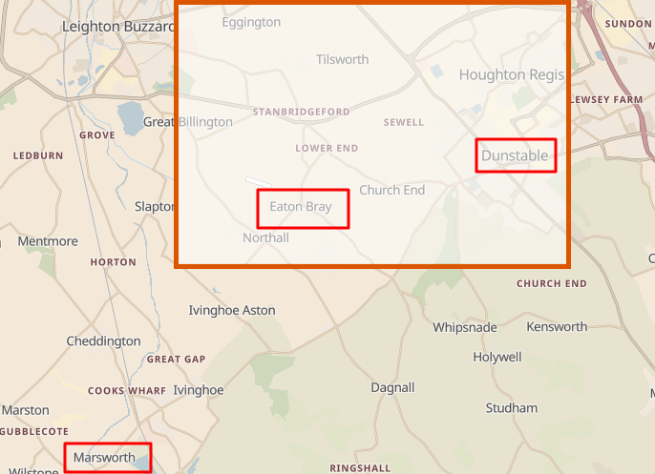

Eaton Bray

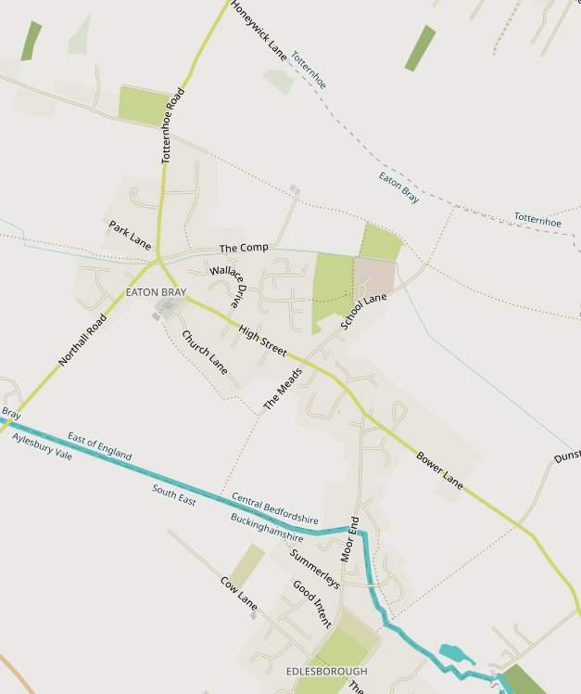

This map provides a little closer look at Eaton Bray. We will discover more about where our ancestors lived as we look at the various census records available to us.
I found a great description of the Parish of Eaton Bray which is shown on the following page. While this description was written in 1912 it gives us the flavor on Eaton Bray.
Citation:
'Parishes: Eaton Bray', in A History of the County of Bedford: Volume 3, ed. William Page (London, 1912), pp. 369-375. British History Online http://www.british-history.ac.uk/vch/beds/vol3/pp369-375
Eaton Bray is a large parish of 2,417 acres on the Buckinghamshire border. More than half the area is arable land, but there are 664 acres of rich meadows for cattle grazing. The country is very open, with a small wooded corner in the extreme south, where 7 acres of Whipsnade Wood extend into the parish. (fn. 1)
The land rises from 290 ft. in the north, reaching 330 ft. in the centre, where the village lies. From here the rise is more marked, and reaches 770 ft. in the south, where the Dunstable Downs stretch for several miles. In a level field south-east of the village Edlesborough Hill rises to a height of 434 ft.
In addition to crops of wheat, barley and beans, plums and damsons are largely grown.
The carnation and rose nurseries and the orchards of Mr. W. E. Wallace, which are situated to the east of the market-place, were started in 1886, and are now in a flourishing state and afford employment for many of the inhabitants. A specialty is made of the culture of carnations, the flowers being sent to the London, Manchester and Glasgow markets.
A market for straw-plaiting formerly held on Fridays has long since been discontinued. In 1891 the local authorities reported that no tolls were collected and that the market consisted of a butcher's stall in the High Street every Friday. (fn. 2)
The village of Eaton Bray stretches for a mile and a-half along the road from Edlesborough to Billington. Eaton Green, the northern part, is the most picturesque, and has several half-timber cottages, among them 'The Rye,' which has a lower story of stone, an upper one of brick and half-timber and a thatched roof. On a stone beam over the fireplace in the living room is the date 1674.
The middle portion of the village is built round an open space containing the village pond, on which four roads converge. The church stands about 100 yds. South in a walled churchyard and contains two old fire hooks. On the opposite side of the road is the vicarage, a modern building with a fine garden.
A cart track leads off the market-place to the site of the old castle, half a mile westward. The disturbed state of the ground and large moat point to an extensive building. The Park Farm is just without the moat on the north-east.
At Moor End, the southernmost portion of Eaton Bray, are many modern houses and the cemetery. A moat, now dried up, gives its name to the small modern cottage it surrounds, known as Moat Hall.
The village is watered by numerous streams, which rise at Well Head and on the Dunstable Downs, and find their way eventually to the Ouzel, which forms the western boundary. On its banks, slightly north of Edlesborough Hill, stands Edlesborough Mill. Steam is employed here when insufficiency of water prevents that power being utilized. On the other side of the stream, in Buckinghamshire, is an old windmill, whose sails were blown down seventeen years ago. A primitive bridge of planks is here placed across the water for the use of pedestrians.
At Moor End is another water-mill where steam is sometimes employed. It stands on the same waterway as the Edlesborough mill, while between them is Bellows Mill belonging to the Lidlington charity.
I discovered that the population of Eaton Bray in 1841 was 1097; 548 males and 549 females. In 1851 the population had grown to 1455; 701 males and here were 701 males and 754 females. In 2011 the population was only 2585 so you can see the area is still very rural.
It sounds like a wonderful place to live. Why would anyone want to leave Eaton Bray?
If you had a desire to actually own property and your own house then the English manors of the Victorian Era were not the place to live. The land was broken up into manors and owned by the nobles. In particular, Eaton Bray manor was owned in 1854 by Anne Macnamara, the widow of Arthur Macnamara and remained so until her death in 1875. Her son Arthur held it until 1906, when it passed to his twin brother Mr. John Macnamara. Our Smiths and their neighbors would have lived in rented cottages or possibly even a house from the manor owner at the time. Most of those listed in the various census records as Farmers or Ag Laborers worked for the manor owner through a Bailiff or foreman, who acted as a middle man. All of our Straw-plaiting ancestors got their straw from farms on the manor or another nearby.

I suspect, however, our Smiths never dreamed of land or home ownership. They were too busy working to get by day by day. We’ll talk about wages and the cost of living in 1850 England later. The move to America for Thomas X and George W. had little to do with their current living conditions and everything to do with the call from their new church leaders to join Zion in Utah. The fact that Thomas and George ended up owning farms and land in America was a consequence of their move and not necessarily their desire. None of their siblings, with the exception of Caleb, ever lived more than a few miles from the place of their birth.

1850’s English Currency and Occupations in Eaton Bray
What was the cost of living in 1850 on the English country side? What were the occupations of the day and how much could our ancestors have earned? Were they poor or well off? Let’s see what we can find out.
To try and answer these questions we need to understand more about the 1850 English monetary system. There was the pound and the crown, the skilling, the pence as well as several other denominations but these few will be enough for our purposes.
There were 4 crowns to a pound
20 shillings to a pound
240 pence to a pound
To get a better understanding of what those denominations were equivalent to in US dollars we need to understand the following:
Each crown contained .8409 troy ounces of pure silver. Four crowns to a pound meant that there were 4 X .8409 or 3.3636 troy ounces of pure silver in a pound.
A United States silver $1 coin contained .7736 troy ounces pure silver. Therefore, to find out how many US dollars equaled one British pound in the 1850’s you would divide 3.3636 by .7736 and find that one British pound was worth $4.35US. So,
One pound sterling was worth $4.35 US. There are 20 shillings to a pound so a
One shilling was worth $4.35/20 = $0.2175. And there are 12 Pence in a shilling so
One pence was worth $0.2175/12 = $0.018125
Again,
1 pound (1£) = $4.35
1 shilling (1s) = 1/20 £ = $ 0.2175
1 pence (1d) = 1/12 shilling = $ 0.018125
Many economists agree that $1.00 US in 1850 would be equivalent to approximately $31.85 today accounting for inflation.

Occupations of our English ancestors:
From the various English Census records of the day we know that the primary occupations of our ancestors were:
Ag Laborer Many of the adult males were Agricultural laborers
Farmer If they weren’t an Ag Laborer they were listed as a Farmer. Edward Smith was a farmer and died a Pauper.
Straw plaiters Most of the children, young women and wives were Straw-Plaiters
Straw Plait dealer Many adult males were plaiters and some became plait dealers
Blacksmith Many of the Gurneys were blacksmiths
Sawyer William Wootton was a Sawyer
Bailiff Caleb Smith was a farm Bailiff later in life
Sewer Later some of the adult women graduated to a bonnet or dress sewer
Scholar Later some of the younger children were fortunate enough to go to a formal school. This was mainly after the Education Acts of 1870 and 1880 that required young children to attend school.

Since the majority of our 1850’s ancestors were straw plaiters or dealers I am going to devote a section of this history to the business of Straw Plaiting in England in the 1900 century.

Straw Plaiting
The industry was one easily carried out in the home, requiring only three simple and inexpensive tools, a straw splitter, a splint mill and a yard measure stick or rod. By 1800 various machines, or ‘sheens’, had been invented for splitting each straw into splits of varying widths. Before plaiting, the split straws had to be pressed flat in the splint mill, a small wooden mangle with boxwood rollers, screwed to a door-post. After the plait was made it was measured into lengths of a score (20 yards or 18.3 meters = 1 score), the unit for sale in the market. Three main forms of plait were produced – plain, pearl and brilliant – with several variations being produced from them, some by using colored straw. Although Berkhamsted had a weekly market, the plaiters from outlying districts such as Fristhsden and Potten End preferred to walk to Hemel Hempstead where the plait market, situated behind the King’s Arms, was a great feature of the town.
Shown here are some of the simple tools needed to plait straw:
This first photograph is of a straw splitting tool. This one could split a straw into 5, 7, or 8 strips. And it would appear that two other splitting options were once available.

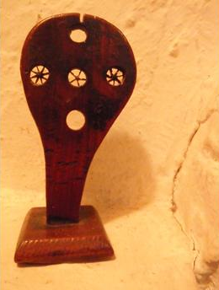
Once the straw was split each section had to be flattened. A tool such as the one below was used to accomplish this.
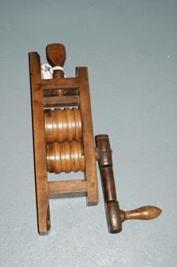
Once the split straw sections were flattened they were ready to plait. This next photo shows a straw plait using ten sections of straw in process.
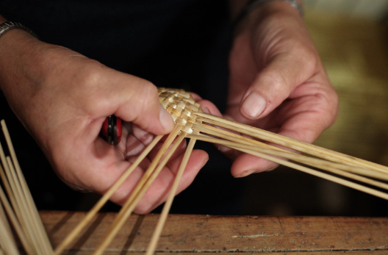

From an 1874 Newspaper article “....Hertfordshire, in 1861, employed in the straw trade (plaiter, sewers etc.) 11,222.....The straw trade became centered in Hertsfordshire and Bedfordshire from the peculiar finess of it’s wheat straw....... one hundred weight of straw is worth 3 shillings. This...is capable of producing about 40 pounds of plaiting straws worth between 8s -18s according to the season or quality. This amount of straw....produces 17-18 pounds of plait worth £7 - 20. This plait can be converted into 16-17 pounds of straw hats or bonnets which wholesale would be worth £23 - £45.....in Hitchin and neighbourhood there are about 1,700 women and children who are straw plaiters. The majority of the women bring their plait every Tuesday to Hitchin market. Two long rows are formed on the south side of Market-square and down the centre walk the buyers.....As soon as a bargain is concluded, the woman gets a ticket.....about eleven o’clock, she goes to the public house where the buyer “puts up” and there receives her money. many of these women walk three to five miles into Hitchin and wait from nine o’clock until twelve before they get their money to enable them to do their marketing.......To procure the necessities of life, they barter their plait away to small shop-keepers, taking the value of their plait out in groceries, save for a few pence which they are bound to have to procure a fresh supply of straws.....In the Hitchin district the money paid for plait in the season (from October to May) is about £600 weekly....The broad twist plait is principally made in the Hitchin parish.” (Nov 1874)

This from another 1874 Newspaper article: “This institution which is situate in Bank Street, Hitchin and was opened on the 5th of August last is already doing flourishing business......The primary object is to enable poor plaiters to dispose of their plait at a fair market price and to receive cash payment without delay instead of by the usual mode of changing the plait for goods at the shops of the general dealers or of selling it in the market on Tuesdays and having to wait until mid-day before the money for it can be obtained and then only at the public house where the buyer makes his stay......the number of sellers.....has risen from 50 in the first week to upwards of 400 in the week just ended.... On entering (the room) we found the seat which runs round part of the clean, comfortable room, occupied by old and young women who were resting after their journeys from the villages where they lived until their turn came to be waited on. Across the room a counter is placed and in front of it are compartments behind each of which stands a buyer or person who is skilled in the quality and value of plait. Each seller in turn takes her stand at one of the compartments and then in a few words the bargain is made........There is a double advantage in the manner in which the plait market is carried on. Not only is the best current price given to the seller but the buyer is able by his knowledge of the requirements of the trade to advise those who come which is the best sort of plait for them to make.....the comforts and advantages (of the new institution will be more and more felt as the winter comes on...” (Oct 1874)

Below is a photograph of the Hitchin District Straw plait market place:
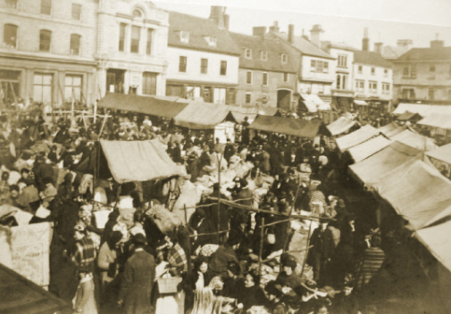

Sources: “Labouring Life in the Victorian Countryside” - Pamela Horn; Censuses 1841-1901; Women’s Institute History of Preston 1953; Hertfordshire Mercury - by kind permission of the Hertfordshire Mercury. Photo courtesy of Hitchin Museum. Hitchin parish records; Sketch map of Preston 1884 from W.I Scrapbook 1953. Extracts re John Izzard Pryor from “A Chronicle of Small Beer” by Gerald Curtis

Straw Plaiting schools
The extent to which the plaiting industry relied upon children is revealed by the establishment of plaiting schools around Luton at the start of the 19th century.
Children were generally taught the basics of plaiting at home before being sent to a plait school between the ages of three and four when their work was considered to be financially viable. Even younger children could be found in the schools and although unable to plait, children as young as two might be tasked with clipping the loose ends of straws ‘with their scissors tied to their bodies’. [ii]
Boys, as well as girls, attended one of the numerous plaiting schools. These schools, found in every town and village in the area, resembled sweat shops rather than places of learning. The misery of the long hours and the rushing discipline of the plait schools is revealed by the Children’s Employment Commission Report of 1864.
Mrs. Wimbush, who had a plait school in Northchurch, stated in her evidence that 41 children plaited in a room 10 feet square, and at busy times the same room held 60 children. She also admitted to caning the children. The parents paid 1d. – 3d. a week and supplied the straw. It was rare for any other subject to be taught, as the main function of the mistress was to ensure that the children completed their work.
At least 10,000 children are believed to have attended such schools in Bedfordshire at any given point during the first half of the 19th century, with as many as 13,000 during the peak of the industry in the 1860s. The schools charged weekly fees of two or three pence, and the children would be expected to earn between nine pence a week aged eight to as much as three shillings (36 pence) a week by the age of fourteen. Although straw plaiting could be done outside, and the children were therefore able to get some fresh air, it also meant that the children were expected to work on their plait almost constantly, indeed:
‘Whilst travelling through the country villages, whether at mealtimes or in the evenings, contemporaries remarked that it was rare to see a girl out of doors without her plait in her hand, and working away busily as she walked along.’[iii]
[i] Charles Freeman (1964) Luton and the Hat Industry. The Corporation of Luton Museum and Art Gallery, Luton, p 12.
[ii] P. Horn (1974) ‘Child Workers in the Pillow Lace and Straw Plait Trades of Victorian Buckinghamshire and Bedfordshire’, in The Historical Journal, Vol. 17, No. 4 (Dec, 1974), p 790.
[iii] P. Horn (1974) ‘Child Workers in the Pillow Lace and Straw Plait Trades of Victorian Buckinghamshire and Bedfordshire’, in The Historical Journal, Vol. 17, No. 4 (Dec, 1974), p 790.

The 1867 Factory Act, banning the employment of children under the age of nine, should have closed the plait schools, but a loophole in the Act allowed them to carry on until 1871. Even after the Education Acts of 1870 and 1880, which made education compulsory, parents kept their children away from the board and village schools in order to plait. Therefore, this area was educationally one of the most backward in the country.
Northchurch, by the way, was eight miles west of Eaton Bray. Below is a painting of what appears to be a much nicer straw plaiting school scene that the one described above.

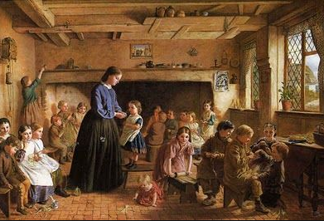

Published in The Dacorum Heritage Trust Ltd. Newsletter No. 21, December 2000.
By Elizabeth Buteaux
4th August 2010

The 19th century was not only a century of industrialization; it was also a century of free trade. This allowed cheap plait to be imported from Italy and later China and Japan. By the 1870’s an experienced plaiters earnings had dropped to about 4s. a week and this led to the decline in the straw plaiting industry. Free trade, therefore, was one of the two reasons for the closure of the plait schools, the other was that in 1891 education was not only compulsory, it was also free.”
By Elizabeth Buteaux
Published in The Dacorum Heritage Trust Ltd. Newsletter No. 21, December 2000.
4th August 2010
Several things happened that caused the decline of the craft. Cheap imports, mechanization, changes in fashion, and the discouragement of the use of child labour (children tended to be excellent at plaiting). The collapse of the Straw-plaiting industry was sudden and caused much suffering to the northern parishes of Essex which had little else to offer in the way of employment. By 1900, there was not a single straw-plaiter left.
When the import of foreign plaits in the 1870s and 80s led to the collapse of the British plaiting industry the hatting industry emerged as the new primary source of income for many residents and continued to expand well into the 20th century. Indeed, some of our ancestors in later years became Hatters and Bonnet sewers.

The Economics of Straw Plaiting
In 1850, the local paper reported "In the surrounding district an enormous amount of straw plaiting is carried on. There is scarcely a cottage in the district where it is not exercised. Until this last 3 months trade has been slack but there is now a growing demand for it, many merchants from Luton I am informed are in the habit of coming to Castle Hedingham to purchase the straw plait. The best kind of makers get 3s 6d a score and a good hand can make a score and a half a week, for inferior kind of work pay varies from 3d to 10d and 1s a score. The earnings of children and girls may be taken as 3d to 6d a day, these are employed on coarser work, and the straw is usually purchased from a local farmer at 6d a bundle which being in quantity as much as a person can carry. The rate of pay for a farm labourer in this district is wretchedly low 6s to 7s a week and were it not for straw plaiting they would be in the worst possible position than now. When plaiting is depressed a considerable amount of work is done for the cheap tailors of Colchester and London who send the different articles to Castle Hedingham and other places in the district to have them made up".
By 1871, there were nearly four thousand people engaged in the work of straw-plaiting.
Let’s review the economics of the 1850 Plaiting industry
We read that:
100 pounds of straw suitable for plaiting cost 3s. That 100 pounds of straw produced
40 pounds of plaitable straw worth 8 – 18 s. That 40 pounds of plaitable straw produced
17 – 18 pounds of plait worth £ 7 – 20. That 17 – 18 pounds of plait produced
16 – 17 pounds of Straw hats worth £ 23 – 45 wholesale.
There was obviously a great variance in the quality of plait produced depending on the quality of the straw itself and the Plaiter herself. And it is obvious that it is the process of plaiting that adds the greatest value to the finished product increasing its value by over 20 times.
We also learned that a top quality Plaiter could get 3s 6d for a score (20 yards) of finished plait and she could possibly make 1 ½ score of plait in a week;
Therefore earning 5s 3d in a week. Another source suggested that a top Plaiter could earn as much as 7s per week.
The younger plaiters could add 3d – 6d per day (1 ½ s – 3s per week) to the family income.
That same newspaper article mentions that a Farmer or Ag Laborer could earn 6s to 7s per week and that was a 10 hours a day - 6 day work week!

Cost of living
So, what did it cost to live on the English countryside in 1850? From what I have read a small family could probably scrape by on £50 per year. But they would be a little more comfortable living on £70 per year. The largest expense was probably renting a cottage on the Manor for about £10 per year.
We will take a look at a couple of the siblings to see if we can determine how they were making out at the time of the 1851 Census.
First we will look at the sibling John Smith and his young family in the 1851 Census. John and his wife Ruth and their 4 year old daughter, Ann are listed as Straw Plaiters. And they had another daughter, Martha, age 2 and a one month old daughter, Hannah.
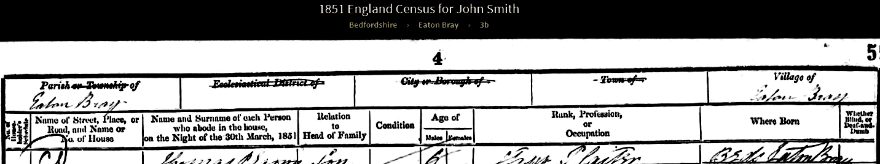
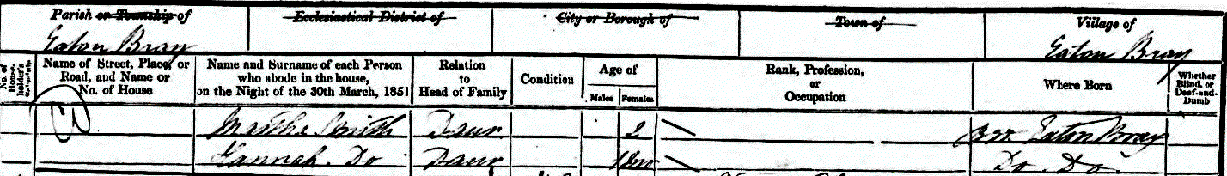
Let’s give John and Ruth the benefit of being top quality plaiters able to earn 5s -7s each per week. Ann, on the other hand, at age 4 could have only added, perhaps, 1s per week. So, say they earned 15s per week total. Even if they could have produced plait all year long that would be about 780s per year or £39 per year. They would have needed help from family and friends to make ends meet. Or perhaps they bartered or training for many living essentials. And with two children two years old and younger Ruth would have had a rough time trying to keep up with her straw plaiting. It is hard to imagine that their four year old daughter was tasked with adding to the family income in order to survive or avoid the Work House.
We will next look at Reuben Smith and his family. He is listed as an Ag Lab (Agricultural Laborer) and his wife, Harriot and daughter Ruth, age 7, are straw plaiters. And he has three other daughters ages 5, 3, and 1.
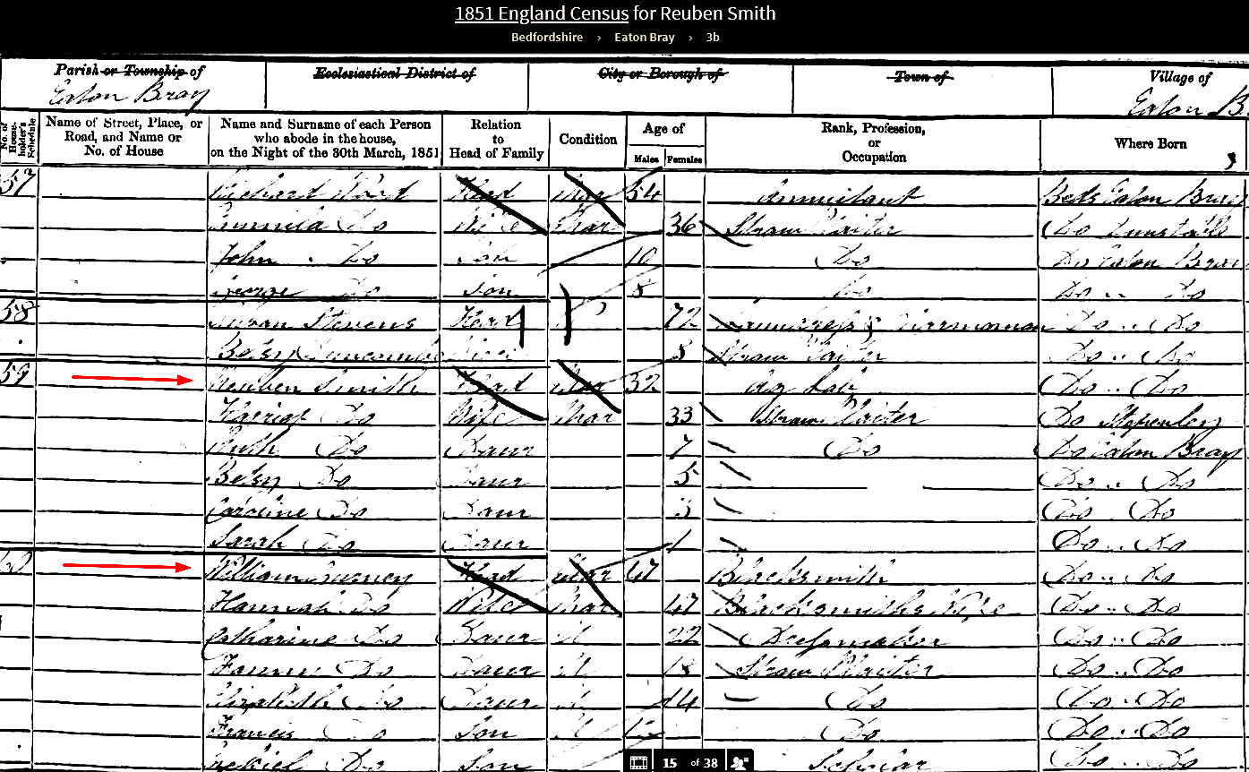

As a strong hard working Ag Lab Reuben could have made 7s per week according to estimates if he worked 60 hours per week. His wife could have also earned 7s per week as a quality Plaiter and Ruth as a 7 year old could have perhaps added 2s per week to the family income. So 16s per week would have been 832s per year or a little more than £41 per year. They too would have been living near the poverty level and barely scraping by.
They could not have turned to their parents since their father George died in 1844 and Patience was struggling to get by as a 58 year old straw Plaiter with the help of her two unmarried daughters, Mary and Esther, who were also Plaiters.
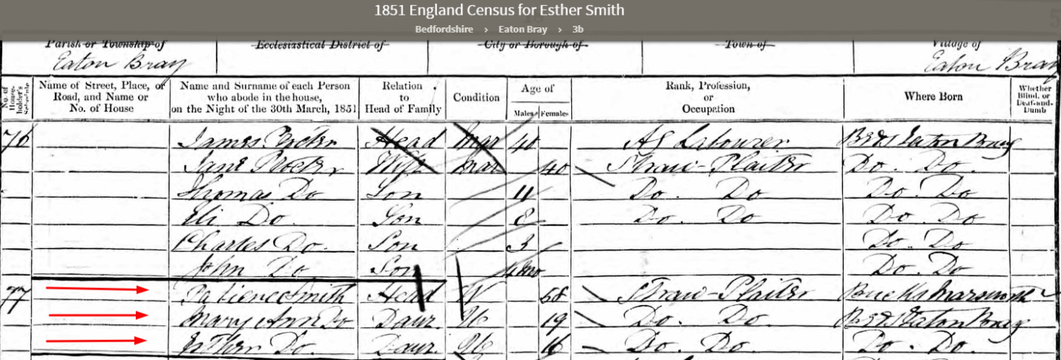
They could have been earning as much as 21s a week together or about £55 per year if they could plait all year long.
Thomas X, in his missionary journal said he visited his brother Caleb and his family in 1880 and found that he was a foreman (Bailiff) of a farm and was being paid 24s per week. If he got paid 52 weeks per year his annual income would have been 1248s or £62.4 per year. He would have been close to making a comfortable living at that time in his life. And, as a Bailiff it is possible he got his housing free of rent or at a reduced rate.
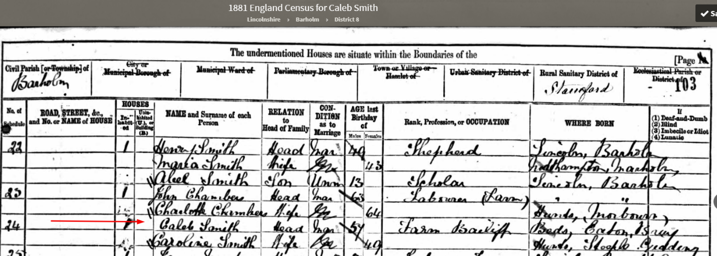
In fact, with all his children out on their own he was probably considered well off for the day.
In US dollars he would have been paid £62.4 X $4.35 = $271.44 per year. In today’s dollars that would be roughly $271.44 X $31.85 = $8,645.36.
Thomas X and George W. were no better off in 1951 than were their brothers. George W. was a Plaiter and Thomas X was a Plait Dealer. There young wives were not shown as working but occupations of the wife were not always shown in the 1851 Census. I would be surprised if they were not straw plaiters as well. I don’t know how either family was surviving.
Remember that Thomas X borrowed money through the Perpetual Immigration Fund to sail to America in 1853. The amount he borrowed was $55.25 for him, wife Margaret, and daughter, Lucy. That was 55.25/4.35 = £12 14s or 254s which was equivalent to 36 weeks of quality work as a straw Plaiter. That must have seems like a fortune and was not repaid with interest until 20 plus years later. George W. chose to stay in England until he could save the money to travel to America and it took him over two years to gather the funds to make the trip.
These Smiths were poor hard working people who barely made enough money to put food on the table with the help of their young children’s labor. I am hoping that our ancestors were able to live somewhat comfortably on less that the £50 that was reportedly needed to do so. Perhaps they had a few chickens or even a cow. Maybe they were able to grow vegetables in a small garden to improve their quality of life.
In one or two of our earlier histories it has been reported that George and Patience probably made a comfortable living since he was an Agricultural Laborer and she was a School Mistress. That simply was not the case. George died relatively young even for that day at age 52. When he died Patience was a straw Plaiter as were their two unmarried daughters. She remained a straw Plaiter at least until she was 69 years old as reported in the 1861 Census. It wasn’t until the 1871 Census when Patience was 79 years old that she was listed as a School Mistress and that is very misleading since she undoubtedly worked as such in one of the local Plaiting School. I suspect she never learned to read or write, with no formal schooling and was likely paid poorly to be a Mistress at the school.

George Smith father, Edward Smith was an Agricultural Laborer all of his adult life as was listed as such in the 1841 Census. He died a Pauper at the age of 82 in 1847. I have shown his death record below:
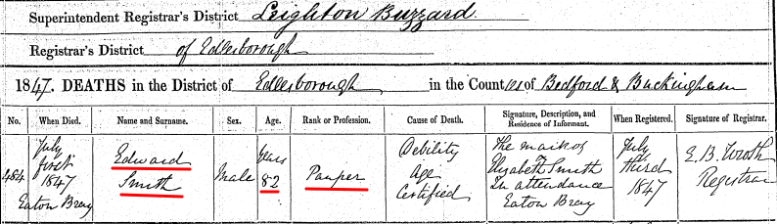
His wife, Ann Burrows, died two years later on September 11, 1849 at the age of 84 and she is listed as a Laborer on her death record!

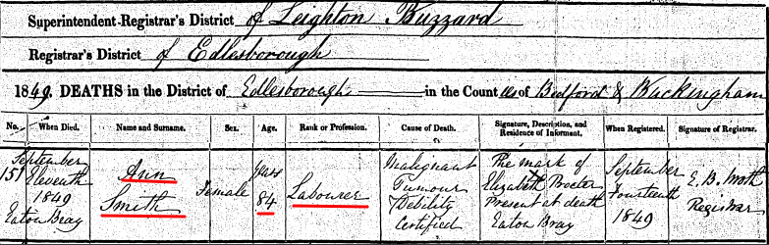

The Siblings Left Behind in England
It is finally time to take a more detailed look into the lives of the George and Patience Smith children. Unfortunately, Thomas X was the only sibling who kept a journal (that we are aware of) and that was mainly while he was on a mission to England in 1880 - 1881. So we have to rely on Church and Civil records and the 1841 through 1911 English Census records to try and piece together their lives. Thomas’ journals do add some great “color” to 1880 England and where his siblings were living during that time and what some were doing for a living.
We read from Lucy’s history of Thomas X that he and his brother, George W. were all but disowned when they joined the Church of Jesus Christ of Latter Day Saints. George W was baptized on 29 October 1848 and Thomas X followed on 17 April 1849. Reuben was also baptized on 16 May 1849. And it appears the rest of the family was not too happy about these men joining this new religion. Another history says that Thomas’ parents did not even come to see them off to America. Thomas and his wife, Margaret Gurney and daughter Lucy sailed from Liverpool, England in 1853. His father, George, had died in 1844 so he had good reason not to see them off. Patience would have been 61 years old and living in Eaton Bray. Liverpool, the Port from which they sailed is 180 miles from Eaton Bray. These people were poor and transportation would have been by horseback, carriage or walking. The railroads where just coming into being in the 1850’s in England but they would not have come near Eaton Bray at that time. We tend to forget our early ancestors were not very mobile. It is possible that what was meant to be said was his family members did not even bid them farewell as they left on their journey to Liverpool to board their ship to America.
This is where we gain some great insight through Thomas’s journals. I have attached a few of the direct entries from his journals where he interacts with his siblings. He clearly had a desire to visit with them and they were pleased to see him and visit with him upon his return to England 27 years later and again as he departed England to return to the United States a year plus later.
There was clearly some suspicion, concern, and dislike for the “Mormon” missionary movement in this area in the 1840s when Thomas X and George W. were baptized. Family and friends were, no doubt, concerned for their family members feeling that they had been deceived or duped. But I don’t get the feeling that the family was close to disowning George W and Thomas X and their families. Thomas’ journal entries seem to bear this out.
A word about the journals. Quinton Harris received from his mother, the original journals written by Thomas X Smith while Thomas was on his mission to England. In the year 2005 Quinton completed the task of transcribing those journals and making a digital copy of the contents for all his posterity to see. His journals, letters, and notes are available on the Smith Family Organization’s website at “smithfamilyorganization.org” under the “Histories” tab.
Below are Quinton’s words regarding these journals and his approach to transcribing them.
“The journal is found in three separate books. The first goes from April 7, 1880 to April 13, 1881, the second starting with April 14th and going to the end of his mission and most of the trip home by sea. The third is a small booklet in which he kept his daily journal from the time of his call to Sept. 17, 1880. I have attempted to leave the spelling as he had it in the book, and added correct spellings in parentheses only when deemed necessary to understand the meaning. Some words were not clear, so a blank was left. When one gets used to the spelling, I ceased to correct it. My computer automatically corrected many misspelled words. I did not attempt to return to the original. I have copied the original journal and will make it available to anyone who desires a copy.”
Quinton S. Harris
Thomas’s journal entries would indicate that he, along with his siblings and spouses did not have any formal schooling and did not know how to write while living in England. Thomas most likely learned to spell phonetically after coming to Utah and his association with other Church members. Remember that Quinton’s computer self-corrected many misspelled words as he typed these journals. I would say he wrote wonderfully well given his education.

Notes from TXs journal while on his mission 1880 -1881.
(May) 5, 1880. Slight walk from Eaton Bray to Dunstable & Luton to see sisters & brother John and found them well. Stade at Luton and returned to Dunstable and lodged at my sisters.
(May) 7. Started from Eaton Bray to Luton with the kindness of William Tent to me with (h)is team to Standbridge. Found station. Had dinner with my brother John and he rec’d me very kindley and treated me well. I had a good talke with him on many things. We enjoid our selves better than I expected. Stayed over night. The next morning he came to my room and wood take my boots and clean them.
(May) 8. Started from Luton to Notingham. Brother accompanied me to the station.
(May) 14. Started from Durbey to Haldom (Hallam) to see my Br. Caleb. Found him and wife well. He is fourman over a farm for Mrs. G. W. Banks. Rec’d me very friendly and was treated well. He is working for twenty four shillings per week. Just eht (eight) Dollars.
(May) 15. Saturday. Had a good walk over the farm with Caleb and agreeable talk with him and taken dinner. Returned to Derbey by way of Stanford. I traveled five miles to Stanford. Got to Derbey at eight o’clock safe. Great deal of difference with my brother since I left him twenty seven years ago. Slept at James Hunt.

(A letter written by Thomas X Smith to his son Fred Smith on Janry 25, 1881)
I receive(d) a letter from George a little while ago and also from brother Caleb, the same day and at the same time Caleb thinks that Salt Lake is Bablon the Great whore and the Roman Catholics are the next and that the Church of England is the following in the same direction. So you see what he thinks of us people in the mountains. I sent him answers to it. I think he will reflect upon if he (h)as got any (h)onest principals in him. It will teach him but he has fought against the truth for thirty years and he’s in the dark because he has rejected the truth.
(Apr.) 19, 1881 Tuesday: Had brackfast at Conference house. Went to Moreside, had dinner at Br. Potter’s. Lernt (learned) when Brother James Burry died at 20 minits to one on Sunday morning and he’s going to be buried on Wensday, the 20th. Came back to Manchester. Received latter from Caleb (his brother) and wrote answer to it same day.
May 25, Wensday: Had brackfst at Br. Carlile, went to Luffenham station, then to Mr. Rogers at Baroden about a farm. Had dinner with them, then came back to Banholm. Had tea with Caleb (Thomas X’s brother) & wife and had some more talk with him, but no better than I was before. His wife felt very well and I stad(e) their all night.
May 26, Thursday: Had brackfast at Caleb’s, then went and bid him good by, started with his wife to the station, went to Petersborough, from their to Luton, to see Brother John (Smith) and family. Had dinner with them. Went to see William Nevel and family & found them well. Had a long talk with them, then came back to sleep to John Smith’s.
May 27, Friday: Had brackfast at John Smith(‘s), then bid them good by, went to Dunstable to see my sisters (Mary Ann & Esther). Found them well, had dinner with them, then went to see Mrs. Stephens & family. Found them well, came back to my sisters and talk(ed) with them upon the principals of the gospel. Staid with them all night.
May 28, Saturday: Had brackfast with them, went to see Brother’s children, Ruth and family. Found them well, went to see Robert Rowe, found him very . Came back to my sisters, Mary Ann & Ester. Had dinner with them, then bid them good by. Reubin(‘s) daughter Betsey came with me to Lancet Hill, then she went back to Dunstable. Thomas’s brother Reuben had died in 1875! His mother, Patience had passed away in 1872. In case you were wondering why he did not visit with them while on his mission. Came to Eaton Bray. Saw John Cobb & wife, then went to Father Gurney. Found him and family all well. Had tea with them, went to see uncle Thomas & Bartle Shuitte. Saw William Orsborn, then went found to the lower end of Eaton Bray, came threw Lunnen Lazer back to Father Gurney’s to sleep.
May 29, Sunday: Had brackfast at Father Gurney’s, went to Northall to Elizabeth Peppit and husband. Found them well. Stade their a little time, then returned to Eaton Bray. Had dinner with Father Gurney & family, went to see John Lugstene, Jabas & wife, found them in a poor condition. Aunt Lugstene was well, went to John Cobb(‘s), took tea with them and stade their about four hours and talk(ed) with them. Gave them some good instructions. They was some good old saints but got in the back ground. I talked to them very kindley and told them to renew their covenants. Came to Father Gurney(‘s) to sleep.
May 30, Munday: Had brackfast at Father Gurney(‘s), then went and got my shoes (----) sold by Mr. Burrage, a man that used to work for me thurty years ago. (According to the 1851 Census Thomas X was a Plait Dealer, so it is possible this Mr. Burrage worked as a Plaiter for Thomas X). Came to Father Gurney to dinner. Went to Mrs. Hankins and family. Found them well. Had a little talk with them, then came to Father Gurney’s to dinner. Bid the folks good buy (bye). Started to Standbridge and to a train for Leighton (Buzzard) with Father Gurney. From their went to Rigby to see Solomon Gurney & family (brother of Margaret Gurney). Found them well, took tea with them, had a walk round some front of that town and it is a very nice place. Stade at Solomon’s all night.
May 31, Tuesday: Had brackfast at Solomon Gurney(‘s), then bid them good by, took train for Burton an(d) went to see John Allm & family. Had dinner with them, then went to Dunshez. Saw sister Lummox & family, had dinner with them. Administered the ordinance to Sister Lumox and her daughter Alice, then started to Manchester. Got their. All night.

It appears to me that his siblings, their spouses and children loved and respected him regardless of his religious beliefs. They obviously had several Gospel discussions both at the beginning of his mission and before he left England for home. He did not appear to change the minds of his siblings but there was obviously loving feelings on both sides. It also appears that there were some hard feelings and maybe even harsh words spoken when Thomas X and George W. joined the Church. Thomas X mentions in his journal that his relationship with Caleb and John were much better than 30 years before. Caleb obviously still had distrust for Mormonism and still considered it the Great Whore and Salt Lake was Babylon. But both Caleb and John loved and missed their brother. John even got up early one morning to clean his brother’s boots!
I’ll do a quick overview of each of their children of George and Patience Smith and then come back to each one in more depth.
Let’s turn our attention to the oldest son, Caleb. He was born on 17 July 1816 in Eaton Bray. As stated earlier, there is three and a half years gap after the parent’s marriage before Caleb is born so it is possible there was another child or miscarriage before Caleb. Caleb lived to be 85 years old and died on 29 June 1902 in Eaton Bray.
Reuben was the next oldest son being born a little over two years later on 6 September 1818 in Eaton Bray. He only lived to the age of 57 and died on 7 November 1875. He died in Dunstable which is only 4.5 miles from Eaton Bray. I say only 57 years old when he died but the average life expectancy of a white male in England in the 1850’s once he had achieved 20 years of age was only 60 years old. His brother, Caleb just lived a good long life! Reviewing Reuben’s death record revealed he died of Paralysis which he had suffered from for 4 years prior to death.
Again the life expectancy for that same white male in England was only 38 years from birth. The lower number is because of the many early infant and early age deaths.
Little James was the third born son. He was born on the 31st of December 1820 in Eaton Bray and was buried on the 5th of November 1826.
Next in line, is George W. He was born in Eaton Bray like his brothers before him. He was born on 2 May 1823. He died in Cottonwood, Utah on 30 June 1888 at the age of 65.
John was born on 25 November 1825 in Eaton Bray and died in Luton on 27 May 1884 at the age of 58.
Thomas X was born in Eaton Bray on 25 December 1828 and died on 1 January 1907 at the age of 78 in Logan, Utah
After having six boys in a row, or possibly seven, George and Patience finally gave birth to a girl. Mary Ann was born in Eaton Bray in 1832 (most likely). I say that since her birth year was derived from her given age of 19 during the 1851 England Census taken in Eaton Bray in April of 1851. She died 20 February 1894 in Dunstable at the age of 62.
The last child born to George and Patience was also a girl. Esther was born in Eaton Bray in 1835. Her birth year was also derived from the fact that her age was listed as 16 in that same 1951 census. Patience would have been 43 that year. Esther died 11 November 1899 in Dunstable at the age of 64.
We only have photographs of George W. and Thomas X. And those photos were taken later in life while they were living in Utah. Photography wasn’t invented until about the late 1830’s. Daguerreotypes were fairly popular by 1837 but would have been much too expensive for our Smith’s to take advantage of. And Eaton Bray was a pastoral country side village hours away from London where daguerreotype photography was likely popular by 1840 or so. Wouldn’t it be wonderful to find some photographs of some of George and Thomas’ siblings who were alive well into the era of popularized photography?
Again, it is sad that we don’t have more journal entries, stories, family bibles to help us “flesh out” the lives of these siblings. We are going to start with the oldest child of George and Patience and work are way to the youngest.

Caleb Smith

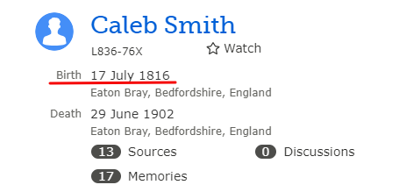
Above is the quick overview of Caleb as found in FamilySearch.org. Note that there are 13 sources attached to him as well as 17 memories. Let’s see what we can find out about Caleb from these attachments. Our first look into the life of Caleb comes from his Christening record as shown below:
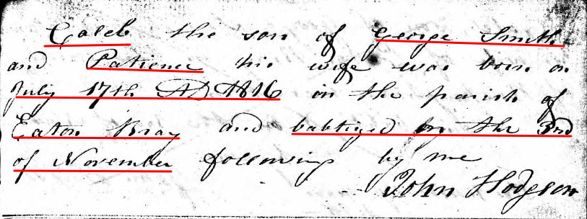

Curiously there is another Christening record for Caleb in the same book on the preceding page. It is also shown:
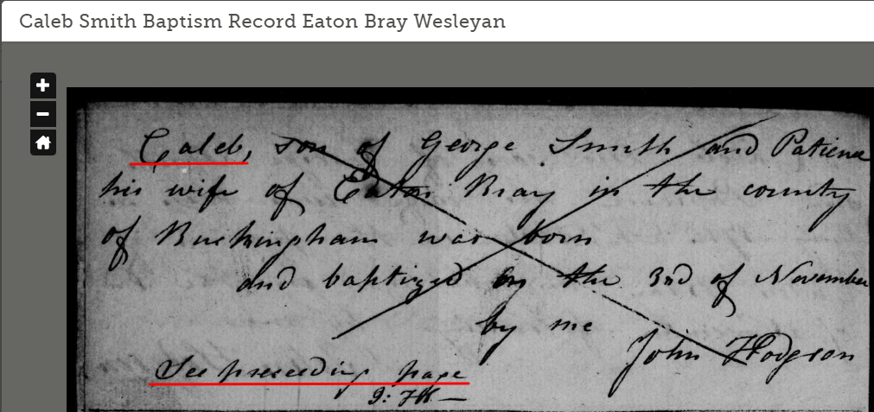
It looks like the birth date and baptism date was given as the same date on this entry so he just crossed it out and prepared the other record showing both the birth date of July 17, 1816 and baptism date as November 3, 1816. There was no correct-type or redo in those days.
Since he was christened in the Wesleyan Methodist Church in Eaton Bray, this is probably a good place to show a photo of that Wesleyan Methodist Church:
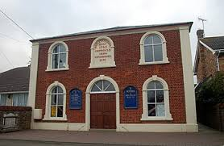
The date of this photograph was 2008 so it is probably dressed up considerably from what it looked like in the 1800’s.
I don’t think our Smiths could make up their mind as to what church to attend; as shown earlier George Smith and Patience Timson were married in the Eaton Bray Parish Church of St Mary the Virgin just a few years earlier. I show three different photographs of that Church. The first two were taken about 1890 and the last one taken in 1876.
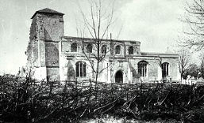

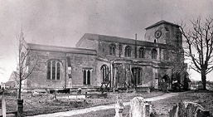
Parish Church taken in 1876:
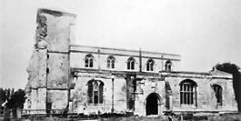
It wasn’t near as nice and beautiful as it is today.

Adding color helps along with several restorations.
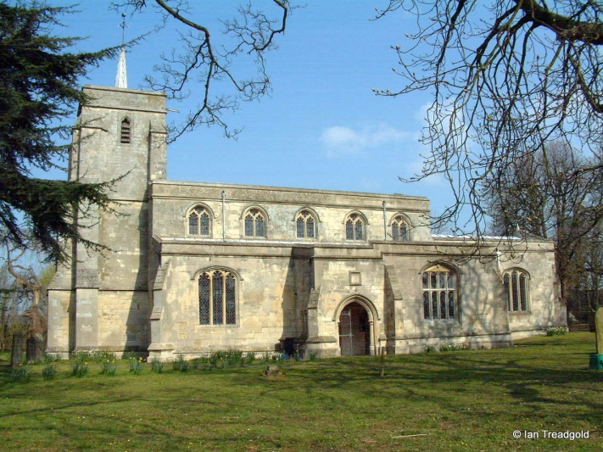

We next get a look at Caleb when he marries Mary Calentt on 31 October 1835. He would have been 19 years old. Mary was 20 years old.
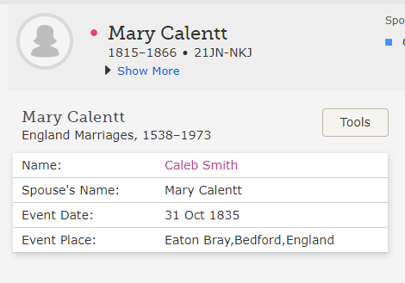
There is some question as to the spelling of Mary’s last name. My sister Jeanne recorded her name as Calcott from her research and another spelling of her name (Calentt) is shown on the Record Index of her marriage to Caleb above. Her name is spelled Corket on the birth record of her daughter Elizabeth, their first son, George, and their second son, Thomas. We have not been able to locate records for her parents under any of these spellings so we will continue to pursue the correct spelling so she can be sealed to her parents.
Since we are going to be taking a close look at the England Census’ as sources of information for all of the siblings it is probably useful to say a few words about the taking of the England Census. The first England wide Census that included names of everyone in the house was taken on June 6, 1841 and then every ten years thereafter on the dates specified:
1841 Jun 6
1851 Mar 30
1861 Apr 7
1871 Apr 2
1881 Apr 3
1891 Apr 5
1901 Mar 31
1911 Apr 2
1921 This census will not be released to the public until 2022 for reasons of privacy. It is also important to know that the 1931 Census was destroyed by fire in 1942 during WW2. And there was not a census taken in 1941 because of the war. This gap is creating some interesting problems for genealogical researchers and will continue to do so in the years ahead.
The next bit of information on Caleb comes from the 1841 Census where we find him and his wife living in Eaton Bray on Church End. It is interesting to note that in the 1841 census the enumerator was instructed to round down the ages of those 15 years of age and older in 5 year steps. Caleb must have been just short of his 25th birthday so his age is shown as 20. Mary, on the other hand must have been just over 25 so her age is shown as 25. There was probably only 13 to 18 months separating their ages. So the bottom line here is that we can’t rely on that census to determine ages of the adults. Also, only the occupations of the heads of households were generally recorded in 1841. Caleb is shown as being a Plait Dealer. Mary was, no doubt a Straw Plaiter herself. They also have a three year old daughter, named Elizabeth.

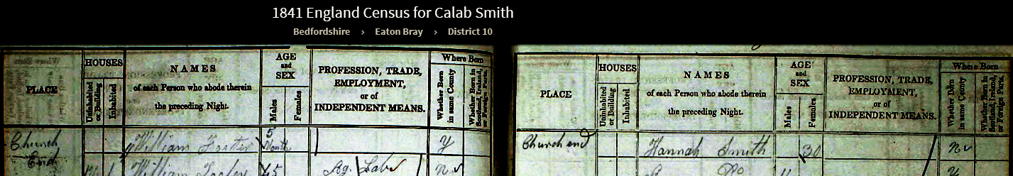
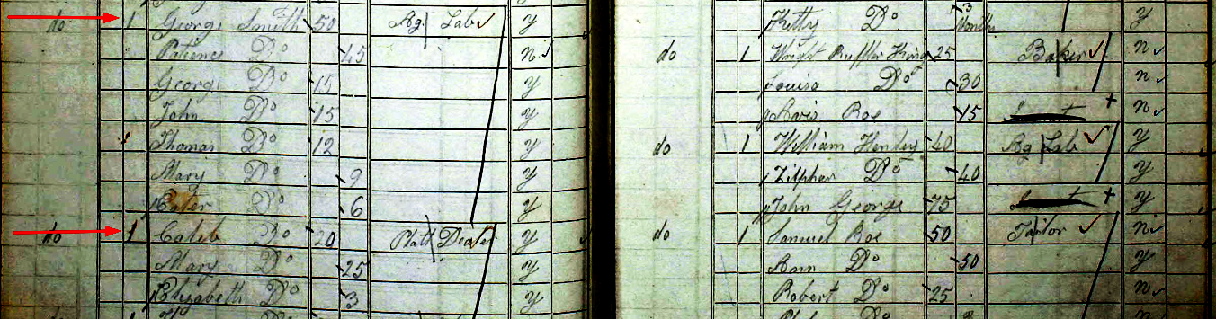
I enjoyed finding that Caleb and his young family were living in a cottage just next door to his parents. I have added an appendix C showing where each of the siblings lived when the 1841, 1851, and 1861 Census’ were taken. I found it very interesting to see that, for the most part, they lived in close proximity to each other throughout their lives
After finding that Caleb and Mary had a child Elizabeth we went looking for a birth record for her and found a civil record of her birth to Caleb Smith and Mary Corket on September 4, 1837. Mary could not write apparently as she only made her mark on the record. Again you see that discrepancy in the spelling of her last name.

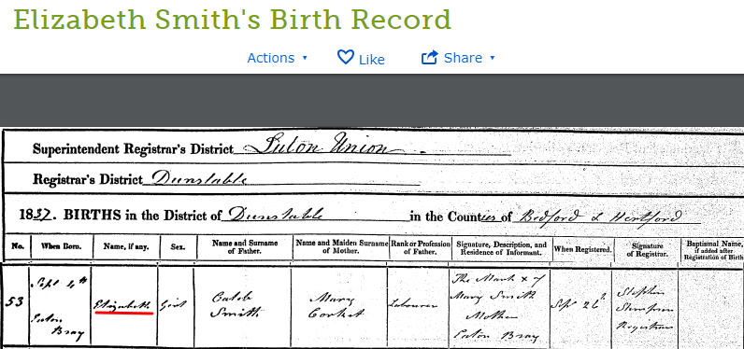

While looking for Elizabeth’s birth record I was surprised to find a baptism record for another child born to Caleb and Mary before the 1841 Census. This was a son, James as shown below:
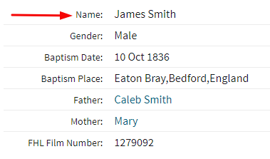
Apparently this James was born on or about his christening date of October 10, 1836 and died before the 1841 Census was taken. We also found this Death Index record for James having died in the 4th quarter of 1837. This would appear to be his death record as he clearly died before 1841.

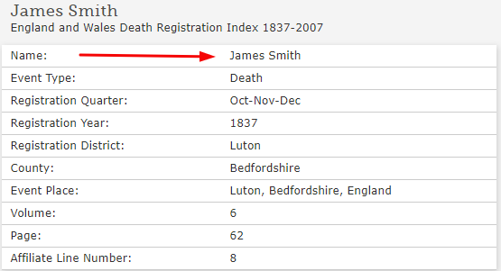

Elizabeth shows up in the 1851 census (age 13) and the 1861 census (age 23). But she is not with her parents in the 1871 census. We found her in that census married to a “Baker” named William Hawkins. They are living on the Western side of the “Road” in a Bakers Shop in Eaton Bray. She has a daughter Mary, age 5 and a son, William age 3. In addition, they have a 16 year old “Groom” working for them as well as an 18 year old “General Servant”. And lastly there is a 20 year old Journeyman Baker living with them. I assume they had living quarters above the bakery and it is obvious they were prospering somewhat as a family. Elizabeth may have been the first of our ancestors not to be living “hand to mouth”.
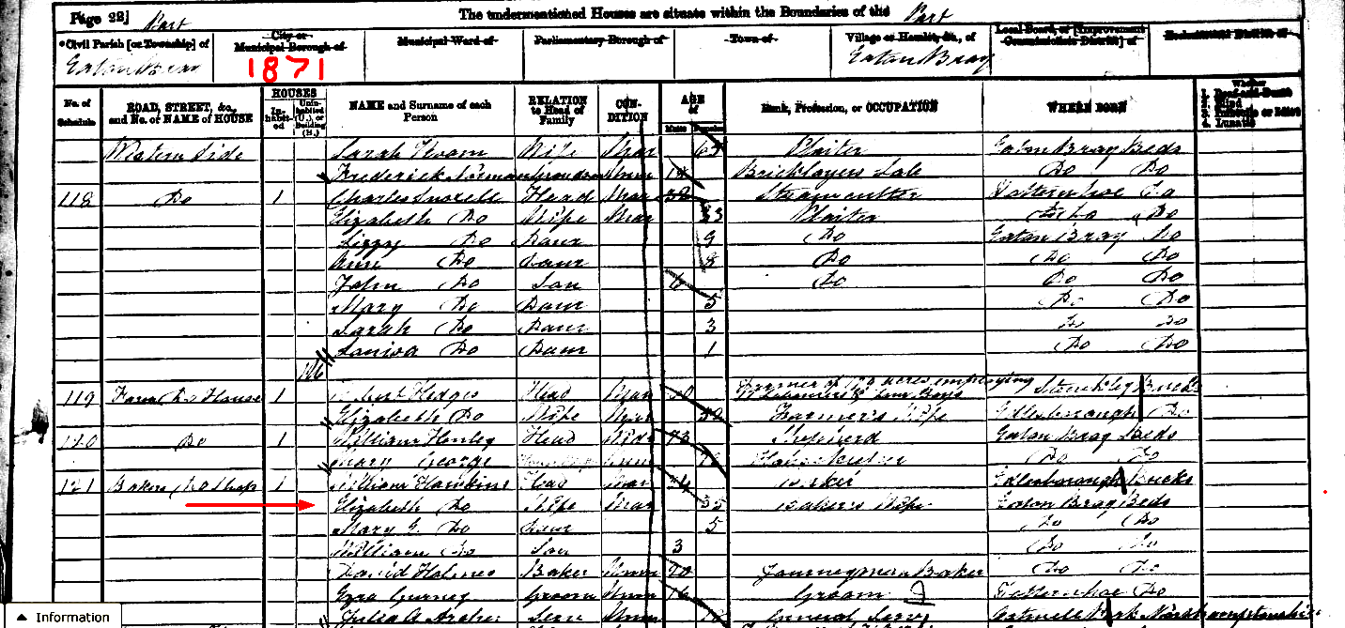
Let me point out that the enumerator of the 1851 census started at the southern end of Eaton Bray and worked his way north on the Western side of the road and then came back through again on the Eastern side of that road beginning again at the Southern end. Only a few of the roads were identified by name.

We were able to find a marriage record for Elizabeth to William Hawkins and it is shown below:

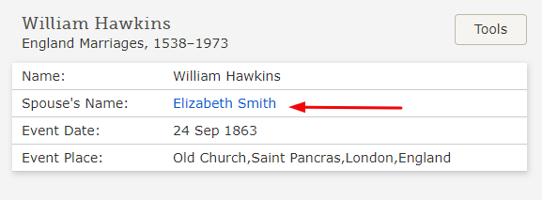
It is interesting to me that they were married in London which is 45 miles or so away from Eaton Bray yet she was living with her family in Eaton Bray in 1861 and they are living back in Eaton Bray when the 1871 census is taken. Her husband was born in Edlesborough just a few miles from Eaton Bray. Perhaps William was doing well enough to actually take a few days off to get married in the big city.
Let’s go back, now and look at the 1851 Census and see what is new:

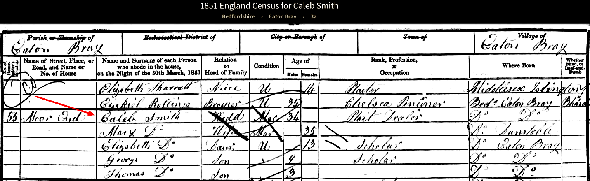

The family is now living on Moor End in Eaton Bray and they have two additional children. George, age 9 and Thomas, age 3. Let’s look at the 1861 Census and then address all additional family members.

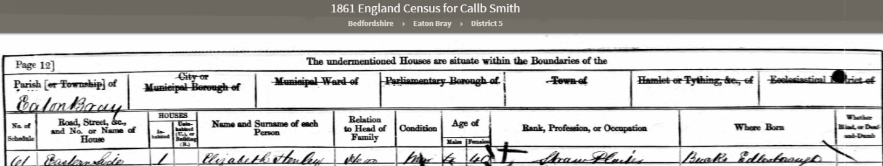
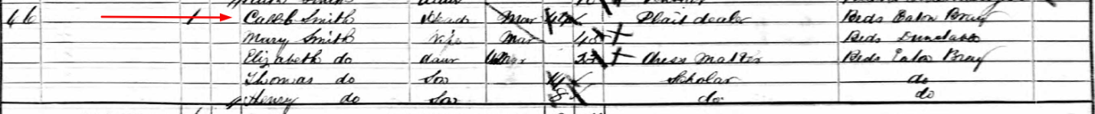
We see that Caleb and his family are living in Eaton Bray but the street name is not given. As mentioned earlier the enumerator only identified the Eastern side and Western side of the “main drag” through the parish. In reviewing some of the other entries near Caleb I identified that he was living more toward the Northern end of Eaton Bray near what was called “The Comp”. Caleb and Mary have added another son to the family by the time this census is taken. Harry or Henry was born about 1853 based on his age of 8 at the time of the census.

We have a birth record for George giving his birth date as March 20, 1844 in Dunstable.
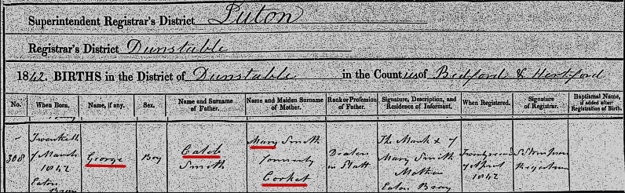
We do not find George in the 1861 census. He would have been 19 years old and he either died, joined the military, moved out on his own, or married. We are looking for him in earnest.
We have an update on George since the above was written five months ago. We found him working as a Warehouseman in an 1881 Census age 39 living in Bethel Green, Middlesex. And; he is married to an Elizabeth age 37 born in Shoreditch, Middlesex. And they have two children, Charles (6) and Clara (2). In an 1891 census we found Elizabeth, Charles, Clara and another son Frederick. She has remarried a Joseph Want and her three children are listed as step children to Joseph. By the 1911 census Elizabeth is again a widow living with her son Charles. We continue are search for the death record of George. This entire family will be sealed together during our August reunion. The records mentioned here can be found as sources attached to George in FamilySearch.org.
Here is their marriage record showing their marriage date as January 7, 1871:
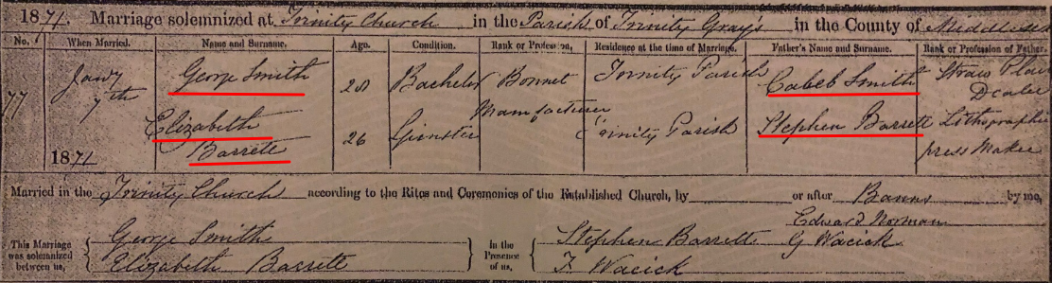
Below is the birth record of Thomas, the next youngest brother. Thomas was born June 7, 1847 in Eaton Bray.
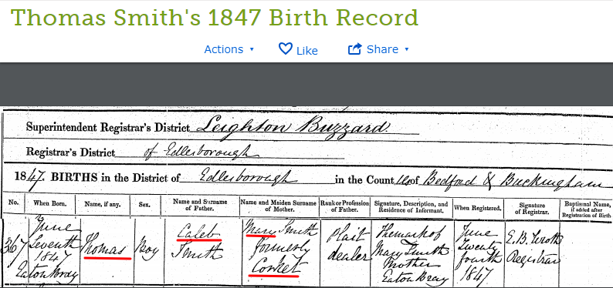
We also have a marriage record for Thomas, who at age 40 marries Alice Lovegrove, a spinster, age 31 in the Parish Church of Kentish Town in Middlesex as shown below:
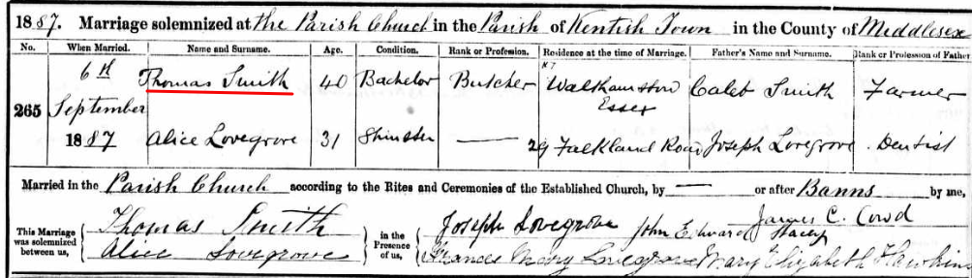
I am confident that this is “our” Thomas because the witness is Mary Elizabeth Hawkins who is, as you will recall, Thomas’ sister. Kentish Town is about 40 miles “southish” of Eaton Bray.

Thomas died on October 22, 1904 at the age of 57 in the presence of his wife, A. Smith. He died from a form of tuberculosis.
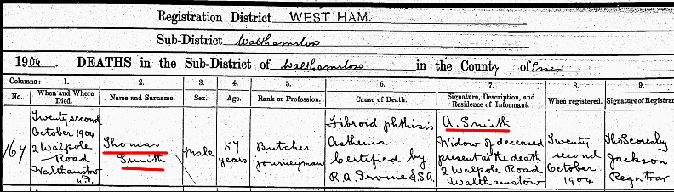
Thomas and Ann had two children together. It is possible they had more than two but only two have been found so far.
Let’s move on to the 1871 Census: Elizabeth, we know is married and has her own family. George has married Elizabeth Barrett and has three children of his own. Thomas is also out on his own somewhere at age 24 and doesn’t marriage until 1887 at the age of 40. Henry or Harry would only be 18 but he is not at home either.
After being missing for 40 years we find him in a 1911 Census married to an Amelia for 26 years with no children. Henry (as he is going by in this census) was listed as 60 years old and Amelia appears to be 69. They would have been around 34 (Henry) and 43 (Amelia). The census indicated that they did not have any children together. After finding this 1911 census we found a 1901 census that again shows Henry married to Amelia with no children. We have not been able to find Amelia’s maiden name as of March 2019 but we continue to look. Below is a copy of that 1911 census.
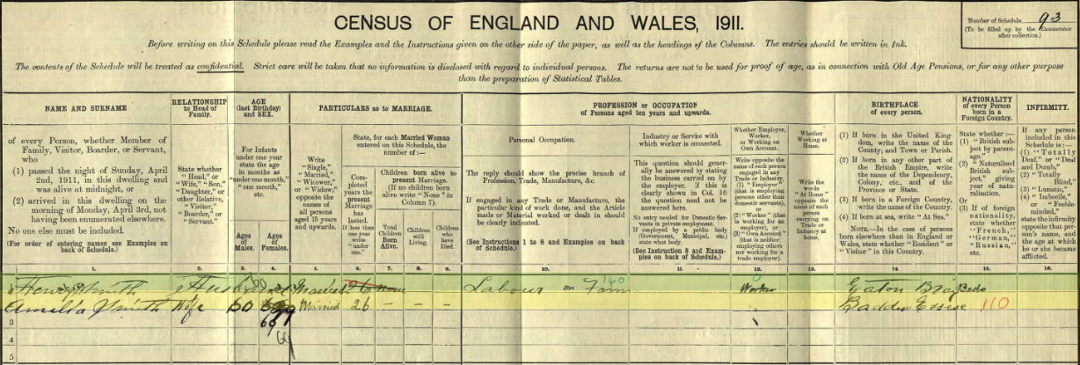

We have a death record for Henry Smith showing that he died on August 30, 1912 in Eaton Bray. This record also names his widow as Amelia Smith (no maiden name given).
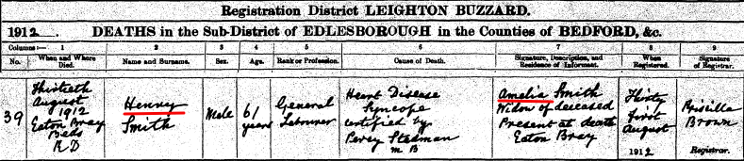
We are sure that this is our Henry because we also found a death notice for a Harry Smith in the Bedfordshire Register dated September 13, 1912. That notice mentions his father, Caleb Smith and his sister, Elizabeth Hawkins. There is no mention made Harry’s brothers, George and Thomas.
You can see why we use the name Harry and Henry both since his name seemed to have been used interchangeably. The 1891 and 1911 Census uses the name Henry as does the death record but the Death Notice below uses the name Harry!

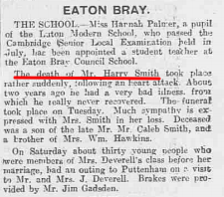

We are looking for Henry and Amelia’s marriage record in hopes of finding her maiden name and sealing her to her, as yet unknown parents.
Back to the 1871 Census and Caleb.
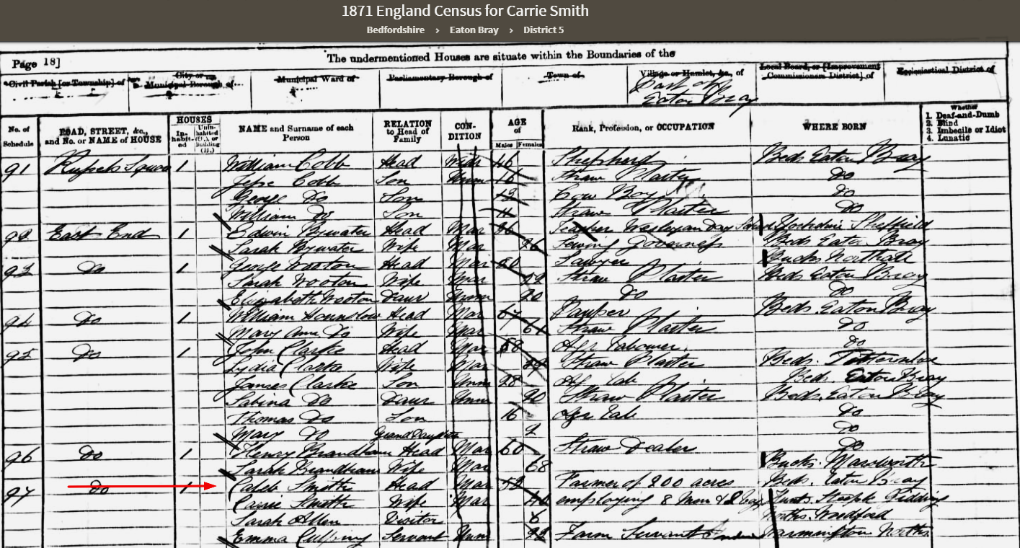
There have been some big changes in the last ten years. Caleb is now living on a farm of 200 acres on East End which was the Northeastern side of Eaton Bray. I suspect that he had the job of Farm Bailiff of these 200 acres. We find out in the 1881 census that Caleb was the “Bailiff” of yet another farm in Barholm, Lincolnshire which is about 75 miles northeast of Eaton Bray. There is an even bigger change in the 1871 census in that he is now married to a “Cassie”. Who is this Cassie and what has happened to Mary?

We found the death record of Caleb’s wife Mary. She died October 14, 1866 in Edlesborough from Atrophy at age 49.
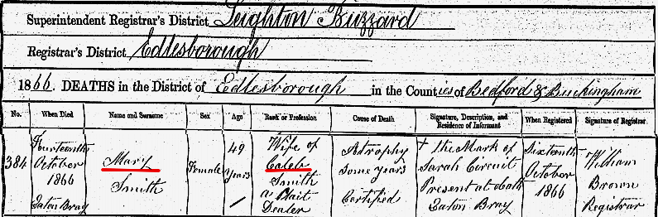

We also found a marriage record between Caleb Smith and Catherine Culpin which we believe is the Cassie listed as Caleb’s wife in the 1871 census:
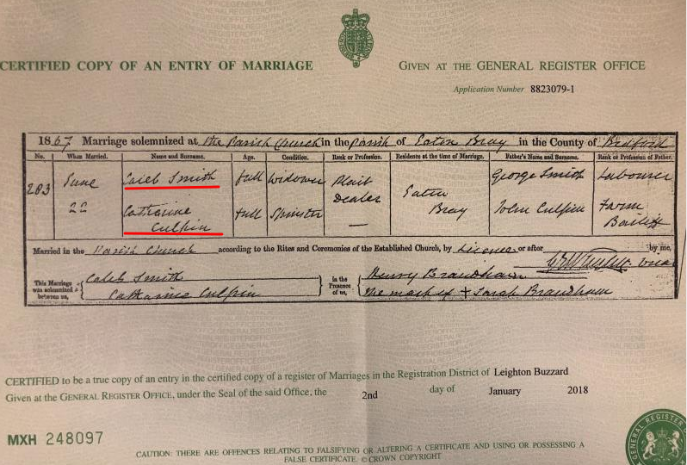
One could look at this marriage certificate and believe that the Catherine named there could possibly be called “Cassie” in that 1871 Census and that is what we originally believed. However, when you see the 1881 Census it tells a different story.
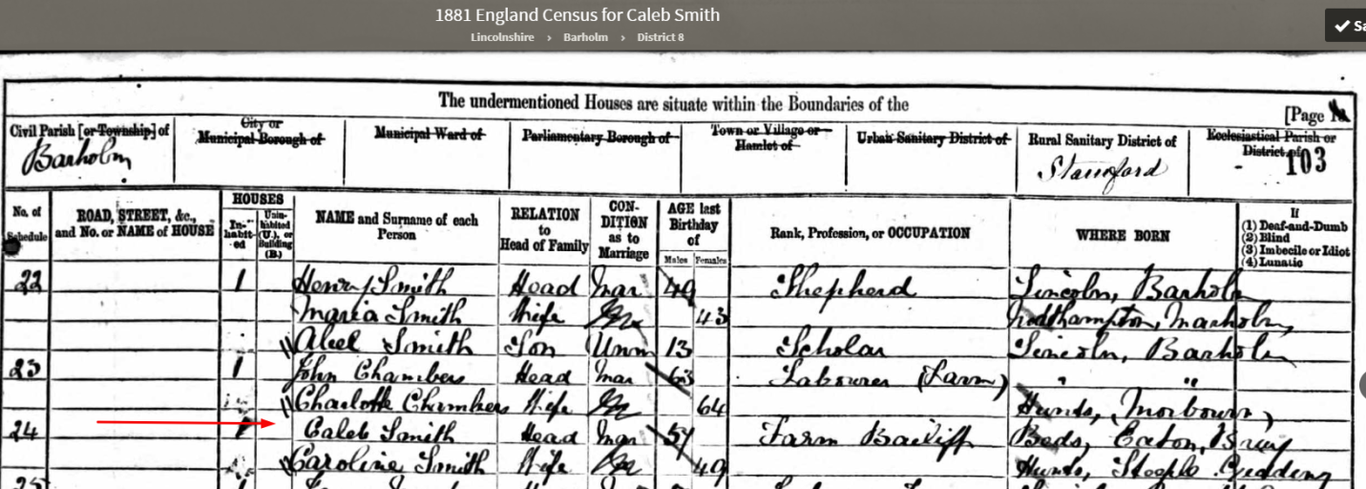
In this census Caleb is clearly married to a Caroline. This required a great deal of additional investigation. Catherine had a sister named Caroline as shown in this insert from FamilySearch.
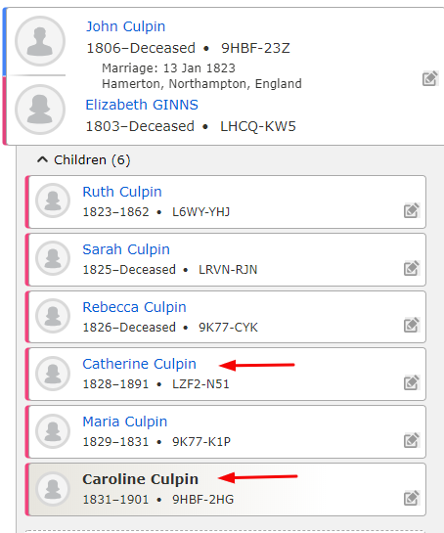
We don’t understand why the marriage license says Catherine but we found another official license like the one above showing this Catherine marrying John Freeman Buse or Bues.
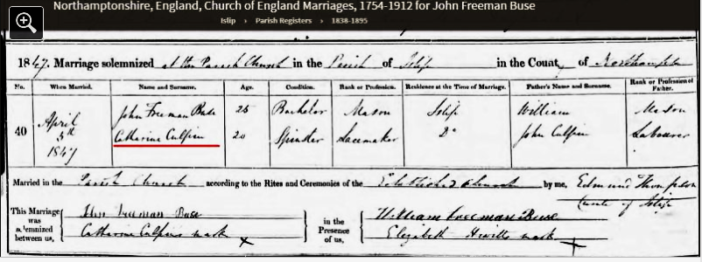
Catherine’s age of 20 in 1847 aligns with her birth in 1828 and she is found in several future census records married to John with children.
So Caleb actually married Caroline Culpin on 22 June 1867. Caleb would have been 50 years old and Caroline would have been 36. It is possible that Caroline could have been married before she married Caleb and it is also possible that Caleb and Caroline could have had a child or two together but there is no evidence of either that we have found.
We have the transcript of the Baptism of Caroline Culpin as shown below:

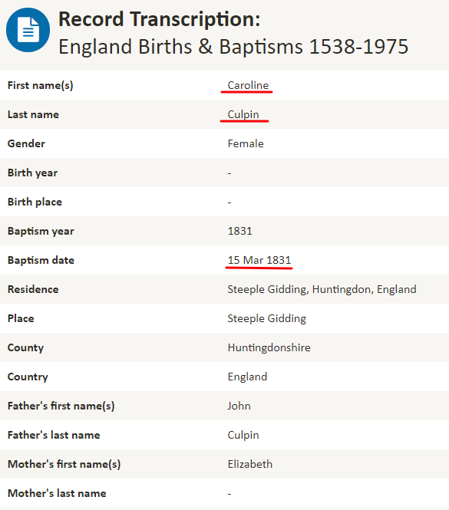
Before we focus more on the 1881 Census there is an interesting incident as reported by the Leighton Buzzard Observer on Tuesday, November 18, 1873
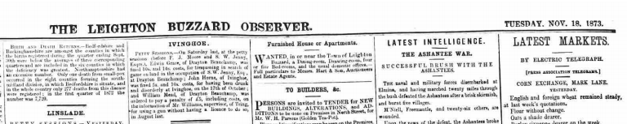

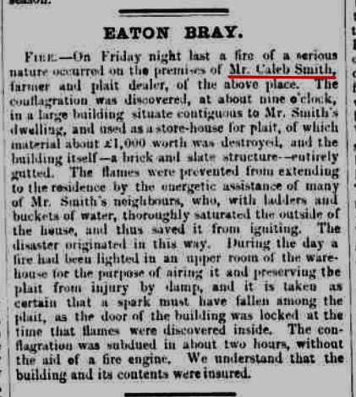

I have the impression that Caleb was able to improve his status toward the end of his life and was a rather large Straw Plait Dealer. £1000 of plait lost was a tremendous amount in 1873. I suspect he did not own all or any of this plait but was storing it for others as a “middle man”.
Caleb and Caroline are “Empty Nesters” in the 1881 Census and he is listed as a “Farm Bailiff”. You will recall that it was 1880 and 1881 that Thomas X visited with Caleb and his wife on this farm, spent the night and had some great conversation with them both. Note that this farm is in Barholm, Lincolnshire which is about 80 miles north of Eaton Bray. Thomas would have made use of the train system in 1880 to get around on his mission when he could. He makes several references to walking or getting to the “Station” in his journal.

Let’s move on to the 1891 Census.
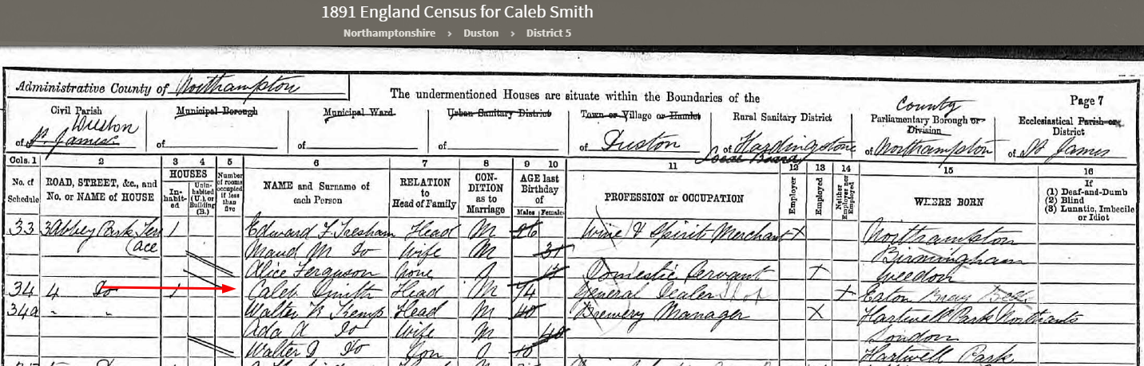
Caleb, 74 years old, is shown as a “General Dealer” living at 4 Abbey Park Terrace. He is still married but apparently Caroline was at a different location when the census was taken. Duston, Northamptonshire is about 40 miles Northwest of Eaton Bray. We have no idea why he is living there. It is possible he was retired as a Farm Bailiff and found work in Duston. There is the word “shop” written in next to his occupation so perhaps he owned some type of shop there.
We found Caroline in the 1891 Census as well. She is visiting her niece, Caroline Traynar in Islip, Northamptonshire which is about 15 miles from where she was born and about 26 miles from where Caleb is living in Duston, Northamptonshire.

We’ll move on to the 1901 Census. We have almost come full circle in that Caleb is living back in Eaton Bray on Moor End. He is now 84 years old, widowed and has no listed profession. I would like to think he moved back to Eaton Bray to be close to family.
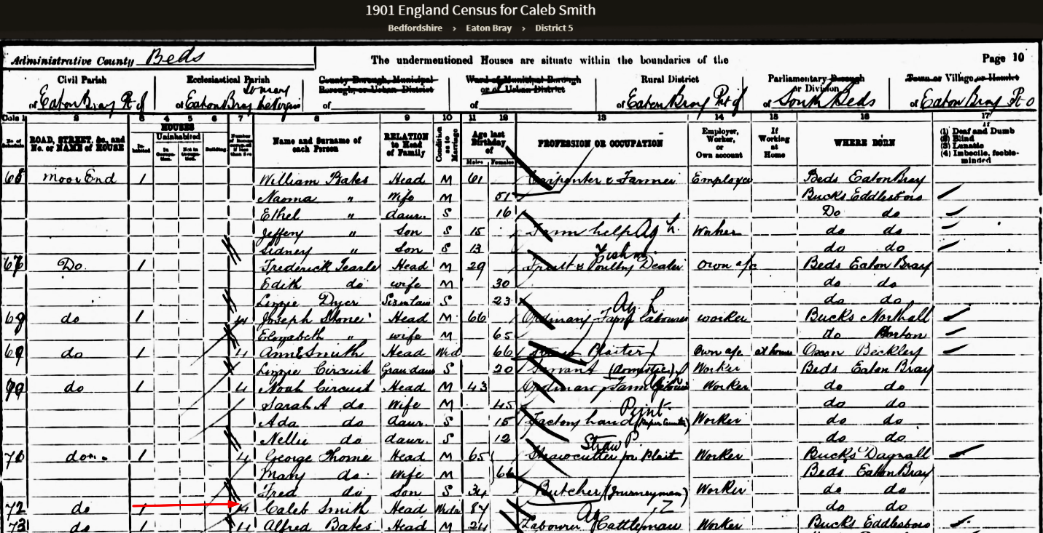

We believe Caroline died in 1901 prior to the census that year. Although we have found a 1901 Census with an Ann Smith of the right age and birth location visiting a friend. The problem is Caleb says he is a widow in the 1901 census and living back in Eaton Bray. We are looking for her death record to confirm one way or the other.
Let’s review Caleb’s five children by his first wife Mary.

James christened on October 10, 1836 He died almost a year later in 1837
Elizabeth born September 4, 1837 she married William Hawkins and had 3 children
George born March 20, 1842 He married Elizabeth Barrett and had 3 children
Thomas born about 1848 He married Alice Lovegrove and had 2 children
Harry born 1853 He married Amelia? But did not have children

Caleb died the on June 29, 1902 at the age of 85 years. He clearly outlived all of the siblings. He also moved around much more than his other siblings and at one point in his life lived almost 80 miles from Eaton Bray in Barholm and about 30 miles away in Duston. But at the end of his life he returned to the home of his youth in Eaton Bray.
His death certificate is shown below. It appears that his granddaughter, Mary E. Hawkins was in attendance in Eaton Bray at the time of his death.
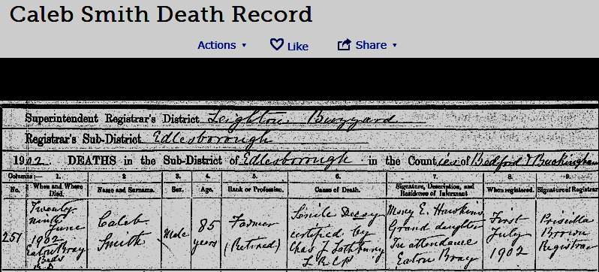

Reuben

Above is the quick overview of Reuben as found in FamilySearch.org. Note that there are 19 sources attached to him. We will probably add more before we are finish researching Reuben’s life through the records now available to us.
We started off our record of Caleb with his Christening record as found in the Wesleyan Church records. He was christened at about 3 months. Reuben, on the other hand, was 8 years old when he was christened in that same church on February 6, 1816. It would appear that our Smith family may have taken some time away from the Church and decided it was time to get their boys christened since the record below shows the christening of their four sons born after Caleb. We see Reuben at age 8, James at age 5, George W. at age 2 and John at age 2 months.

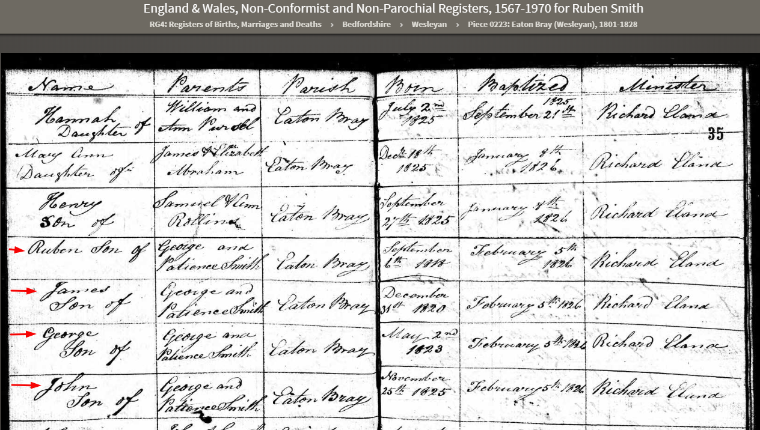

Next we will look at the 1841 Census once again.
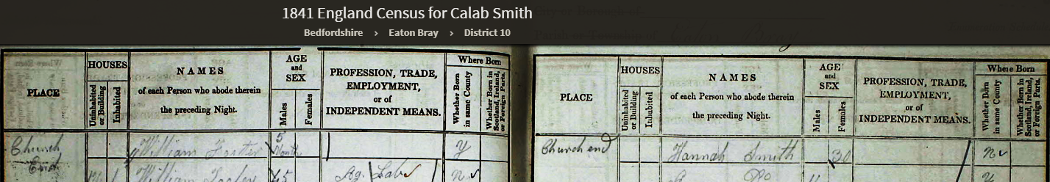
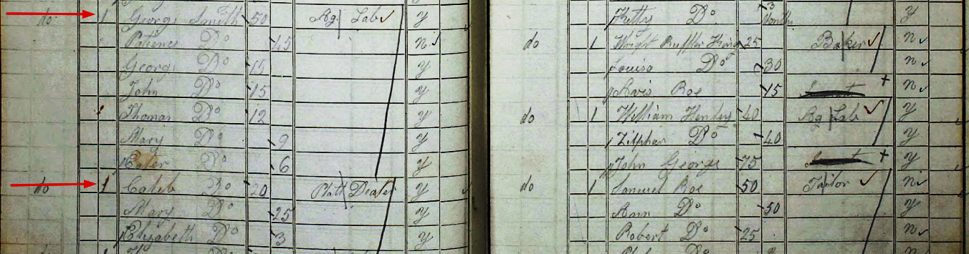
We see from this census that not only has Caleb moved out of the home but Reuben has as well. Caleb was easy to find since he was living next door to George and Patience. Where was Reuben? Not too far away as it turns out!
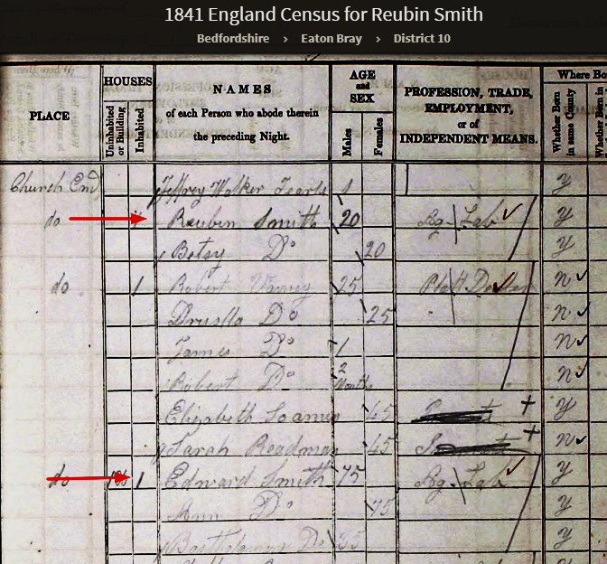
We see that Reuben is also married and living on Church End Street with his wife, Betsy (Duncomb). They are both listed as age 20 but remember that ages were rounded down. We know that Reuben was 22 when this census was taken. If you look closely you will notice that Reuben is living just one cottage away from his grandparents (George Smith’s father, Edward Smith and his mother, Ann Burrows). Edward is still an Ag Lab at age 75 (actual age was 77).
What can we find out about Betsy? She was born on August 23 1816 in Eaton Bray. And we were able to find her Christening record which was a little bit unusual in that she was christened as an adult in 1837. It does give her birth date as August 23, 1816.
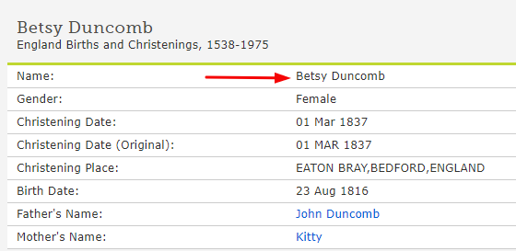

Reuben and Betsy were married in Eaton Bray on August 25, 1839. She would have just turned 23 and Reuben was 20 years old.
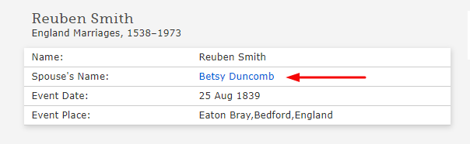

Let’s jump to the 1851 Census and see what can discover.
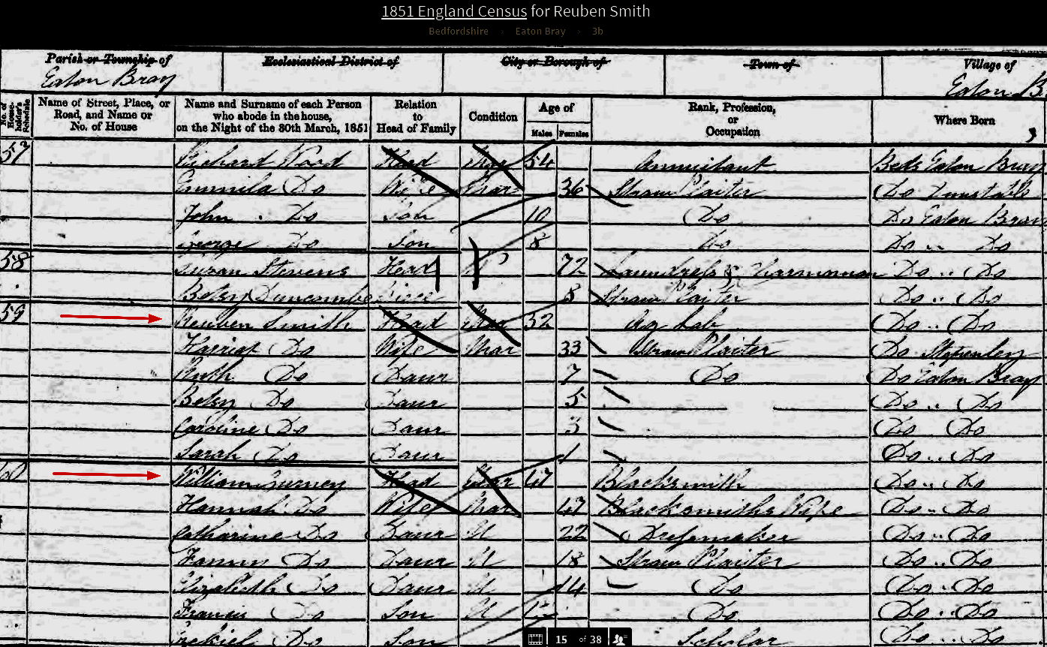

At first glance you would think that this is not our Reuben because he now has four children and his wife is named “Harriet”. But he is living in Eaton Bray and, by the way, is next door to William Gurney “Blacksmith” and his wife, Hannah (Sear). They are the parents of Margaret Gurney, the first wife of our Thomas X. So this is our Reuben but what has happened to Betsy? Our assumption is she died sometime after giving birth to a son named Jabez. Thanks to the great detective work of Craig Albiston we have a copy of Betsy’s death record which is shown below:
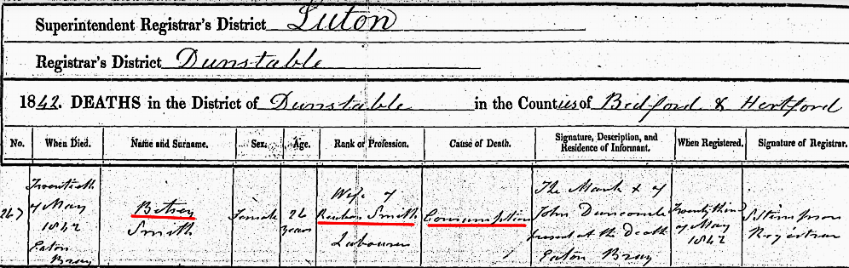
Betsy apparently died of “Consumption” on May 20, 1842 less than two years after she married Caleb and just 5 months after giving birth to their only child (as we will see). While searching for Betsy we found that she and Reuben had a child who was christened on November 22, 1939. They named him Jabez. This was a very unusual name for one of our Smiths who seemed to like the same 6 or 8 names for all their family members.

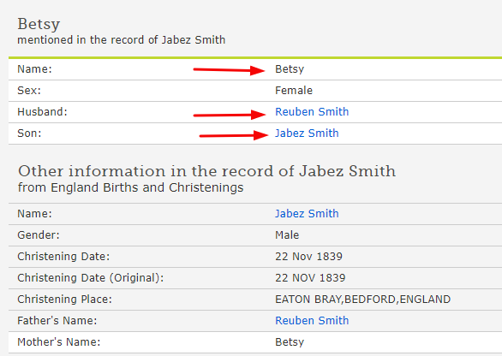
There is not much question that Jabez belongs to Reuben and Betsy. We are left wondering what has happen to Jabez since he too is missing from the 1851 Census. Sadly, he too passed away as an infant.
And, again, Craig has located both birth and death records for Jabez as shown below:

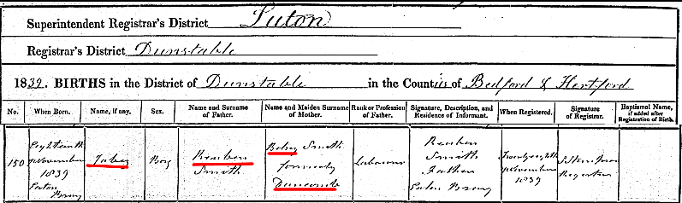
Jabez was born November 18, 1839 and Betsy Duncomb is clearly the mother. He died on August 24, 1840 having lived just nine months. The cause of death was listed as unknown.
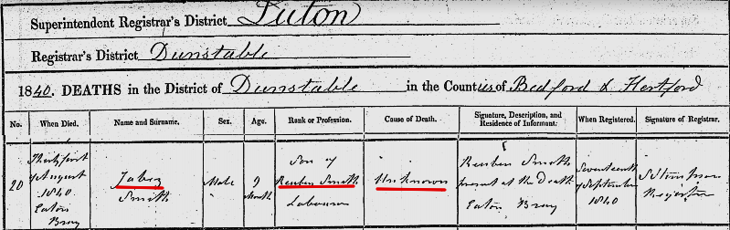
Betsy died from what was called Consumption in the 19th Century. It was Tuberculosis and there was no cure until after the discovery of penicillin and in recent years more specific drugs are used. In the late 1800’s it was a major cause of death. Consumption was highly contagious and it is possible that Jabez, who was obviously in close contact with his mother also died of the disease.

We are left to find Reuben’s new wife, Harriet and their four daughters Ruth (7), Betsy (5), Caroline (3), and Sarah (1),
The record index below shows the marriage of Reuben to Harriet Cook in 1843.
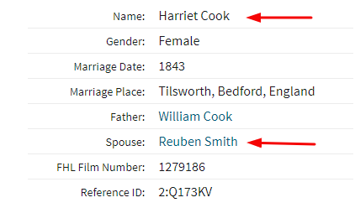
Reuben and Harriet were married on 20 November 1843 in Tilsworth, Bedfordshire, England which is only 3.5 miles North of Eaton Bray. We don’t know much about Harriet other than her father was named William. More research into her early life and parents, siblings, etc. will be added to our list of work to do.
An interesting event occurred in Reuben’s life which we found as we were looking for records in the 1840’s. Reuben and his brother, George W., were arrested for rioting and assaulting a peace officer in the fall of 1845. There were several young men in Eaton Bray who were involved in this incident but only Reuben, George, and a fellow named Thomas Fountain were found guilty and sentenced. To date we have not found the cause or nature of the riot but we’re still on the hunt. I suspect the riot had to do with the Poor Laws and living conditions since there were many such riots recorded. Both of the brothers were sentenced to 1 month at hard labor and threatened with a £30 fine if they got in trouble with the “Law” over the next year. The article below was found in a newspaper called the Bedfordshire Mercury.
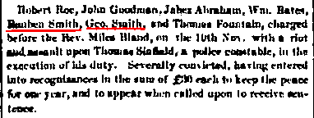
The riot seems to have occurred in the fall of 1845 since they first appeared before the court on November 10th of that year. Next is the Court record of the actual sentencing which took place on the 30th of June 1846 and they began serving there sentence on that date.
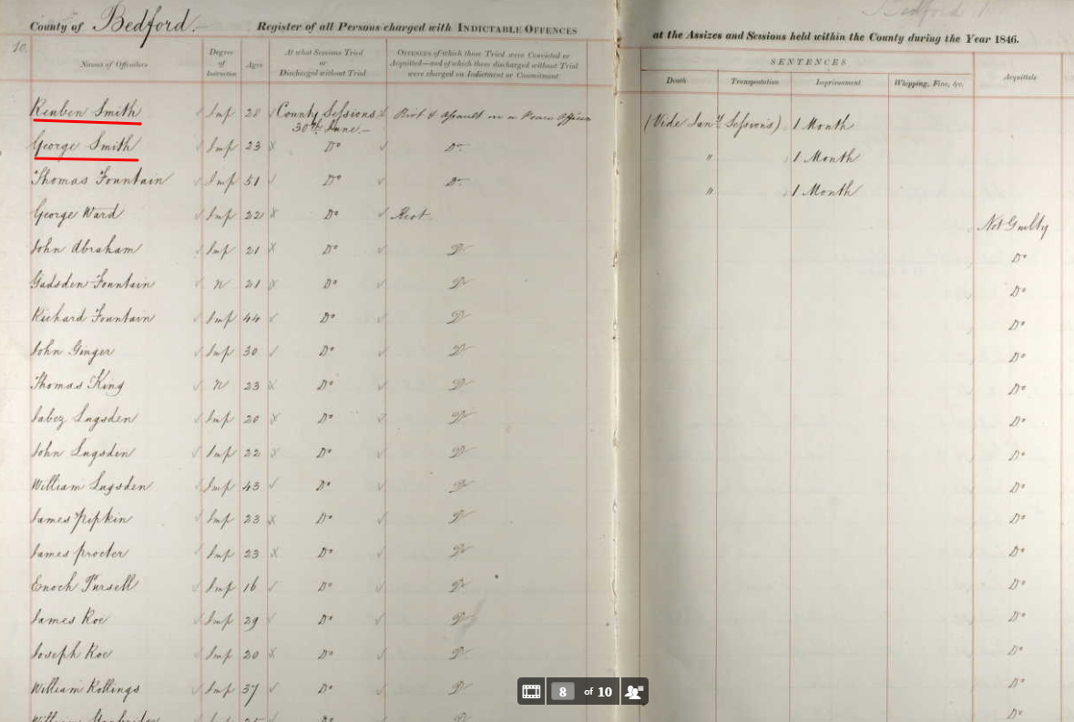

There was some great benefit that came out of this Gaol sentence and that is a wonderful description of both Reuben and George W. Reuben’s record is shown below:
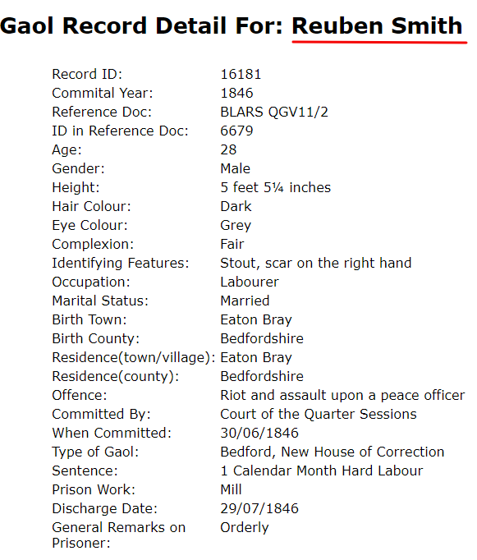

Back to our task at hand of finding the children listed in the 1851 Census. Here is the birth record Index for the first child of Reuben and Harriet. She was named Ruth and was born in the second quarter of the year 1844. That is as close as we can get with the records we have found to date. We will try to order her actual birth record before publication.
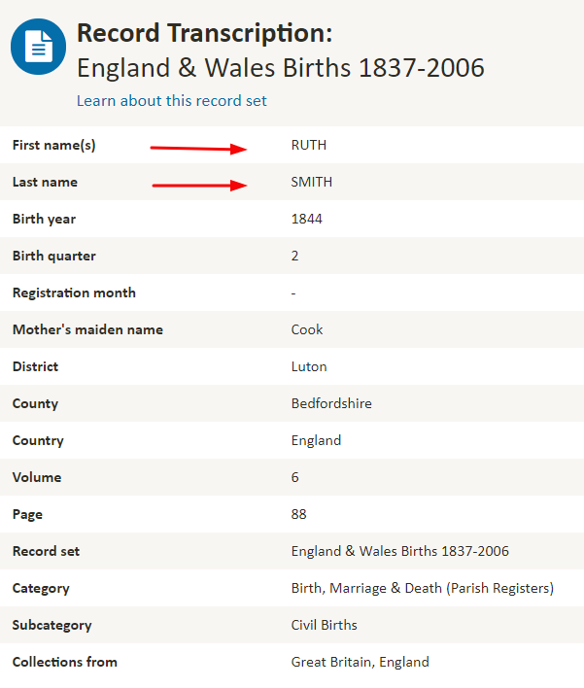

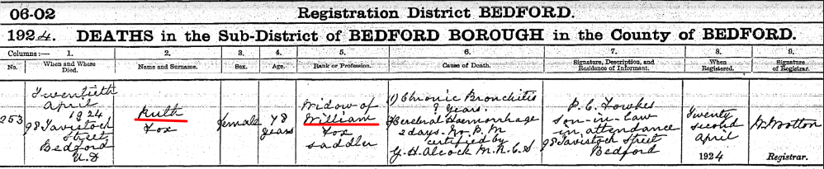
Ruth married William Tripp Fox on October 9, 1877 and they had four children. She died April 20, 1924 at the age of 78 years. Her death record is shown below:

The second daughter born to Reuben and Harriet is named Betsy. Based on the 1851 Census we showed above, Betsy was calculated to be born in 1846 since she is listed as being 5 years old at the time the census was taken.
We do have a record of her christening on 30 July 1848 when she would have been 2 years old.
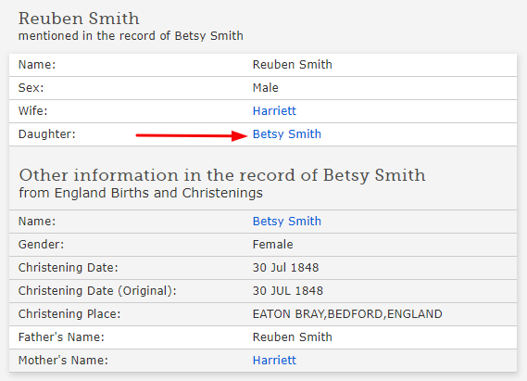

Betsy is living at home in the 1861 and 1871 Census (as we will shortly see). And it appears she is living as a boarder with a friend, Mary A. Sharp in Dunstable. Both are single and Bonnet Sewers. Reuben’s daughter Betsy walked with Thomas X in Dunstable as he was leaving near the end of his mission in May of 1881. Betsy would have been 35 years old at this time. Thomas X doesn’t mention her having a family for what that is worth. Unfortunately we lose track of her from there so we don’t know when she may have married or if she had children or when she died. She is on our high priority list to find more records of her adult life.

The next daughter is Caroline and she was born on December 27, 1847 in Eaton Bray as shown on her birth record below:
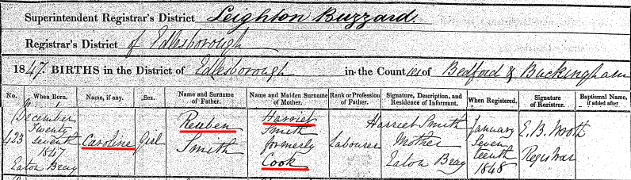

We also have her christening record which shows she was christened on 30 July 1848 which is the same date as her sister, Betsy.

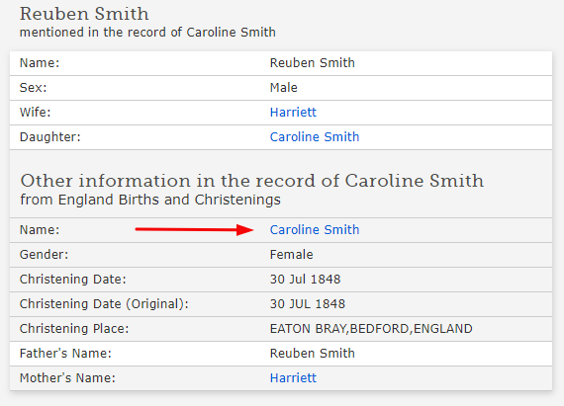

Caroline appears to have died young as so many of the others have. We have a death Record Index for her showing that she died in December of 1864 at the age of 16 or 17. We don’t have her death record to know exactly what she died from. We will continue to search for her death record.
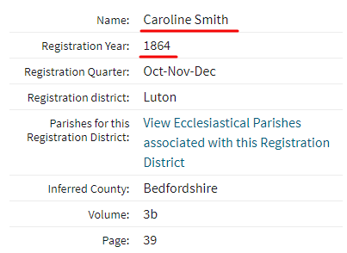

The last child to be listed in the 1851 Census is Sarah, only 1 year old at the time of the census taking. We were able to obtain her birth record which is shown below:
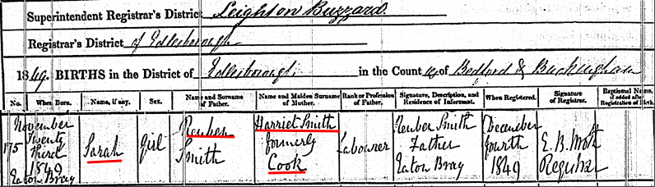
You can see for the attached that she was born on November 23, 1849.

Sarah had a daughter out of wedlock when she was 25 years old. Her name is Maud Smith and she was born on August 11, 1875. Her birth record is shown below.
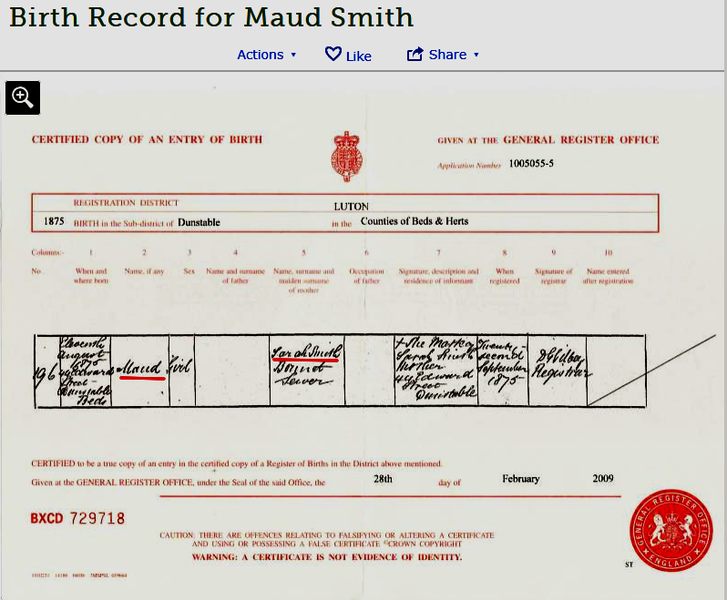
Maud went to live with Mary Ann and Esther Smith, the two sister siblings, at some point after her birth but before the 1881 Census as she is shown in the 1881 and the 1891 census records living with them. Those will be shown when we get to the “sisters”. Sarah later married Charles Allison at age 34. Sarah died September 29, 1925 without having any additional children that we have been able to find. Below is a death notice showing that see died a widow and her daughter, Maud was the heir to her estate of about £169. Sarah would have been 74 years old when she died.

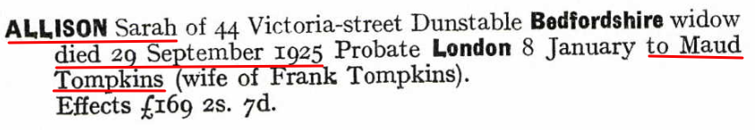

So we have accounted for the new wife Harriet and their first four children. Let’s see what another 10 years brings by looking at the 1861 Census.

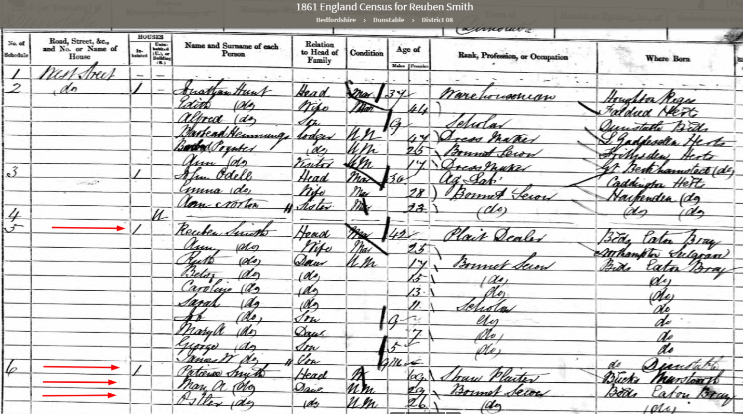
The first thing I noticed about this record was that there were a lot more children. Secondly, I noticed that Reuben was living right next door to his mother, Patience and her two unmarried daughters, Mary A and Esther. And, by the way, they are now living in Dunstable. Remember that Dunstable is only 3.5 miles away from Eaton Bray so they haven’t moved very far. Third, I noticed the big surprise; Reuben is married to an “Ann” and not “Harriet”. So questions need to be answered. Who is Ann? What happened to Harriet? How many of the new children listed are Harriet’s and how many are Ann’s.
The girls, Ruth, Betsy, Caroline and Sarah are all still accounted for. The new additions are Job (9), Mary Ann (7), George (5) and lastly, James W. (9 mos.).
Let’s look first at the new additions. It is not immediately obvious who the mother is. Job likely belongs to Harriet since he is nine in this 1861 census and would have been born a year after the 1851 Census was taken (1852). Let’s see what we can find about Job.

Job was christened on April 14, 1857 and with that knowledge we were able to find both his birth record and his death record. Both are shown below:
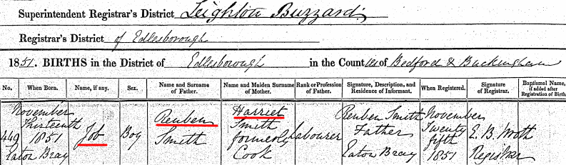
We see that Job was born on November 13, 1851 in Eaton Bray and Harriet is his mother as we suspected. Job died just after reaching his 11th birthday on December 28, 1861 in Dunstable.

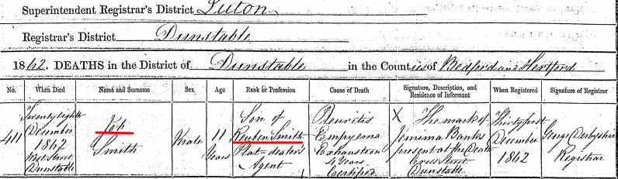
Let’s look at the next oldest child in the census, Mary A, age 7. We also found a Christening record for Mary Ann Smith, April 14, 1857. And she is shown as the daughter of Harriet. She would have been born in 1853 or 54. So she was obviously three or four years old when she was christened on the same date her brothers Job and George (as we will see) was christened. That is actually consistent with some of Reuben’s other children’s christenings. He seemed to save them up for a good day.
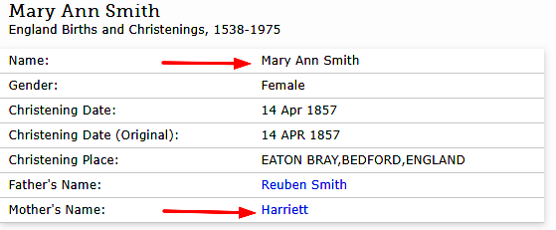
We also have the birth record for Mary Ann. She was born on December 4, 1853. She too is the daughter of Harriet

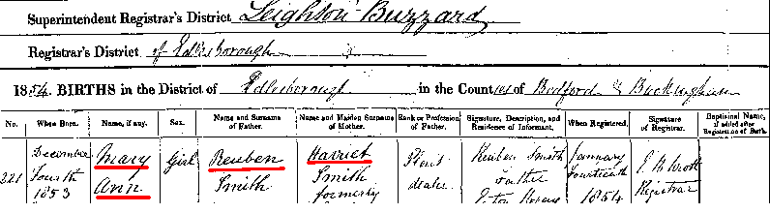
We see Mary Ann again in the 1871 Census at age 17 and then she disappears. She too is on our top priority list to find. Did she marry and have children? We’ll keep searching. It is very difficult to find the daughters as they marry. Especially true with common names like Mary!
George is the next child listed in the 1861 Census and he is also Harriet’s son. We have his birth record as shown below.
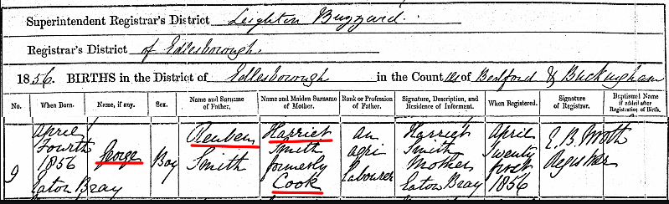
It is nice to have an exact birth date for George since about every third boy child in 1850 Eaton Bray, England was named George. He was also christened on April 14, 1857 along with Job and Mary Ann. George married Eliza Green on January 1, 1878 at age 21 and they had nine children together. Eight of those children have been found but one is still missing. The information of nine children comes from the 1911 census where Eliza notes that she had nine children and seven were living and two had died. George died about 1890 since Eliza is shown in the 1891 Census remarried. George’s youngest child was born in 1895. So he died between those two dates.
Here is an update on George’s ninth child. His name was Arthur and he was a twin to his brother William. He only lived four months. The next born son of George and Eliza they named Arthur, no doubt in remembrance of the twin who died. This was a wonderful tribute but a nightmare for genealogical record searchers everywhere. Good job Craig for finding this one!
There is another child attached to Reuben and Harriet in FamilySearch.org by the name of John, born in 1856 and Christened on the same date as Job, Mary Ann and George. However there are no sources or records attached to this John other than an undocumented Christening record. He has had his ordinance work done and is sealed to Reuben and Harriett. More research is needed to verify his existence but he would have had to have been a twin of George and we should have already found his birth record or a christening record for that matter. We have not.
We are down to the last child listed in the 1861 Census and he was named James W. only 9 months old on April 7 of 1861 when this census was taken. So we are looking for a James William Smith born in July or August of 1860. Craig ordered his birth record based on a hopeful Record Index and we have his birth record below.
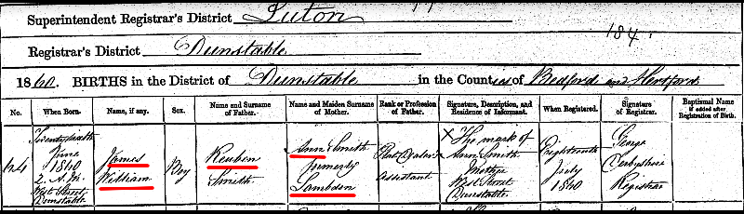
James William was born to Reuben Smith and Ann Lambdon on June 26, 1860 at 2 am at their home on West Street Dunstable. James went on to married an Elizabeth Smith (probably not her maiden name) about 1893 and they had three children together. We don’t have a death date or record at this point.

We also located a marriage record for Reuben and Ann Lambdon on February 6, 1860 in Luton, Bedfordshire, England. Only the Index for that record is shown below but the facts have been verified.
They were married on February 6, 1860 in Luton.
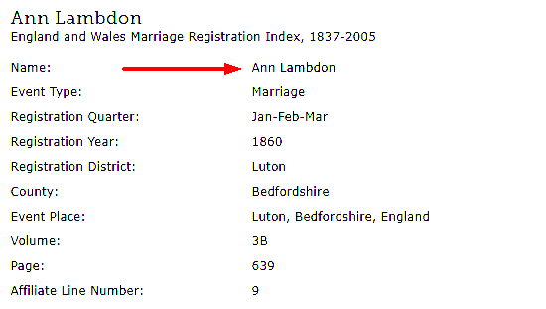
So they married about a year before the 1861 Census was taken and apparently only about 5 months before James William was born.
We found a death record for Harriet and it is shown below. She died March 16, 1859 at home on West Street in Dunstable. She was only 41 years old.

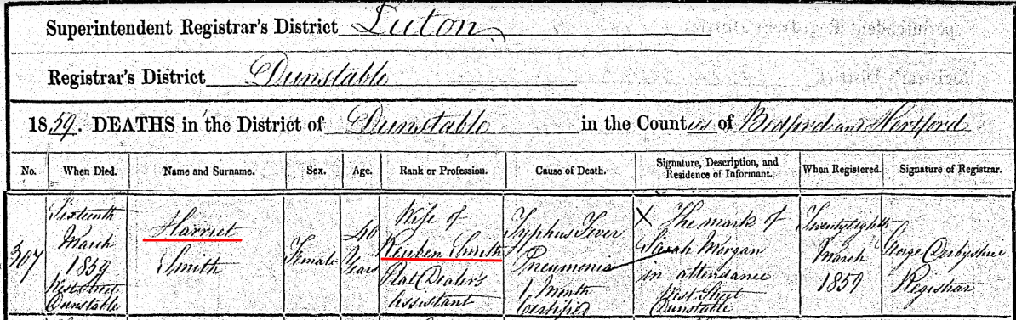

Let’s move on to the 1871 Census and see what is new.

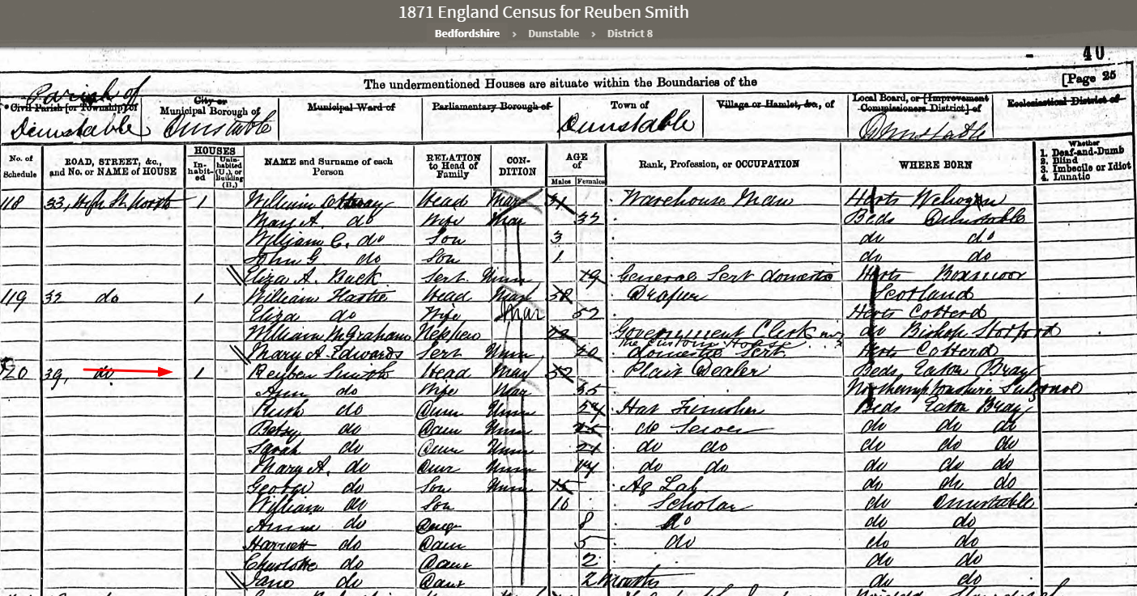

Reuben and his expanding family are still living in Dunstable at #39 High Street North. We see that Reuben has added four more children to his family: Anne is 8 years old, Harriet is 5, Charlotte 2, and Jane is 2 months old. So far we have following children identified:
From Betsy Duncomb we have just one Child
Jabez (1839- 1840)
From Harriet Cook we have seven children:
Ruth (1844-1924)
Betsy (1846 -?)
Caroline (1848-1864)
Sarah (1849-1925)
Job (1852-1862)
Mary Ann (1853-?)
George (1856-? after 1910)

So far from Ann Lambdon we have five children:
James William (1860- 1910?)
Annie Maria (1862-after 1911)
Harriett (1865-1945)
Charlotte (1868-1944)
Jane (1871-1873)
If my math is correct that is thirteen children and 10 of those children are in the home in 1871. Jabez and Job have died and Caroline is married and out of the house. Let’s find these new additions to the family. Before we do that let’s look at the 1881 Census to see if there are any additional children and then see if we can find details on all of them.

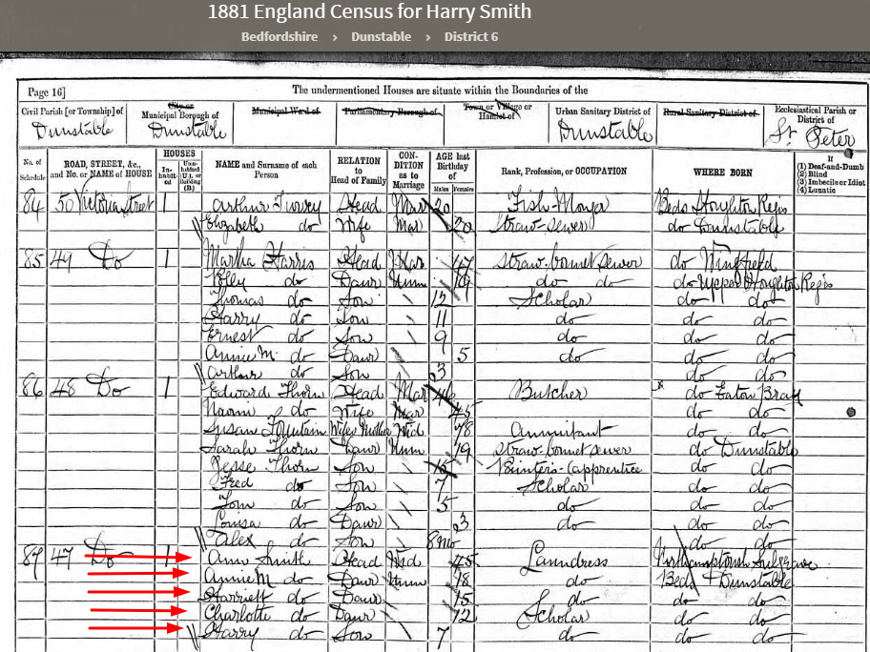
There is another child, Harry age 7, and the family is still living in Dunstable but the address is now #47 Victoria Street. We have now accounted for 14 children in total.
Unfortunately it looks like Reuben died sometime between the 1871 and the 1881 census since he is missing from this census. Jane, who was just 2 months old in 1871 in not listed on this census and has also apparently died. Let’s see what we can find about them both.
We have a copy of the official death record of Reuben showing that he died on November 7, 1875 at the age of just 57 years.
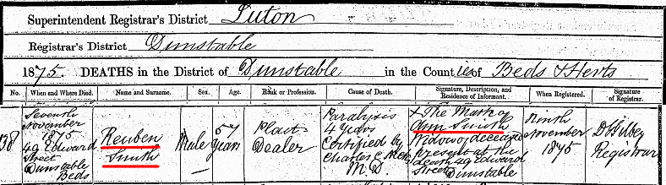
Reuben would have died just a couple of years after his last child, Harry, was born. We note that his wife Ann (Lambdon), like most of our ancestors of this day, could not write her name as the witness to Reuben’s death. She only made her mark. Also note that he died at 49 Edward Street in Dunstable where they were most likely living at that time.
Let’s turn our attention to Jane who was 2 mos. old in 1871 and missing in 1881. We found Jane’s birth record as shown below:
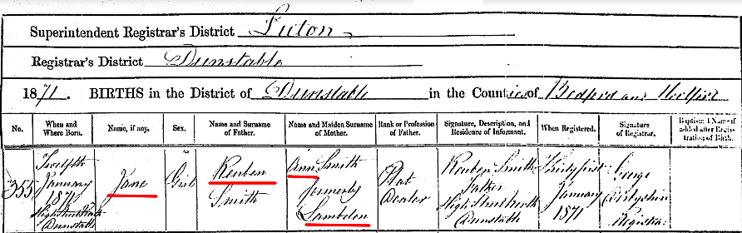

Jane was born on January 12, 1871 at home on high Street West in Dunstable. Unfortunately Jane died about two years later on March 21, 1873 of Pneumonia as shown on the record below:
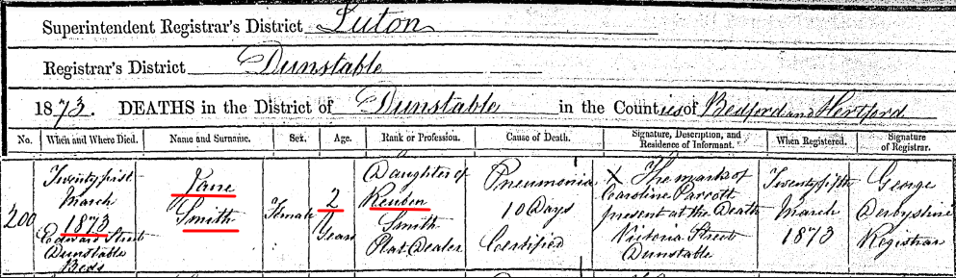
At this point let’s go back to where we left off with what details we have on Reuben’s children.
We have the birth and death of Job. We have Mary Ann accounted for already. As is George and James William. So that brings us to Anne Maria. We have the birth record of Anne Maria, born June 23, 1862 and it is shown below.
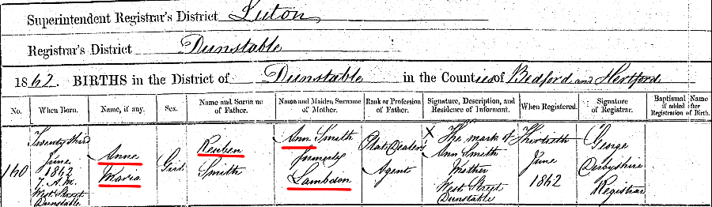
Annie Marie married Harry George Powell on February 19, 1882 and they had two children. Annie is alive at the time of the 1891 census but we don’t know the exact date of death.
The next child born to Reuben and Ann is Harriet who was born April 7, 1865. We don’t have a birth record for Harriet but she gives her exact date of birth in the 1939 Register. Harriet never married and died on January 21, 1945 at the age of 79 years.
Charlotte was born July 3, 1868 Dunstable. She married Robert Bruno Kurth on November 23, 1911 at the age of 43. She and Robert did not have any children and in September of 1944 at the age of 76 years.
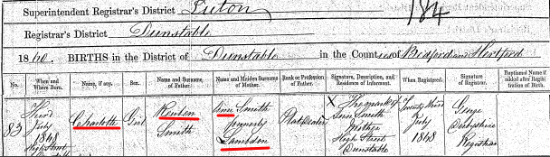
Jane was next born and we have already covered her short life. The last child born to Reuben was Harry.
Harry was born on September 13, 1873 in Dunstable.
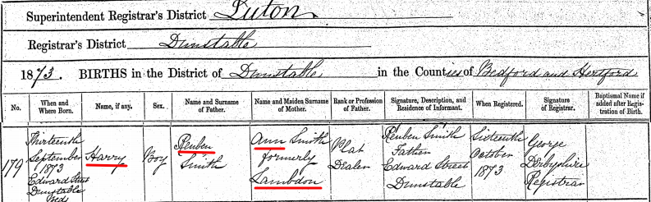
Harry married Florence Annie Kukins in October of 1998 at the age of 25. Florence was 22 years of age. As far as we can tell they had no children. They are in the 1911 Census and Florence states she had no children living or dead in 1911 when she was 37 years old and Harry was 39. Harry is also found in the 1939 Register living with his wife Florence. By the way, he is living in the same dwelling as his sister, Charlotte and her husband, Bruno Kurth.

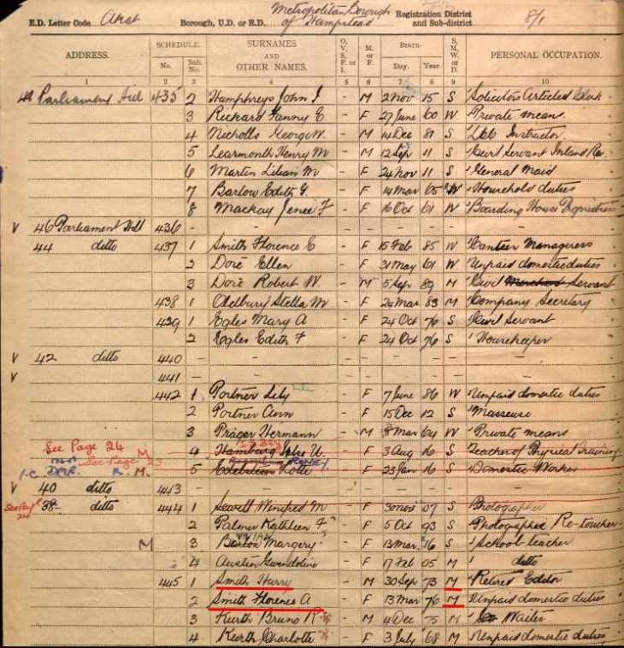
Harry died on at the age of 82 years in Hampstead. A niece by the name of B. M. Richards signed the record as a witness. We have initiated a search for her.

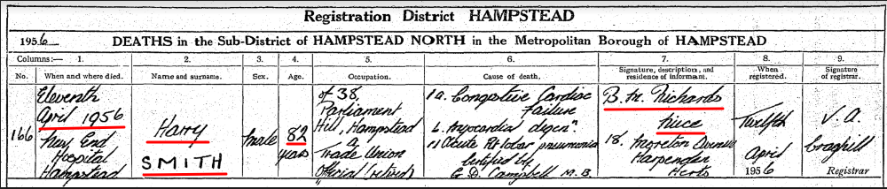

Ann Lambdon Smith lived on for another 46 years after the death of Reuben as we will see from the next few census records. Below is the 1891 census:

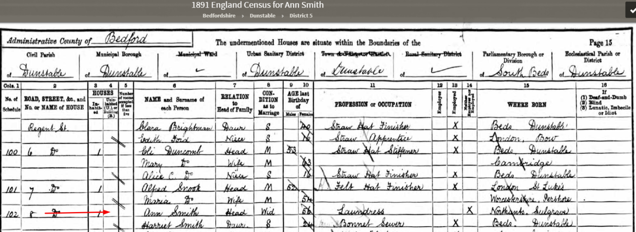
Ann is listed as a 56 year old widow living at #8 Regent Street with her daughter, Harriet, single and age 24. Ann is still listed as a Laundress. Ten years later, in the 1901 census, we see that Ann is still living with her daughter but they have moved about 10 miles east in Luton. She has finally retired at the age of 67. Her daughter, Harriet is listed as a Straw Hat Finisher.
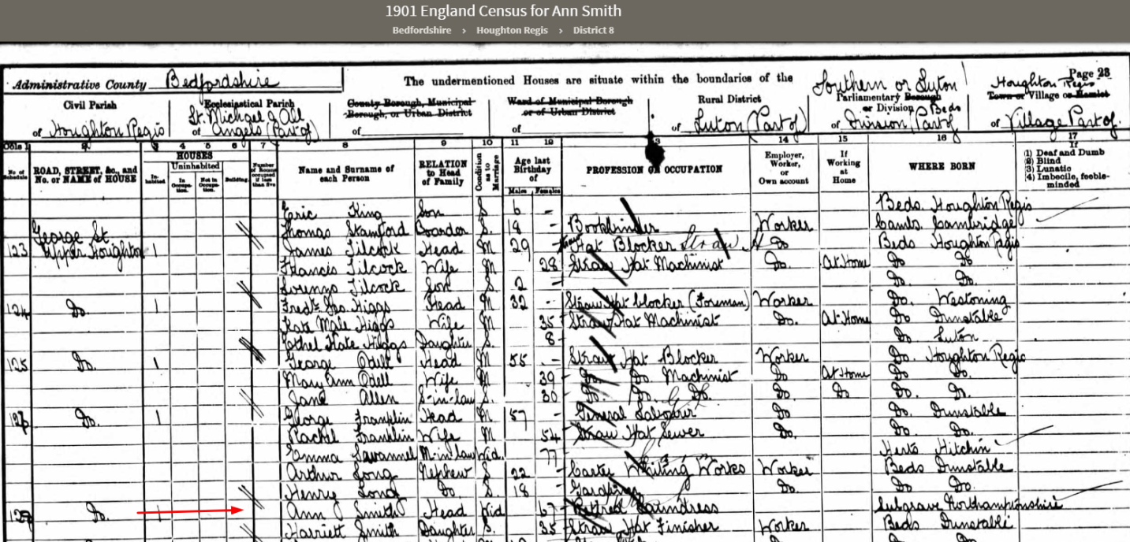
After another 10 years Ann, now 76 is still retired and still living with Harriet, age 44, single and listed as a Straw Hat Finisher in 1911.
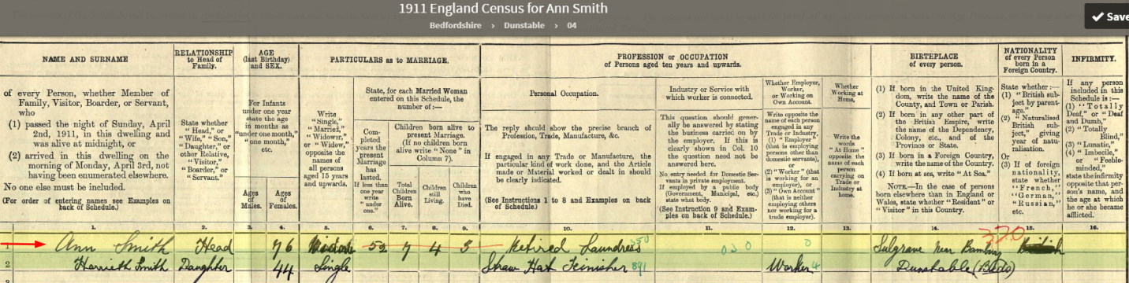

The 1911 England Census provides some questions that are of a great benefit for genealogists. One, How many children have been born alive in this marriage? And, two, How many of those children at still living? And three, How many have died? Ann answered these questions with 7 children born to this marriage. Four children are still alive and three children have died.
We have only accounted for six children, not seven. It looks like Ann and Reuben had a seventh child who died before 1911.
Again, through the great detective work and diligence of Craig Albiston we how have the birth and death record of Ann’s seventh child, Thomas Smith. He was born March 23, 1867 and died two days later on March 25, 1867. The cause of death appears to be written as “Instability from birth”.

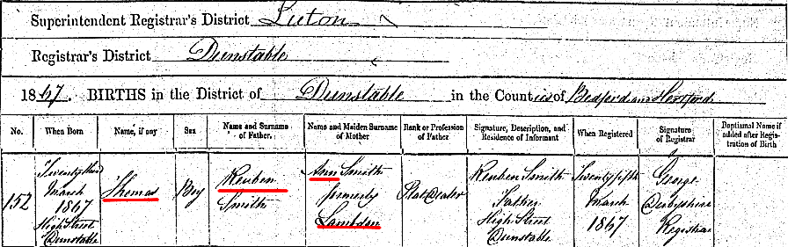
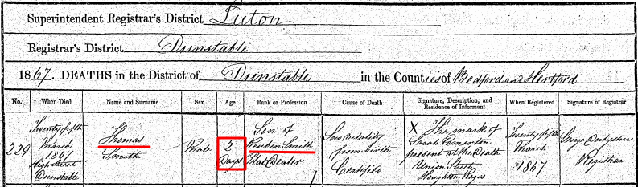

Had Thomas’s mother, Ann, not lived to be counted in the 1911 census where “those” questions were asked Thomas would likely not have been found in this earth life. Now we have his name reserved and he will be sealed to his parents during our reunion this August; one hundred and fifty two years after his birth and death.

As was mentioned earlier, the 1921 Census will not be released to the public until 2022 but we do get one last glimpse of Harriet, age 65, retired as a Straw Hat Finisher, and living alone in Dunstable. This from a 1939 England Registration record:

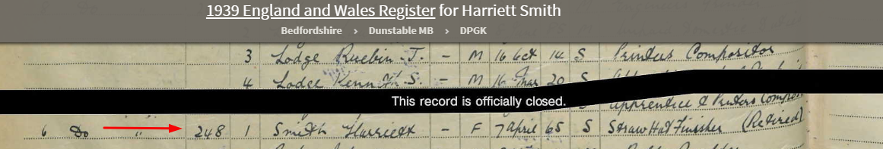

We found the death record for Ann Lambdon Smith and it is shown below.
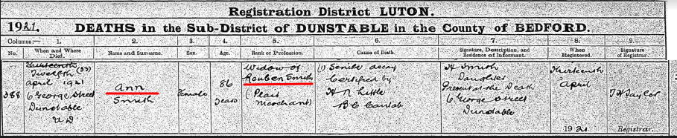
So she died at the age of 86 on April 12, 1921 and was still living at #6 George Street in Dunstable when she passed away.
So, in total, Reuben had fifteen children. Five of those children died between the ages of 2 days and 16 years. Daughters, Mary Ann and Betsy are yet to be accounted for as adults and the search will continue. Rueben had 19 grandchildren who we have accounted for.

Just for fun I located Rueben’s residences from the 1851, 1861, 1871 Census and from his death record and put those on a google map. It was interesting what I found: he lived his whole adult life within a couple of blocks in Dunstable.

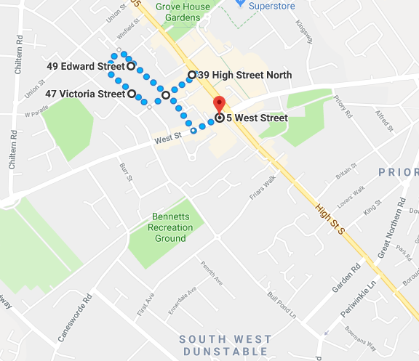

And if I add in his address in Eaton Bray where he grew up we find that he did not travel far from the place of his birth. In fact, Church End in Eaton Bray where he grew up is only 2.7 miles away from his residence on West Street in Dunstable.

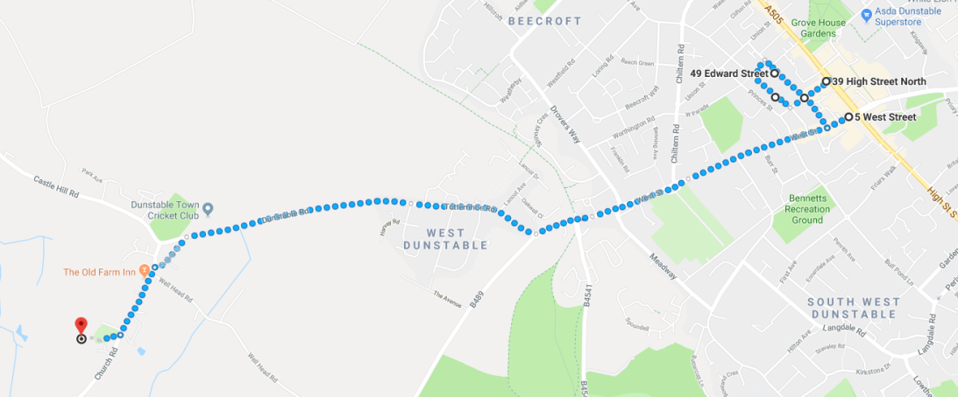

I believe we have closed out all we currently know about Reuben, his three wives and fifteen children. We will move on to James.

James:

Unfortunately we have very little to report on the life of James Smith. He was the next to be born to George and Patience on 31 December 1820 in Eaton Bray. Unfortunately, James died at the age of five years and was buried on 5 November 1826. We do not know the cause of his death and our prospects of finding out are not good.

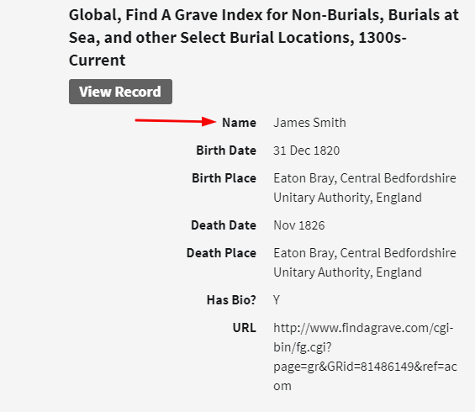

We have no choice but to move on to the next sibling.

George W.
Since this history is focused on the siblings of George W. and Thomas X we won’t go into any depth on him or his family. I’ll simply show the summary information as found in FamilySearch.
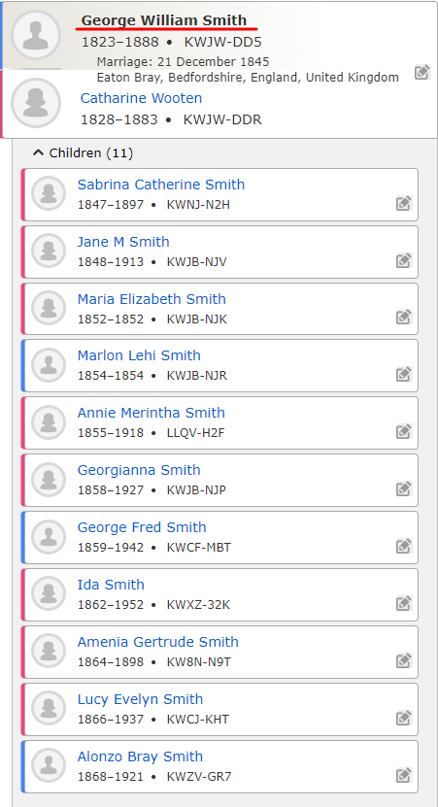

We got that great description of George W. from his prison record and that is all the more we will say about him and his family.

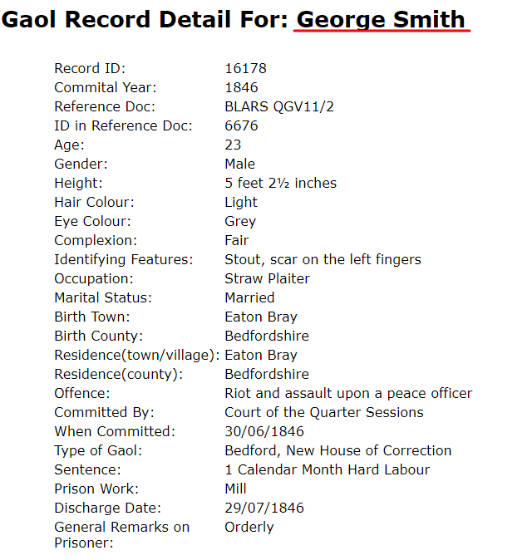

So as a 23 year old George W. was a stout 5 feet 2 ½ inches tall. No wonder so many in our family are so short.

John

We’ll start off or research on John as we did for Caleb and Reuben with the brief overview of John as found in FamilySearch.org. Note that there are 16 sources attached to him. And we will hope to add more.

John was born November 25, 1825 in Eaton Bray so we should see him in the 1841 Census at home with his parents.

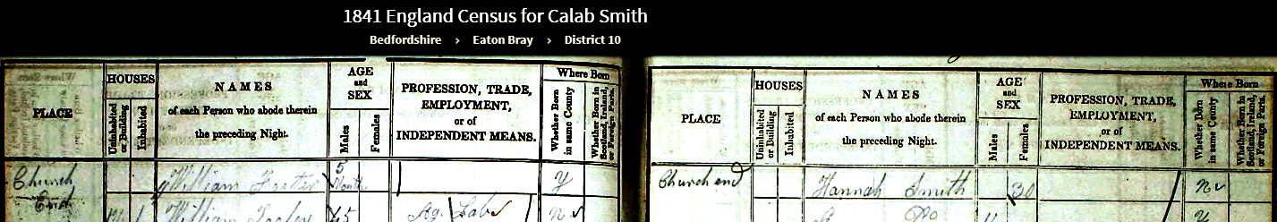
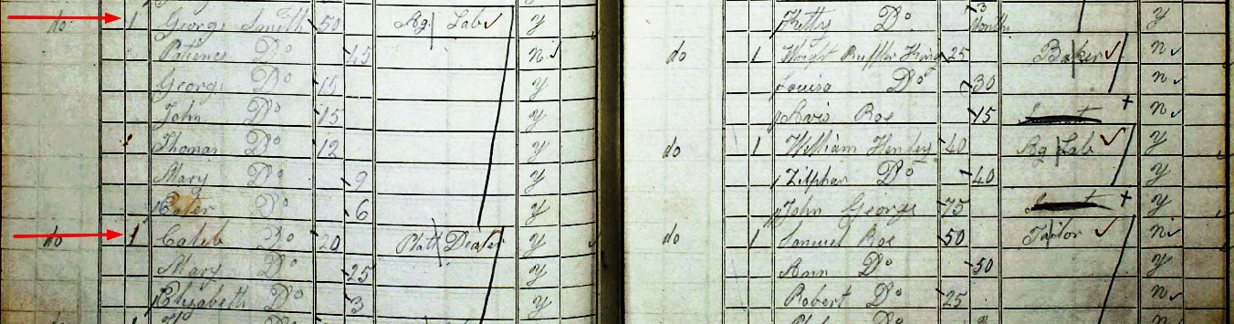
And John is right where he is supposed to be, Caleb and Reuben are married and on their own. George W, John, Thomas X, Mary and Esther are still with their parents at home.
Attached below is John’s christening record from the Wesleyan Methodist Church showing the date of February 5, 1826 for the Christening and a birthdate of November 25, 1825. Reuben, George W., and James were also christened on this same date.

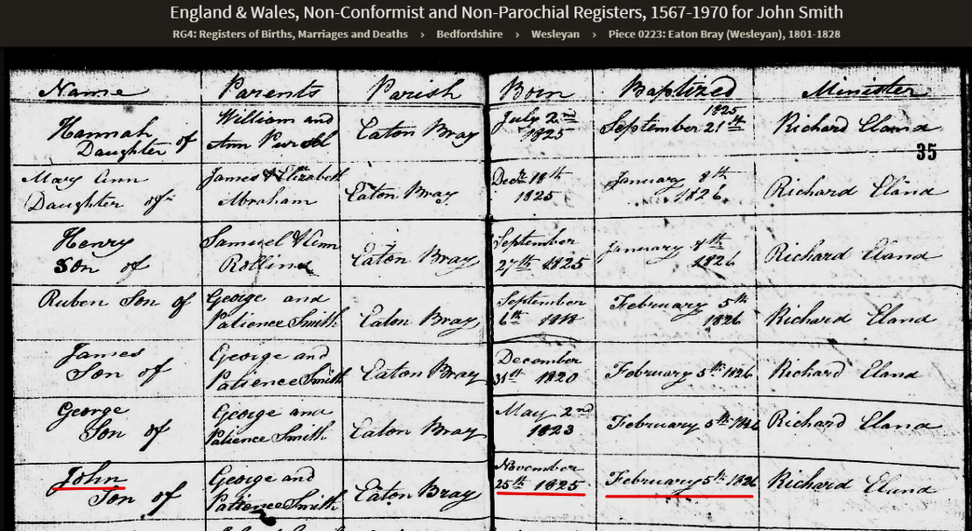

Let’s move on to the 1851 Census

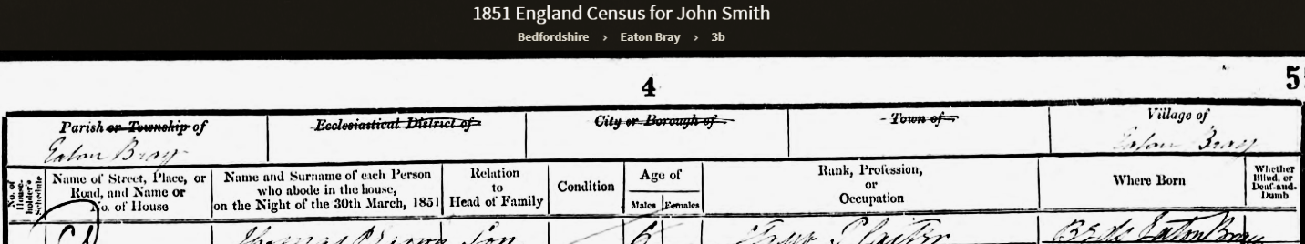
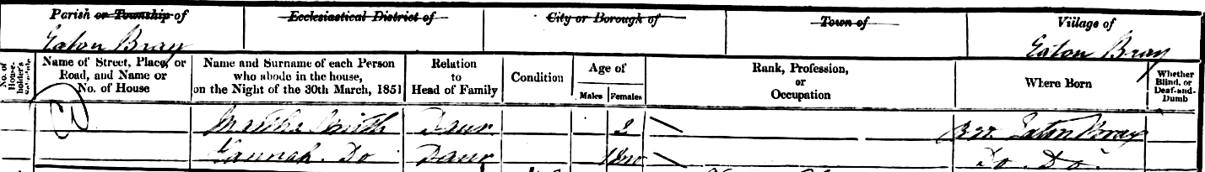
John has gotten married and is living with his new family in Eaton Bray. His wife is named Ruth and they have three girls, Ann age 4, Martha age 3, and Hannah age 18 months. So we have plenty to investigate. I used this census record earlier when researching the economics of this era. It is hard to imagine that 4 year old Ann is working as a Straw Plaiter. I am sure they needed all the shillings they could earn as a young family out on their own.
Ruth is 28 years of age and was born in Edlesborough, Buckingham. We should have enough to find her.
The easy part was finding a record of their marriage. That record is shown below.
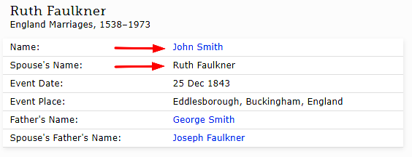

Finding her with her birth parents is a different story. Ruth’s maiden name was Faulkner and she and John were married on Christmas Day in 1943 at Edlesborough, Buckinghamshire. John’s father is George Smith and Ruth’s father is Joseph Faulkner. We found what appears to be Ruth’s family in the 1841 Census but we have no proof as yet. Joseph and his wife Charlotte with three daughters, Martha age 20-24, Ann age 15-20, and Hannah age 10. But there is no Ruth. She would have been about 18 or possibly 19 years old when this census was taken so it is possible she was a boarder or servant somewhere but we have not been able to find her as of yet. For right now we are considering this family hers.
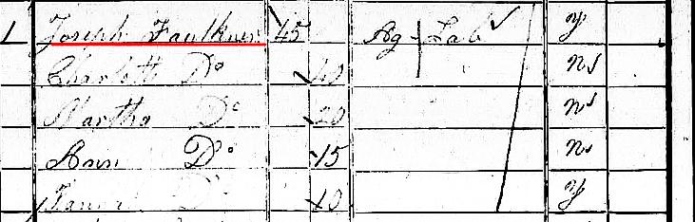

What about the three daughters of John and Ruth? Ann age 4, Martha age 3, and Hannah age 18 months. Can we find their records?
Craig Albiston just recently found the birth record for Ann and it is attached below:
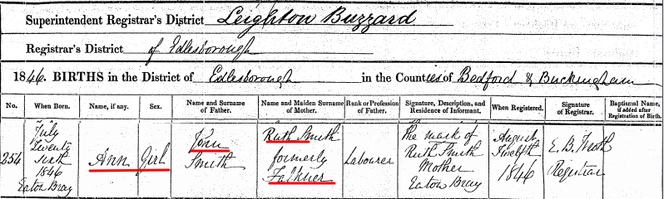

This is clearly our Ann and now we have her exact birth date of July 24, 1846 in Eaton Bray.
Ann grew up to marry Peter Champkin in 1865 and they had ten children together.
We were also able to locate the birth record of Martha, the next oldest daughter. She was born on October 15, 1848 in Eaton Bray. Ruth, too, only made her mark on these two birth records which likely meant she could not write. We have seen that most, if not all, of our Smith ancestors had no formal schooling in their youth.

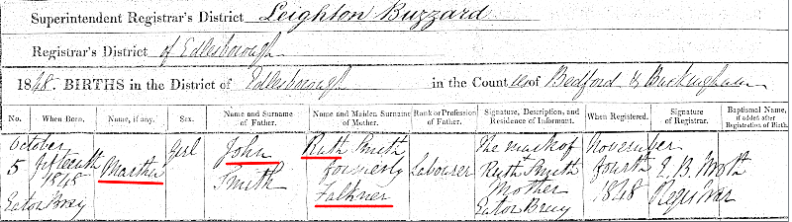

That only leaves us one birth record to find for this census period: the birth record of Hannah who was 1 month old on Mar 30, 1851 when the 1851 Census was taken. We have not been able to find a birth record or index for her birth. We will estimate her birth date as February 1851. The search continues for the actual birth record.

It is time to take a leap forward to the 1861 Census and see how things have changed.
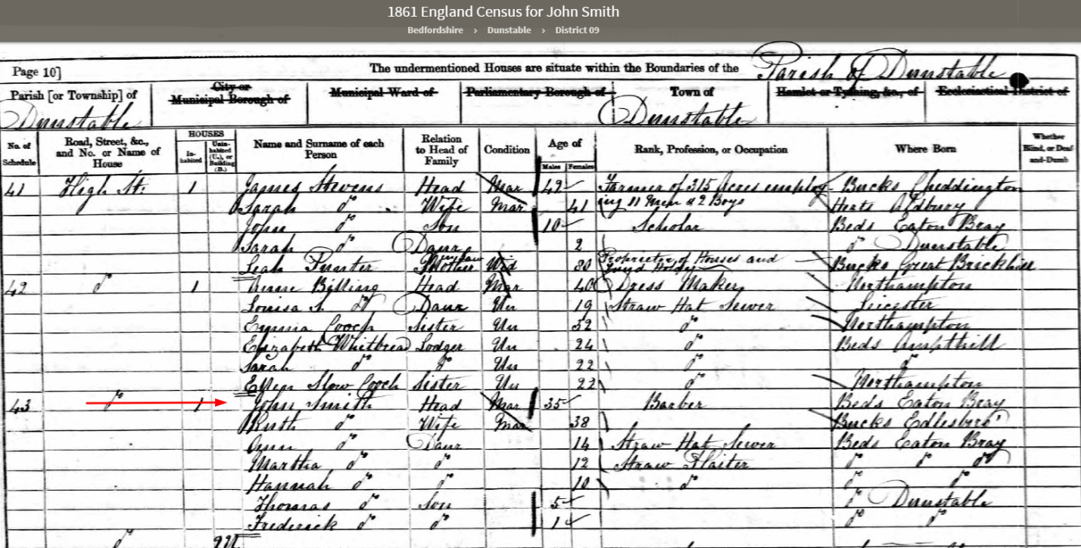
John and his family are living on High Street Dunstable which was about 3.5 miles from where they were living in Eaton Bray. His brother, Reuben and his family and his mother, Patience and sisters, Mary Ann and Esther are also living in Dunstable on West Street at this time. High Street and West Street intersect each other in Dunstable so they would have even been living very close to each other. Another observation is that John is now a Barber rather than a Straw Plaiter. Ruth is not listed as working and that may just be because she had a one year old boy to take care of. Or maybe barbering paid well enough that she did not have to work. Ann, Martha, and Hannah are all Straw Plaiters so that would have added some additional income for the family.
The Smiths have added two boys to their family since the previous census. Thomas is 5 years old and apparently was born in Dunstable as was the youngest, Frederick age 1.
Let’s see what kind of luck we have finding birth records for the boys. We have a birth record for Thomas and it is shown below:
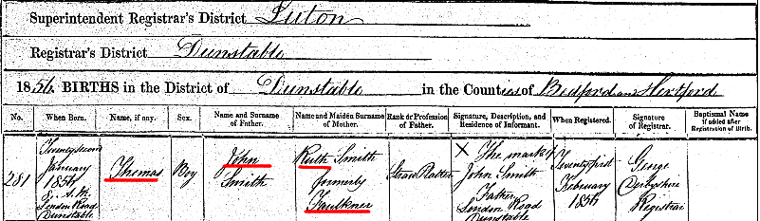
Thomas was born on January 22, 1856 at 8:00 am at home, I assume, on London Road, Dunstable. John Smith made his mark as the Informant (indicating that he too could not write).
Thomas married Jane Fensom on April 19, 1880. Their marriage record is shown here:

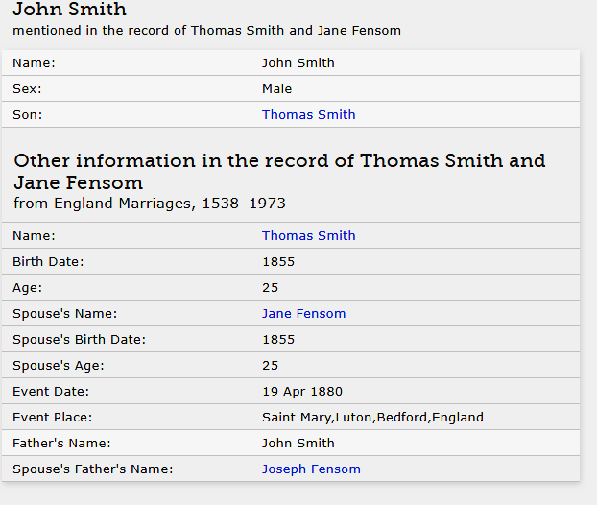
We were even able to find a newspaper notice of their marriage and I thought it would be fun to show.
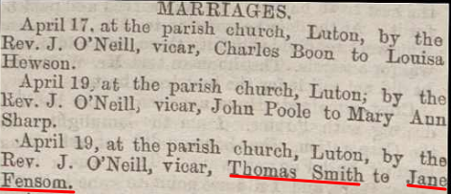

And son, Frederick’s birth record is shown here:

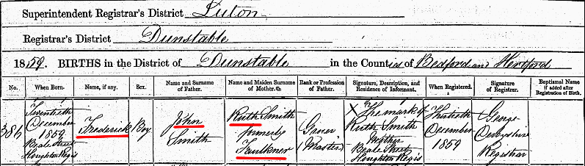
Frederick was born December 20, 1859 on Beale Street, Houghton Regis. Apparently the family had made a move sometime after brother Thomas was born in 1856. Houghton Regis is a small town and civil parish in Bedfordshire. This new location is only a mile or so from their previous address on London Street.
Through some great detective work on Craig Albiston’s part we have found that a daughter was born to John and Ruth prior to the birth of these two brothers. I say that this was great detective work since this daughter does not appear in any England Census. Below is the birth record of Sarah Smith.
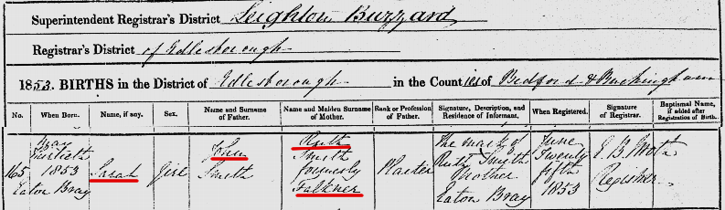

Daughter Sarah was born on May 30, 1853 in Eaton Bray and would not appear in the 1851 Census. Unfortunately, she does not appear in the 1861 Census either meaning she must have died before the census was taken on April 2, 1861. Sarah’s death record is shown below indicating that she died of Whooping Cough at the age of 22 months on March 22, 1855. Whooping cough was a major cause of death among young children at this time in England.
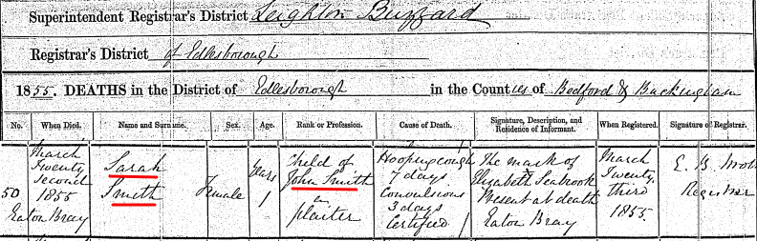
Finding Sarah’s death record also tells us also that the family did not move to Dunstable until sometime after her death in 1855 but before Thomas was born in Dunstable in January 1856. Sarah will be sealed to her parents at our temple sealing session during our August reunion.
Just as we are ready to move on to the 1871 census yet another child born to John and Ruth has been found. Below is the birth record on Emily, born just a couple of months after the 1861 census was taken.
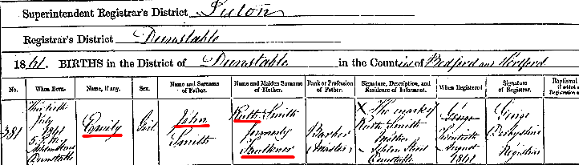
Emily was born at 5pm on July 13, 1861 on Ashton Street in Dunstable. I Googled Ashton Street in Dunstable and the only place that came up was St. Peters Church of England at Ashton Street. I suppose it is possible Emily was born there. It is only minutes away from their previous location on Beale Street.

We are ready now to look at the 1871 Census.

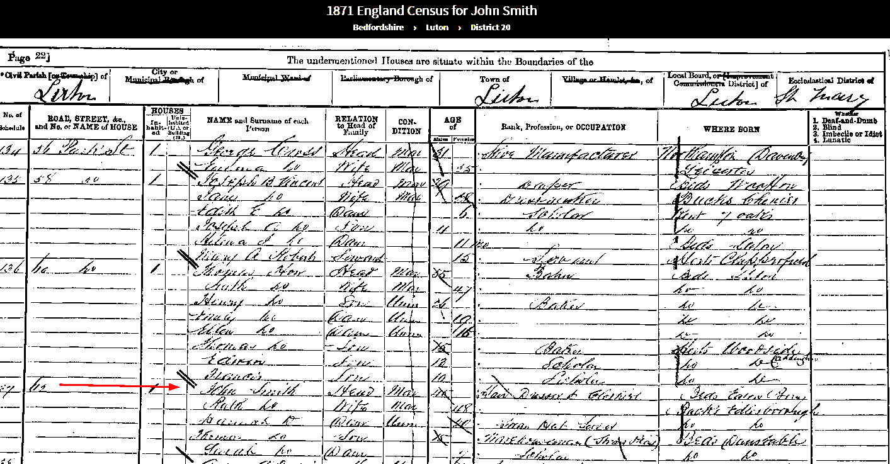
We notice that the family has moved once again. They are now living in Luton at 62 Park Street. This is a move of about 5 miles from their last known location on Beale Street in Dunstable. On a sad note, Emily who was born on July 13, 1861 is not in this census and must have died. Based on that information Emily’s death record was found and is shown below:
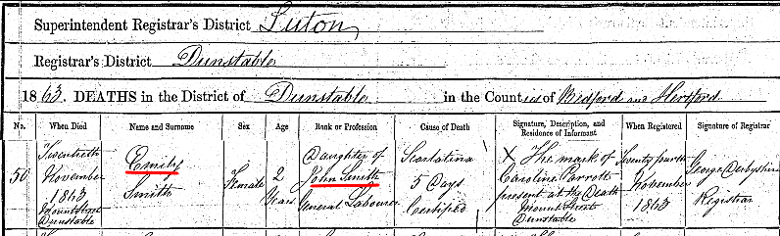
We don’t know why John’s occupation is listed as “General Laborer” rather than Barber or Hair Dresser as it was in the 1861 and 1871 Census’. We are also concerned about the death location on Mount Street. And who is Caroline Parrotts, present at the death? Since the cause of death was Scarlatina or Scarlet Fever it is possible she died in some type of isolation or “Fever Ward”. More research is necessary.
John’s son, Frederick died also during this time and his death record in shown here. Frederick also died of Scarlatina just two days after his sister, Emily died from the same “Fever”. Frederick was just 3 years old.
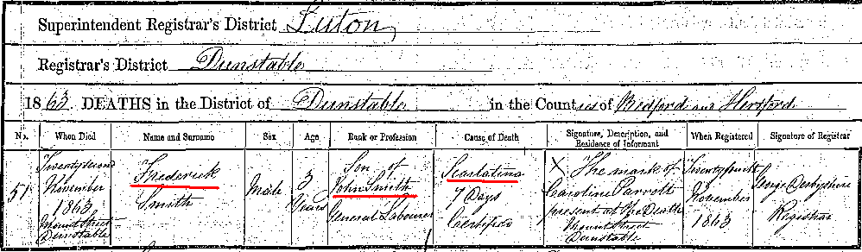
Frederick has been sealed to John and Ruth already. Emily has just been found so she will be sealed to her parents during our August reunion.
It is difficult to imagine losing two of your children just two days apart. Without penicillin to fight this very contagious fever many children died within 48 hours after showing symptoms of Scarlatina. As with sister Emily, Frederick died at the same location with the same Caroline Parrotts present at death. This appears to add credence that these children were at a hospital or fever ward at the time of their death.
In the 1871 Census John lists his occupation as Hair Dresser and Clothier. Daughters, Ann and Martha have moved out of the family home. We know that Ann is married but Martha is just missing and more work is required to find her. On a positive note, John and Ruth have an additional child, a girl, whom they have named Sarah (surely after their Sarah who had passed away). This practice of naming a new child after one of their children who had died was very common in this day and causes great challenges to genealogists both professional and novice.
So we have a new Sarah, age 7, added to the family. Based on that information we were able to find her birth record and now know that she was born on May 23, 1863 at Mount Street in Dunstable. Her record is shown below:
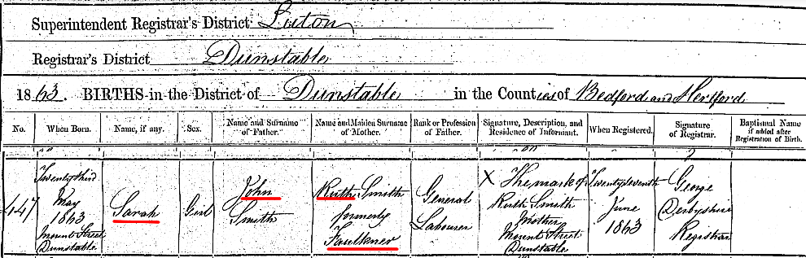
This “second” Sarah fared much better than her name sake sister. She married Walter Edward Whitby. They had three children the last of which died in 1976. It is very likely we can find some living relatives of John and Ruth through this line; A good subject for a future project.
Yet another child of John and Ruth was discovered while researching their family.
Arthur William Smith was born April 16, 1866 at their home on High Street in Dunstable.

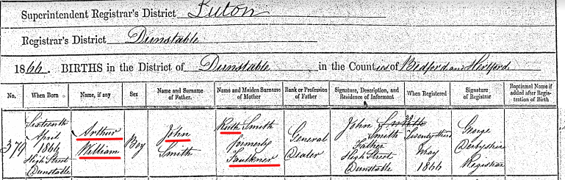

Arthur William died less than two years later on March 17, 1868 at Castle Street in Luton. The cause of death is listed as unknown. His sister, Martha is listed as witness to his death.

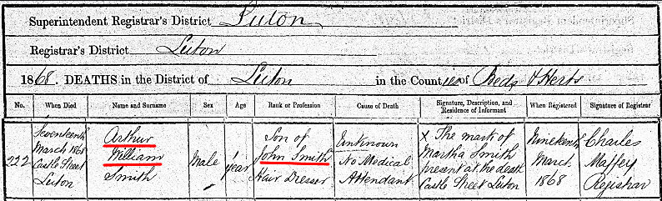

Let’s summarize the Children of John and Ruth:
Ann born July 20, 1846 Married Peter Champkin and had seven children
Martha born October 15, 1848 Lived to adulthood but is missing after 1871 census
Hannah born January 1850 Lived to adulthood but is missing after 1881 census
Sarah born May 30, 1853 Died March 22, 1855 at 22 months of age
Thomas born January 22, 1856 Married Jane Fensom and had three children
Frederick born December 20, 1859 Died November 22, 1863 at age 3
Emily born July 13, 1861 Died November 20, 1863 at age 2
Sarah born May 23, 1863 Married Walter E. Whitby and had three children
Arthur William born April 16, 1866 Died March 17, 1869 at age 23 months
Four of their nine children died under the age of 4 years.

John Smith died on May 27, 1884 in Luton. His wife, Ruth, was present at his death. His death record is shown below.
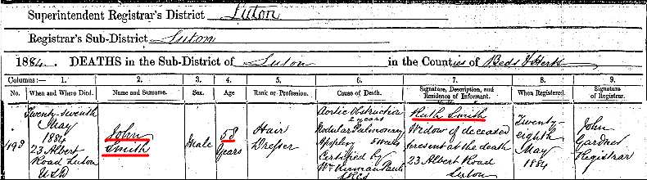

We also have the probate record and last will and testament for John’s estate leaving his personal estate of £88 to his wife Ruth. 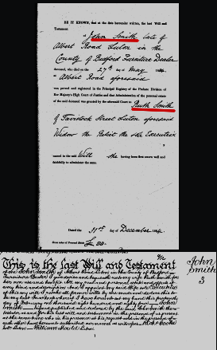
Like his brother Reuben, John died too young. He was only 58 years old. It was good Thomas X was able to visit with John and his family in 1881 and reconcile some of their differences.
In the 1901 and 1911 England census Ruth at age 78 and 88 is living with her daughter, Sarah Whitby in Luton.

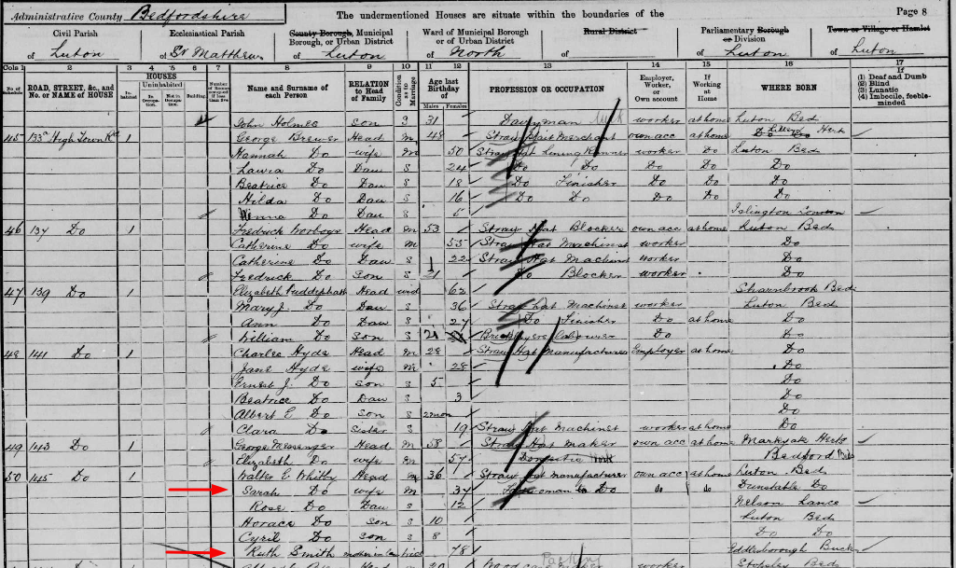

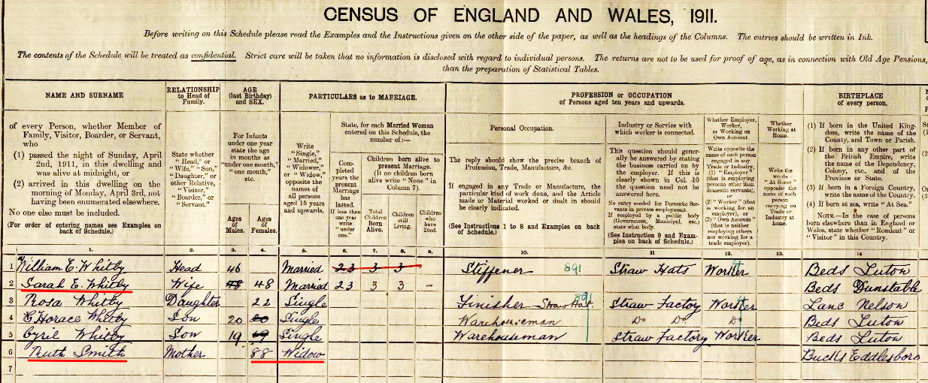
Ruth passed away on December 14, 1911 at the age of 88 as seen from her death record below.
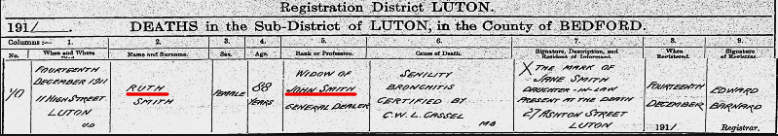

Like his brother Rueben, John never lived more than 5 or 6 miles from the place of his birth.

Thomas X
As I did with George W. I will only show the summary for Thomas X and his family as found in FamilySearch:
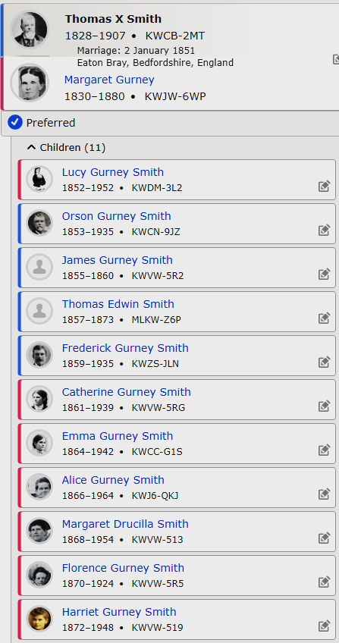

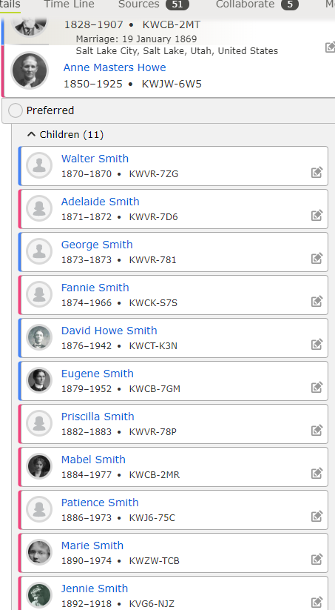

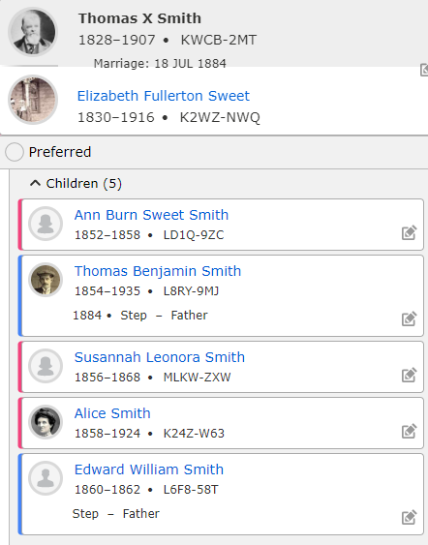

Mary Ann and Esther
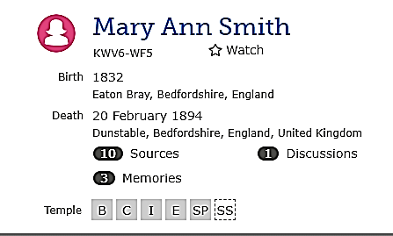

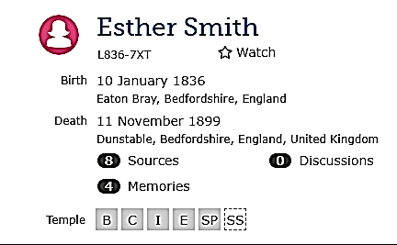
I am showing both Mary Ann and Esther together because they seemed to have done everything together throughout their entire life. We first see evidence of these two sisters in the 1841 England Census shown living with the parents, George Smith and Patience Timson.

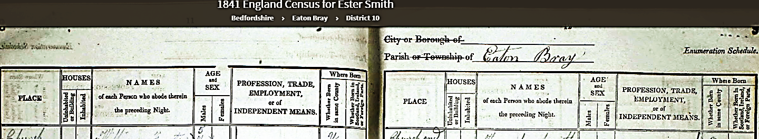
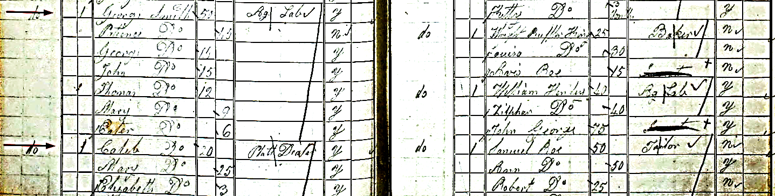
We have seen this census before but we are only interested in the two sisters, Mary listed as 9 years old and Ester (Esther) listed as 6 years old. We have not located birth records for either of these two so we have calculated, based on the 1851 Census, their birth years as 1832 for Mary and 1835 for Esther. Both were born in Eaton Bray.
We will jump 10 years to 1851 and look at that census.
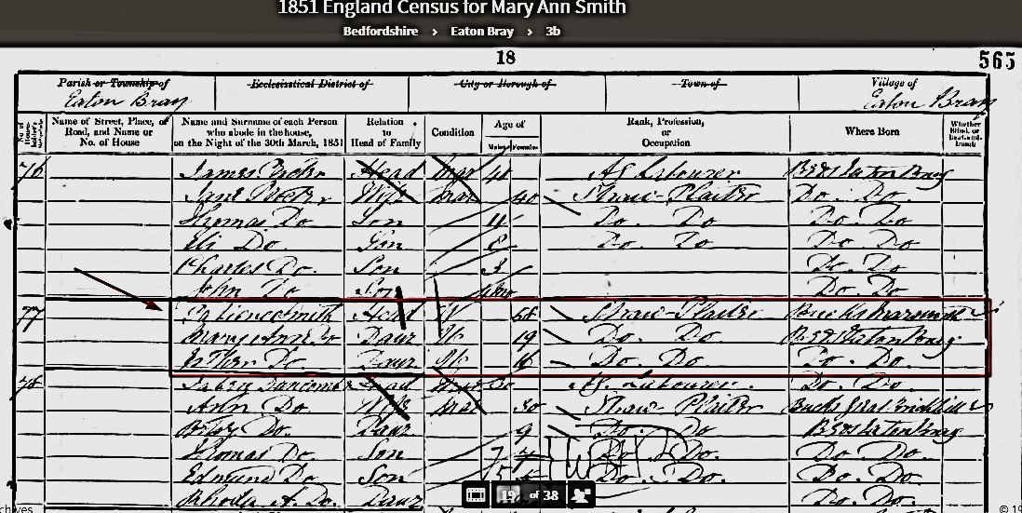
Both Mary Ann and Esther are shown living with their mother, Patience who is listed as a 58 year old widow. They are living in Eaton Bray presumably at the same location. Mary Ann is age 19 and is 59.
What has happened to George? Well, George passed away at a relatively young age even for this era in England. He was only 52 years old. Even George’s father, Edward, outlived him! Esther would have only been 8 or possibly 9 years old when George died. Mary Ann would have been 12 years old. Below is a Burial Index record for George showing his burial date as June 9, 1844. And he was buried in the Church yard of St. Mary The Virgin which was the Parish Church of Eaton Bray.

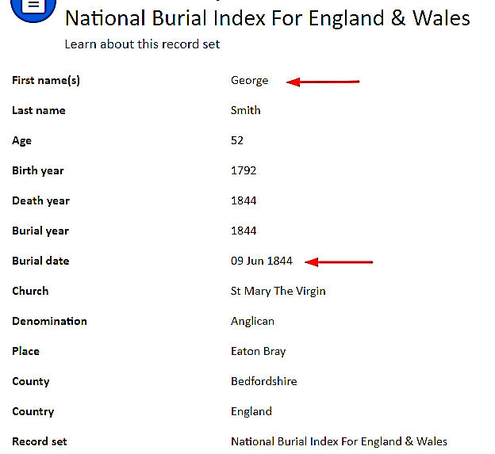

There is also a very complete Find A Grave record for George which is shown below and states that the death date was June 3, 1844.

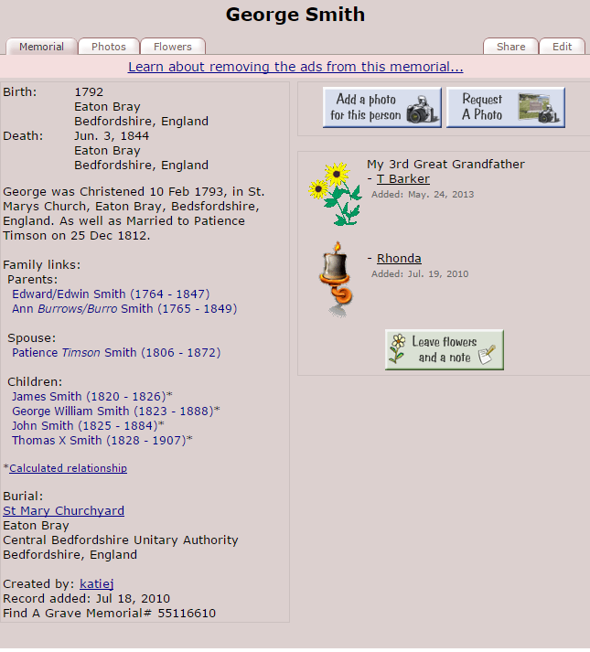

Let’s look at the 1861 Census and see if anything is different. As it turns out there are some things that have changed. Patience and her two unmarried daughters, Mary Ann and Esther are living in Dunstable. And as was pointed out earlier in this history they are living next door to Reuben and his family on West Street. I would like to think that Reuben convinced his mother and sisters to move into a home next to him so he could look in on them from time to time. Mary Ann and Esther are now bonnet sewers and were, no doubt, paid better than a straw plaiting.

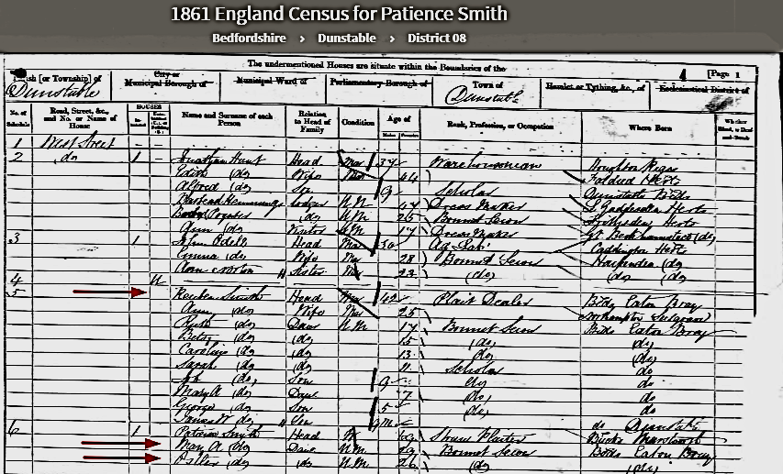

We will move on to the1871 Census where we find Mary Ann and Esther still living with their mother, now age 77 (shown but actually age 79) and listed as a School Mistress. Mary Ann and Esther are both still Bonnet Sewers and still unmarried. I addressed my belief that Patience was a School Mistress in charge of one of the many Plaiting Schools of the day. I don’t think she ever learned to write or ever attended any formal schooling herself. Any education they received was “self” education. However, she was a Master Straw Plaiter since she had been plaiting since before she was married in 1812. They are still on West Street in Dunstable but it is unclear if they are in the same home they were in 10 years earlier. Reuben and his family are not next door and, in fact, have moved to High Street a short distance away, likely less than a mile.
Since none of these siblings owned any real property in England they apparently tended to move around as they circumstances changed or the rent changed.
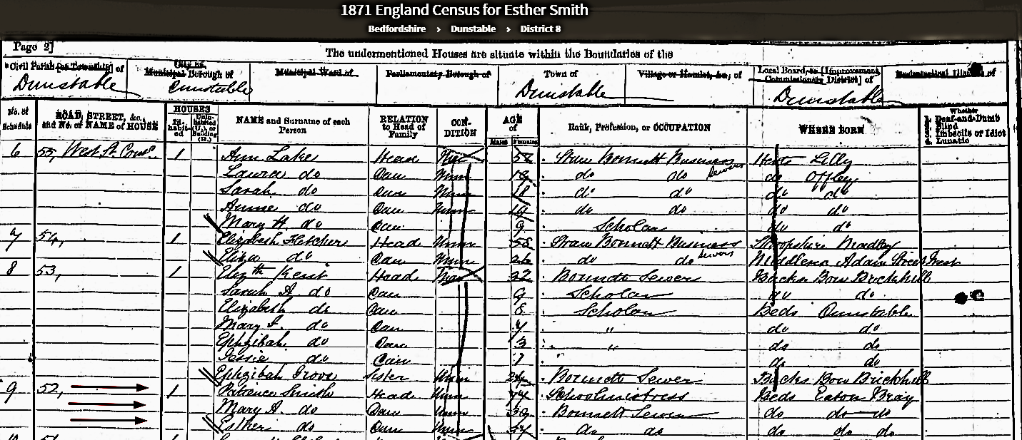

We are up to the 1881 Census and we find that Patience has passed away. The sisters are still living on West Street, no doubt in the same home. Mary Ann is listed as the Head of household and both sisters are still Bonnet Sewers. There is a new person in the home, however. Maud Smith is 5 years old and shown as a niece. She was, in fact the daughter of Reuben’s daughter, Sarah. Since Sarah was unmarried when Maud was born she (Maud) was sent to live with her great aunts. She is a story on her own for another time.

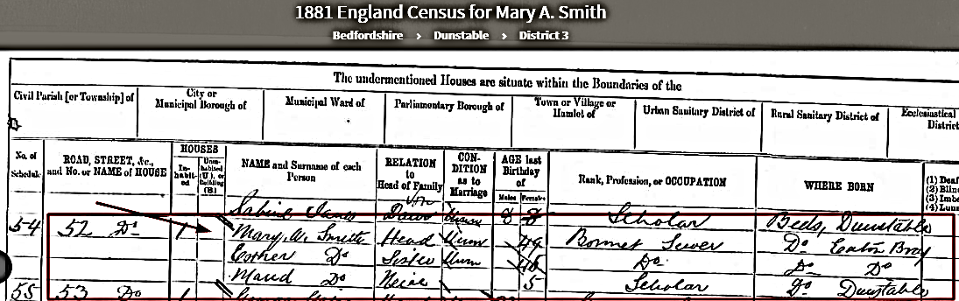

For completeness I show the death record of Patience Smith (nee Timson).

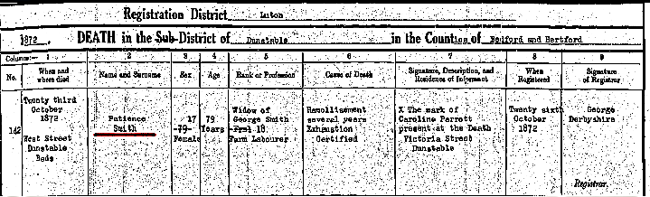
‘
She died on October 23, 1872 at the age of 79. She was still living on West Street in Dunstable. Her cause of death caught my interest since I had never heard of the word “Ramollisement” (Exhaustion I understand).
Here is what I found out about Ramollisement:
Softening of the Brain. Ramollisement.
INFLAMMATION of the brain, when it has run its course, sometimes leaves this organ, or portions of it, in a softened condition. The same mischief may happen to the brain from the blood vessels which run to it being diseased, so as not to be able to carry blood for its proper nourishment.

Symptoms.
The most remarkable symptom of this disease is the rigid contraction of the muscles which draw up the limbs; the hand may be clenched and pressed against the shoulder, or the heel carried up to the hip. The early symptoms are tingling, numbness in the ends of the fingers, perverted vision and sometimes blindness. The person usually tidy in habits and dress now becomes careless and slovenly. She occasionally complains of sleeplessness and the temper becomes irritable and friends notice that she takes offense when usually she would not notice. Her forgetfulness is very noticeable at times to the extent of forgetting her name and that of her family, later on the symptoms are similar to those which will be described under the heading "Dementia."

Since Patience was listed as a school mistress just 17 months before she died hopefully she was in the early stages of this disease and was simply worn out from 79 years of hard work.

We are nearing the end of this history of the siblings. Let’s move on to the1891 Census and see what we find.
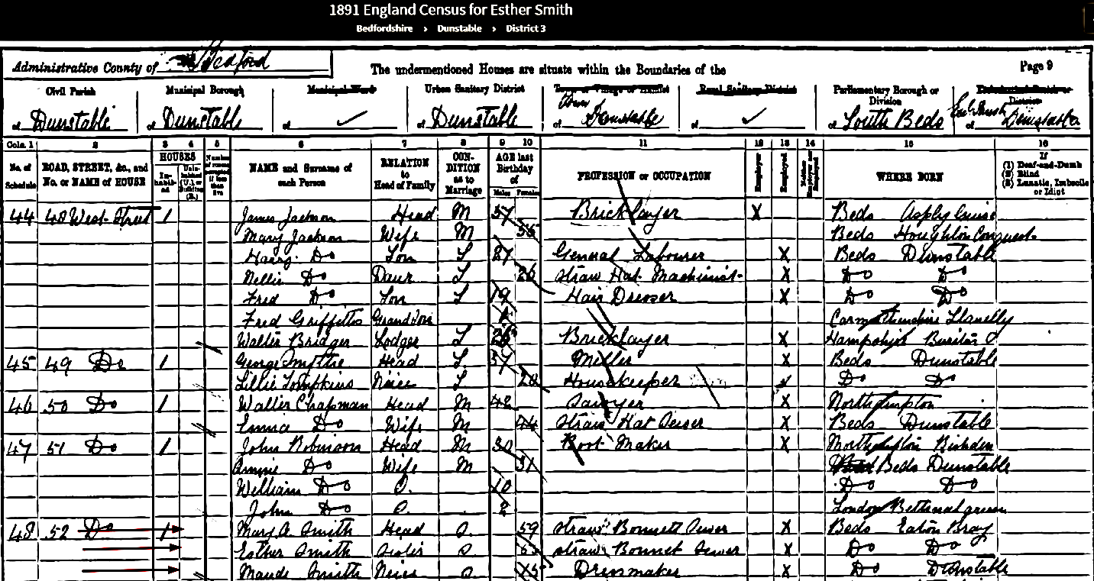
Not much has changed. Mary Ann (59) and Esther (56) are still living at 52 West Street and they are both still Straw Bonnet Sewers and still unmarried. Maud, at age 15 is now listed as a dress maker.
Unfortunately neither sister is found in the 1901 Census 10 years later. On February 20, 1894 Mary Ann passed away at the age of 62 of Cardio Failure. She was still living at 52 West Street in Dunstable when she died and her death is witnessed by her sister, Esther’s mark.

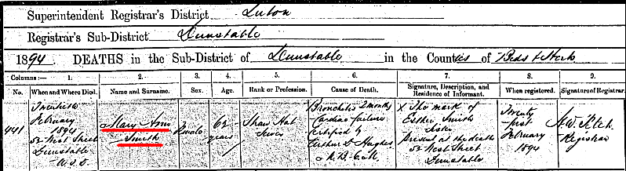

About 5 ½ years after her sister died, Esther passed away as well. Her death record is shown below:
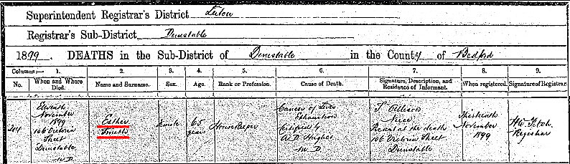

She died on November 11, 1899 from Cancer of the Liver. Her death is witnessed by her niece, S. Allison (that would be Sarah Allison, Maud’s mother and Reuben’s daughter). It is possible that Sarah was caring for Esther during her last days. Esther and her sister Mary Ann had, after all, taken care of Sarah’s daughter, Maud, since she was a young girl. It is also interesting to note that Sarah and her husband, Charles Allison, a married Maud (Maude Tomkins and her two children, Elsie Maude (2) and Cyril Frank (9 mos) are all living in the home of Esther and Mary Ann at 106 Victoria Street in Dunstable at the time of the 1901 Census.
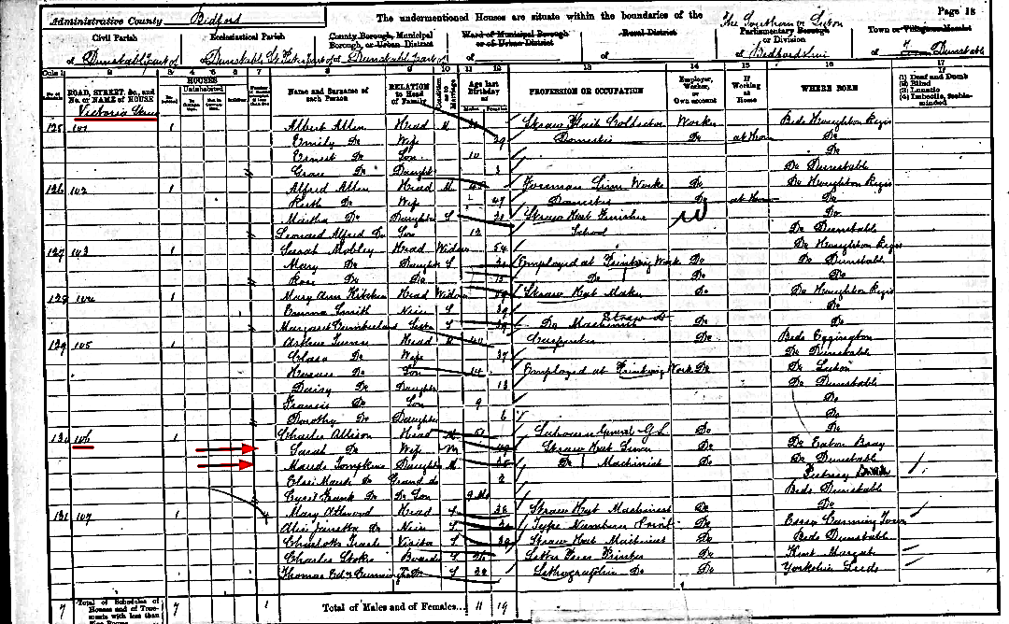

Noted contradictions
This research contradicts many of the earlier histories written about Thomas X and George W. Smith and their family. Histories vary depending on whom is telling the story so some contradictions already exist among histories already published. I’ll attempt to address some of those contradictions below:
- Thomas X and Margaret Gurney didn’t meet at a hat factory or straw plait factory. There were no such factories in or near Eaton Bray in the 1840’s
- Margaret Gurney was the first of our family members to join the Church but probably did not tell Thomas X she would not marry him unless he joined the Church. Thomas X was baptized on March 28, 1849 but they did not marry until almost two years later in January 2, 1851.
- Straw plaiting was not a professional occupation. It was a skilled labor and one that almost all of our ancestors in 1850 England were engaged in from an age of as young as four, in an attempt to keep food on the table.
- Almost none of our ancestors in 1850 knew how to read or write and had no formal schooling.
- Patience Timson Smith was not a School Mistress as we would think of the job. Patience never learned to write her own name and never attended a public school. She was almost certainly a School Mistress at a Straw Plaiting School that was prevalent in Eaton Bray in 1870. She was a straw Plaiter all her life and would have been well qualified to teach that skill to children.
- Our Ancestors were poor people barely eking out a living. Caleb was the only sibling who may have qualified as being somewhat well off in his later years. John’s estate amounted to 88£ at his death. Father Edward Smith was an agricultural laborer until the day he died working 10 hour days, 6 days a week well into his late 70’s. And he died as a Pauper.
- The Smith Family did not disown Thomas X or George W. when they joined the Church. I am sure there were heated discussions around the topic of Mormonism and it was felt that those joining the Church were being deceived, brain washed or mislead. In the 1851 census we find George W, Thomas X, living on the same street with their parents, and siblings. If feelings were terrible I am sure they would have moved apart. Thomas X visited all of his living relatives while on his mission in 1880-81. He stayed in their homes, ate their food, and slept in their beds. He expressed there were good feelings and they had discussions on the topic of religion and Mormonism even though they still did not want to have anything to do with the Church.

The Next Chapters in the Story
Certainly there is a great deal more to learn about the posterity of the siblings of Thomas X and George W. Smith. What a privilege it has been to play a part in locating so many family members and see them sealed to their parents and spouses. And we how have a priority list of sons and daughters, missing spouses, parents of spouses, and more who are waiting to be found. No doubt there will be opportunity for additional histories to be written and presentations to be given as we locate these missing family members.
Lastly, I want to give thanks again to Craig Albiston who was relentless in locating records documenting many of the family members mentioned in this history.

Appendix A: Chart showing siblings, wives, children and status of records documenting each
Person | Spouse | Child | Birth | Christening | Marriage | Death | Burial | Other | Posterity
Caleb |  |  | July 17, 1816 R | Nov 3, 1816 R | Oct 31, 1835 R | June 29, 1902 R |  | Age 85 at death | 5 Children
 | Mary Calentt R |  | 1817 Calc |  | Oct 31, 1835 R | Oct 14, 1866 R |  | Age 49 at death | 5 Children
 |  | James |  | Oct 10, 1836 RI |  | Qtr 4 1837 RI |  | Age 1 at death | NO
 |  | Elizabeth | Sept 4, 1837 R |  | Sept 24, 1863 R  William Hawkins | After 1912 she is mentioned in notice of Harry’s death |  |  | 3 children
 |  | George | Mar 20, 1842 R |  | Jan 7, 1871 R  Elizabeth Barrett | ? |  |  | 3 Children
 |  | Thomas | June 7, 1847 R |  | Sept 6, 1887 R  Alice Lovegrove | Oct 22, 1904 R |  |  | 2 children
 |  | Harry | 1853 Calc |  | 1885 Calc  Amelia ? | Aug 30, 1912 R
 | Caroline Culpin R |  | 1831 Calc | Mar 15, 1831 R | June 22, 1867 R | Abt. 1901 |  | ? | None found

R = Record found and attached in FamilySearch
RI = Record Index attached and references a record can be found using that index
Calc = No record attached. Used another record to calculate the date or event

Person | Spouse | Child | Birth | Christening | Marriage | Death | Burial | Other | Posterity
Reuben |  |  | Sept 6, 1818 R | Feb 5, 1826 R | See wives | Nov 7, 1875 R |  | Age 57 at death | 15 Children
 | Betsy Duncomb |  | 23 Aug, 1816 R | Mar 1, 1837 R | Aug 25, 1839 R | May 20, 1842 R |  | Age 26 at death | 1 child
 |  | Jabez | Nov 18, 1839 R | Nov 22, 1839 R |  | Aug 24, 1840 R |  | Age 9 mos at death | None
 | Harriet Cook |  | 1818 Calc |  | 20 Nov 1843 RI | Mar 16, 1859 R |  | Age 41 at death | 7 Children
 |  | Ruth | 2nd Qtr 1844 RI |  | Oct 9, 1877 R  William T Fox | Apr 20, 1924 R |  | Age 78 at death | 4 Children
 |  | Betsy | 1846 Calc | Jul 30, 1848 R | ? | ? |  | ? | ?
 |  | Caroline | Dec 27, 1847 R | Jul 30, 1848 R |  | Dec 1864 RI |  | Age 17 at death | None
 |  | Sarah | Nov 23, 1849 R |  | Oct 27, 1884 R Charles Allison | Sept 29, 1925 R |  | Age 74 at death | 1 Child
 |  | Job | Nov 13, 1851 R | Apr 14, 1857 R |  | Dec 28, 1862 R |  | Age 11 at death | None
 |  | Mary Ann | Dec 4, 1853 R | Apr 14, 1857 R | ? | ? |  | ? | ?
 |  | George | Apr 4, 1856 | Apr 14, 1857 R | Jan 1, 1878 R  Eliza Green | Before 1910 |  |  | 9  Children
 | Ann Lambdon |  | 1836 Calc | Apr 3, 1836 R | Feb 6 1860 RI | Apr 12, 1921 R |  |  | 7 Children
 |  | James William | Jun 26, 1860 R |  | Abt 1893 Calc Elizabeth Smith | ? Before 1911 Census |  |  | 3 Children
 |  | Anne Maria | Jun 23, 1862 R |  | Feb 19, 1882 R Harry G. Powell | ? |  | Alive in 1911 | 2 Children
 |  | Harriet | Apr 7, 1865 R |  | Spinster | Jan 21, 1945 R |  | Age 79 at death | None
 |  | Thomas | Mar 23, 1867 R |  |  | Mar 25, 1867 R |  | 2 days | None
 |  | Charlotte | Jul 3, 1868 R |  | Nov 23, 1911 R Robert B Kurth | Aug 11, 1944 R |  | Age 76 at death | None
 |  | Jane | Jan 12, 1871 R |  |  | Mar 21, 1873 R |  | Age 2 at death | None
 |  | Harry | Sept 30, 1873 R |  | Dec 4, 1898 R  Florence Annie Hukins | Apr 11, 1956 R |  | Age 82 at death | None

Person | Spouse | Child | Birth | Christening | Marriage | Death | Burial | Other | Posterity
John |  |  | Nov 25, 1825 R | Feb 6, 1826 R | Dec 25, 1843 R | 27 May 1884 R |  | Age 58 at death | 9 children
 | Ruth Faulkner |  | 1822 Calc |  | Dec 25, 1843 R | Dec 14, 1911 R John Smith |  | Age 88 at death | 9 children
 |  | Ann | July 20, 1846 R |  | 1865 RI  Peter Champkin |  |  |  | 10 children
 |  | Martha | Oct 15, 1848 R |  |  |  |  |  | ?
 |  | Hannah | Jan 1850 Calc |  |  |  |  |  | ?
 |  | Sarah | May 30, 1853 R |  |  | Mar 22, 1855 R |  | Age 22 months at death | None
 |  | Thomas | Jan 22, 1856 R |  | Apr 19, 1880 R  Jane Fensom | After 1911 |  |  | 3 children
 |  | Frederick | Dec 20, 1859 R |  |  | Nov 22, 1863 |  | Age 3 at death | None
 |  | Emily | July 13, 1861 R |  |  | Nov 20, 1863 |  | Age 2 at death | None
 |  | Sarah | May 23, 1863 R |  | June 12, 1888 RI Walter E Whitby | Dec 1930 RI |  | Age 67 at death | 3 children
 |  | Arthur William | Apr 16, 1866 R |  |  | Mar 17, 1868 R |  |  | None
Mary Ann | None |  | 1832 Calc |  |  | Feb 20, 1894 R |  | Spinster age 62 at death | None
Esther | None |  | Jan 10, 1836 |  |  | Nov 11, 1899 R |  | Spinster age 63 at death | None

Appendix B: List of issues to resolve or Missing Records
- Caleb’s George (G9MC-9PX) b. 20 March 1842 is missing after the 1851 Census. Dead? Married? Military? USA? RESOLVED and updated George married Elizabeth Barrett and they had three children together.
- Caleb’s first wife, Mary Calentt, Calcott, Corket (21JN-NKJ) b. 1817 Calculated. Why can’t we find her parents under any of these spellings? No record of her birth or Christening under those names. She is Calentt on the marriage record and Corket on the birth record of two of her children.
- Caleb’s Henry (9XB2-Q4L) b. 1853 Calculated from 1861 census. No birth record found. Where is he since he is in the 1861 Census. Is he a Butcher Journeyman in an 1871 Census currently attached to him as a source?
- Caleb’s Henry (9XB2-Q4L) his wife, Amelia Smith (GMBM-HPW) no maiden name. She was 43 when she married Henry. Did she have a previous marriage? Children by a previous marriage. What is her maiden name?
- Caleb’s second wife, Caroline (9HBF-2HG) b. 1831 Calculated from Baptismal record. Found her and Caleb living separately in 1891 Census. Both say they are married and she is visiting a friend (Census attached). In 1901 Caroline may be seen visiting a friend still married but Caleb in back in Eaton Bray living alone and says he is a widow. I wonder if they separated late in life. Can we find a death record for Caroline?
- Reuben’s daughter Betsy (LHB1-Z73) b. 1846 Calculated. Where does she go after the 1851, 1861, and 1871 Census? She is 25 living at home working as a “Hat Sewer” and then we lose track of her. Did she marry and have a family?
- Reuben’s daughter Caroline (K42G-RMV) Did she die in Dec 1864? The attached source from Linda Harker suggests a GRO record of about Dec 1864. Can we get her death record for verification and cause of death.
- Reuben’s daughter Mary Ann (27SV-L6Z) b. 4 December, 1853 Like Betsy she disappears after the 1871 Census where she is 17 and a “Hat Sewer”. At one time FamilySearch had her married to a Jeffrey Archer but there is a collaboration note that is adamant she was the wrong Mary Ann. So where is Reuben’s Mary Ann? Married? Family?
- Reuben’s son George (L71X-2GB) b. 4 April 1856 married Eliza Green (LZFR-24X) on January 1, 1878. According to the 1911 Census she is remarried to a John Else but she indicates she had 9 children, 7 living and 2 dead. These are all children of George. I have found 8 but am missing one. George dies sometime after the birth of his last child in 1895 and 1901 because Eliza says she has been married to John for 10 years in 1911. Can we find a death record for George? And his missing Child! RESOVLED missing child. Found a twin of William named Arthur. He only lived four months. Reuben named his next born son Arthur as well.
- Reuben’s son James William (LHB1-83M) b. 26 June 1860 married Elizabeth Smith (no Maiden Name) about 1893 Calculated. They had three children. Can we find a maiden name for Elizabeth? A marriage record? A death record for James William and Elizabeth?
- Reuben’s son Harry (9XYY-NP6) b. 30 September 1873 Harry married Florence Annie Hukins on December 4, 1898 and they are together in 1939 based on the 1939 Register. They could have had children but in the 1911 census, after 12 years of marriage they did not. Harry died sometime after 1939 but before 1964 when Annie’s estate was probated. Can we find a death record for Harry?
- John’s daughter, Martha (KC44-V2P) b. 15 October 1848. Martha is at home in the 1851 and 1861 census and she appears to be a boarder living with the Scott family in 1871 at the age of 22 as a “Hat Finisher” then what happened to her? Marriage? Children? Death?
- John’s daughter, Hannah (KCC5-27M) b. February 1851 Calculated. Hannah is at home in 1851, 1861 and 1871. The 1871 Census says she is 20, unmarried and a “Straw Hat Sewer”. Where did she go from there? Marriage? Children? Death?
- John’s son, Thomas (LHJ1-45W) b. 22 January 1856 marries Jane Fensom on April 19, 1880. According to the 1911 Census Jane had three children, one alive, and two dead. Their son Thomas is living with John and Jane in 1911, 27 years old and single. Where are the two deceased children? Need birth and death records for them. I have added two “Smith” children to FamilySearch as holders for them. We don’t have death records for either Thomas or Jane.
- Sibling Mary Ann (KMV6-WF5) b. 1832 Calculated. Why can’t we find a birth record for her to get an exact birth date?
- Sibling Esther (L836-7XT) b. 10 January 1836. There is no record of her birth and yet there is a specific birth date for her. Is it a legitimate date? And can we find a birth record for her?
- The last item deals with the history from Thomas X daughter, Lucy Smith Cardon, who writes that He, Thomas X, was the seventh son in the family of nine born to George smith and Patience Timpson. Did George and Patience have a ninth child, a seventh son? There is 3 years 7 months between the time they were married and the birth of Caleb. Only 2 years 2 months separate the births of Caleb and Reuben. There is only 2 years 3 months between Rueben and James and 2 years 5 months between James and George W. And only 2 years 7 months between George W. and John. There is 3 years 1 month between John and Thomas X. We don’t need to go any further than that since the last two girls and TX was said to be the seventh son. We really only have two possibilities; they either had a child that died before Caleb or they had one that died between John and TX. The best possibility being that George and Patience first child died. In those days three years and seven months is a long time for a first child if you are going to have any at all. Can we find another child?
.

Appendix C: Map and narrative showing where each of the siblings lived when the 1841, 1851, and 1861 Census’ were taken.

The Census taken in Eaton Bray in the years mentioned was taken by the enumerator starting at the Southeast end of the manor near Edlesborough Gate and working his way Northwesterly along Summerhays, Moor End, High Street, Church End, The Comp, Great Green and the Rye. He would pick up dwellings on the few side streets along the way. The enumerator would do this for the homes on the Eastern side of the roads and then start over at the beginning and do the same on the Western side of the same roads. Depending on who the enumerator was the street names were either omitted or were written down in a “Hit and Miss” fashion. They were just visiting every dwelling on the Eastern and Western side of the main thoroughfare. There were no addresses as we might know them. Dwellings were just counted starting with #1 closest to Edlesborough and ending in the Rye to the upper Northeast.
The hand drawn map I show on the following page attempts to show where our Smith’s and others were in relationship with one another on the street where they were living. In 1841 they were all living on Church End on the Eastern side of that road. In 1851 they had all moved to Moor End and living on both side of that road. By the 1861 Census Thomas X and George W. and their families were living in Utah and William Wootton and most of his family were crossing the plains to Utah. Patience and her two unmarried daughters had moved to Dunstable where they remained the rest of their life. Reuben and John had also moved to Dunstable. Caleb had moved also but was still in Eaton Bray near The Comp. Remembering that there was little or no home ownership in the Manors it was not a major event for families to move from one cottage to another as yearly leases were completed. I am sure they had very few personal possessions to move.
I give a little more detail about their living situation by each Census period after reviewing the map. Referring to the map, names in Green represent where they lived in 1841. Black represents 1851, and Blue represents 1861 locations.

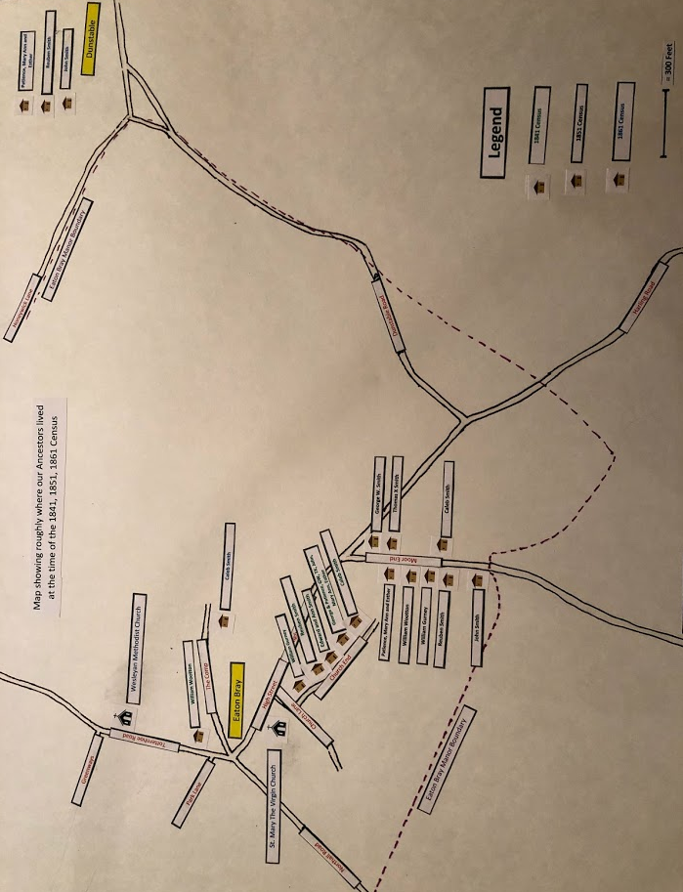
1841 Census:
In the 1841 Census George Smith and his wife, Patience, and the unmarried children, George W, Thomas X, John, Mary Ann and Esther are living together in a single dwelling. Caleb and Reuben are living with their young Families in separate dwellings as are George’s parents, Edward Smith and Ann. Thomas X’s future Father in Law, William Gurney is also living close by. All of these dwellings are on Church End Street in Eaton Bray.
William Gurney family were in dwelling # 47
Reuben and family were in dwelling # 52
Edward Smith and wife were in dwelling # 54
George Smith and family were in dwelling # 60
Caleb Smith and family were in dwelling # 61
You can see that all of the Smith families are living within 9 dwellings of each other on this short dead end street, named Church End.

1851 Census:
In the 1851 Census George W, Thomas X, and John have all married and are living separately. George Smith has died and Patience, Mary Ann and Esther are living together in one dwelling. Edward and Ann Smith have also passed away. Everyone including William Gurney and William Wootton (George W.s Father in Law) are living on Moor End.
By the way, there were a total of 153 dwellings on the Eastern side of Eaton Bray housing 352 males and 385 females for a total of 737 persons. There were 146 dwellings on the West side of Eaton Bray with 349 males and 369 females for a total of 718. Thus the total population of Eaton Bray in 1851 was 1455 persons.
John Smith and family lived on the West side in dwelling # 19
Caleb Smith and family lived on the East side in dwelling # 55
Reuben Smith and family lived on the West side in dwelling # 59
William Gurney and family lived on the East side in dwelling # 60
William Wootton and family lived on the East side in dwelling # 64
Patience, Mary Ann and Esther lived on the West side in dwelling # 77
Thomas X and family lived on the East side in dwelling # 77
George W. and family lived on the East side in dwelling #83
You can see they are a little more spread out but still very much together on a single street!
1861 Census:
In the 1861 Census things have change quite a bit. Thomas X and George W. and their families are living in Utah and William Gurney and the younger members of his family are about to cross the plains into Utah as well. Reuben and his family, John and his family and Patience, Mary Ann and Esther have all moved to Dunstable. Caleb has moved to the Eastern End of Eaton Bray where he is a Straw Plait Dealer.
Dunstable is a much bigger town than the village of Eaton Bray and was a hot bed of the Straw Hat industry. Reuben was a Straw Plait Dealer, Patience was still a Plaiter but Mary Ann and Esther were Bonnet Sewers by this time. Perhaps the larger town provided more opportunity for them. John was a barber and certainly would have benefited from a larger population.
1

