Their Journey of Faith
Liverpool to the Great Salt Lake Valley

Thomas X and George W. Smith and Family
Compiled by George W. Smith’s Great Grandson
Brent N. Smith
2022

Their Journey of Faith
Liverpool to the Great Salt Lake Valley

Thomas X and George W. Smith and Family

Compiled by his great grandson – Brent N. Smith
2022

The primary purpose of this history is to enlighten and strengthen the lives of the descendants of these two great men, Thomas X and George W. Smith, their wives and children. The contents have come from multiple resources including photographs in the possession of the Smith Family and stories both written and oral from Smith Family members. I have drawn upon several well documented histories of 1850’s England, the immigration
of LDS Saints from England to Utah via sailing vessel, Steam ship, wagon train, and on foot. Opinions, assumptions, and commentary are those of the author alone. If there are errors and or omissions please bring them to my attention. This is a work in process and more information will surely come to light in this digital age.
I relied heavily upon two exceptional works which I will mention upfront. The first is the journal of James Jack. He was called to be the Secretary of the Church Organization established aboard the Falcon (the ship Thomas and family sailed on to New Orleans) prior to its departure. His journal is a treasured resource for researchers and family members alike. His entries were detailed and insightful. Not only did he document the voyage of the Falcon but he continued on with his duties as Secretary of this company from New Orleans until their arrival in the Great Salt Lake Valley. His journal will be quoted often in this work. Appendix A contains his complete journal from Liverpool to Salt Lake. I have been dismayed not to be able to find out much more about James Jack. He deserves to be brought into the light and honored for his service as the Secretary of this Company of Saints. More research is needed.
The second most valuable resource comes from the English artist, Frederick Piercy, a convert to the Church in England. He was given the opportunity to travel to America and come across the plains and document his travels with commentary and sketches along his way. His excellent work is the focus of a book entitled, “Route from Liverpool to Great Salt Lake Valley”. This book was edited by James Linforth and published by Franklin D. Richards in Liverpool in 1855. I show several of his sketches in this work. They
are a true treasures. I found his commentary not only informational but a joy to read. I have attached much of his book as Appendix E to this work.

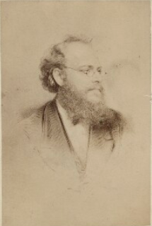
I found this photograph of Frederick Piercy. He was born in Hampshire, England in 1830. He join the Church in 1848.

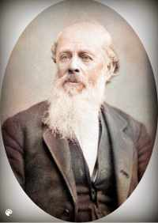
Colorized Photograph of George William Smith. The original photographs came from the Daughters of the Utah Pioneers Museum. No date given but likely around 1880 at age 57

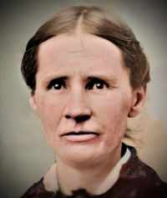
Colorized photograph of Catherine Wootton Smith. No information as to the origin or date of this photograph. Catherine died in 1883 at the age of 55 years so it is possible her photo was taken at the same time as George. This is the only know photograph of Catherine Wootton Smith.

Their photographs were colorized by MyHeritage.com.

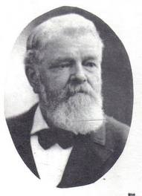

As with the photographs of George and Catherine there is no information regarding the date of these photographs of Thomas X Smith and his wife, Margaret Gurney.

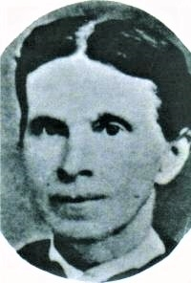

Like Catherine, Margaret also died young at the age of 50 years. Photos were perhaps taken around 1870 when Margaret was 40 and Thomas would have been 42 years of age. This is the only known photograph of Margaret Gurney Smith

Table of Contents
Our Smiths in England 7
Getting from Eaton Bray to Liverpool 19
Crossing the Atlantic - Liverpool to New Orleans 28
Sea Sickness, Disease, and Deaths 48
Some tragedies: 49
Some Miracles 50
Charles Dickens Visits an Emigrant Ship 52
The Voyage of the Ship “Falcon” (Thomas and Family) 53
A Compilation of General Voyage Notes 53
New Orleans to St. Louis and on to Keokuk (Thomas and Family) 61
Staging sites for overland travel 73
What do we know about Keokuk, Iowa? 76
A Side Trip to Nauvoo 81
Outfitting 85
Crossing the Plains (Thomas and family) 89
Appleton M. Harmon Company 89
Summary of Thomas and Family’s Journey to Utah 99
The Odometer or Roadometer 100
Voyage aboard the Clara Wheeler (George W. and Family) 103
New Orleans to St. Louis (George and Family) 110
George and Family in Limbo 113
Mormon Grove (Atchison, Kansas) 1855 Departure Point 114
George Borrows from the P.E.F. after all! 116
George and Family finally leave for the Great Salt Lake Valley 120
Milo Andrus Company 120
Summary of George and Family’s Journey to Utah 134
Appendix A James Jack’s Account of the Falcon and CORNELIUS Bagnall Emigrating Company 135
Appendix B Autobiography of Peter McIntyre 177
Appendix C The Milo Andrus Company 188
Appendix D Mode of Conducting the Emigration 195
Appendix E Excerpts from the Book “ Route from Liverpool to the Great Salt Lake Valley Edited by 203
Appendix F Photographs, Sketches, and other stuff 308

Our Smiths in England

George W. and his younger brother, Thomas X grew up in Eaton Bray, England. They were two of eight children of George Smith and Patience Timson Smith. I note that “W” stands for William while Thomas’s X does not stand for anything. At some point in his life (apparently after he arrived in Utah) he added the X to differentiate him from all the other Thomas Smiths in the world.
The parents, George and Patience, were married in Eaton Bray on Christmas day in 1812. They lived their entire lives in Eaton Bray and were buried in Eaton Bray. The remainder of the Smith children never ventured more than a few miles from their birthplace.
Some early background is in order. Eaton Bray, England was in the 1800’s, and is today, to some extent, a small rural village whose boundaries are mostly made by streams.
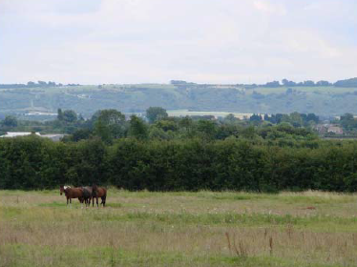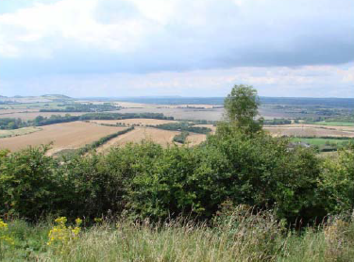
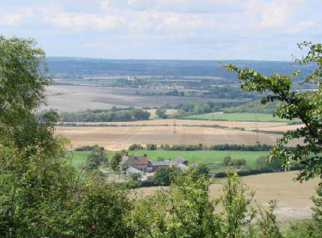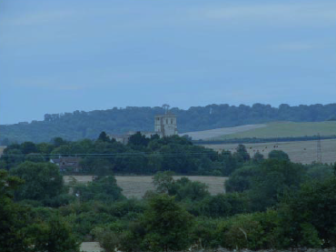
From these four more recent photographs we can see that Eaton Bray is still quite pastoral and seeing what a beautiful place it appears to be today it might make you wonder why Thomas X and his wife, Margaret Gurney Smith and daughter, Lucy left Eaton in 1853 and his brother George W. Smith and his wife, Catherine Wootton and their two young daughters, Sabrina and Jane left a year later. I say that and yet we know why they did; the Holy Ghost converted them to the Gospel of Jesus Christ and they followed the council of their new Church’s leaders and came to America to join the Saints in “Zion”. It must also be noted that America also held the promise of land ownership and independence, something our Smith’s did not have nor would they have had if they stayed in England.
George W. Smith married Catherine Wootton on December 21, 1845 in Eaton Bray. It should be pointed out that the name “Wootton” was often spelled “Wootten” and even “Wooten” in the records we have researched. However, there is a village close to where our Smiths lived called and spelled “Wootton”. I will use the Wootton spelling throughout this text. Catherine was just 17 when she married the 22 year old George W. By the way, George’s full name, as stated earlier, was George William Smith but most all records just referred to him as George W. or Geo. W. I’ll use George W. throughout this text. Their first child, Sabrina (also sometimes spelled Sobrina) was born April 29, 1847 in Eaton Bray.
Thomas X married Margaret Gurney on January 2, 1851. Thomas was 22 and Margaret was 20 years of age.
For completeness below is shown the entire George and Patience Smith family as shown in Family Search:

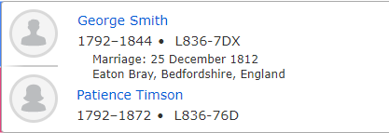
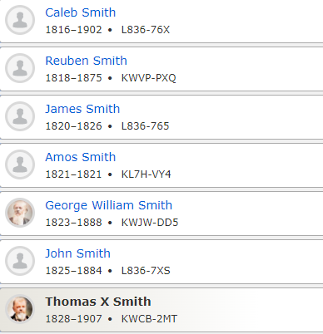
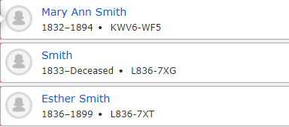
There is no evidence, that we have found, that there was another Smith child between Mary Ann and Esther. Neither is there any sources that document Amos Smith as a child of our George and Patience.
There was a great missionary effort by the Church of Jesus Christ of Latter Day Saints underway in the British Isles at this time. The first seven Church of Jesus Christ missionaries landed in Liverpool, England on July 19, 1837. In less than two years there were more than 1500 converts as a result of their missionary efforts. By 1851 there were 24,199 LDS converts in England. We know that George and Catherine received the missionaries and joined the Church in 1848. George W. was baptized on October 29, 1848. Catherine was baptized on December 15, 1848 after recovering from the birth to their second child, Jane, born October 04, 1848. They were both baptized by Elder John Mead. George’s younger brother, Thomas X Smith joined the Church a few months later being baptized April 17, 1849. Thomas’s future wife, Margaret Gurney, had joined the Church six months earlier on October 08, 1848. George W.’s older brother, Reuben, was baptized May 16, 1849 but his wife, Betsy Duncomb, did not join nor did they immigrate to America. There is no evidence Reuben remained or ever was active in the Church. None of the remainder of the George and Patience Smith family joined the Church.
Throughout these early years of missionary work in England there was great opposition to the movement. Other Churches openly preached against the “Mormons”. Those individuals that joined the LDS Church were often “disowned” by friends and family alike. It has been mentioned in some of our other “Smith” histories that the remaining members of the George William Smith family had little or nothing more to do with those that accepted the Gospel. I am more of the opinion that George and Thomas were thought to be a little crazy or had even been duped to join the Church and even crazier when they made the decision to leave England. Thomas X served a mission in England many years later and his journal records that he had several friendly meeting with his siblings during that mission but had no success convincing them of the truthfulness of the Gospel. On the other hand, all of Catherine Wootton’s family joined the Church around the same time as Catherine did. In fact, her father and mother, William Wootton and Deborah Roe, were baptized the same day as George W., October 29, 1848. It would be interesting to know the nature of the missionary effort going on at this time in Eaton Bray. Who influenced who? Did the Woottons influence the Smiths and Gurneys? Or was it the Gurneys that influenced the others. The Smiths and the Woottons were related through marriage at this time and the Gurneys would be also a few years later. These three families lived very close to each other. Most of the Smiths, Woottons and Gurneys were straw plaiters and worked out of their homes in close proximity to one another. We are just happy they were influenced by the missionaries and the Holy Ghost and joined the Church of Jesus Christ when they did. Another of our histories state that Margaret said she would not marry Thomas unless he joined the Church. I am not sure how true that is since they weren’t married until almost two years after he joined the Church.
Shortly after the restored Church of Jesus Christ was officially established, the Prophet Joseph Smith received a revelation that focused on the doctrine of gathering Israel in modern times: “And ye are called to bring to pass the gathering of mine elect; for mine elect hear my voice and harden not their hearts; wherefore the decree hath gone forth from the Father that they shall be gathered in unto one place upon the face of this land, to prepare their hearts and be prepared in all things against the day when tribulation and desolation are sent forth upon the wicked” (D&C 29:7–8). This exodus of Saints from “Babylon” was considered as important as the Israelites exodus out of Egypt. The Saints were to gather in Zion in preparation for the “Last Days”.
Thus, Church encouraged their converts to immigrate to America and strengthen the main body of the Church in Utah. In 1852, the First Presidency issued the following counsel: “When a people, or individuals, hear the Gospel, obey its first principles, are baptized for the remission of sins, and receive the Holy Ghost by the laying on of hands, it is time for them to gather, without delay, to Zion; unless their Presidency shall call on them to tarry and Preach the Gospel to those who have not heard it; and generally, the longer they wait the more difficult it will be for them to come home; for he who has an opportunity to gather, and does not improve it, will be afflicted by the devil.” See Seventh General Epistle, 18 April 1852, in James R. Clark, comp., Messages of the First Presidency of The Church of Jesus Christ of Latter-day Saints, 6 vols.

Samuel W. Richards, the President of the British Mission, wrote this article in the October 2, 1852 addition of the Millennial Star entitled, “Emigration”
The season of Emigration for the Saints is fast approaching; many are exerting themselves in preparing to leave their homes, their kindred and their native land, to join those who are more dear to them, in a far distant region. The invitation of the First Presidency of the Church is by no means unheeded; the tidings that go forth from Zion seem to carry to every honest soul, the very peace that dwells within her borders: and a desire is kindled that cannot be satisfied until they become dwellers in her habitations, and heirs to an inheritance that shall secure them to them her eternal glories.
Less than two months later on November 20, 1852 Richards wrote another article in the Millennial Star entitled, “Gathering”. In this article he acknowledges that while most Saints were trying their best to gather to Zion, some were not willing to make the effort. Richards explains,
“They are engaged in business, and say they cannot wind it up, or they are partners in a firm, and cannot dissolve their partnership, or they are afraid when they get to Zion they will not obtain the social, literary, and scientific temporal luxuries which they enjoy in Babylon, or they cannot sacrifice them for the dangers of a sea voyage, the hardships of a journey over the plains, or the inconveniences of a new country”
It is clear that the Church wanted and needed these European Saints in “Zion”. There were more members of the Church in Europe at this time than there were in Utah. They needed to strengthen each other. The vast majority of those that joined the LDS faith were considered poor. Many had no jobs and few prospects. The Church didn’t necessarily want them to come to Utah for their wealth but for their strength, diversity, and faithfulness. They would bring with them their skills, work ethic and desire to improve themselves and their Church.
Likely, none of these converts owned land in England. So, while Eaton Bray and other parts of England may have been beautiful our family members had little or no opportunity to own property or improve their situation in life. From 1847 to 1869 more than 32,000 British and Irish converts left their homeland for a new life in pioneer America.
It is very possible that these articles written by Samuel W. Richards were the impetus Thomas needed to leave his homeland for Zion. Thomas X and his wife, Margaret Gurney Smith and their daughter Lucy (born January 5, 1852) were the first of the Smith brothers to leave for America aboard the Ship Falcon on March 28, 1853. This would have been less than a year after the First Presidency’s directive to gather in Zion. And only a few months after Richard’s articles in the Millennial Star. George W. and Catherine and their two daughters, Sabrina and Jane left 13 months after Thomas aboard the Clara Wheeler on April 24, 1854. Catherine’s father, William Wootton and her brothers Frederick (born 1844) and Charles (born 1847) and brother, Jessie Milton (born 1830) and his wife, Margaret Gates (born 1836) all left Eaton Bray to be with the Saints in Utah before the end of the 1861. Catherine’s mother, Deborah, died in Eaton Bray in 1857 and the young age of 50.
Below is a page from the ship Falcon registry showing Thomas, Margaret and Lucy at the bottom of the page.

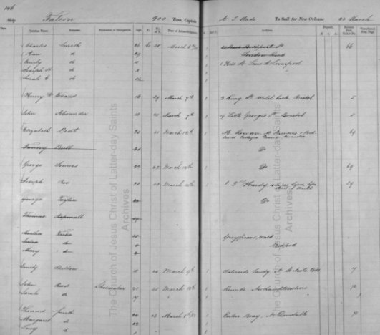
Thomas Smith is listed as age 24 from Eaton Bray, Dunstable. His profession is not listed on this register. Margaret is listed as age 22 and their daughter, Lucy is shown as one year of age (actually 14 months old at the time of departure). There is also a notation that they received Acknowledgment on March 8, 1853. That would have been 20 days before they set sail for New Orleans. Because Thomas and family were part of an Organized Church chartered ship and they, in particular, were PEF passengers, there is no notation of fare or balance do, etc.

Thomas borrowed, at least, $55.25 from the Church’s perpetual Emigration Fund to pay for their passage from England to New Orleans and from there on to the Salt Lake Valley. That was a tremendous amount of cash money for a poor English laboring family in 1853 and it was not repaid in full by Thomas X for another 25 years. It is of note that Thomas also payed $3.06 interest on his PEF loan when he finally cleared his debt. Below is a note showing Thomas’ PEF loan paid in Full (dated July 11, 1878).
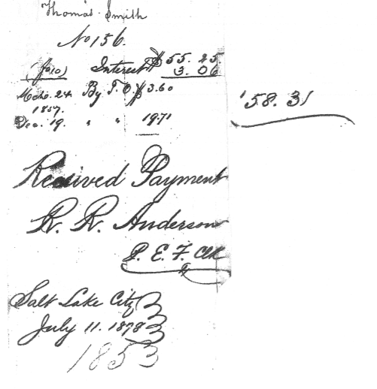
I don’t believe this was the sum total of what Thomas paid to travel from England to Utah. The amount he borrowed from the Perpetual Emigration Fund (PEF) would not have been sufficient to get him and Margaret to Utah. I’ll have more to say about this later.
Of all the grand designs devised by President Brigham Young and others to aid the immigration, perhaps the most effective and best known was the Perpetual Emigrating Fund (PEF). This revolving fund helped between 20,000 and 30,000 individuals immigrate to Zion during its 38-year history, from 1849 to 1887. Since travelers received the funds on loan, they were expected to repay the costs they incurred. However, debt collection proved difficult for the Perpetual Emigrating Fund Company. By 1877 over 19,000 people were in debt to the Perpetual Emigrating Fund, and many had defaulted on their loans. In that same year, a printed pamphlet was circulated that listed the names of all “Persons and Sureties indebted to the Perpetual Emigrating Fund.” The pamphlet was recirculated in 1878 and included a letter from John Taylor to local Church leaders. The letter provided instruction on how to collect payment and what to do if someone in debt had died. It also encouraged children to help pay the debts of their parents. It is probably not a coincidence that Thomas X paid off his debt the same year this letter was sent to all the Bishops in Utah requesting that they try to collect PEF debt from their ward members. Thomas X was the Bishop of the Logan 4th Ward at the time the letter was circulated. Below is a page from the Pamphlet showing Thomas’s indebtedness to the PEF from 1853.
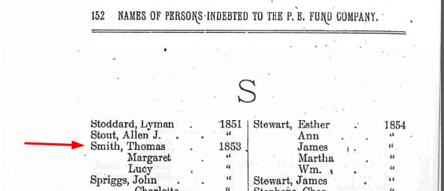

It is not clear why George didn’t leave for America when Thomas did. They were obviously close as brothers as well as brothers in the Gospel. We may never know but here is some speculations.
One, George and Catherine had just experienced the death of a new born child a few months prior to when Thomas left. Catherine gave birth to her third child, Maria Elizabeth on September 18, 1852. She only lived a few days and died on October 1, 1852. Infant death was certainly more prevalent in their day than in ours. Still the passing of this infant could have had something to do with George and Catherine staying in England while Thomas and family left.
Two, All of Catherine’s family joined the Church about the time she and George were baptized. None of the other members of our Smith family joined, neither did Margaret Gurney’s family. Maybe Catherine was reluctant to leave her parents and was waiting and hoping her parents and siblings would come to America with them. As noted earlier, Catherine’s mother died in 1857 and her father, William, and two of her brothers did eventually immigrate to America in 1861.
Three, George and Catherine decided they could work another year and save as much money as possible and leave the next year rather than obligating themselves to the PEF.
Four, A PEF loan was not offered to George at this time. The details of the PEF are not entirely clear. There is evidence that the Church wanted families to come at separate times thinking it easier to get a few family members to Zion and then hope they could help pay the way for other family members at a later date. Not everyone who applied for a PEF loan was granted a loan. Brigham Young wanted men of Integrity foremost but he also wanted those coming first with skills and occupations needed in the Great Salt Lake Valley. I am sure Thomas and George both met the integrity requirement but I doubt there was any need of Straw Plaiters or plait dealers in Utah at the time.
Five, and this possibly ties in with three and four above, George pooled what savings he had with Thomas’ funds so he an Margaret and Lucy could go and then they would work together to get George’s family to Zion.

Regardless of the reason George and Catherine and their two daughters finally left beautiful Eaton Bray, leaving behind family, friends, and two children in graves to come to America. In addition to Sabrina and Jane, and their deceased baby, Maria Elizabeth, Catherine and George had a fourth child, and first son, Marlon Lehi, who was born March 08, 1854 but died the same day.
On 24 April 1854 George W. 30, Catherine 25, and their daughters, Sabrina 6, and Jane 5 sailed from Liverpool, England for America aboard a large three deck vessel, the Clara Wheeler. This was not a “regularly organized company of Saints” and as such there were only 29 Mormon passengers on board. This was unusual since it was the practice of the Church to get a large company of Saints together and then charter an entire ship, as was the case when Thomas and family sailed a year earlier.

Getting from Eaton Bray to Liverpool

I am going to take a step back at this point to examine by what means our Smiths got from the rural area of Eaton Bray to the busiest sea port in England. In our previous histories we have not mentioned how our Smiths got to Liverpool, only that they departed for America from Liverpool. As you can see from the map below there is a considerable distance between the two locations. But just how far is it?
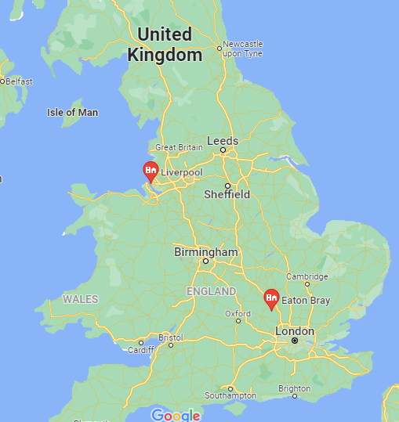
Below is a current map showing the best route between the two locations and how many miles must be traveled by existing roads.

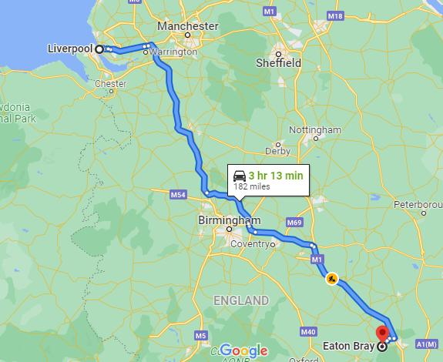
The distance by road is 182 miles and we can probably assume the roads as shown on the current map where roughly the same roads that existed 170 years ago.
Our Smiths were poor to say the least so could they have possibly walked to Liverpool? Walking would have taken 10 days at a minimum to travel the 182 miles. Thomas X and Margaret had 14 month old Lucy to consider so they would not have walked. They would not have owned a horse or wagon but perhaps they could have borrowed one. That would beg the question, how did the horse and wagon get back to the owner? There were carriages for hire but most of them operated in the big cities and not in rural Eaton Bray. The most likely conveyance was a train. Passenger train travel had been in existence for over 20 years in England by the time Thomas and family traveled to Liverpool for their Atlantic voyage. While there was a train that traveled between London and Liverpool in 1853 it did not stop at or near Eaton Bray.
There was a railway between Leighton Buzzard and London for passenger travel to London. So it is possible and even likely that Thomas’s family, and later George W’s family traveled by train from Leighton Buzzard to London and from there to Liverpool. Below is a map of the 1850 railways showing these routes.

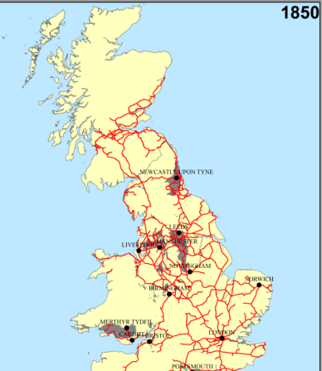
Leighton Buzzard is only 5 miles from Eaton Bray and I am sure a friend would have given them a wagon ride to the train stop in Leighton Buzzard. A rural person thought nothing of walking 5 miles to get where they wanted to go but our Smith’s would have taken some worldly possessions with them and perhaps some necessities for their long journey. I will have more to say about these necessities later. In Thomas’ case, it is likely that his brother George, and possibly Catherine as well, borrowed the wagon and drove them to Leighton Buzzard. In a history written by Thomas’ daughter, Lucy she indicates that no family members came to see them off to America. Only Thomas and George had joined the Church from the Smith family and apparently the rest of the family weren’t too happy about their new religion. This would be especially true when they found out that this new religion required them to leave England and gather on the other side of the world. Any family good byes would have taken place in the day or days preceding their departure. Margaret would never see any of her family members again in this life. Thomas, we know, returned to England on a mission for the Church years later and saw and spent time with all of his living family members as well as Margaret’s family.
In George’s case, I suspect he and his family were taken to the rail station in Leighton Buzzard by Catherine’s parents who had joined the Church the same time as George did. This would be the last time George saw any of his family members (other than Thomas) in this life. Catherine would have said goodbye to her mother for the last time as her mother died just three years later in 1857 at the age of 50. Her father and brothers came to Utah a few years after that in 1860.

Some railroad history, the Railway Regulation Act 1844 made it mandatory that English railroads provide at least one train a day for 3rd class passengers at a reasonable price with passenger seats and a covering. Prior to that time 3rd class travel was most often an open car without the benefit of seats leaving passengers to crowd into an open air car and stand while they traveled.
I have tried to find exactly how much it would have cost our Smith’s to travel by rail from Leighton Buzzard to Liverpool via London and while I found some rates it is unclear what their exact cost would have been.
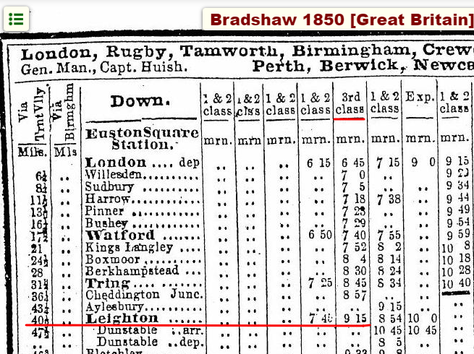
This first table shows that a train with a 3rd class car left Leighton Buzzard at 9:15am daily for the 40 mile ride to London.
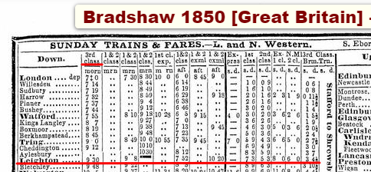
This second table shows the fare per person for that 3rd class car from Leighton Buzzard to London was 3 shillings and 4.5 pence. You can see that there was quite a difference in fares between the classes.
The table below shows the schedule between London and Liverpool for a 3rd class car. A distance of 201 miles. And if I am reading it correctly there was again only one train a day for 3rd class passengers and it left London at 8:30 pm daily.
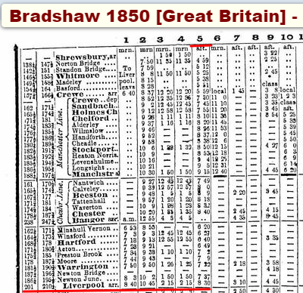

This last table shows the fare per person for that 3rd class 201 mile ride from London to Liverpool. The cost per person was 16 shillings 9 pence.
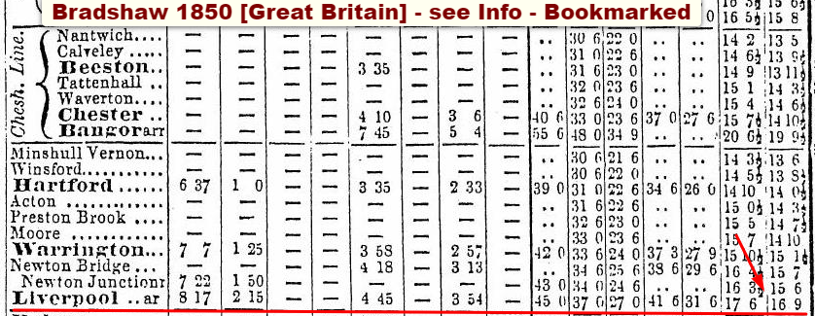
So, how much would they have paid in equivalent US dollars in the 1850’s? An English Pound was worth $4.35. This is based on the fact that a US silver dollar had .7736 ounces of silver content and an English pound had 3.3636 ounces of silver content. We also need to know that there were 20 shillings per pound and 12 pence per shilling. Thus a shilling was worth $4.35 / 20 = $0.225 and a pence was worth $0.225 / 12 = $0.01875
So if the fare was, indeed, 3 shillings and 4.5 pence per person from Leighton Buzzard to London that would have been 3 X $0.225 + 4.5 X $0.01875 = $0.7625 or about $0.75 or $1.50 for Thomas X and Margaret. Lucy would have been a babe in arms and rode for free. If George W. and Catherine, Sabrina, and Jane took that same train in 1853 it would likely have cost them about $3.00 unless the girls got to travel at half fare thus saving them $0.75.
Getting from London to Liverpool would have been much more expensive. If the fare was 16 shillings and 9 pence then it would have cost each adult 16 X $0.225 + 9 X $0.01875 = $3.76875 or $3.75 each adult.
Thomas’s Family would have got from Eaton Bray (Leighton Buzzard) to Liverpool for around $9.00 and George’s family would have paid between $18.00 and $13.50 depending on whether or not Sabrina and Jane had to pay full fare. That doesn’t sound like a lot of money unless you don’t have any cash money. And when you consider that Thomas’ PEF loan was in the amount of $55.00 which covered his family’s food and transportation across the Atlantic, up the Mississippi and across the plains that was a very expensive train ride. Also, the fare table I used was for 1850 and there could have been both increases and decreases in rates in 1853 and 1854.
There is some evidence which I will discuss later that would indicate that the $55.25 did not cover the entire cost of their journey to Utah; Meaning that Thomas had put some money of his own into his passage.
From previous research work conducted for another project two years ago I found that a quality Straw Plaiter could earn as much as 5 – 7 shillings per week. George and Catherine were both experienced plaiters as were Thomas X and Margaret. Thomas was listed in the 1851 English Census as a Plait Dealer while George was listed as a plaiter. It is likely that the Smith Family were working together to plait straw and then selling the straw plait at the local market rather than working for another dealer or agent. This may have provided all of them with a little more income than plaiting for someone else. So let’s say that George and Catherine learned as much as 15 to 20 shillings per week and if they worked year round maybe they made 1000 shillings per year or £50 per year. That same research I did indicated that it took about £50 a year for a small family to subsist in the 1850 English Country side.
Our Smiths were poor so even a 20 shilling train ride would have taken careful saving and planning.
It looks like, based on the train schedule they could have gotten from Eaton Bray to London and on to Liverpool in one long day. Thomas would have found the Church agent at the Liverpool docks to obtain his boarding tickets. S. W. Richards is listed as the Immigration Agent in Liverpool from January of 1853 through April 1854. S. W. stood for Samuel Whitney Richards and he was the brother of Apostle Franklin Dewey Richards.

Crossing the Atlantic - Liverpool to New Orleans

We can now turn our attention once again to getting our Smiths across the Altantic to the Port of New Orleans. I want to first write about the Church Emigration efforts and sailing conditions in the 1850’s in general as this information pertains to both Smith brothers and their families. I’ll then focus on Thomas, Margaret and Lucy’s journey to New Orleans since he left England a year before George W. and family did. I’ll then try to document George and family’s voyage.
Kind of an aside, I found this entry showing that the 56th Emigration Company was the first to transport PEF passengers:
Fifty-sixth Company — Kennebec, 333 souls. January 10, 1852, in the morning, the Kennebec, a new and commodious ship of one thousand and seventy tons register, went out of the Bramley-Moore Dock, at Liverpool, England, with three hundred and thirty three souls of the Saints on board, under the presidency of John S. Higbee. Included in the number of Saints who emigrated in the Kennebec, were sixty nine passengers whose fare was paid by the Perpetual Emigrating Fund Company—the first ones who emigrated by that means.

As mentioned earlier, a little over a year after this first Perpetual Emigration Fund (PEF) sailed, Thomas and family took advantage of the PEF to book passage not only to New Orleans but all the way to Utah. His loan was in the amount of $55.25 and that covered transportation and food from Liverpool to New Orleans, up the Mississippi by steamboat to Keokuk, Ohio and from there to the Great Salt Lake via an oxen pulled wagon. Even with the $3.06 interest he had to pay this was a great bargain and a wonderful blessing for Thomas and his family. It is possible that Thomas put some of his own money down as a deposit toward his passage and thus making it not quite the bargain we have imagined. Below is an interesting table showing ships sailing from Liverpool in 1853 and 1854 under the direction of the LDS Agent Samuel W. Richards. It shows Thomas’ Falcon voyage in March of 1853 as well as George’s Clara Wheeler voyage in April of 1854.
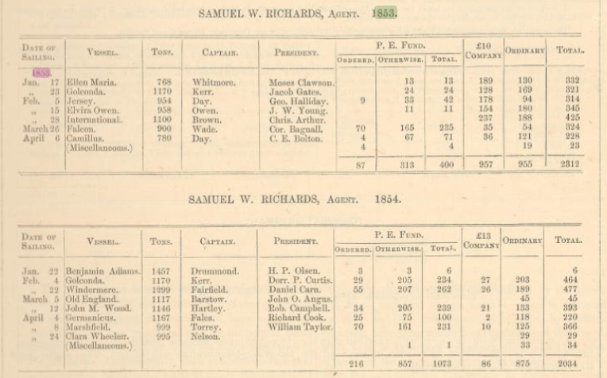
What is interesting about this table is that it lists how many passengers came by what method. Under the heading of P.E. Fund were three sub headings, “Ordered”, “Otherwise”, and “Total”. As I understand it the “Ordered” PEF had their passage paid by a person or persons already in Utah by donating in their behalf, by name, to the PEF. The “Otherwise” were those like Thomas and family whose who were able to take advantage of the PEF to travel.
There are some other headings of interest. There was something called the £10 Company in 1853 and the £13 Company in 1854. And then there was the “Ordinary” passenger and the “Total”. As I have come to understand the Church decided to try and get immigrants from Liverpool to the Great Salt Lake Valley for £10 per person in 1853 and found that not quite sufficient to cover the expenses so in 1854 they raised the amount to £13 each. Costs each year were going up especially the cost of oxen and wagons as demand when up. The “Ordinary” passenger was one that paid his own way entirely. The £10 and £13 companies were abandon after 1854 because of rising costs of supplies.
So, in 1853 when Thomas and Family sailed the Church found that £10 per person wasn’t quite sufficient. The US Dollar equivalent to £10 was $43.50 for each adult and Lucy would have been free. The PEF loan amount of $55.25 does not cover the estimated cost of 2 X $43.50 it probably took for Thomas and Margaret to immigrate to Utah. This is why I suspect Thomas must have paid some of his own way to Utah. So here is yet another possible reason George and family didn’t leave when Thomas did. What if they pooled their money and decided that Thomas, Margaret and Lucy should go first and George and Catherine and their two daughters, Sabrina and Jane, who were probably just becoming proficient straw platers themselves at ages 6 and 5 respectively would stay and earn money to come the following year. We know that Thomas took George and his family in for a season after their arrival in Farmington in 1855. Anyway, it is a kind and generous possibility but there is nothing we have found that would substantiate that theory.
Liverpool was the primary embarkation port for the large immigration of Saints throughout most of the 1880’s. It was also the headquarters of the Church’s British Mission. In the 1840’s there were over 200 thousand people living in Liverpool.

This is a map of the Liverpool area around 1870 – 1880 era. It clearly shows the density of population near the Liverpool sea ports.
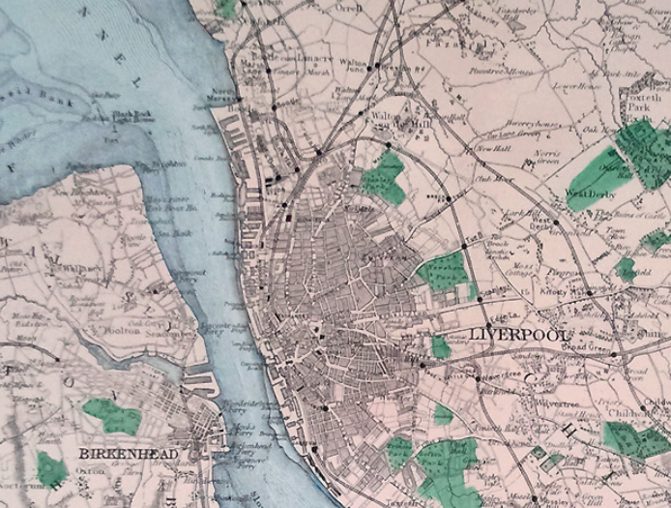

This sketch shows several sailing vessels lined up in the Port at Liverpool with their sails stowed and waiting to be loaded with cargo and or passengers.

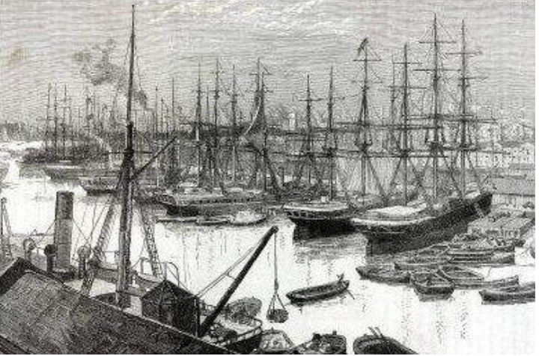

This sketch shows a much busier port in the Liverpool area. I believe the white building in back was the Customs House.
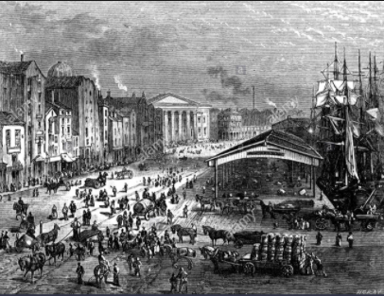

Below is a sketch by Frederick Piercy in 1853 of a sailing ship being towed out to sea.
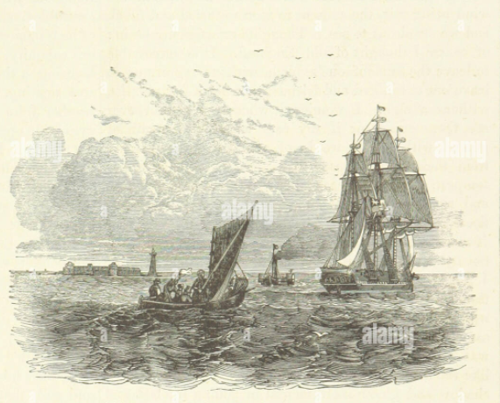

I believe this next sketch shows the Canning Dock near the Customs House in Liverpool.
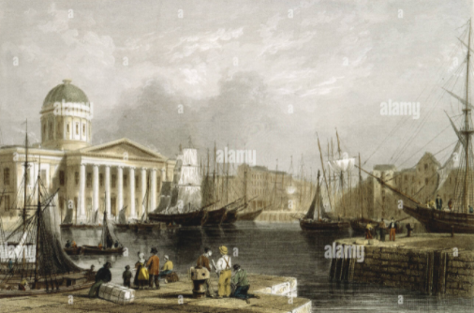

Liverpool, during this time was full of men wanting to and succeeding in taking advantage of the immigrants. To avoid being taken advantage of the “Saints” were directed to go immediately to the British Mission office. The mission president and other Church leaders were appointed to advise emigrants regarding provisions and lodgings and counseling them concerning the Atlantic crossing.
The Latter-day Saints' Millennial Star was the official publication of the Church in the British Isles from 1840 to 1970. In an article appearing in “The Latter-day Saints Millennial Star” in April 1841, The Twelve provided several reasons why converts should follow the counsel of the newly appointed Latter-day Saint Emigration agent:
We have found that there are so many “pick pockets’, and so many that will take every advantage of strangers, in Liverpool, that we have appointed Elder Amos Fielding, as the agent of the Church, to superintend the fitting out of the Saints from Liverpool to America. Whatever information the Saints may want about the preparations for the voyage, they are advised to call on Elder Fielding, at Liverpool, as their first movement when they arrive there as emigrants. … It is also a great saving to go in companies, instead of going individually.
First, a company can charter a vessel, so as to make the passage much cheaper than otherwise.
Secondly, provisions can be purchased at wholesale for a company much cheaper that otherwise.
Thirdly, this will avoid bad company on the passage.
Fourthly, when a company arrives in New Orleans they can charter a steam boat so as to reduce the passage near one-half.
Fifthly, a man of experience can go as leader of each company, who will know how to avoid rogues and knaves.”
The Millennial Star was also used by the Mission President to advise perspective emigrants of ship departures, what to bring and what not to bring with them, when to be in Liverpool, etc.
Samuel Whitney Richards was the Mission President during the time Thomas and his little family would have arrived in Liverpool. He was also the Emigration Agent for the Church as was noted on the table just presented above. He was the agent to charter the “Falcon” on which Thomas and family sailed to New Orleans. It was the practice to accumulate “applications” from the Saints wanting to emigrate and then charter a ship for the voyage. Once a vessel was chartered the agent would notify prospective passengers by printer circulars. These circulars provided instructions on how to proceed. In addition, agents would contract a fare with the railways to convey the Saints to Liverpool. It is possible that Thomas and family traveled to Liverpool for even less that the $9.00 I estimated previously.

Each Organized Company of Saints once on board their Charter ship had a President appointed by the British Mission President to preside over the Company until they reached the “plains”. The newly called President chose two Councilors to assist him. The Company was then split into “Wards” with Priesthood leaders to govern each ward. In this way order and cleanliness was maintained and regulations were put in place for health, safety, and the comfort of the passengers. These arrangements, no doubt were responsible for making the best of difficult conditions a board each ship. Many of the Captains of these Chartered ships mentioned that the “saints” were the best passengers they ever had the pleasure to take across the Atlantic. All, but a few of the Captains, received the same high praise from their company of saints.
In the late fall of 1852, the following article was published in the Millennial Star entitled,
“Notice to Intending Emigrants”: We beg to inform the Saints intending to emigrate that we are now prepared to receive their applications for berths. Every application should be accompanied by the names, age, occupation, country where born, and £1 deposit for each one named….Passengers must furnish their own beds and bedding, their cooking utensils, provision boxes, etc…. Every person applying for a berth or berths should be careful to give their address very distinct, in order to insure the delivery of our answer to them be letter carriers….
In that same article there is again a reference to the £10 minimum required to emigrate from England to Utah. This adds credence to the likely possibility that Thomas had to come up with as much as another £8-10 over and above his PEF loan. It may be possible, however unlikely, that only he was granted a PEF loan for his passage and he had to come up with the funds for Margaret. That doesn’t make a lot of sense but the PEF loan of $55.25 would have been the equivalent of about £12 15S. That is more than he needed for himself but not enough for both him and Margaret.
…By reference to STAR no 32 (I assume this is a reference to the Millennial Star no 32) it will be seen that £10 each was named as the lowest sum upon which single persons or families could be encouraged by us to emigrate from Liverpool to Great Salt Lake City; therefore persons not having that amount should apply for passage to New Orleans, as we do not purpose to ship any Saints but those who are prepared to go through to the Valley without detention….
Passengers were told to arrive one day before the schedule departure. They were allowed to board the ship that day and prepare themselves for the voyage. They were told to bring a claw hammer, a few ten penny nails, and some strong cord to affix their personal luggage in their assigned area on the boat. Experience was that if they waited to secure their luggage until after they were at sea they would be too seasick to do it and luggage would be tossed about the ship. For those arriving more than a day early for their departure the Elders living in Liverpool would try to find safe and affordable lodging which was not an easy task in this unsafe area of England.
On board the ship each passenger was allotted 10 cubic feet of luggage space near their berth. That space would be equivalent to a box about 2 feet by 2 feet by 2 ½ feet. They were to lash this box to the deck with the nails and cord to keep it from sliding around or breaking open during rough weather. Only items they would need during the voyage where to go in the box. Every other item they brought with them had to be stowed in the Hold. Emigrants were also advised not to bring with them heavy or bulky items as it would cost more to ship them that it would to replace them in America.
Each passenger was responsible for their own blanket and pillow as well as their eating utensils. They also needed an eating tin and a vessel that would hold three quarts of water as they would receive that allowance of water once per day. There was provided a straw mattress for each berth. I can only imagine what those mattresses looked like or worse, felt like!
This report was from the early 1860’s when steamships had come into more use. It seems conditions had not improved much from the 1840’s and 50’s. “Steerage passenger space was usually very limited, and situated in the worst part of the ship, subject to the most violent motion, to the dirt from the stacks and the odors from the hold and galleys... the only provisions for eating are frequently shelves or benches along the sides or in the passages of sleeping compartments. Dining rooms are rare and, if found, are often shared with berths installed along the walls. Toilets and washrooms are completely inadequate; saltwater only is available.
It was true that the only wash basins available on board pumped cold seawater and it certainly could not be drunk and probably not very pleasant to wash your hand and face with, let alone other parts of the body. After a meal a large tub of potable water was heated for the washing of dishes and utensils. However if you were not among the first in line to wash your dishes the water would be so full of grease an bits of food, etc. that most resorted to washing out their tins in sea water from the limited basins available.

In 1848 the U. S. Congress attempted to improve steerage travelling conditions, by passing the American Passenger Act. This legislation prescribed a legal minimum of space for each passenger and one of its consequences was the building of a new, larger type of ship called the three-decker. The Falcon and the Clara Wheeler were these newer larger ships with three decks counting the top deck. The top deck was, of course, open to the air. No one slept on the top deck. Steerage was either on the second deck or the third deck. If you were lucky enough to be assigned the second deck you could take in some fresh air on a calm night by opening up some of the hatches but you also had to suffer the stench that came up through the floor from the third deck below. It was very dark in the lower deck and there was also a shortage of fresh air. The height of these lower decks could range from six feet to eight feet.
Their berth was perhaps six feet in length but might only be 18 - 24 inches wide and they were stacked on top of each other two or three high. Some other accounts tell of family berths where as many as five would share a berth perhaps 48 wide.

Below is a sketch of life in the Steerage deck:
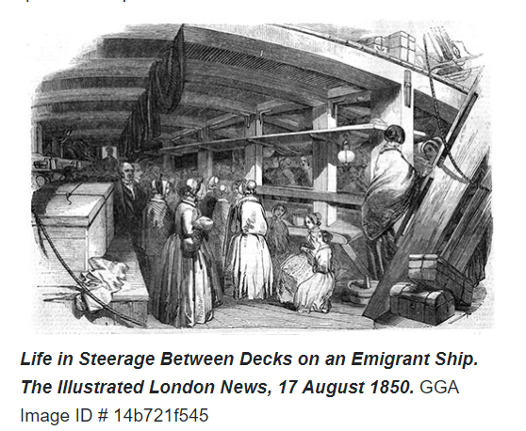

I suspect that the sketch paints a much more pleasant, airy, well lite view of what the steerage area was really like. I show another sketch that is not quite as rosy but likely more accurate:
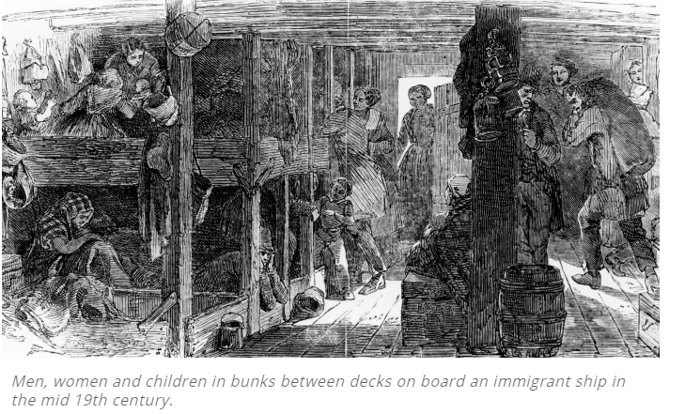

Here are a couple of addition renditions of what Steerage life might have been like:
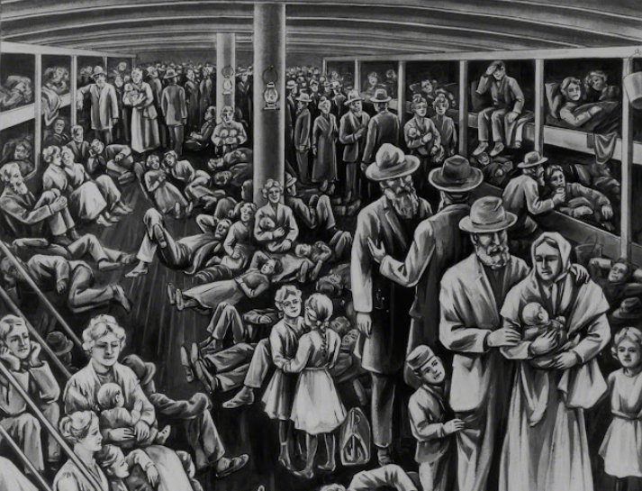
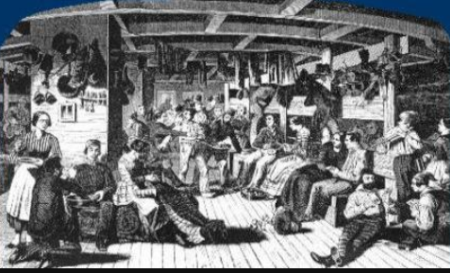
From these depictions and from reading many journal entries steerage life in good conditions was crowded, dark and smelly. I can only imagine what conditions prevailed when nearly every passenger on board was seasick and the hatches were locked to prevent passengers from getting to the top deck and possibly falling overboard in a raging storm!
Many people in the nineteenth century didn't bathe regularly and the connection between personal hygiene and disease was not well understood. Due to the cramped and overcrowded conditions in steerage, people could not really take baths and made do with a clean-up with a damp cloth under a blanket. There are some accounts where children were bathed in tubs on the top deck when conditions permitted. These tubs were fill with cold salt water. People did not have the room or privacy to change their clothing. What clothes they had would have to be washed out in a basin of cold salt water. Some wore the same 'clothing for the entire voyage. Facilities for washing clothes were very restricted. People didn’t use deodorants and many people didn’t even clean their teeth often.​ One can only imagine the smells of soiled baby cotton nappies, grubby clothes, and unwashed bodies in a crowded environment. The first commercially available deodorant did not go on the market until 1888, by the way. Some people used scented powders and oils to mask odors but not likely our steerage passengers. By the way, commercial toilet paper didn’t come along until 1857 so who knows what was used in the crude toilets on board these ships. I hesitate to even venture into the area of toilet facilities because very little can be found written about them. And I didn’t find any favorable reports. The United States Passenger Act of 1855 stated that there must be one bathroom for every one hundred passengers. That doesn’t sound too favorable and that requirement didn’t come until after both our Smith families were safely across the Atlantic.
A little later on in this text I show some journal entries from the very ship Thomas and family came across the Atlantic on. Once their ship entered the warmer and calmer waters of the Carribbean the men, on calm, still mornings would lower themselves via ropes to the water and bath in the ocean water and then be pulled back on board ship. No mention of the women bathing was made but perhaps they took advantage of the men being gone to sponge bath below deck.
I show below a cross section of a three deck sailing ship to give another perspective of how these sailing ships were configured.
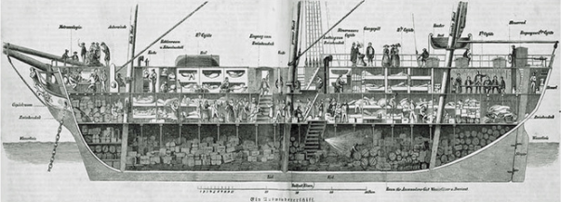
These sailing ships took on average about six weeks to cross the Atlantic to New Orleans. With adverse winds or bad weather the journey could take as long as fourteen weeks. The shipping companies were required to provide provisions for 70 days at sea. If the ship arrived in less than the 70 days the passengers were allowed to take the excess with them at the end of the voyage. There were several instances where rations had to be cut as the Captain realized they would not conclude their passage within the 70 days. Some ships would get becalmed in the Caribbean thus adding significant time to their voyage. They often had to put into a port to take on more water and provisions.
According to the Carriage of Passenger Act 0f 1855 (mentioned above) here is a list of what constituted provisions per passenger for the 70 days:
All vessels are required to have the following minimum amounts of provisions per passengers, well-secured under deck, all of good quality:
20 pounds of navy bread
15 pounds of rice
10 pounds of wheat flour
15 pounds of peas and beans
20 pounds of potatoes
1 pint of vinegar
60 gallons of fresh water
10 pounds of salted pork
10 pounds of salt beef, free of bone
The following substitutions are allowed:
At places where either rice, oatmeal, wheat flour, or peas and beans cannot be procured at good quality and reasonable terms, the quantity of any of the others may be used to substitute for it.
In case potatoes cannot be procured at reasonable terms, one pound of any of the aforementioned items can be used to substitute for five pounds of potatoes.
Passengers were also advised to bring some lime juice to mix with the water if they could afford it. The lime juice mixed with sugar made the drinking water on board taste better. The water barrels were often not cleaned out well between trips or they were not rinsed out after carrying other materials such as vinegar or pickles. Other items passengers were encouraged to bring aboard was marine soap, pepper, onion, carbonate of soda, baking powder and dried fruits.
That same act also required a minimum of 18 square feet of deck space for every passenger on board. Berths had to a minimum of 6 feet by 2 feet per individual or 6 feet by 4 feet for a family berth for three persons maximum. There was to be a minimum height below deck of 7 ½ feet and the berths couldn’t be stacked more than two high. Another welcome regulation stated that two ventilation tubes (12 inches in diameter) had to be installed to carry outside air to the steerage decks. The captain of each ship could be fined if found not complying with these guidelines. Again, all of these regulations came into effect after our Smiths had crossed the Atlantic.
There was to be some space set aside for a “Hospital” and at least one medical practitioner aboard.
This is probably a good place to show the route taken between Liverpool and New Orleans during the time or Smith’s made the voyage.
The Church Emigration ships as early as 1840 sailed to New York but it was determined that the travel overland from New York to Nauvoo was long and difficult to accomplish. By 1841 the Church started chartering ships to sail to New Orleans where the Saints could take a steam ship up the Mississippi and get close to their destination. Remember that the Saints final destination was Nauvoo until 1846. The New Orleans route was a longer sail but a quicker route in total when the overland trip from New York was factored in. The New Orleans route was also less expensive for the passengers since the ships carried passengers to New Orleans and then loaded these ships with Southern States cotton to be taken back to the English mills. So these merchant ships were getting “bonus” money to take passengers to New Orleans where they had to go anyway to bring back the cotton.
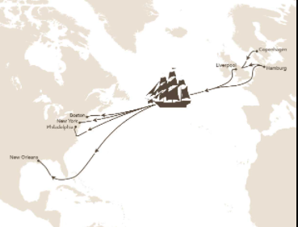
By 1855 the Church was once again sailing the emigrants to New York, Philadelphia and even Boston. It was determined that the difficult climate change from Liverpool through the Caribbean and on to New Orleans was causing serious sickness among the immigrants. This was particularly true when ships departed late in the season and landed them in New Orleans during what they termed “The Sickie Season”. This move away from New Orleans was a wise one no doubt. In 1853, the year our George and family arrived in New Orleans, 7848 people died from a Yellow Fever epidemic in that city. In a letter dated 2 August 1854, Brigham Young counseled British Mission President (and Emigration Agent in Liverpool), Franklin D. Richards as follows: “You are aware of the sickness liable to assail our un-acclimated brethren on the Mississippi river, hence I wish you no more to ship to New Orleans, but ship to Philadelphia, Boston or New York.” This correspondence was published in the Millennial Star dated 28 October, 1854.
It was also becoming easier to connect to the Midwest by rail. The last “Saints” emigration ship left Liverpool for New Orleans on January 17, 1855.

Sea Sickness, Disease, and Deaths

One common difficulty in the early sailing years was overcrowding and the stench of seasickness caused by sickly steerage passengers (steerage being the large area below deck used for low-cost accommodations). William Clayton, who crossed the Atlantic in 1840 aboard the North America, stated, “Such sickness, vomiting, groaning and bad smells I never witnessed before and added to this the closeness of the berths almost suffocated us for want of air.” Manchester Mormons: The Journal of William Clayton, 1840–1842, ed. James B. Allen and Thomas G. Alexander (1974), 173.
Ebenezer Farnes, who aided the sick on the 1862 voyage of the William Tapscott, wrote: “The first day out of the harbor all the emigrants were seasick, and I was called on to help give out water and provisions, which I did until we landed in New York. The trip on the ocean was a red letter day in my life. The first day out was rather rough and the second day rougher, and all the people were seasick. After the fourth day out things on board ship went smooth and some of the people came on deck, others lay in their berths afraid they would die, and others afraid they wouldn’t die.” Reminiscences of Ebenezer Farnes, Church Archives, 2.
Even a worse treat than sea sickness was the potential of not completing the voyage at all. In a five year period (1847-52) 43 emigrant ships out of 6,877 failed to reach their destination, resulting in the deaths of 1,043 passengers. In 1854 the Steamship “City of Glasgow” carrying 480 emigrants went missing after leaving Liverpool and was never heard of again. Thankfully none of these ships were chartered “Saints” ships.

Some tragedies:

However, there were those who, due to illness caused by dysentery, measles, and other diseases, never did get up from their beds of affliction. They were eventually consigned to a watery grave. This was done by putting the deceased in a canvas bag and attaching weights to the body (to avoid sharks) and sliding it on a board into the ocean. Such scenes were painful for loved ones to behold. It is estimated that between the years 1846 and 1869, approximately 670 Latter-day Saint immigrants died while crossing the oceans to gather to Zion. See “I Have a Question,” Ensign, July 1998, 40–44.
The ship Berlin sailed from Liverpool for New Orleans with two hundred and fifty-three Latter-day Saints on board, September 5th, 1849, under the presidency of James G. Brown. {Millennial Star, Vol. XI, page 363.) The company had a tedious voyage, during which the passengers suffered much from cholera, and forty- three deaths. This was the greatest loss of life up to that time that had been experienced among the Saints wending their way to Zion, since the emigration from Europe commenced in 1840.
While we do not know much about the voyage of the Clara Wheeler which George and family took in April of 1854, the next time the Clara Wheeler left Liverpool on December 7, 1854 with 422 Saints on aboard measles broke out on board and 20 children died along with two adults.

In contrast, many were restored to health as the elders stood by both willing and able to bless the sick.

Some Miracles

There were several miracles witnessed and recorded in the journals of the immigrating Saints. . One such experience occurred when a severe Atlantic storm struck during the 1851 voyage of the Yankee ship Olympus:
“Captain Horace A. Wilson sent his second mate to Elder William Howell, president of the emigrant company. ‘You go to the captain of the Mormons,’ the master ordered, ‘and tell him from Captain Wilson that if the God of the Mormons can do anything to save this ship and the people, they had better be calling on him to do so, for we are now sinking at the rate of a foot an hour; and if the storm continues we shall all be at the bottom of the ocean before daylight.’
“Lying in his bunk, Elder Howell sent a message telling Captain Wilson: ‘Our God will protect us.’ Elder Howell summoned twelve men to join him in prayer. According to Wilson G. Nowers, as they were praying, the motion of the ship changed. The pitching and rolling eased, and the storm ‘suddenly abated.’ The Saints and Captain Wilson attributed their deliverance to Providence.
Another journal from a passenger aboard the Olympus reported the following: “After repairs were made, the skipper gave the Latter-day Saints permission to hold religious services for the entire ship. Members responded enthusiastically and preached to everyone who would listen. At first, a baptismal font was improvised from a large barrel, which could be entered via a ladder on deck; some time later, a platform was suspended from ropes and lowered into the ocean, where more baptisms were performed. During the 54-day passage, 50 converts were baptized, including one before sailing and one after arrival at New Orleans.”
Doctrine and Covenants and Church History Seagoing Saints by Fred E. Woods
Another miracle recorded; The Forty-sixth Company. —Argo, 402 souls. January 10, 1850, the ship Argo sailed from Liverpool with a company of four hundred and two Saints, under the presidency of Jeter Clinton, an American Elder, who returned home from a mission to Great Britain. After a prosperous voyage, the company arrived in New Orleans, March 8, 1850. Sister Jackson, one of the emigrants who now resides at American Fork, Utah County, Utah, relates that on one occasion during the voyage, when the Argo was nearing the shores of Cuba, in a pitch dark night, the captain expressed fears that the ship might be wrecked, as he knew that land was near. Suddenly a heavenly light, which for a few seconds illuminated the surroundings, revealed to the captain the fact that a large rock rose boldly out of the ocean, right in front of the ship, only a short distance away. With considerable presence of mind, and quick as thought, the captain gave orders to change the course of the vessel, and thus escaped what might have proven a terrible disaster a few minutes later.
This next account, and the last that I will mention in this writing, comes from the Ship International which left Liverpool just one month ahead of the Falcon which was the ship that carried the Thomas X family across the Atlantic
International, 425 Saints. The ship International, Captain Brown, with a company of four hundred and twenty-five Saints, under the presidency of Elder Christopher Arthur, sailed from Liverpool, February 28th, 1853.
True to its name, this vessel carried a cargo of 425 Saints from England, Scotland, Ireland and Wales. Just two weeks after leaving Liverpool, this square-rigger also confronted an angry storm, which sent many prayers to heaven. Experiencing The captain and most of the crew of the International were baptized, due to the example and teaching of the Saints on board. Exhaustion from fighting the storm, Captain David Brown had an unusual dream “that himself, mates, and crew were all baptized in the Mormon faith, and when he awoke he found himself at prayer.” Shortly thereafter, the mariners began to be converted. On 6 April 1853, a lively celebration was held on board the International as the Saints celebrated the twenty-third anniversary of the establishment of the Church. By the time they reached New Orleans, following a five-thousand-mile Atlantic voyage in fifty-four days, others also desired to flee Babylon (meaning the world) and gather with the Saints in Zion. Upon arrival in New Orleans, Mormon company leader Christopher Arthur reported to the British Mission president, Samuel W. Richards, who was stationed at the British Mission in Liverpool, the following: “I am now glad to inform you, that we have baptized all on board, except three persons. We can number the captain, first and second mates, eighteen of the crew, most of whom intend going right through to the Valley. . . . The others baptized were friends of the brethren. The number baptized in all is forty-eight since we left our native shores.”

Charles Dickens Visits an Emigrant Ship

I was reminded of what era we are currently reviewing when I found this interesting article:
A visitor to the ship Amazon, leaving the London dock in 1863, was the novelist Charles Dickens. "I . . . had come aboard this emigrant ship to see what eight hundred Latter-day Saints were like," he wrote. "Indeed, I think it would be difficult to find eight hundred people together anywhere else, and find so much beauty and so much strength and capacity for work among them" (The Uncommercial Traveler[1863], 446).
Fully expecting to "bear testimony against" the Latter-day Saints, Dickens changed his opinion after observing the passengers: "To my great astonishment," he said, "they did not deserve it"
In Dickens's book, The Uncommercial Traveler, he describes the scene he beheld with wonder:
"Nobody is in an ill temper, nobody is the worse for drink, nobody swears an oath or uses a coarse word, nobody appears depressed, nobody is weeping, and down upon the deck, in every corner where it is possible to find a few spare feet to kneel, crouch, or lie in, people in every unsuitable attitude for writing, are writing letters”.

The Voyage of the Ship “Falcon” (Thomas and Family)

It is probably time to look at what we know about the specific voyage of Thomas, Margaret, and little Lucy; The Falcon. The Church through Brigham Young University has created a wonderful resource documenting all of the emigration voyages from Liverpool to America during the years 1840 through 1931. It is called, “Saints by Sea” and can be found at https://saintsbysea.lib.byu.edu/ Below is the general description of the Voyage of the Falcon. It has some great information in these few sentences:

A Compilation of General Voyage Notes
"SIXTY-SIXTH COMPANY. -- Falcon, 324 Saints. The ship Falcon, with three hundred and twenty-four Saints on board, under the direction of Elder Cornelius Bagnall, sailed from Liverpool, England, on the twenty-sixth (or twenty-eighth) of March, 1853. After a successful voyage she arrived in New Orleans on the eighteenth of May. Four children died during the voyage, but the general health of the company was good. From New Orleans Elder John Brown, the Church emigration agent at New Orleans, accompanied the Saints up the river. They landed in St. Louis May 27th, and re-embarked for Keokuk the same day, arriving in the latter place in the beginning of June."

Margaret would have been 21 years old and 6 ½ months pregnant when they left Liverpool. Thomas was 23 and Lucy just 14 months old.

This voyage was obviously an organized Charter of Saints with 324 member of the Church on board. The Falcon set sail for America on March 26 or 28, 1853. The two different departure date appears to have something to do with clearing the medical examination that took place after the ship was towed off of the dock but before it was allowed to leave the port. According to wonderful records that were written by the Secretary of the company the ship finally set sail at 2:00 p.m. on the 28th.

The Falcon arrived in New Orleans on May 18, 1853. Having spent 51 days at sea.
That Compilation tells us also of the trip up the Mississippi River under the direction of the Church Immigration Agent, Elder John Brown. And showing their arrival date in St. Louis as May 27, 1853 just nine days after their arrival in New Orleans. Lastly it tells us that they left for Keokuk the same day and arriving the beginning of June. More on this information later.

The Falcon was classed as a 900 ton merchant ship. It had three decks including the top deck and was rigged with square sails. Since I have been unable to locate a sketch or drawing of the Falcon I show below a painting of the Clara Wheeler which was the ship George and Family sailed on in 1854 as an example of what these ships looked like.

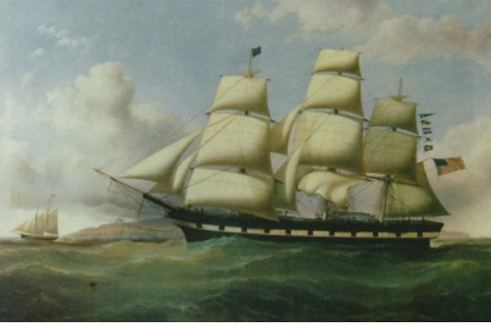
It was also noted in the Compilation that Cornelius Bagnall was appointed as President of the Company of saints aboard the Falcon. This appointment would have come from the British Mission President and Emigration Agent Samuel W. Richards.
Later President Bagnall chose Elders James McNaughton and James Caffall to be his councilors. President Bagnall called for a 6 o’clock wake up each morning followed by 7 o’clock prayers and held worship twice on the Sabbath. One from 11:00 a.m. to 1:00 p.m. and the second from 5:00 p.m. to 7:00 p.m. The ship Captain gave the company permission to hold their Sacrament meetings on the main deck and he would be pleased to attend.
On the Sabbath Elder Caffall and Elder James would to go around the berths and appoint young brethren to carry the meat from the passengers to the cook and return it to them so as not to cook on the Sabbath. President Bagnall instructed the saint to not make a sound after 8 o’clock p.m. as the sailors went to bed at that time. If anyone stayed up past 8 they were not to make any noise.
The Company was divided into six wards and presidents appointed over each. The presidents of the different wards then counseled together and it was agreed ….that on Monday a general dinner of rice should be cooked together, and that on Tuesday oatmeal….on Wednesday pork and potatoes, and on Thursday rice again and on Friday Oatmeal and on Saturday pork and potatoes and the same order should be observed on the Sabbath.
James Leatham, who was an emigrant aboard the Falcon, provided a further glimpse of the activities of these sea going Saints, noting on 14 April that he was already making preparations for crossing the plains, as he was on deck and sewed a piece of the tent Cover.
It was the practice of the organized companies to provide British Twilled Cotton on the ships in sufficient quantity for the saints to sew the tents they would sleep in on the plains and sew wagon covers that would carry their supplies along the way. These activities helped pass some of the time when the weather was calm enough to engage in such activity.
Records indicate that a school for the children was suggest to be organized during a meeting of the Priesthood brothers on April 9th
From President Bagdall, “Brethren I wish to lay before you some things that are on my mind. I thought of organizing a school for the children and as we have got the cloth for the tents on board which I would like to see commenced too as soon as possible, I thought that if the school did no more good than keeping the children out of the way for 3 or 4 hours every day it would always be so much gained. Several of the brethren spoke their feelings on the subject when it was moved by Elder William Davis, seconded, Elder James McNaughton that a school [p.24] be organized and that the hours be from 10 till 12 forenoon and from 2 till 4 afternoon. Elder William Aird was then appointed to take charge of the school and Elder Hendry [Henry] John and Teacher John Bagnall to assist him and that they commence their labors on Monday first.
Both the school and the sewing of the tents and covers began on Monday, the 11th of April. So this school served two purposes: one, was to provide some educational instruction for the children and, two, free up the women (and men) to sew their tents and wagon covers.
Provisions for each week were divided out by the ship captain and mates. The Captain was responsible for making sure the provisions would last throughout the entire voyage. They tended to error on the side of caution in the beginning of the voyage to ensure food stuffs would last.
In the notes taken for this voyage the mention of the hospital on board was made. All ships carrying more than 100 passengers was to have an area set aside as a hospital and a ship doctor provided. At least we know that, on the Falcon, a hospital was indeed provided. It was probably just a less crowded space below deck where one could be attended to away from the rest of the passengers and crew.
Toward the end of their voyage, as the weather became warmer the saints were granted a 10 p.m. curfew above deck as long as they were quiet and not singing after 8;00 p.m. Several times during the voyage the entire company was called on deck as sailors and stewards cleaned and washed out the below decks. Thanks you very much!!
According to James Jack’s records the Falcon was boarded by a pilot on Monday, May 16th and from there was towed by two pilot steamers and crossed the bar at 5:30 p.m. that same day. Where the Mississippi emptied into the sea the currents and debris and silt creating a sand bar that had to be avoided. Several records mention crossing that bar meaning there were now officially on the Mississippi River. They reached the Port of New Orleans on May 18 at noon.

We are fortunate to have a few great journal entries from faithful saints aboard the Falcon. These entries gives us wonderful insights into the Falcon’s journey across the Atlantic. Whereas James Jack’s records were focus primarily on the Spiritual aspects of the voyage of the Falcon these journal entries often added a different perspective.
Below are excerpts from the Autobiography of James Ririe, a passenger aboard the Falcon:
On Saturday, 12th of March I got notification to be in Liverpool to sail with the Falcon on the 28th of March. Sailing vessels were very scarce that year as the “gold Fever” had broken out in Australia and all were going there. We watched our luggage by turns until Monday the 28th of March when we sailed out of Liverpool. It was a fine day but cold.
Tuesday 29th, a cold but calm day. Some wind in the afternoon.
Thursday 31st, a strong gale at night. A complete storm. The trunks were rolling, tumbling, breaking. The ship was cracking, children and women were crying. I never was in such a scene. I was very sick. The ship rolled fearfully. I thought we would go to the bottom. My mind was calm as a summer morning, yet I was sorry to lay down my salvation there. Yet, I thought I, the will of the Lord is done. In the excitement I asked of the Lord if we should be saved or not. I got a manifestation of the Spirit that we would all be saved and that the storm would abate in two or three days ant the general fair weather would ensue after that.
Friday, April 1st. The storm was a little over, yet the sea was still rather high and the ship rocked much at night, very much. I was very sick. I was scarce able to be up and so were most of the company.
On Thursday the 5th we had an awful experience of thunder and lightning.
Monday 16th. We only this day came in sight of the lighthouse at the bar at the mouth of the Mississippi. A 3 p.m., the pilot came on of us, about 5, we come in sight of the land and houses. Could see the grass. Particular feeling of gratitude and joy prevailed to the Providence of Heaven in being brought safely through thus far.
Tuesday 17th. This morning scenes of delight passed us on each side of the river. To see the fruit fields was a beautiful experience.
I can see in my mind’s eye 24 year old Thomas and his 22 year old, and 8 months pregnant, wife, Margaret and 16 month old Lucy standing on the deck of the Falcon and having those same thoughts of gratitude to have that leg of their journal safely at an end.

This from the Journal of James McNaughton (one of President Badnalls Councilors):
On the evening of the 31st (March) we had a severe gale or storm and what it was most frightful below was that on account of many or nearly all of the tins were untied so that at every roll of the vessel the tins and the boxes slipped from side to side, an made a most alarming noise. The same day brother Stewart’s child died and was committed to the deep.
We left Liverpool on the 28th of March 1853, and arrived at New Orleans, on the 18th of May, 1853, being a passage of seven weeks and two days. During this time there were 3 marriages and 4 deaths of children. Meeting for sacrament and testimony were held on the middle deck, and on the upper deck we had a more public one in the p.m. We had first rate times in those meeting. The Lord certainly recognized us and blessed us. Also every morning and evening at which time we had prayers. The weather in the latter part of our journey was very mild and pleasant. The greatest difficulty we had to combat on board the Falcon was cooking. The convenience being so limited but even in this matter we got along much better than we had ever anticipated.
He continues his journal entries after arriving in New Orleans so I will share more when we get to that point.
From the Diary of James Leatham:
Monday 28th, March. The Saints was engaged in singing the songs of Zion while the sailors was heaving out the ship. We got clear through the gates about 5 minutes past 2 o’clock p.m. when the steamer tugged us out a few miles and then left us, moving along at about 4 or 5 miles an hour.
Tuesday 29th. This morning I got up about 6 o’clock a.m. for prayers but after getting my clothes almost on I felt very sick and returned to my bed again. I vomited considerable and being at the fore end of the ship I was brought down to about the center to sleep with Brother Livingston for convenience of him waiting on me, and to where the ship did not heave so much. I continued sick all that day and kept vomiting now and then.
Wednesday 30th. I continued sick all his day and could eat nothing but drank water and vomited it up again.
Thursday 31st. I was still sick. I could take no meat. This day a child died age 11 months. In the evening the wind began to rise and about 7 o’clock all in a sudden the shop commenced to rock and dart at such a rate and the tins tumbling back and forth, and also the boxes, for there were few of them tied for we was not looking of a storm. And the chests began to tumble, them that was not in bed nor prepared for had to rush into bed clothes and all. The chests continued to dash from one side of the ship to the other in great fury. In the waves was dishing over the ship and was running in all the seams of the boat at a considerable rate which terrified some of the women and children. It continued in this way till about morning when it got a little tamer.
Friday 1st of April. In the morning the hatches was took off and they began to get up and everyone was seen looking for their property among the water and confusion of boxes, tins, etc. some chests was broke and their contents scattered, many of which was never got, an a great many of the tins had to be thrown overboard. I was still unwell.
Sabbath 17th (April) This morning I felt first rate. It was a beautiful morning and we enjoyed ourselves reading the stories etc. till 11 o’clock a.m. when we convened together in the fore end of the ship for preaching and dispersing the sacrament etc, the Spirit of God rested on them that addressed the meeting.. After the sacrament the Saints bore testimony and much of the Spirit of God was felt by all present.
Friday 6th (May) Some of the brethren at 6 a.m. this morning went into bathe, It be very calm and warm still, but the wind rose a little and we went on somewhat quicker.
Sabbath 8th This morning we got up at half past 4 a.m. and got a bath.
Wednesday 11th. It was still very calm and very warm this morning and one of the boys was in bathing at the fore end and letting go (of the rope) and swimming away. The ship got before him and he could not get the rope again but the 3rd mate threw him one at the stern as he passed and he got up and this put an end to their bathing.
On Tuesday 17th we anchored at night in sight of New Orleans, and landed the next day.
Again, how fortunate we are to have gotten these glimpses into what the conditions were on the very ship Thomas and family were sailing on. I can imagine the three of them huddled together the night of that terrible storm with boxes, tins and chests rolling about and the ship itself creaking from the stress of the storm. Lucy was only a little over one year of age and Margaret was several months pregnant during this terrible storm.
Cleanliness was important and the Saints did what they could to keep their decks clean to prevent odors from building and for disease control. Each morning before prayer the decks were cleaned. This was particularly important after a rough night at sea. On calm days their straw mattresses were taking up on the top deck to be cleaned and aired out while their berths were cleaned and scrubbed below by the sailors and stewards.
The Falcon reached the Port on New Orleans on May 18, 1853 after 51 days at sea.

New Orleans to St. Louis and on to Keokuk (Thomas and Family)

I show a few sketches of the Port and City of New Orleans in the 1850’s:
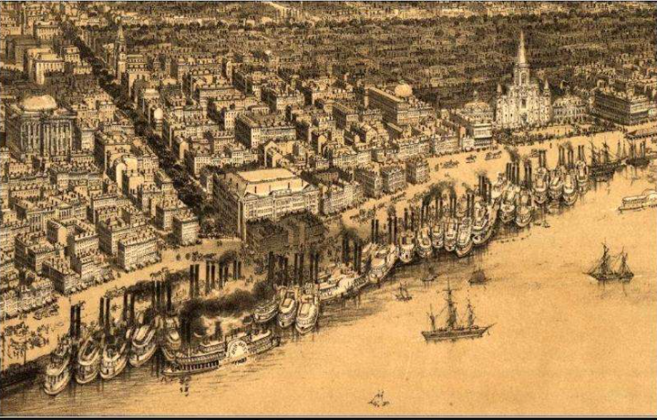

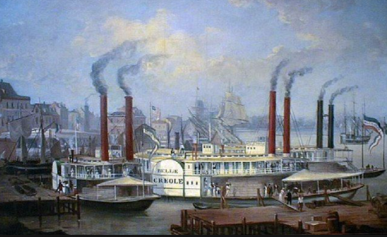
As has been mentioned previously, during the years our Smith’s crossed the Atlantic the port of New Orleans was their destination. By 1840 New Orleans had already become the second most active port in the United States. Nearly eighteen thousand Saints passed though the New Orleans between 1840 and 1855.
When Thomas and family arrived in New Orleans May of 1853 there was Yellow Fever epidemic raging. By the end of 1853 nearly 10% of the inhabitants of New Orleans had died from one disease or another. Luckily the saints, for the most part, were in and out of the Port of New Orleans within two days of arriving there.

This message was written in the “Mormon” newspaper published in St. Louis from November 1854 to December of 1855 called, “The Luminary”. “In every seaport of any consequence in this country and in Europe, emigration agents are located to give information to the inquiring, and to aid those who desire to go to Utah, and arrange for their safe and speedy transportation.”
There were agents to assist our Smiths in Liverpool, again in New Orleans and Saint Louis to assist them on the next leg of their journey to Zion.
Emigrants receiving assistance from the Perpetual Emigrating Fund were advised to “go directly through to Utah.” All others were to concentrate at St. Louis and report themselves at the Luminary office (late 1854). Of course, Thomas and family arrived in 1853 before Luminary was in existence but I am sure they were directed to report to the Conference President. It would appear in fact that the Conference President, Horace S. Eldridge was on the dock waiting for the Emigrants traveling on the St. Nicholas since they were on their way to Keokuk the same day they arrived in St. Louis.
Elder John Brown was the Emigrating Agent in New Orleans when Thomas and family arrived and he accompanied the Falcon saints up the Mississippi on the steamer, St. Nicholas. From what I read from various journals from that day the cost of the fare from New Orleans to St. Louis on a steam ship was $2.50 per person including luggage for adults and $1.25 for children. The PEF and £10 passengers had their fare included already.
Riverboat travel was perhaps even more dangerous that sailing across the Atlantic in the 1850s. Below I share a descriptive narrative regarding steamboat travel on the Mississippi and the Missouri Rivers:
Most steamboat captains loaded cargo and animals first and then passengers took up whatever place they could on the deck,"… "The deck passengers were just regular people who had to bring their own food, they took their chances with the elements; they basically lived outside."
Historian Paula Rose, who works in education and preservation at the Steamboat Arabia Museum in Kansas City, describes the journey of deck passengers this way:
"You were riding right alongside the hot boilers, you were riding alongside livestock and other passengers, it was very crowded, sweaty, dirty, smelly – it was not a fun way to travel, but it did get you out west," Rose said. "And you might be able to start a new life."
Meanwhile on the upper decks, the cabin passengers paid many times the amount that the deck passengers did, but had their own private room and a very different experience. They ate in stately dining rooms, were served cuisine on par with the finest hotels. They drank in bars with gambling tables, or lounged on the deck and watched the river.
"There were two absolutely different experiences on a steamboat and that also reflected the class structure of the United States at large at that time," Rose said.
But regardless of whether you were rich or poor, the river was dangerous. Carol Lewis grew up in Hannibal, and was raised to respect and fear the river.
"It's dangerous. My parents ingrained in me, you don't go on the river," Lewis said. "The current is strong and look at all the debris. But I love the river. It's pretty, it's big, it's mighty."
In the early 19th century, this would have been a hazardous trip, particularly when traveling on the Missouri.
"The Missouri River was notorious for eating boats," Capt. Terry said. "The average lifespan of a newly built steamboat back in Sam Clemens’ [Mark Twain's] era was two years. On the Mississippi river, it was four to five years."
We are reminded that another famous author was alive at this time. His stories of Tom Sawyer and Huckleberry Finn told of their exploits on the Mississippi. Samuel Clemens was born November 30, 1835 and died April 21, 1910. Clements would have been 17 years old when Thomas and family traveled up the Mississippi.
"There were about 289 steamboats that sank or possibly more on the Missouri River in the mid-19th century," Rose said. "The Arabia sank by hitting a tree snag, which was very common, but also boiler explosions were common and people would die in those situations."
I am not sure how much livestock our saints had to deal with on their steamboat trip up the Mississippi since the Mormon Emigration Agents would charter a whole boat for the journey but it would still have been crowded, dangerous and smelly. I am sure our PEF passengers did not get the luxury of an upper deck cabin but vied for space on the lower deck.
Frederick Piercy, the artist and writer mentioned earlier, traveled up the Mississippi just about six weeks before Thomas and family traveled the same river. He referenced a cost of $12 – $15 for a cabin room on the riverboat he took up the river. He also mentioned the crowded conditions on the decks below where emigrants lived for a week while going up the river.
From James Jack’s journal we get this detailed day by day account we see that the saints from the Falcon left New Orleans at 6 o’clock p.m. on Friday May 20, 1853d after spending two days in New Orleans. It would appear that the Saints spend the night of the 18th on board the Falcon. On the 19th their baggage was transferred to the St. Nicholas so the saints would have spent the night of the 19th on board the St. Nicholas. They then started their journey toward St. Louis on the 20th.
It took a little less than seven days for the St. Nicolas to travel the 1100 miles or so from New Orleans to St. Louis. Records indicate that Mississippi steam ships could average about 220 miles upriver in a 24 our period.
Again the Journal of James McNaughton gives us additional detailed information regarding this company of saints trip up the Mississippi river.

Friday May 20th 1853. at 6 o'clock p.m. we sailed from New Orleans for St. Louis on board the steamer, "St. Nicolas." Elder Brown our Emigrating Agent accompanying us.
Friday May 27th 1853. At 30 minutes past 4 a.m., we arrived at St. Louis. Met with our agent, Elder Eldrige, [PROBABLY, Eldridge] & got all our luggage on board the Packet "Die Vernon" then sailed for Keokuk at 4 p.m. same day.
As a result of a tragic accident we have a good description of the steamer, “St. Nicholas. She was a sidewheel steam ship rated at 666 tons, a wood hulled Packet measuring 264.7 feet long x 35.5 wide x 7.3 draw. Built in 1853 and destroyed by boiler explosion and fire on April 24, 1859. Sixty people lost their life.” (Berman 1972, 290).
This steam ship must have been almost new when Thomas and family travel from New Orleans to St. Louis.
The accident encountered by the St. Nicholas steamship was by no means an abnormality. Between 1810 and 1850 more than 4,000 people were killed or injured in steamboat disasters, and 576 boats were lost on the western rivers. The Falcon saints all arrived in Saint Louis without incident.
Below is a photograph of a large 1850 era side paddle steam boat on the Mississippi River. The St. Nicholas was probably about this size.

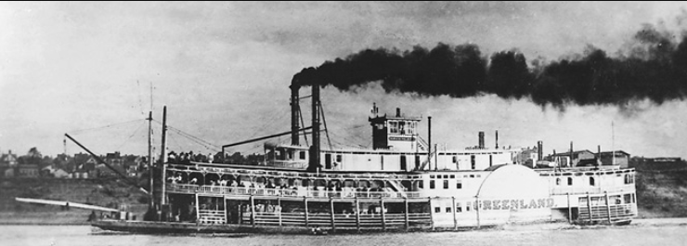

Here is one more photograph of a smaller side paddle steamship on the Mississippi.

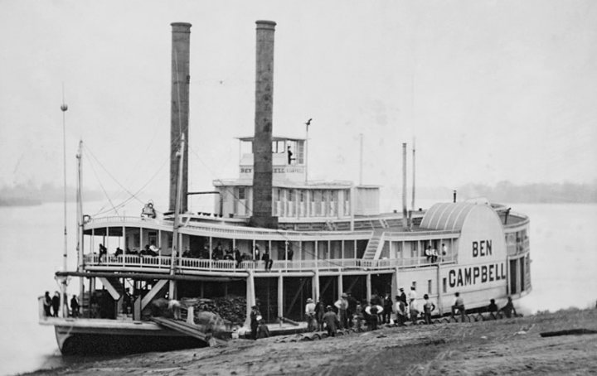

I found a couple of sketches and painting of St. Louis from the 1850s. They provide an idea of what our Smiths might have seen upon their arrival into the city of St. Louis, Missouri.

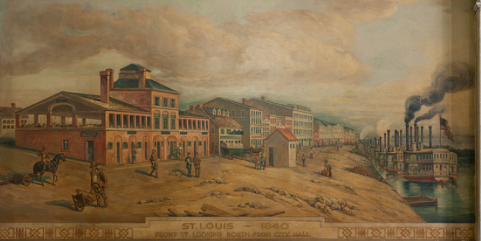
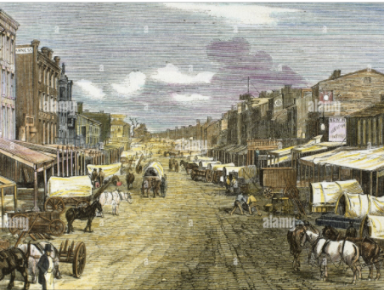

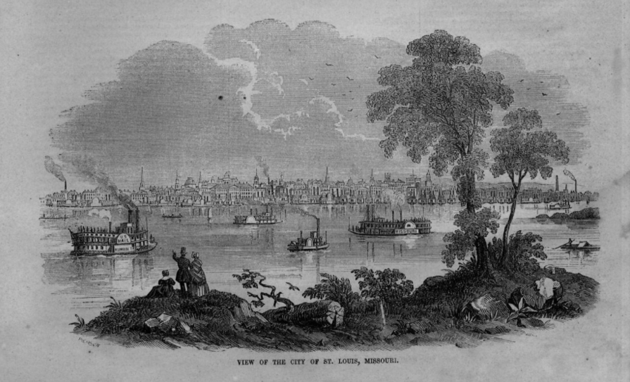

This daguerreotype of 1852 St. Louis probably shows a true depiction of the number of riverboats traveling up and down the Mississippi River in the 1850s.
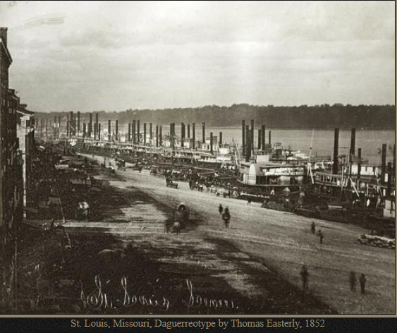

According to James Jack’s records the saints continued morning and evening prayers each day as they traveled up the Mississippi River toward St. Louis.
Friday May 27th 1853. At 30 minutes past 4 o'clock morning we arrived at St. Louis saw Elder Eldridge and got all our boxes on board the Packet "Die Vernon" and sailed for Keokuk at 4 o'clock afternoon.
Saturday May 28th 1853. At 4 o'clock afternoon we arrived at Keokuk and stopped in the depot all night.
Sabbath May 28th 1853. We got all our luggage taken up to the camp got our tents pitched and our companies organized. [p.62]
May 30th, 1853, Monday: We got a week’s provisions served out to us, of 7 lbs. flour and 1 ½ lbs bacon to each individual wkly (weekly). President Bagnall gave in his report to Elder Height and delivered over the balance of the money he received from S. W. Richards to him.
James Jack goes on to describe how five Priesthood holders were put in charge of four tents each and an Elder Walker was put in charge of 3 tents of the £10 company. They kept the emigrants together that were traveling via the £10 companies because they received few provisions as per their agreement. I pointed out earlier that the £10 companies soon realized that they could not be provisioned properly on the amount. We know that the following year it was increased to £13 and still found insufficient. These experimental plans were abandon altogether after 1854.
I would like to think that those 3 tents of saints were treated fairly and they shared what provisions there were available to the Company.

Staging sites for overland travel

I am going to take another step back here to review the many “Outfitting sites chosen by the Church to stage the saints for the trek across the plains.
The outfitting location for the trek west was changed from year to year. From 1840 to 1846 immigrating saints worked their way to Nauvoo, the headquarters of the Church at that time. In 1847 and 1848 the Saints were gathering at Winter Quarters in Nebraska. Once the main body of the Church was settled in the Great Salt Lake Valley the call went out for all members of the Church to “Come to Zion”.

In 1852 the saint gathered in Kanesville, Iowa to outfit themselves for the trek to Utah. As the saints got the word to come to Utah many of the Kanesville saints abandon their homes and joined the Trek West. The remaining non- mormons in Kanesville changed the name to Council Bluffs and trying to take advantage of the Westward movement by raising prices on needed supplies to outfit the saints. This caused the Church to again change their outfitting location in 1853. They chose Keokuk, Iowa. The advantage of Keokuk was that it was a Mississippi River port; and only one more day travel by riverboat. Church officials wanted to avoid not only the inflated outfitting costs at Council Bluffs, but also the treacherous Missouri River itself. The previous year, Latter-day Saints had experienced the worst maritime disaster in the history of Mormon migration when the boiler on the steamboat Saluda exploded, killing more than two dozen Mormon converts. A disadvantage was that it was 350 miles in the wrong direction from Great Salt Lake.

During the Spring and Summer of 1853, more than 2,500 Mormon emigrants would swell the population of Keokuk, which was estimated at about 3,000 before their arrival. The authorities and people of Keokuk co-operated with the Mormons and rendered them every assistance and at Sugar Creek a field of 2000 acres was offered to the emigrants for pasture for their livestock. The Church only used Keokuk for the emigration in 1853. Costs for Cattle was high in and around St. Louis and Keukuk added 300 miles to the western trip. The Church was advised that better ships were now being used to navigate the Missouri River. The Church leaders opted to use the Missouri once again and chose West Point Missouri for their staging place in 1854.
For completeness I show below all of the staging sites chosen and used by the Church and the year(s) they were used to gather and outfit the saints for their trip west.

Until 1845 they went straight to Nauvoo, Illinois. Afterwards these other points of departure were developed:
- Winter Quarters (later Florence), Nebraska, 1846–48
- Kanesville (later Council Bluffs), Iowa, 1849–52
- Saint Louis, Missouri, 1852
- Keokuk, Iowa, 1853
- Westport, Missouri, 1854
- Mormon Grove, Kansas, 1855–56
- Iowa City, Iowa, 1856–57 (There was no formal immigration in 1858 because of the “Utah War.”)
- Florence, Nebraska, 1856–63
- Saint Joseph, Missouri, 1859
- Genoa, Nebraska, 1859
- Wyoming, Nebraska, 1864–66
- North Platte, Nebraska, 1867
- Laramie City, Wyoming, 1868
- Benton, Wyoming, 1868
Below is a map showing the Saints Departure points and route west:
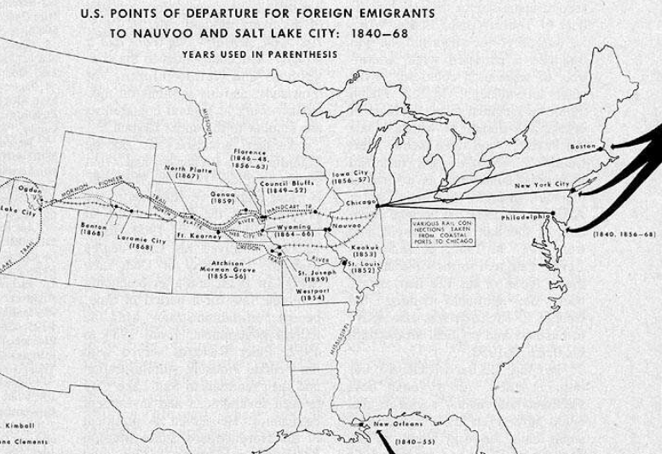

What do we know about Keokuk, Iowa?

These excerpts are from The 1853 Mormon Migration through Keokuk
By FRED E. WOODS AND DOUGLAS ATTERBERG
Keokuk is just twelve miles downstream from Nauvoo. Keokuk was chosen as the outfitting location for the saints starting the trek across the plains toward the Great Salt Lake in 1853. That prime location and adjacent acres swarmed for three months with Latter-day Saints encamped there in 1853 to join Church wagon trains being outfitted for Utah. Artist Frederick Piercy was there, and his drawings and writings and others’ diaries depict a vast tent and wagon camp sprawling along that bluff top. There, between late March and early July 1853, Church emigration agent Isaac C. Haight and his assistants blended together 2,548 Saints, 360 wagons, 1,440 oxen, and 720 milk cows to create ten wagon trains that rolled successfully some fourteen hundred overland miles to Utah by mid-October.

Below is a sketch of Keokuk by Frederick Piercy. You can see the tents along the top of the bluff leading down to the Mississippi below.
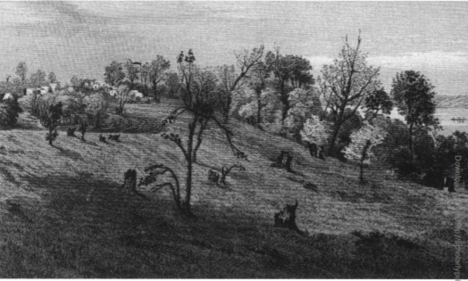

As I have mentioned three on-site Church agents in America directed the 1853 LDS emigration. At New Orleans, John Brown met the sailing ships from Liverpool and helped Saints transfer to river steamers. St. Louis agent Horace S. Eldredge helped them board boats going up to Keokuk. At Keokuk, Isaac Haight directed the outfitting and departures; and, by May, Elder Eldridge came up to Keokuk to help him.
Late in 1852 Elder Haight was busy assisting LDS travelers in England. On February 8, 1853, Elder Eldridge noted Isaac Haight's arrival from Liverpool. Haight and Eldridge then began to prepare for the emigration season, purchasing 14 wagons for $58.00 apiece from St. Louis. While Eldridge spent the bulk of his time supervising migration in St. Louis, Haight headed upriver to play a prominent role in migration matters at Keokuk. Haight not only selected the site for the 1853 Mormon encampment, but he was also involved in local business transactions to prepare for the incoming emigrants. Haight made the following notes in his journal in the early spring of 1853
March 24 Thurs. Started with 50 wagons up the Mississippi River.
March 25 Fri. Arrived at Keokuk, looked out for a location on the bluff north of the town.
March 26 Sat. Bot [Bought] 8 yoke of cattle at Alexandria.
March 28 Mon. Went out in the country to find a place to keep our cattle. Mr. Porter kindly offered to let me keep them on his land back of Montrose, the principal men of Keokuk were pleased to have me fit out the Emigrants at that place. In the evening started for St. Louis.
March 30 Wed. At St. Louis found a company of Saints, got them aboard the steamer Hindoo for Keokuk.
March 31 Thurs. Made a contract with Mr. Ames for bacon....
April 5 Tues. Contracted with Isaac Henry of Ill. To purchase me 280 cows at $21.50 per head. Started for Keokuk.
April 7 Thurs. Arrived had a meeting with the Saints, gave them much instruction, had much of the spirit my heart rejoiced in the Lord to see his Saints gather home.
This camp was said to be “situated in an unsettled land with considerable timber and an open range where the campers turned the stock to feed and there were woods nearby where firewood was free for the taking. Haight gained permission on 28 March 1853 from a Mr. Potter to use his field of two-thousand-acre to locate the saints as they waited to travel west. This field was two or three miles west of Montrose, along Sugar Creek
With camp and grazing grounds reserved, Elder Haight next tackled five major tasks:
(1) arrange how to temporarily house and feed emigrants whenever they arrived;
(2) provide for the emigrants’ spiritual needs while in camp;
(3) purchase wagons, oxen, and milk cows for the wagon companies, herd those to the grazing grounds, and obtain equipment and provisions for the wagon trains;
(4) group the emigrants into workable-size wagon trains and appoint captains and officers for each train; and
(5) manage the emigrants’ funds and keep accurate financial accounts.
Haight enlisted several of the arriving emigrants to help him. There were, between January and early April 1853, eight tall sailing ships from Liverpool that brought brought 2,586 Mormons to New Orleans. A few stayed there, but most moved up the Mississippi River on steamers to St. Louis and then to Keokuk.
Also gathering to Keokuk were Saints residing in St. Louis and converts from the United States and Canada. Most Saints reached Keokuk on steamboats belonging to the Keokuk Packet Line, after a twenty-four hour trip from St. Louis, two hundred miles away.
Sometimes, though, frontier conditions created hardships for the emigrants. Upon arrival at Keokuk, Hannah Cornaby described the Mormon encampment on a hill near the Mississippi River. Here we found the wagons and tents. We had just placed our baggage in the wagons; some were making awkward attempts at erecting tents while others were trying to place the covers on the wagons, some of which obstinately refused to reach over at both ends, when we were struck by a furious storm of wind and rain, accompanied by thunder and lightning such as we had never heard or seen before. The storm raged with such fury that we feared the wagons would be upset, and after the wind subsided, the rain poured down incessantly three days and nights, our luggage and bedding becoming thoroughly soaked, and the camp ground ankle deep with mud. Under these circumstances, my second child was prematurely born.
That last statement made by Hannah reminded me that Margaret was 8 months pregnant herself when they arrived in Keokuk at the end of May of 1853. Continuing from the excerpts from “The 1853 Mormon Emigration through Keokuk” we find more difficulties just getting started across the plains:
The British immigrants also had a difficult time with the animals. Hannah Cornaby vividly recalled, "The oxen were wild, and getting them yoked was the most laughable sight I had ever witnessed; everybody giving orders, and nobody knowing how to carry them out. If the men had not been saints, there would doubtless have been much profane language used; but the oxen, not understanding 'English,' did just as well without it. Most foreign converts had a trying time once they began their westward trek from Keokuk. One emigrant stated, "The Saints generally thought the way to Zion was a hard road to travel but found out later that they were not up against the real thing until they began to outfit for the plains and come in contact with a herd of wild Texas cattle with horns like a rainbow.
The 1853 Mormon Migration through Keokuk FRED E. WOODS AND DOUGLAS ATTERBERG
I don’t know what the Immigration Agents got paid or if they received anything besides room and board but what wonderful servants they were to the emigrating Saints. Again we read from these exepts:
From James McNaughton’s Journal we get this information regarding the saints from the Falcon as they entered Keokuk.
Saturday May 28th, 1853. 4 o'clock p.m. we arrived at Keokuk & after seeing Elder [Isaac C.] Haight, Wheelock, & Lyon we stopped all night at the depot.
Sabbath May 29th 1853. Early in the morning wagons were sent down from the camp & took up our luggage to the camping ground. Here we had the unspeakable pleasure of being in the camp of Brothers Barnes & Allen, from Hull and of seeing their families. What a meeting!
Sabbath June 5th 1853. Meetings were held for public worship at the camp ground, at past 10 a.m. & at 4 p.m. The Saints were addressed by Elders Harmon, & McNaughton.
Sabbath June 12th 1853. Meetings were held on the ground at past 10 a.m. Addressed by Brother Haight in the afternoon by Elders Haight & McNaughton. In the evening a testimony meeting was held where many of the Saints bore testimony. These were good times, on both Sabbaths. The Lord truly blessed us.
Monday June 13th 1853. A month's provisions were served out. Flour, bacon, sugar, soap & saleratus; each wagon a washtub, bucket, [-] pan, baking kettle, a whip & a hatchet between 2 wagons.
Wednesday June 15th 1853. In the morning got everything packed up, our oxen yoked, hitched on and moved off at past 9 o'clock a.m. Camped in the afternoon after traveling 9 miles. Elder Harmon leading the company. . . . [p. 39]
. . . October 16th 1853. Our train & also captain Brown's got into Great Salt Lake City. It being Sunday the meeting was convened in the Tabernacle not withstanding we were met by many of the natives & old acquaintances. . . . [p. 40]

A Side Trip to Nauvoo

I have one more entry from the Autobiography of James Ririe that reminds us of the time period when all of this is happening:
On Sunday (probably June 5th 1853) about 20 of us went across the Mississippi River to Nauvoo. We saw the ruins of the Saints’ homes, the ruins of the Temple and we visited the Nauvoo Mansion. We saw Mr. Bidamon, the man who married Emma Smith. We saw Lucy Smith, the Prophet’s mother, and also Emma. We also saw his three sons, Joseph, Frederick, and David. David was in his 9th year and Joseph was 21. This was about the first of June 1853.
Near Montrose, we lightened up our loads. The understanding before we left Liverpool being, that each 10 Pound Company would have a wagon, for oxen, two cows, and each could take 100 pounds of luggage besides being furnished enough provisions for the journey. But we had to take twelve in a wagon and consented to reduce our extra luggage to seventh five pounds and if possible to fifty. There was no way to hire our extra luggage taken to the Valley so we burned the boxes and extra weight. We put our clothes in sacks.
Could our Thomas have been one of those 20 that visited Nauvoo? What an experience that would have been for those few saints to visit Nauvoo and visit with Emma and Lucy and the others!
Sketch of the Nauvoo Temple Ruins drawn by Frederick Piercy 1853.

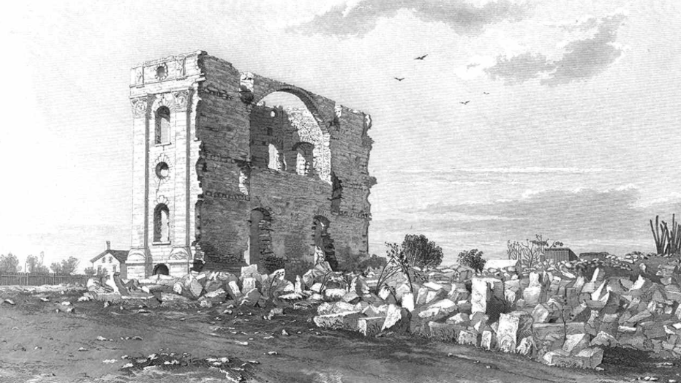

While visiting Nauvoo in 1853 Frederick Piercy met and sketched Joseph Smith’s mother, Lucy Mack Smith.
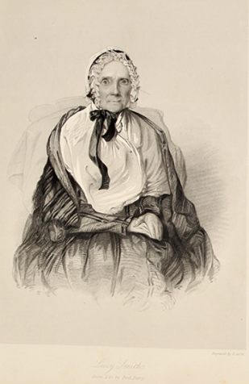

Another sketch of Nauvoo from across the Mississippi drawn by Frederick Piercy in 1853.
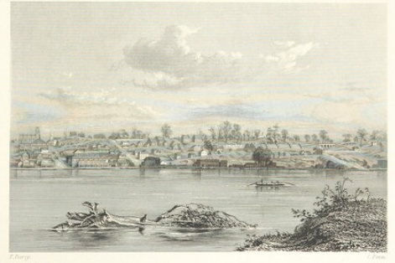

Outfitting

PEF Emigrants were assigned 10 person per wagon. Each wagon had two yoke of oxen and two cows. In 1852 the cost of that outfit was about £40. Just a year later the cost had risen to £45. The California and Oregon emigrants traveling west increased the demand for outfits as did the increasing number of Saints crossing the plains.
The wagon was 12 feet long, 3’ 4” wide and 18” deep. And they were meant to carry loads of up to 2000 pounds. The Church decided that these “lighter” wagons were better suited for the rough terrain and the ups and downs of the hills and mountains. As a mentioned earlier the tents they were to inhabit on the plains were made by the emigrants themselves while sailing across the Atlantic. The covers for the wagons were also made while at sea. These were made from superior twilled cotton procured in England prior to the voyage. It took 44 yards of 27” wide cotton for the tent and another 26 yards to make the cover for their wagon. The cost of the twilled cotton was reported to be about 2 guineas (£2.1)(about $9.00). These PEF wagons were furnished with:
1000 pounds flour
50 pounds of sugar
50 pounds of bacon
50 pounds of rice
30 pounds of beans
20 pounds of dried apples and peaches
5 pounds of tea
25 pounds of salt
10 bars of soap
1 gallon of vinegar
It has been suggested that most of the emigrants got better food on the plains than they did back in their home country. But I will say, it came with a lot of hard work and often Companies ran low on supplies by the end of the Journey and rations had to be cut until addition provisions could be procured.
In addition to the food stuffs each adult emigrant was allowed 100 pounds of luggage which included there bedding and clothes. Children under 8 years of age were allowed 50 pounds of luggage. By the time George and family came across the plains the personal luggage allowance had been reduced to 50 pounds each.
Let’s talk about the oxen for a moment. What exactly is an ox anyway? If a young male Bovine is castrated he becomes a steer. If not he becomes a bull. A steer can be trained to become a useful draft animal. Ox is a term for such an animal when it reaches about four years of age. An oxen can grow even larger than a bull in adulthood but maintain a mild temperament.
Why were oxen chosen over horses or mules as the best draft animal to use to cross the plains? First was cost; Oxen were by far the cheapest animal. A ox could be purchased for around $40 whereas a good horse could cost $250 or more a good mule was a little less.
Second, Horses and mules had to have grain as supplemental feed to the prairie grass. A ox did just find on grass and water. Third, Indians loved to steal mules and horses but had no use for an ox other that, perhaps, to eat it.
Here is a photograph of a yoke of oxen:
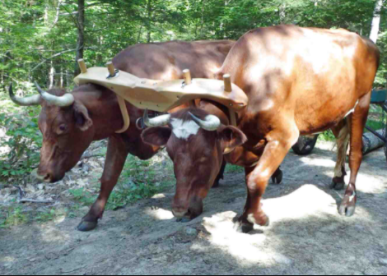
And here is a closer look at the actual yoke used on the oxen:
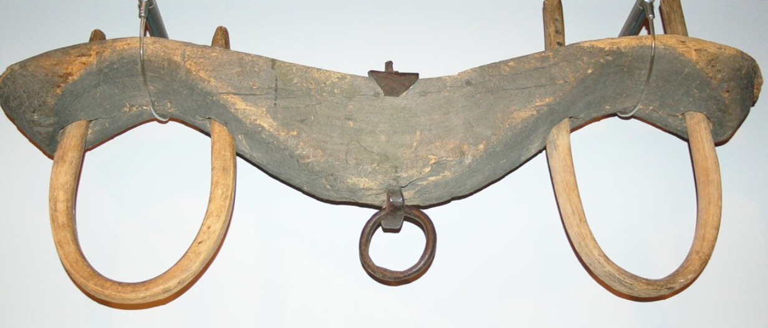
So, each morning your oxen had to be yoked together and then hitched to your wagon. At the beginning of the journey it was said to be quite a process to get the oxen corralled, yoked and hitched. This process had to be repeated at the noon stop so the oxen could get water and grass. And then reversed at night to water, graze and rest. Then start over the next day, seven days a week generally for four months in Thomas’ case and three months for George.
Here is a photograph of a two yoke oxen team and wagon that was perhaps typical of what the pioneers used to cross the plains. Notice that the driver is not up in the seat but walking alongside his ox team. He is walking with his team to his right side. He is also holding a “buggy” whip in his right hand. The whip was used to help command the oxen along with voice signals. A shout of “Haw” to the oxen meant for them to go away from the driver while “Gee” meant go toward the driver. Further, the whip over the neck meant to Haw and a whip over the back meant to Gee.
You can imagine our Smith’s after having seen oxen for the first time in their life trying to drive a two yoke wagon. Not much could have been more foreign to them.
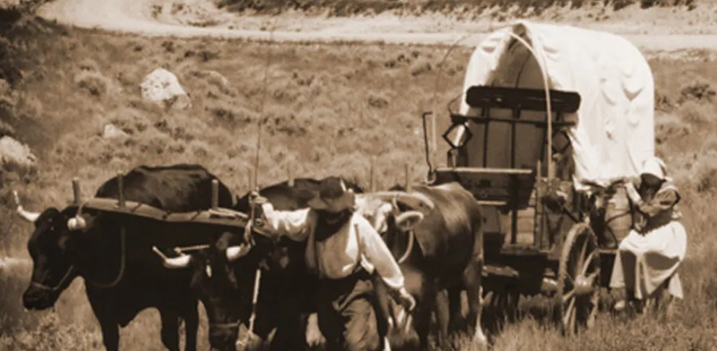

Crossing the Plains (Thomas and family)

We are now ready to address Thomas and family getting across the plains and finally arriving in the Great Salt Lake Valley.
When Thomas X and his wife and Lucy embarked for Salt Lake on June 15, 1853 from Keokuk. They were part of the Appleton H. Harmon Company. Here is what we know about the Company in general from the Church’s official website:

Appleton M. Harmon Company

Departed On 1853 June 15

Departed From Kanesville, Iowa

Arrived On 1853 October 16

Vehicle Type Wagon

Company Type Church Train

Company Direction Westbound
About 200 individuals and about 22 wagons were in the company when it began its journey from the outfitting post at either Keokuk, Iowa or Kanesville, Iowa (present day Council Bluffs). This company crossed the Missouri River on 14 July 1853.
The company departed 15-16 June 1853.
Based on journal accounts including Secretary, James Jack, The Appleton M. Harmon Company did, in fact, depart on June 15, 1853 from Keokuk (not Kanesville) Iowa at 9 O’clock a.m., with but with 23 tents according to James Jack’s journal.

Not only did James Jack hold the calling as Secretary for the emigration company aboard the Falcon but he carried on with these responsibilities as the majority of his same “Falcon” company came across the Plains under the direction of Appleton M. Harmon. His journal is a treasure, remembering that his primary focus was to record the Emigration from the Church/Priesthood perspective. Even with that focus there is a remarkable amount of invaluable information useful to this study. Perhaps the most important piece of information our family got from James Jack’s journal is shown below:
July 4, 1853, Monday: We started and traveled 13 miles to our noon halt. Watered our cattle and moved on 6 miles and camped making 19 miles during the day. At 4 o’clock p.m. Sister Thomas Smith was delivered of a son (Orson Gurney Smith) under the care of Sister Robert Orr, wagon stopped 4 miles from camping ground.
These are also entries from James Jack’s journal:
Monday May 30th 1853 We got a week’s provisions served out to us, of 7 pounds flour and 1 ½ pounds bacon to each and individual [-]. President Bagnall gave in his report to Elder Haight and delivered over the balance of the money he received from S. M. Richards to him.
Tuesday May 31st 1853 The clerk was instructed by President Bagnall to call a meeting of the priesthood as 2 o’clock. President Bagnall, moved that a president be appointed for each tent and that the persons whose names are first on the tickets they have received by appointed for the present council. Moved by Elder [James] Bishop, that there be 6 presidents appointed over the 23 tents Moved by Elder Cowdey [Cowdy that Elder Joseph Gray be appointed to take the presidency of the first 4 tents carried. Moved by President Bagnall, that Elder Walker by appointed to preside of the 3 tents of the Ten Pound Company carried. . . . [p.63]
Since ten people had to share a wagon west smaller families had to join together. This wasn’t always a match made in heaven. I found this example I thought was kind of funny:
“They invited a Butler family—a couple with six or seven children—to join them. Two Butler children and the Bagnall boy were small, so, Forsdick said, “we averaged ten adults.” (He added that many times during their trip to Utah, he and the Bagnalls wished they had enlisted other family. “Butler was a shoemaker and was fit for nothing else, while his wife was entirely out of her element on the plains. They had two good sized boys, but one of them was too lazy to eat, and other one, Jack, did fairly well.”
With our Thomas being a Straw plaiter or dealer and Margaret 8 ½ months pregnant with an 17 month old, I wonder if they were looked upon as the shoemaker was. They were certainly out of their element but I suspect they were not lazy and tried to do their share!
At one point in the summer of 1853 there were about 3000 emigrants camped in that large field in Keokuk. Some of the campers organized themselves by nationality. Germans, Scandinavians, Danish, British, etc. Others may have stayed together as a “ship” company.
While the Saints were encamped at Keokuk good health as a rule prevailed among them; also a most excellent spirit, and one of the Elders writes that it certainly was a great pleasure to walk through their camps in the evening, and hear their songs of praise and humble petitions as they offered them up from their tents and wagons.
Living was “very cheap” at Keokuk, William Clough noted, where flour cost 2.5 cents a pound, forty-eight eggs cost 25 cents, and beef from 5 to 7 cents per pound. In camp, they received a weekly allowance of twenty-one pounds of “excellent flour.” They gathered fire wood and made tent poles and pegs from the nearby woods. They got their water from a nearby stream.
Many of the emigrants were able to work in Keokuk while waiting for their Company to move out. Here are a few example found in the work by William G. Hartley, “LDS Emigration in 1853: The Keokuk Encampment and Outfitting Ten Wagon Trains for Utah”
Piercy said he saw few idlers in the encampment. Those who could got work in Keokuk at their trades, Piercy learned, and others worked on the city roads. Such work helped emigrants add “little comforts” for their journey. Sarah Birch “secured work in the town so I could earn enough to purchase a few things I needed, before starting.” Keokuk’s wages ranged from $1 to $2 per day. Scotsman James Ririe (from our ship the Falcon) said he and Adam Smith worked fourteen hours one day at Keokuk unloading a boatload of salt for $.3.50, “the biggest money I ever made in one day.”
I wrote earlier of James Ririe’s visit to Nauvoo. He and the 20 or so that went with him was apparently not all who made the trip to Nauvoo while waiting to travel west. Here are some other accounts from the work quoted above:
While waiting for teams, some Saints took time to explore. Quite a few, converts after the Church had deserted Nauvoo in 1846, visited Nauvoo. Sarah Birch saw the ruins of the temple and visited with Lucy Mack Smith, the Prophet’s mother, and Emma Smith Bidamon, the Prophet’s widow. Artist Piercy went to Nauvoo with eight or ten others. Stephen Forsdick said that “a lot of us concluded that we would visit Nauvoo,” so they ferried across from Montrose and “visited the house that Joseph Smith built.” They “found his widow living there, but she had married again. She told us that Brigham Young had no right to lead the church, that he was a false prophet.” Forsdick’s reaction? “They might just as well have tried to turn the Mississippi River upstream as to make us believe that. Our faith was too strong.” James Campbell Livingston, before the Harmon ox train left Keokuk, was guarding a cattle herd opposite Nauvoo. He crossed over and met Emma Smith’s husband, Major Bidamon, “who took us in his carriage and showed us the residences of Brigham Young and several of the Twelve Apostles and also Joseph’s farm. The temple was burned, but part of the walls were standing and we were much interested even in the ruins.” Twenty year-old John V. Adams and three friends visited Nauvoo and “viewed the ruins of the great portion of the city and Temple.
Again from William Hartley’s work we find that Elder Haight chose 10 wagon masters to take the saints west, one wagon company at a time as quickly as wagon, oxen, cows and provisions could be obtained. Appleton M. Harmon being chosen to head up Thomas’ wagon train. Here is a little information regarding Appleton Harmon:
Appleton Harmon (33) was born in Pennsylvania on 29 May 1820. He had lived in Nauvoo, had crossed Iowa during the Mormon exodus, and had gone to Utah in Brigham Young’s 1847 pioneer company. A skilled mechanic, he earned a place in history by constructing an odometer that the 1847 pioneers used to measure distance. He went east on the Mormon trail in 1850, heading for England. At Keokuk, he was returning from that mission.
The John Brown Company (the last company to leave in 1853) started west on July 1 with 10 wagons. According to James Jack’s detailed journal the Brown company had caught up with the Appleton Harmon Company on 27th of July. They appeared to travel near each other for the rest of the journey west. On the 21st of August the Brown Company passed the Harmon Company while the latter was camped for the day. There were journal entries of helping the Brown Company fix a wagon, etc. during the journey.
You may recall that John Brown was the Emigration Agent in New Orleans who met the Falcon Company and joined up with them coming up the Mississippi aboard the St. Nicholas.
John Brown (32) was born in October 1820 in Tennessee. He had lived in Nauvoo. He led a group of Saints from Mississippi west in 1846, returned to the South, and then served as a captain of ten in the original 1847 pioneer company. He was a Perpetual Emigrating Fund Company agent in the states in 1850 and then returned to Utah. As noted, he had been the Church’s emigration officer at New Orleans early in 1853.
I made the notation earlier that I didn’t know what these Emigration Agents were paid but whatever it was it wasn’t enough. Here is some praise Esaac Haight received from Joseph Young (a nephew to Brigham Young and one of the 10 captains chosen) for his efforts to get the saints in Keokuk outfitted, organized and sent off across the plains:
“No one can form a correct idea of the perplexity of fitting up a company of people who are unacquainted with traveling for a journey over the plains,” Captain Young assessed. “God alone is able to reward those who act for the good of the Saints from foreign nations. Elder Isaac Haight is worthy of the highest praise for his untiring zeal in trying to make the Saints comfortable.” Elder Haight’s grand finale as agent-in-charge was sending off the wagon trains from Keokuk.
Brother Haight organized the saints into companies including trying to keep Nationalities together as well as some of the original ship companies somewhat together. Thomas’ Company (The Appleton Harmon Company) was comprised of 23 wagons and about 200 emigrants. The John Brown Company had 10 wagons from the £10 Emigrating Companies and PEF emigrants. I am thinking that these two Companies carried a majority of the Falcon Emigrants west. There were a total of 324 saints aboard the Falcon. Captains Brown and Harmon definitely knew each other and were probably friends. Both had traveled west with the original Brigham Young Company in 1847 and had crossed the plains more than once.
Our Smith’s had spent 17 or 18 days living in this tent city waiting for their turn to head out. For whatever reason, their company was the next to last to leave Keokuk. Finally their time was at hand.

From James’s Jacks’ journal we read:
June 15, 1853, Wednesday: In the morning we got everything packed up for starting. Got our oxen yoked, and put (everything) into the wagons and moved on at ½ past 9 o’clock. We camped in the afternoon after traveling 9 miles.
June 16th, 1853, Thursday: …. By the time the companies were organized a constable from Keokuk had come to the camp and found a pair of oxen with ours, not belonging to us, which had been driven along by mistake and president Harmon was arrested under a charge of larceny and taken before Squire Stobbs, Keokuk. He called for an adjournment until 2 p.m. the 17th and he had to deposit 160 dol(lars) as security for his appearance. Stopped all day.
Their wagon train got off to a rather slow start with the oxen incident and a couple of days later Appleton was again appearing before a magistrate because of an unsettled debt over metal shoes for his oxen. The debt of $24.95 was settled and the shoes were delivered. But in the first five days they had only covered 31 miles. This may have been a blessing as it gave the many inexperienced emigrants time to adjust to driving ox teams, living out of wagon boxes, putting up tents and pulling them down again. Watering their livestock three or more times a day. Etc.
After just a week on the trail they were directed to rid themselves of all excess baggage since the oxen were having a difficult time pulling the heavy wagons. They put their clothes in cloth bags and disposed of heavier wooded boxes and hard side luggage. Journal entries made mention of folks abandoning books and other heavy items that were going to slow them down.
After their first week they were averaging perhaps 15 miles per day. They rose early each morning and were prepared to begin the day’s journey around 7:00 a.m. They had traveled 215 miles by July 4th. As reported above this is the day Orson Gurney Smith was born at 4:00 p.m. in the afternoon as recorded my James Jack. His journal indicated that Margaret was assisted with the birth by Mrs. Robert Orr. I researched the Orr family and they came across the Atlantic on the Falcon. Elizabeth was the wife’s name and they came across the plains with six children. It is possible the Orr’s were sharing the wagon with the Smith’s.
It took them until the 9th of July to travel the 303 miles to Kanesville (Council Bluffs) which had been the starting off point from 1849 to 1852.
In Council Bluff Appleton bought more provisions for his train. 100 pounds of flour for each wagon in addition to 10 pounds of bacon each, tea sugar and soup.
Some Sabbath days they would camp all day and others they would travel a few miles and then make camp. Appleton Harmon was an experienced wagon master making his third trip across the plains so he had a feel for how the provisions were holding out and how early or late in the season it was getting so he kept the wagons moving along as necessary without putting too much strain on the oxen and cows. There were reports of cows just up and dying on the road or being too weak to continue so they were left behind on the trail. Oxen, too, just failed to get up in the morning. Appleton bought oxen and cows along the way if they were available for purchase.
There were reports of cutting timber to make wagon tongues, and axle trees to repair the wagons as they constantly broke down during the journey. James Jack also noted cutting timber to make charcoal and tar. The tar was painted onto the feet of the oxen and cows to help mend their hoofs. Charcoal was used for cooking with Dutch ovens.
On July 16th there is another mention of the Smith Wagon while the ferry was being loaded to cross the Missouri River. I don’t know if that meant Thomas was in charge of that particular wagon or it was just his turn to drive the oxen. Thomas, Margaret, Lucy and baby Orson would have been sharing a wagon, and a tent for that matter, with at least one other family. Perhaps the Orr family as mentioned above.
On July 22nd there were six wagons from Kanesville that joined Appleton’s wagon train for the remainder of the journey. No additional specific mention was made to these wagons they were just absorbed into the Company. In addition to those that joined the train at least one wagon decided to stay in Kanesville.
On the 26th of July the platte River was crossed via a ferry costing each wagon $1.00 to cross.
On August 4th 18 trees were cut down to build a new bridge. Heavy rains had caused the river to swell requiring the new bridge. They built the bridge and still managed to travel 3 miles.
The company came across Indians on several occasions the further west they traveled. Most just begged for food which they received and some had shoe to trade for food.
A couple accounts of killing a buffalo for food was noted. Always the meat was cut up and shared amongst the Company.
On August 14th, the Sabbath, there was a burial of a 20 year old daughter who had been sick for years. A meeting was held where Captain Appleton admonished the Company to be more united and help each other and work together and they would be fine. Captain McNaughton also admonished a few in the Company for swearing. This was the only record made of any disaccord within the Company during the entire time on the plains.
On the 22nd, a Monday, it was reported that they came up on the Brown Company who had passed them the day before while they were camped for the Sabbath.
The 26th was one of two days during the journey where the Company traveled 20 miles or more in a single day. They started at 6:45 a.m. and walked along the Platte for 20 miles.
On August 30th they repaired a wagon in the Brown Company and camped a mile from Fort Laramie. Fort Laramie was owned by the Unites States Army and housed around 100 soldiers at this time. It was a good place to provision and perhaps have some down time of it could be afforded.
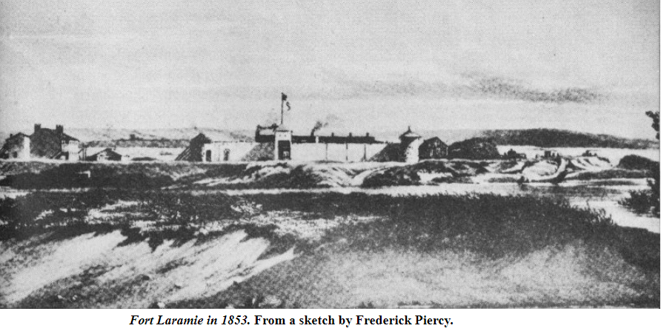

September 1st The roads were hilly and yet they traveled 22 miles (longest day of the journey).
On the 2nd there was a baby born. They put shoes on some of the oxen and put tar on the others. They also cut more wood to make more tar.
On the 6th a cow just up and died on the road.
On the 11th, a Sabbath, they met mail carriers from Salt Lake.
On the 15th they drove to Devil’s Gate and camped beside a trading post.
On the 16th another child was born.
On the 19th they passed four wagons of missionaries heading east. An ox died and a cow was left behind.
On the 20th a three day old baby died.
On the 23rd they were passed by the mail.
On the 29th there was an unusual entry. They sent 8 men ahead to attend Conference. I assume that meant they were sent ahead to the valley to attend the October conference.
On October 1st they met three men from Fort Bridger with flour to sell for $0.12 per pound.
On the 2nd, a Sabbath, they met two wagons from Salt Lake with flour.
On the 4th they met five wagons selling flour for sale for $0.15 per pound.
On the 5th they drove on to Fort Bridger.
On the 9th, a Sabbath, they met with some friends. I assume these friends came to meet them from Salt Lake.
On the 12th they were at the Weber River and mentioned two wagons were upset. I assume those wagons tipped over on rough and steep trail.
On the 14th they drove to the foot of Big Mountain.
On the 15th they started over Little Mountain.
On October 16, 1853, a Sabbath, they entered the Salt Lake Valley and camped in the public square after traveling the last 7 miles of their 1312 mile journey across length of 3 states and into Utah.

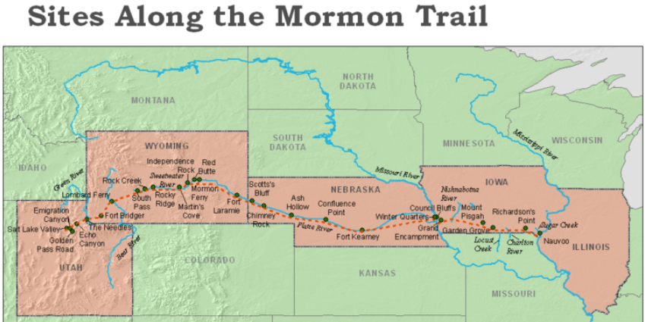.

Summary of Thomas and Family’s Journey to Utah
Thomas, Margaret and Lucy started out at Keokuk near the eastern border of Iowa on June 15, 1853 and entered the Salt Lake Valley on October 16; A distance of 1313 miles in 123 days as a family of four.
Here is a recap of their entire journey from Eaton Bray to the Great Salt Lake Valley:
Eaton Bray to Liverpool 1 Day March 25, 1853
Liverpool to New Orleans 54 Days March 26 to May 18
New Orleans to St. Louis 9 Days May 18 to May 27
St. Louis to Keokuk 1 Day May 28
Camped at Keokuk 18 Days May 28 to June 15
Keokuk to Great Salt Lake 123 Days June 15 to October 16, 1853
-----------------------------------------------------------------------------------------------------
Eaton Bray to Great Salt Lake 205 Days March 25 to October 16, 1853

The Odometer or Roadometer

How exactly did the Saints know now many miles they travel each day? In 1847 William Clayton, while crossing the plains with Brigham Young’s original wagon company, wanted an answer to the same question. To find the answer he marked one of the rear wheels of his wagon (some say he tied a piece of string to the rim others say a piece of yarn). This mark was affixed to the metal tire (rim) of the wheel. He then counted every revolution of that tire all day. At the end of the day he added up the revolutions and multiplied that number by the circumference of his rear wheel (in feet). He then knew the exact number of feet, and thus miles, they traveled that day. Not wanting to count revolutions all day every day he and a fellow traveler with a scientific mind, Orson Pratt (one of the original 12 apostles of the restored Church), drew up plans for a Roadometer. This Roadometer was to be a box of gears and cogs that could be attached to a wagon and count the revolutions. Another traveler in that company was Appleton Harmon (the same who was the wagon master of Thomas’ Company in 1953). He was a skilled craftsman and mechanic and he built what Clayton and Pratt had designed. Harmon’s journal indicates that he attached his Odometer to his wagon on May 10, 1947. The photograph of the odometer below is not of the original. Unfortunately the original is not be found. This is a representation of what it may have looked like.
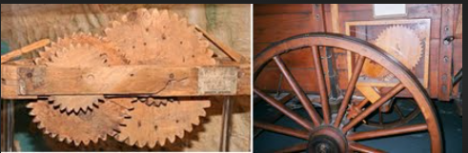
After Brigham Young’s Company entered they Great Salt Lake Valley in July of 1847 Clayton petitioned Brigham Young to let him return to Winter Quarters with the Odometer attached to his wagon and record the mileage from the Valley to every landmark and camping area all the way back to Winter Quarters. He would then publish a guide that would benefit all the Companies that followed. He was encouraged to do so and the guide below became the “Bible” for all Companies coming west.
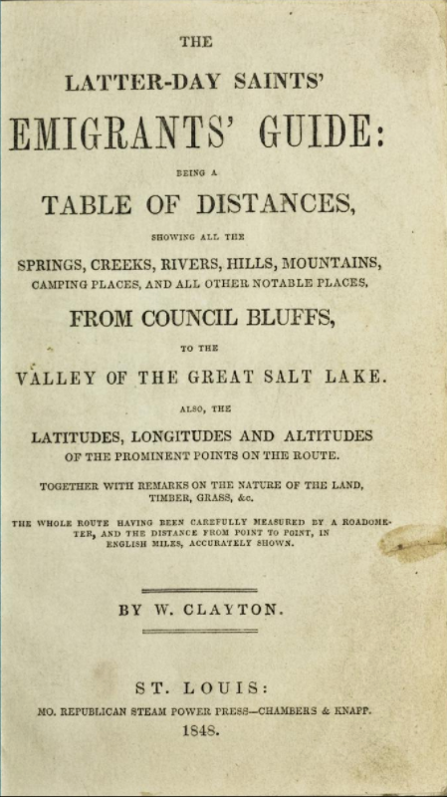
The Latter-Day Saints' Emigrants' Guide: Being a Table of Distances, Showing all the Springs, Creeks, Rivers, Hills, Mountains, Camping Places, and all Other Notable Places, From Council Bluffs, to the Valley of the Great Salt Lake .... The Whole Route Having Been Carefully Measured by a Roadometer, and Distance from Point to Point, in English Miles, Accurately Shown. St. Louis: Mo. Republican Steam Power Press, Chambers & Knapp, 1848.
Here is a sample page from the Clayton Guide:
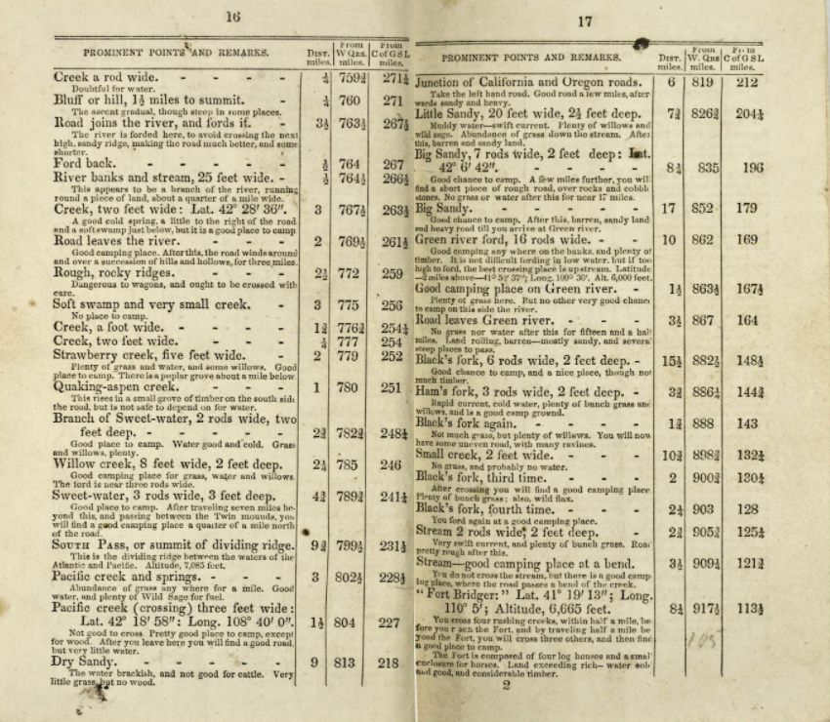

If you look at the lower right hand corner of the page you will see Fort Bridger. The long. and lat. and elevation are given. It is situated 917 ½ miles west of Winter Quarters and 113 ½ miles east of Great Salt Lake Valley (along the Mormon Trail). It also indicates it is 8 ¼ miles from the previous reference to Stream. There are also notes regarding the Fort: “The fort is composed of four log houses and a small enclosure for horses.” The guides were indispensable to Wagon masters and Emigrant alike. There was not an abundance of odometers available. Because of Clayton’s efforts an odometer was not needed.

Voyage aboard the Clara Wheeler (George W. and Family)
.
Although I have not been able to document this information, other histories written about our Smiths have indicated the following: “They had originally booked passage aboard the ship Germanicus sailing to New Orleans in February of 1854 but that ship was delayed in port for maintenance and repairs”. I do know that the Germanicus was cleared to leave Liverpool on April 1, 1854 and departed for New Orleans on April 4, 1854. This was an Organized Company of Saints with 220 Saints on board and Captain Fales in command. I don’t know yet if this ship was, indeed, delayed from a scheduled February sailing but we do know that our George W. Smith and family were not aboard.
I previously showed this list of ships carrying Saints across the Atlantic from Liverpool in 1853 and 1854. The Germanicus is shown leaving on April 4th and the Clara Wheeler three weeks later on April 24th under Captain Nelson.

I don’t know why George and family did not sail with the Germanicus on April 4th or on one of the two other “organized” ships that left in February or one of the two “organized” ships that left in March or the Marshfield that sailed on the 8th of April. We do know that Catherine gave birth to a baby boy (Marlon Lehi) on March 8, 1854 and that baby died the same day. Catherine was probably not physically or mentally able to take some of those ships in February and March or early April. What we do know is that George W., Catherine, Sabrina, and Jane did leave England via Liverpool aboard the sailing ship Clara Wheeler on April 24, 1954. It remains a mystery to be solved.

As I was studying the ship register for George and his family I did find some interesting comments in the remarks section. I show below four sections of this register. I broke it up into these four parts so it could be more easily read.

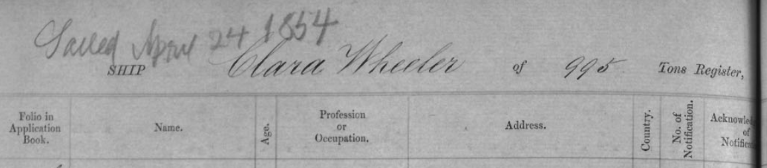
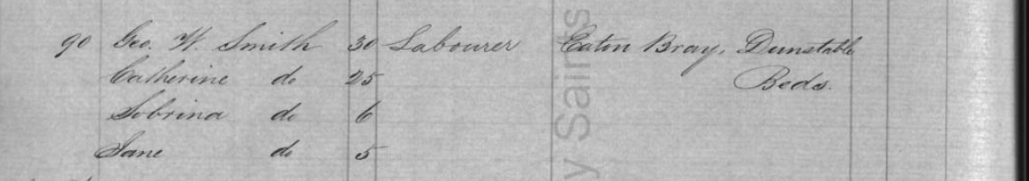

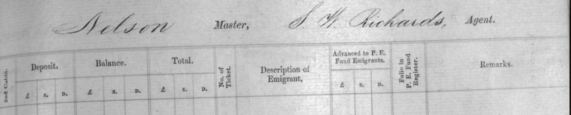
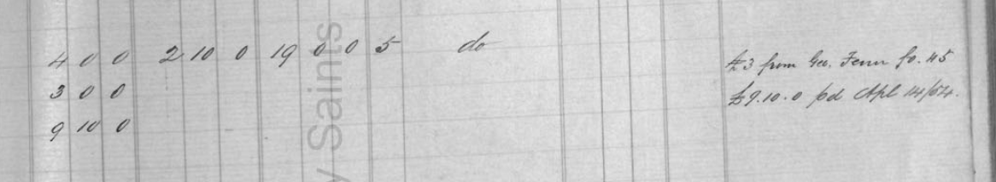
The first section shows the Clara Wheeler as a 995 Ton ship sailing April 24, 1854. In the second section it shows Geo. W. Smith age 30 a Laborer from Eaton Bray, Dunstable, Bedfordshire. Catherine, age 25 is also listed along with Sabrina, age 6 and Jane, age 5.
Section three is the right half of the Ship register and shows that the Ship Master’s name was Nelson and the Shipping Agent was S.W. Richards.

It is section four where some interesting information is found. It shows that George had paid a deposit of £4 and still owed £2 – 10 shillings. There is also a payment of £3 and in the remarks it says “£3 from Geo. Fenn fo.45. To me this means those funds were either given to our George as a gift or was owed those funds by Geo. Fenn (more about Geo. Fenn later). There is also a credit of £9 – 10 shillings and in the remarks it says “£9 - 10 paid April 14 1854” This could be a credit finally given on the 14th (ten days before the ship was to depart) for their Germanicus booking that was postponed back in February. The £4 shown as a deposit would be £1 for each of the four passengers as required to accompany their application for Emigration.
The total fare was £19 pounds for our four Smiths to sail aboard the Clara Wheeler to New Orleans.

The £3 from Geo. Fenn is another mystery. I did some research on the Fenn family and found this:
John Fenn and his second wife Ann Cherry were the first to lodge the Mormon Elders at Eaton Bray, Bedfordshire, England and permitted them to use their home for meetings. John’s oldest son from his first wife was William (born and his oldest was George, who had gone to Utah in 1851, had returned in 1852 to the area of his own people as a missionary. Elder George Fenn was influential in causing many Saints to immigrate to Zion, and his father’s large family was among them. They sailed from Liverpool on 4 April 1854. They would have sailed on the Germanicus.
With that little bit of background our Smith’s would have known the Fenn Family. They probably went to the same Church meetings. George Fenn was on a mission in his home town of Eaton Bray in 1852 and “was influential in causing many Saints to immigrate to Zion”. Did he gift our George £3 or loan him that amount? In any event that £3 gave George what he needed to pay his fare to New Orleans.

Below is a partial view of a page from the New Orleans, Louisiana U.S. Passenger List for the Clara Wheeler’s voyage leaving from Liverpool, England on 24 April 1854 arriving in New Orleans, Louisiana, United States on 03 July 1854 and shows George W. Smith, wife Catherine, and daughters, Sabrina and Jane. George W. is listed as 30 years old and his occupation as Straw/Manuf. It is interesting that this register entry is not exactly the same as the one I showed above which was from the Ship Register made out in Liverpool before their departure. George is listed here as a Straw Manufacturer from Bedfordshire but it is clearly the same family.

The Ship Marshfield was the last “Organized” Charter of the 1854 Emigration year. There were 366 Saints aboard and sailed on April 8, 1854. While the Clara Wheeler was not an “Organized” voyage, S.W. Richards clearly chartered passage on that ship for 29 Saints including our four Smiths. It is certainly possible that Agent Richards went against his better judgement and the recommendations of Church leaders to send the Saints only on “Organized” ships and chartered space on the Clara Wheeler to get the remnants of the 1854 season to New Orleans.
The Clara Wheeler was an American made ship and we have found some records and paintings of this ship. I showed this painting earlier in this study because no image of the Falcon has been found.

The above painting by Duncan McFarland of the Clara Wheeler in the foreground and the pilot schooner, “The Duke” ahead in the background. It was painted in 1964 while off the point Lyras.

Here are some addition facts regarding the Clara Wheeler. Unfortunitely, since this was not an “Organized” Charter very little is known about this voyage across the Atlantic. They arrived in New Orleans on July 3rd after 70 days at sea.

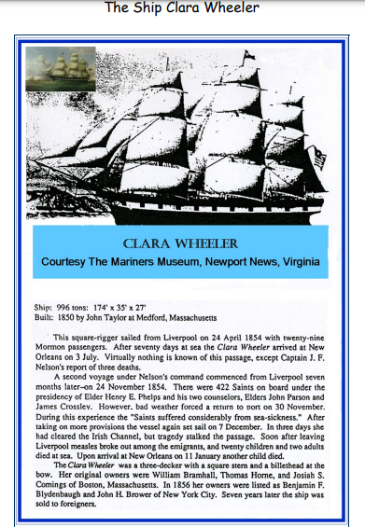

New Orleans to St. Louis (George and Family)

As it was when Thomas and Family got to America in 1853, the Church had agents in New Orleans as well as at St. Louis to assist the saints upon their arrival in getting to their next destination. From New Orleans the agent would have helped our Smith’s get passage on a riverboat headed to St. Louis. Assuming they departed New Orleans a day or so after their arrival that would put our Smith’s in St. Louis no earlier than the 17th of July and possibly several days later than that date.
In 1854 the departure location was moved to Westport, Missouri. In 1855 the departure camp was Mormon Grove (four miles from Atchison, Kansas). The sketch below shows the various locations used for the trek west.
After arriving in St. Louis in 1854, Church Emigrants from Europe and the eastern states would have outfitted themselves to cross the plains prior to or after their arrival at Westport, Misssouri.
Mormon emigration agents in St. Louis were tasked with chartered steamboats to transport LDS converts up the Missouri River to the staging point. In 1853 and 1854 the Emigration Agent was Horace S. Eldredge. He was appointed to St. Louis late in the fall of 1852 and he began presiding over the local Saints on November 21 of that year.
Agent Eldridge would have known that the last wagon company of the 1854 season had already left Westport or was about to leave for Salt Lake. That last wagon company left Westport on July 18, 1854 headed up by Captain Robert L. Campbell.
George and family had missed their opportunity to travel west in 1854. They likely had little or no money but even if they did they could not have gotten outfitted in time to join that last wagon train west. It was about 400 miles up the Missouri from St. Louis to Westport.
Those who missed the opportunity to go west with the last wagon company of the season or those lacking the necessary funds to continue west, or both, were encouraged to find employment in St. Louis for a season. At that time, more than twelve hundred members from a dozen church branches were reportedly living in the area, many making plans for their journey to the Salt Lake valley. Housing was possibly the biggest issue in St. Louis.
When Emigrants arrived at the Luminary office in St. Louis, they were schooled on commodities needed for the next leg of their journey: “Every independent person will need to have . . . one hundred pounds breadstuffs, and a few pounds bacon or dried beef, and as much sugar, tea, coffee, and dried fruit as they calculate to eat during a three month’s journey over the plains.” Once outfitted with the necessary provisions, emigrants were notified of dates and places of expected departures from Atchison, Kansas, the next destination on their westward trail.
I hope our Smith’s reported to the Luminary office or consulted with the Conference President (Elder Eldridge or Elder Erastus Snow depending on when our Smiths got to St. Louis) to know where they might find lodging and work for the season. Our Smiths had to decide where to go next. They would surely have looked to the Elder Eldridge, the emigration agent, and or Milo Andrus who was the Stake President in St. Louis for guidance. They would have encouraged them to stay in St. Louis until the following spring and then head to the departure site. George would have been low on or even out of money so earning money would be a top priority. I suspect they stayed in St Louis or nearby. Elder Eldridge was also tasked with trying to find temporary housing for those who were staying in St. Louis for a season to earn money for the westward trek. This was surely a difficult year for our Smith’s. They had little or no money, no employment, likely few friends. I would like to think that some saints better off than our Smith’s took them in or helped them in some way to make it through to the following spring.
The many who were unable to go because of economic hardship remained in St. Louis for several months or even years. Thus, in April 1854, President Young and other Church leaders designated St. Louis as a location where the “Saints might gather with approbation who were unable to go directly through to Utah.” Apostle Erastus Snow was chosen to journey to St. Louis, organize a stake, preside over the region, and oversee general emigration matters in Iowa and Missouri.
Before his arrival, Elder Snow already had plans to establish and edit a Latter-day Saint periodical, which he called the St. Louis Luminary. As with the Millennial Star and the Frontier Guardian, Elder Snow intended that the paper be used as an emigration guide of sorts for the many scattered Saints, offering news from the Valley, support, and instruction. Just one month after the organization of the St. Louis Stake, he published a cry for assistance in the December 2, 1854, issue of the Luminary, explaining, “Soon we will have a great many of our foreign emigration here, and some of them perhaps destitute. I wish . . . every man in Israel . . . consider themselves a vigilance committee, to keep their eyes and ears open, and learn of every opening and avenue by which they can throw their employment in the hands of those who stand in need.”
Moreover, Elder Snow gave instructions to the European converts and Eastern States Mormon emigrants who planned to stop just briefly in St. Louis before continuing forward to the Salt Lake Valley. In an article titled “Emigrants for Utah,” he counseled:
My assent will not be given for any Saint to leave the Missouri River, unless so organized in a company of at least fifty effectual well armed men, and that too under the command of a man appointed by me; one who will carry out my instruction. . . .
Choice wagons made to order and delivered at the point of outfit, with bows, projections, &c., will be about $78, without projections, $75. Oxen, with yokes and chains, from $70 to $85 per yoke; cows from $16 to $25 each.

George and Family in Limbo

So far our research has them in limbo and surely in dire straits from July 4th when they landed in New Orleans until they departed with the Milo Andrus Wagon Company on August 4, 1855. Research will continue. How wonderful it would have been if a James Jack had made the trip with George as well as Thomas!
I took the time to research the other 25 Mormon Saints who came to America on the Clara Wheeler with our 4 Smith family members. I was hoping to find a wealth of information on them and their journal entries documenting their immigration to America but no such luck at present.
Only three of those 25 came to Utah via the wagon trains of the 1850’s and 60’s.
James Aitkin and John Todd, both age 21, traveling as lone individuals, came to the Salt Lake Valley with the Moses Thurston Company
William Phillips, age 43 and traveling alone came west with the Henry Miller Company in 1862
I have not located these three men in FamilySearch as of yet.
In late August 1854 Brigham Young directed Milo Andrus, the current stake president in St. Louis, to find a place on the western frontier where the European immigrants could safely and temporarily settle before continuing on to Utah. He wanted a place that was beyond St. Louis, closer to the frontier. He specifically named Kansas as a possible settlement and outfitting location. In his opinion, the immigrants would have a better opportunity “to labor for cattle, provisions, etc. in these healthier localities.” In previous years many shiploads of immigrants had been “unhealthily crowded into rooms at St. Louis,” where they found it difficult to obtain short-term work.

Mormon Grove (Atchison, Kansas) 1855 Departure Point
On February 17, 1855, Milo Andrus and others left St. Louis bound for the western Missouri River frontier to find an outfitting location that could be used for the spring emigration. On March 20th, Milo reported that he had secured land in a hickory grove approximately four miles west of Atchison, Kansas, that could be used for a staging ground. It was on a bend of the Missouri River 12-miles farther west than any other outfitting point, and had good grazing land and water. He named it Mormon Grove. Atchison is 50 miles north of present-day Kansas City and about 300 miles from St. Louis.

The first large group of Mormons debarked the riverboats in Atchison in April 1855 and moved westward to Mormon Grove.
There, they immediately began to fence 160 acres and planted crops. The site, at the head of Deer Creek, also served as an excellent camping place with water, wood, and range for the stock. Like the other Mormon camps along the Missouri River, it was close enough to the port city so the Mormons could easily purchase supplies. The temporary village also had a small cemetery and a couple of permanent structures, but most residents lived in tents, covered wagons, or make-shift dwellings. Their route across Kansas appears to have been northwest on the “New Ft. Laramie Road” to the vicinity of Kennekuk, Kansas and then continuing on the “Old Ft. Laramie Road” as established by Major Wharton in 1844 to the head of Walnut Creek in present-day Brown County.
In May 1855 Milo returned to Mormon Grove with 550 head of oxen and cows that the Mormons would use in crossing the plains. When emigrants started arriving they divided according to nationality and then by overland company. The camps were organized with rows of tents framing streets and alleys between them. These camps were also organized into branches that were presided over by church leaders. They were organized as had been done before by captains over 100, captains over 50 and captains over 10.

As I have been researching the trek west I have wondered why the wagon trains did not leave earlier in the year than they did. Generally the first train west did not leave until late May or June. It came down to something we wouldn’t even consider today. Since they were traveling in large companies with families, needing great numbers of wagons and animals, they were forced to wait for a sufficient growth of grass on the plains. Certainly the ice on rivers and streams had to have melted. Hence they could seldom start before early May. And these large wagon trains left a few weeks apart to give the grass on the plains some time to grow enough to feed the stock as the next train traveled West over the same routes. Probably a bigger issue was the massive logistics of rounding up the necessary wagons, oxen, cows, provisions, etc. And they had a short window for departure since they needed to leave before the first of August to cross the Rockies before winter came. Ideally the saints would have left Liverpool around the middle to the end of March of a given year so they would arrive in New Orleans 50, 60 or even 70 or 80 days later and still travel up the Mississippi River for 8 to 10 days and then take four more days to get to the embarking point by the end of June. We already examined Thomas and his family’s journey to Utah. They left Liverpool on March 25, 1853 and arrived in New Orleans on May 18, 1853 (54 days). They traveled up the Mississippi and made it to Keokuk in time to leave for Salt Lake on June 15, 1853 (27 days) and completed their journey to Salt Lake on October 16, 1853 (123 days).
As companies with several hundred people in each were readied, they moved out onto the prairies to begin their march westward. At the direction of Mormon leadership, with only about a 12-hour notice, Milo Andrus led the last of the 1855 wagon trains with 461 individuals from Mormon Grove on Aug. 4, 1855. Milo as apparently ill and did not want to lead this wagon train to Salt Lake. However, Milo was an experienced wagon master having crossed the plains more than once. And he was a very faithful pioneer saint and obeyed the call. This was a late in the season departure and no doubt brother Andrus pushed this company so as to arrive on Oct. 24, 1855 in Salt Lake Valley in just 81 days. They only had two deaths along the trail. This was rather amazing as they encountered some significant snow fall during the last few weeks of the journey.
In total, 2,030 emigrants, 337 wagons, 2,433 oxen, 319 cows, 86 horses, and 8 mules had journeyed from Mormon Grove in 1855.

The next year, in 1856, the outfitting post moved from Mormon Grove to Iowa City, Iowa. It was selected because Saints could travel there by rail, making the journey faster and more economical. In 1856 most of the ships sailing out of Liverpool were directed to go to the Eastern ports of New York, Philadelphia, or Boston.

Back to George and family! They could have been among those first saints arriving in Atchison (Mormon Grove) in April of 1855 but if they were why would they have traveled in the last company of saints to leave Mormon Grove in August of 1855 (which we know they did)? I think they stayed (maybe camped) somewhere in or near St. Louis until they had to make a choice of staying yet another year in the area and earn more money or catch a steamboat in St. Louis and travel up the Missouri River to Atchison in time to travel in the last wagon train company of 1855. This decision was made harder by the fact that Catherine was about 7 months pregnant (at the time they started across the plains) when the decision was made
I don’t think George and family were successful finding enough work to do anything more than just survive while in St. Louis. George was a hatter, not a farmer or a carpenter or a blacksmith. The need for straw hats was not likely a high priority among the many individuals trying to find the means to get to the west. They were probably able to do some trading of hats for food and other necessities but when it came time to continue to the west he did not have enough money to outfit him and his family for the trek.

George Borrows from the P.E.F. after all!

I believe, having made the decision to travel west in 1855 he also made the difficult decision to borrow money through the PEF. I wrote earlier that I had found this booklet that showed “Names of persons indebted to the P. E. Fund Company”. This booklet named individuals with unpaid debts owed the Fund as of 1870. It shows the debt Thomas incurred in 1853 and, to my surprise, it also shows a debt owed by George W and his wife and children taken out in 1855 (as they, no doubt, prepared to come west). We have known for years that Thomas borrowed money from the PEF and we had copies of a receipt and a contract of sorts. It has just come to light this year that George and Family also borrowed from the PEF after they had paid their own way across the Atlantic and up the Mississippi to St. Louis.

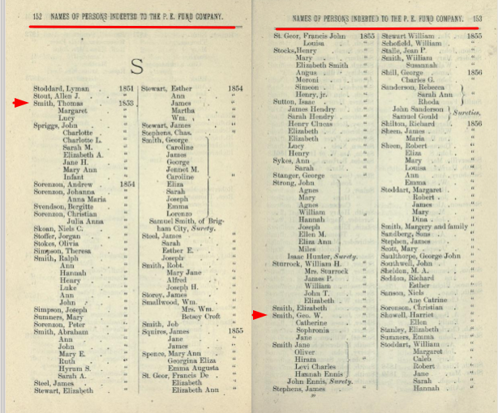

After I found the George’s name in the booklet I went searching for additional documentation and found the following.
This first document is an interesting one in that someone gave George W. the middle name of “Washington” making it very hard for a researcher to find and identify him as our George Smith, which he clearly is. It identifies George and Catherine with their correct ages at the time of their PEF loan. I don’t know why Sabrina is only shown with an “S” but Jane is identified and their ages are correct. This particular document doesn’t show the amount of their debt, only that they took out a loan.
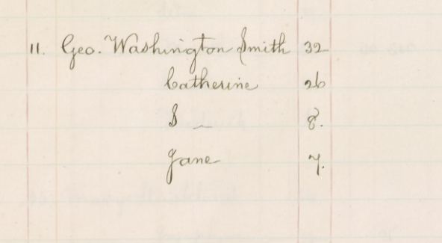
This next document clearly shows their loan in the amount of $91.20 and identifies that the loan was to outfit them for their trip from Atcheson (Mormon Grove) to Utah in 1855.
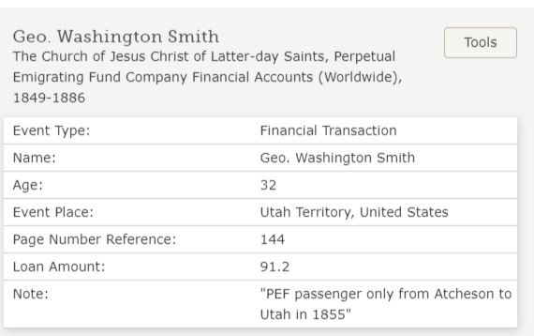
I found this entry in an Index to PEF Ledger entries. This indicates that the ledger entry I want is on page 144 of Ledger B but when I go to that page I don’t find the entry.
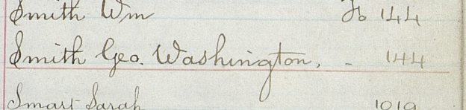
I did find this additional ledger entry showing some of the information as above. It is dated December 21, 1855 so this is a recievable of $91.30 as of that date. There is a ledger entry somewhere yet to be found where the above information in written.

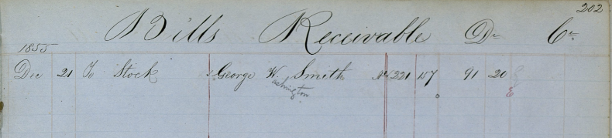
That $91.20 did not buy them a wagon or an oxen team, only passage and the provisions and food stuffs necessary for the trek west. A yoke of oxen cost between $75 – 110 in 1854. A cow was $25 – 40 and a wagon was $67 plus around $6-10 freightage to get it to Westport. Two guns were $12.00. The prices for these critical items had gone up considerably in the two years since Thomas and family outfitted.
While I have no proof as yet I believe Thomas and Margaret paid around $45.00 each for their entire trip from England to Utah (their PEF loan doesn’t bear that out but £10 was cited several times as the minimum amount needed for one person to make the journey in 1853. The $91.20 George borrowed could mean it cost $30 per adult and $15 per child to just come across the plains two years later.
From what I have been able to find this loan was given by PEF Agent Erastus Show on or about July 28, 1855. This would be only about six weeks before they headed west as part of the Milo Andrus Company (the last company to go west in 1855).

George and Family finally leave for the Great Salt Lake Valley
Below is the Summary description of the Milo Andrus Company

Milo Andrus Company
Departed: On 1855 August 4 (August 3 according to Andrus letter below)
Departed from: Mormon Grove (Atcheson), Kansas
Arrived: On 1855 October 24
Vehicle Type: Wagon
Company Type: Church Train
Company Direction: Westbound
461 individuals were in the company when it began its journey from the outfitting post at Mormon Grove, Kansas (Near Atchison). There were “upwards of 50 wagons” in this company.
This was a very large company of Saints. The Appleton Harmon Company (Thomas’ company) had 200 Emigrants and 22 wagons.
This was a Perpetual Emigrating Fund Company.
As with Thomas’ train there were typically 10 persons assigned per wagon and two yoke of oxen. There were 455 persons in the Milo Andrus train and “Upwards of 50 Wagons”. So our Smith’s would have had additional companions with them in “their” wagon. And I use the word “in” lightly since the wagon was used to carry their supplies and maybe a driver and only an occasional passenger. Sabrina and Jane would likely have walked the entire way. I hope Catherine did not have to walk too much since she was 7 month pregnant when they left Mormon Grove as has been mentioned. She certainly would have ridden for days after she gave birth at Devil’s Gate. By this time in their journey the wagon would have been emptied of at least 2/3 of their food supply and, thus, more room in the wagon for passengers.
George probably saw an oxen team for the first time in his life in St. Louis or possibly just prior to his departure on this wagon company. Accounts of this company indicate that there was a shortage of oxen and many were young and unbroken and unexperienced drivers (i.e. George W.). There was a great deal of difficulty getting underway and cattle and drivers alike had to learn what was expected of them. In the wagon they would have started out with 1500 pounds of flour, 50 pounds of sugar, 50 pounds of bacon, 50 pounds of rice, 30 pounds of beans, 25 pounds of salt, 20 pounds of dried fruit, 5 pounds of tea, a gallon of vinegar and 10 bars of soap. Each passenger was also allowed up to 50 pounds of personal baggage. All of this, plus their tent, had to fit in a wagon box measuring 12 feet long by 40 inches wide by 18 inches deep.
Each wagon company was organized with captains over 100, captains over 50 and Captains over 10. That would almost put captain over each wagon. I can’t imagine George W. being made a captain over his ten but it is possible. The captain over 10 was responsible for waking each head of household at 4:30 a.m. so they could be ready to roll out by 7:00 a.m. These wagons had very little in the way of springs or suspension so it may not have been much of a treat to ride rather than walk. It was said that if you put fresh milk in the churn in the morning and let it ride in the wagon it would churn itself into butter by the end of the day!

Below you will find a partial listing of the Milo Andrus Company that verifies that our Smiths and their new born daughter, Anne Merintha, were members of this wagon train.
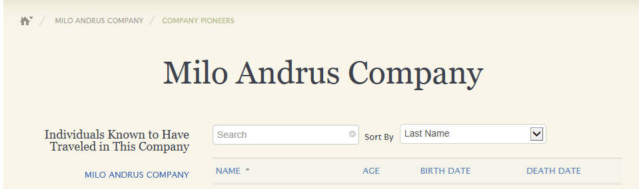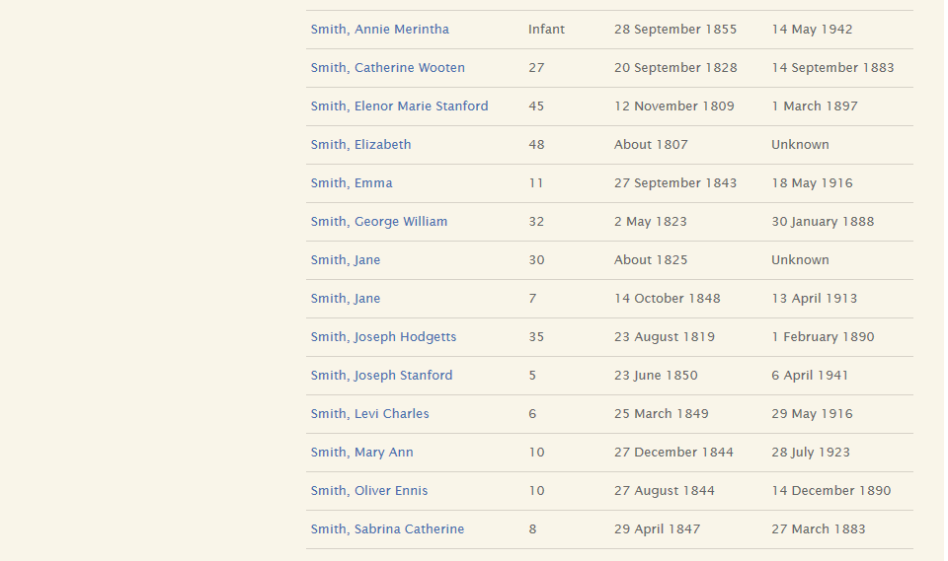

I have attached here a couple of letters Milo Andrus wrote Brother John H. Hart who was the President of the St. Louis Stake High Council and was also the current publisher of the Luminary. Brother Hart also took Milo’s place as the President of the St. Louis Conference (Stake). The first letter was written just a couple of days into the journey west on August 6, 1855. And was later published in the Luminary.

ANY NEWS from the Emigration upon the Plains, will be interesting to our readers; we therefore present the following items from Elder Milo Andrus:
Thirty miles from MORMON GROVE, Aug. 6, '55. (three days into their journey)
DEAR BROTH. HART: After the toil of the day, I take a leisure moment to write you a few lines, to let you know our whereabouts, and progress. In the first place, I will say that we started from the Grove on the 3rd, and on the 4th we overtook brother [Isaac] Allred's company on Big Grasshopper. We are both now encamped on Walnut, with barely team enough to roll us on agreeable.
I have in my company, the tail end of the Emigration, and a scanty number of experienced men, which causes the burthen of the camp to rest upon me, with an almost insupportable weight. My health is worn down with fatigue, but still, my spirit is determined to take the camp entrusted to my care, safely to the home of the Saints.—We have health in our midst—our progress has bettered itself every day, which causes me to feel grateful to our heavenly Father, and my soul to rejoice in that paternal aid, which is ever ready to render assistance, and support us in time of need.
The season is late to start to the mountains, but we trust in the arm of Jehovah to direct our movements, and we then have nothing to fear.
Remember me in their prayers that I may accomplish the things the servants of the Lord hath placed upon me.
With love to yourself, I remain your friend and brother.

MILO ANDRUS.

This second letter to Brother Hart was written about 11 days into their journey.
On the West side of the Big Blue,
Wednesday evening Aug. 15, '55.
I take another opportunity to inform you of our progress. Health, peace, and happiness is made manifest in our encampment, and above all, the Lord is prospering our progress; to-day we ferried the Blue which is exceedingly high on account of so much rain. We are a few rods west from brother Harper's encampment, and are in good travelling condition. We have nailed our colors to the top of the mast and are determined before long, to breathe the fresh breezes of the beautiful Platte river valley. We shall from time to time, as opportunity affords, drop you a line, to let you know our progress, but both you and the Saints must excuse lengthy letters from us, as we are all the time in a hurry. May peace and blessings crown your labors, in your Presidency of the Saint Louis Stake, is the constant prayer of your friend and brother. We know not the distance that Allred's camp is behind us.
Yours in haste, MILO ANDRUS.
This third letter to Brother Hart was written on August 22, 1855 (less than three weeks into their journey)
30 miles up the Little Blue, Aug. 22, '55.
BROTHER HART: Another opportunity presents itself for me to write you. The Salt Lake Mail is just passing and waiting to take this note. Our progress is still onward; although, since I wrote you last, we have had a few drawbacks; two wagon axles, one wheel, and several tongues broke which has caused us some little delay; but notwithstanding we are up with brother Harper's company, who is now starting from this place. We have also had two deaths of aged persons, and some slight cases of sickness, but as a general thing I am thankful to say, health reigns predominant. From over-exertion and fatigue, my health has been, for the last few days, much impaired, but this morning I feel quite well again, and am doing all in my power to push on this camp which is in my charge, as I am deeply anxious for their welfare. My brethren well know if there is not exertion used on our part, the season being so late, we shall feel some inclement weather when we are some hundreds of miles further West. The Saints feel well and cheerful. We are in excellent traveling condition, as our yesterday's work will tell—we came not less than twenty-five miles.
My love to all. I remain your brother in the gospel of Christ.
MILO ANDRUS.
I can only imagine what our Smith’s felt like during those first couple of weeks on the trail. George trying to learn the “ropes” of driving his wagon and oxen team. It appears from Brother Andrus’ letters that the inexperienced drivers and oxen quickly learned what they needed to know to move quickly across the plains.
You will remember from the detailed journal of James Jack that the much smaller Appleton Harmon company only traveled over 20 miles in a single day twice during their 1300 mile journey. You can tell from the tone of these letters that Brother Andrus was worried about the lateness of their departure and was making a real effort to keep the company moving. The Appleton Harmon Company was at Kanesville on July 9th which is about the same location as the Milo Andrus Company when they departed on August 3rd. Milo had already reported broken axles, tongues and wheels within the first three weeks of their journey.
I have been on a number of modern day “Treks” and the most I ever walked in one day was 17 miles and it did take all day. What great troopers Sabrina and Jane were to walk 20 plus miles a day on their young legs. And what of Margaret and Catherine both of whom were well along in pregnancy when they began their trek across the plains.

This summary of the Milo Andrus Company comes from the Pioneer Database of the Church of Jesus Christ of Latter Day Saints.
This was the last of the Perpetual Emigration Fund companies for 1855. Milo Andrus received the assignment to captain the train the night before the party was to leave Mormon Grove (just outside Atchison, Kansas Territory) and had just 12 hours to get himself ready. Two things made this last-minute appointment necessary: the season was very late and no one else with plains experience was available. Thus Andrus and his two assistants had an enormous responsibility.
The company had few oxen, and many of these were small and unbroken, so they had to be trained in route. Part of the company left Mormon Grove on August 1; the rest left on the 3rd. inexperienced drivers had to shuttle some wagons forward, then return with the teams to bring up others. One emigrant recalled that early on it took four men to drive one yoke of oxen. There were 461 individuals in the company when it set out.
No sooner had the company left Mormon Grove than the U. S. Marshall for Kansas Territory arrived with an order to attach the train for debts attributed to Brigham Young, Heber C. Kimball, and Jedediah M. Grant (at that time the First Presidency of The Church of Jesus Christ of Latter-day Saints). Captain Andrus convinced the marshall that the train belonged not to the First Presidency, but to the Perpetual Emigration Fund Company. The lawman then tried to take Andrus back to Atchison to "get sufficient good security from amongst the Citizens there to secure the debt & cost," but the Captain refused to leave his train. At this critical moment, the marshall "was taken with the bellyache and wanted a little brandy," which Captain Andrus quickly supplied. He then fed the marshall supper and drove him in a buggy to his lodgings. Nevertheless, the marshall ordered Andrus and three other brethren to appear at the October 3rd term of the U.S. court in Leavenworth, and when he got back to Mormon Grove, he attached four or five Mormon-owned wagons, "a few lame cattle," and some calves.
Sketch by Frederick Piercy 1853 Saints crossing the plains.
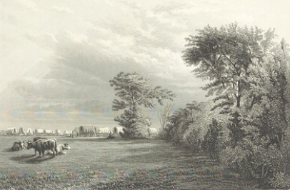

The Andrus train overtook Captain Allred's emigrant company on Big Grasshopper Creek; later, both parties camped on Walnut Creek. Tired of leapfrogging his wagons, Captain Andrus decided to leave a Perpetual Emigration Company thrashing machine in the care of a local farmer (Captain Allred left five wagons with this same man at that time). Andrus now set a pace that was "as hurried as he could urge, push, and cajole, the group over the plains, up and down the mountains, through the canyons, across the rivers, and through the miles of the thick dust of the trails."
At some point, the train encountered a large herd of buffalo that "ran across our train, while in motion, and knocked down and [bore] off the horn of one of the oxen." The Indians that the train met were friendly. At Big Blue River the train used the ferry because the river was running high. Near there the party camped just a few rods west of Captain Harper's company. It was here that Andrus "nailed our colors to the top of the mast." From Little Blue River, the Captain wrote: "Two wagon axles, one wheel, and several tongues broke which has caused us some delay; but notwithstanding . . .
I . . . am doing all in my power to push on this camp . . . as I am deeply anxious for their welfare." Two elderly emigrants had died. The train followed the Platte River and must have crossed the South Platte. It stopped at Ash Hollow, where Andrus learned that General William S. Harney and about 700 soldiers had "found a party of the Sioux Indians about eight miles from Ash Hollow and a battle had ensued on the 3rd of September. The General sent over word to Andrus on the 5th keep an advanced guard stating at the same time that the best information that they could get was that they had killed one hundred and twenty Indians, taken about fifty-eight prisoners, mostly women; had four soldiers killed and five wounded. He stated, also, they were going to lay out a fort a small distance below Ash Hollow after which they calculated to proceed to Fort Laramie, and from thence to wherever they could find any of the Sioux Nation."
"A few miles from where they were encamped there were about forty Indians that were in the battle near Ash Hollow. Nothing came of this. The company passed Court House Rock, Chimney Rock, and Scotts Bluff.
By September 13 the company was 12 miles below Fort Laramie. It then passed Laramie Peak, Independence Rock, and Devil's Gate. At the latter place, on September 28, the emigrants met brethren from the Salt Lake Valley.
It was at Devil’s Gate that Annie Merintha was born to Catherine Smith, making them a family of five, on September 28, 1855. It would be almost another month of cold and difficulty before the company reached the Great Salt Lake Valley.

Below is another of Frederick Piercy’s sketches from the Mormon Trail. This is what came to be known as Devil’s Gate near where Annie Merintha was born.

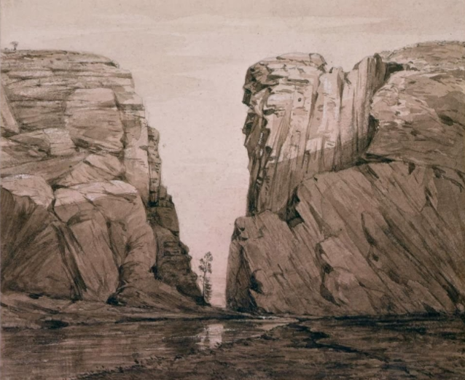
On October 4 the train crossed Devil's Backbone, "a most awful mounting [sic] of stone." That night "came on a dredfull [sic] storm of snow." On the 6th the train crossed South Pass.
Near Chimney Rock 20 oxen and 2 cows died "from something the[y] had eat or drank [sic]." Upon reaching the Sweetwater River many more cattle died. There was little feed for the animals; in all, the Andrus train "lost 11 animals above 50%."
At the fifth crossing of the Sweetwater it snowed three inches. The train
crossed the Green River on October 11 and arrived at Fort Bridger four days later.
From the fort, Captain Andrus sent word to Salt Lake that he needed fresh animals and that "many of the men, women and children were almost barefoot and very destitute of clothing."
Below is a sketch by Frederick Piercy of Saints nearing Fort Bridger.
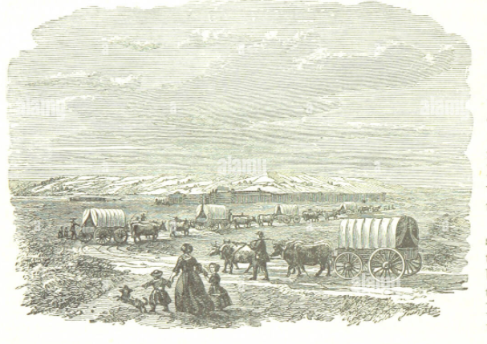

Fort Bridger was actually quite a shabby facility built by Jim Bridger and his trading partner Benito Vasquez in 1842. He traded with the Indians as well as Emigrants headed west. His prices were inflated and Brigham Young established a Mormon Supply Post just a few miles away. The fort had a parameter of wood poles with crude housing within that perimeter providing some protection from Indians and keeping livestock safe.
By the time the train reached the Weber River, the emigrants were running out of provisions. They crossed Big Mountain and Little Mountain.
A delegation of dignitaries from Salt Lake met them at the mouth of Emigration Canyon. Here the emigrants formed a circle around the welcoming party and "sang a piece of poetry composed for the
occasion":
"Come Zion's sons and daughters,
Who seek this blest abode,
That over plains and waters
Have come to serve our God;
Our gratitude demanding,
Let praise to Him abound,
That we are favored, standing
On consecrated ground.
Oh! This we've long expected,
For this we've prayed and sighed,
Like Israel's sons neglected,
By Babel's limpid tide;
And now befo
. . . When on the way to Zion,
And every heart was hope,
The means we'd to rely on
Was fastly closing up;
But as the darken'd shadows
Declared a brighter sun,
We felt a power to glad us,
Th' Apostles would make known.
Tho' elements did battle,
As late the season pass'd,
And weakly seemed our cattle,
We're in the "hive" at last:
No power should withstand us,
Declared Erastus Snow;
And Captain Milo Andrus
Thank God, has brought us thro'.
We come not here for pleasures
That carnal minds can prize,
Nor seek aurif'rous treasures
Of th' West to aggrandize;
We come with spirits fervent
To fully serve the Lord;
To hear His holy servant,
And live by every word.
And as the arms of Moses
Required bearing up,
So every soul proposes
To be our Brigham's prop:
Tho' late and last our carriage
Across the mountains' brow,
We hope, like Jesus' marriage,
There's best wine even now."
The Andrus train, with "upwards of 50 wagons," arrived in Salt Lake City October 24th. Because of the lateness of the season, Captain Andrus had pushed his people hard. Undoubtedly, this is
why one of the travelers described him as "a terrible bully and tyrant." However, another emigrant wrote, "It was not an altogether unpleasant trip."
For his part, Captain Andrus had been ill during much of the journey. He said that leading this 1855 train was "one of the hardest burthens that I have been called to bear in the midst of Israel during my sojourn in mortality" this from a man who had been with Zion's Camp, who had been in Nauvoo at the time of the Martyrdom, who had "helped watch the city by night, and worked on the temple by day," who had gone to Carthage at the time of the indictment of the murderers of Joseph and Hyrum Smith, who had experienced the persecutions leading up to the abandonment of Nauvoo, and who had participated in the Latter-day Saint exodus westward, a man who, himself, had led several other emigrant companies.

Below is a sketch of the Great Salt Lake Valley in 1850. Author unknown.
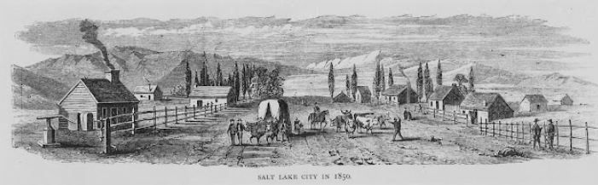

Another Frederick Piercy sketch of the Great Salt Lake Valley in 1853
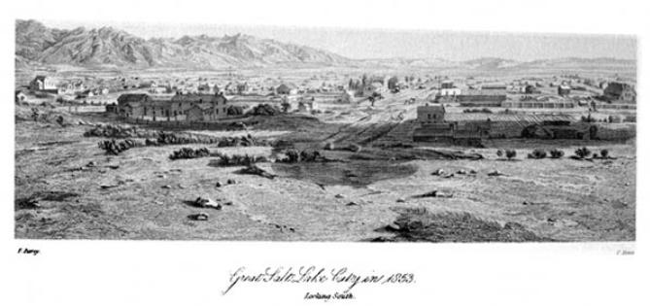

This company completed their 1000 mile, late in the season journey, in 82 days suffering only two emigrant deaths. They lost an abundance of oxen and cattle and were near destitute for clothing and shoes. They averaged 12.35 miles per day! Catherine was seven months pregnant when they left Kansas and she gave birth to Anne Merintha, about the time the cold weather set in and snow began to fly. Milo, being the experienced wagon master he was, really pushed his wagon company since they had left so late in the season. They were only 82 days in route. In contrast, Thomas X’s company took 123 days to reach Salt Lake. Of course, Keokuk was 300 miles further east than Mormon Grove.

Summary of George and Family’s Journey to Utah
Here is a recap of their entire journey from Eaton Bray to the Great Salt Lake Valley:
Eaton Bray to Liverpool 1 Day April 23, 1854
Liverpool to New Orleans 70 Days April 24 to July 3
New Orleans to St. Louis 10 Days July 3 to July 13
Layover in St. Louis 376 Days July 13, 1854 to July 24, 1855
St, Louis to Mormon Grove 4 Days July 24 to July 28
Mormon Grove to Great Salt Lake 82 Days August 3 to October 24, 1855
------------------------------------------------------------------------------------------------------
Eaton Bray to Great Salt Lake (excluding his 376 day layover in or around St. Louis) 167 Days April 23, 1854 to October 24, 1855

Appendix A James Jack’s Account of the Falcon and CORNELIUS Bagnall Emigrating Company

This appendix includes the notes of the Falcon voyage across the Atlantic and the Wagon train journey across the plains from Keokuk to the Salt Lake Valley as recorded by the official recorder and secretary of this chartered ship, James Jack. The Falcon and Cornelius Bagnall Emigrating Company
JAMES JACK, SECRETARY (Mar. 25, 1853) Liverpool, Bramley Moore Dock on Board the Falcon, March 25th, 1853.
Friday evening ½ past 7 o’clock. Meeting called to order by President Bagnall. Hymn sung, “Come, Come Ye Saints,” etc. Prayer by President Bagnall. The President then said that the reason this meeting was called was to get their sanction to the appointments that Bro. S. W. Richards had made and as they all knew that it was necessary that some should be appointed to take charge of this company. He would leave it with this meeting to give their approval or disapproval of Bro. Samuel’s appointments. It was then moved by Elder James McNaughton, seconded by William Ross, that Elder Cornelius Bagnall should take the Presidency of this company to the Great Salt Lake Valley. Carried unanimously. President Bagnall then moved that Elders James McNaughton and James Caffall should be his counselors, seconded by James Curray, carried unanimously. President Bagnall then said that it would be necessary that they should have a clerk to take minutes of all their proceedings and he should move that Priest James Jack should be appointed, seconded by Elder James McNaughton, carried unanimously. President Bagnall then said: “Brethern and Sisters, I realize the high and important station to which I am called and of myself I am weak, yet by the strength of God and of my Bretheren which have been appointed with me, along with you, my Bretheren and Sisters, being united together we shall be able to preserve order and harmony all the way and would just say to the Bretheren, take no undue liberties with the Sisters, and you Sisters live humble and pure before God and I shall be watching over you all the time, and if I should see any undecent (indecent) conduct in any of you, Bretheren and Sisters, I care not who they may be, I shall reprove it and that perhaps sharper than you would like. I do not wish that any iniquity should be in our midst, but that the Spirit of God should be with us all the time and I shall have to make some other appointments, but as it is getting late, I shall dismiss the meeting at present as we shall have plenty of time afterwards.” Hymn was then sung, “Guide Us O Thou Great Jehovah,” etc. 5 Prayer by Elder James McNaughton.
(Mar. 26, 1853): Saturday, March 26th, 3 o’clock, afternoon. The Clerk was instructed to get the names of all the priesthood on Board with the different offices which they held and to call a counsel meeting at ½ past 4 o’clock. Counsel met ½ past 4 o’clock when President Bagnall said the reason he had called this meeting was to know what number of his Bretheren had the Priesthood of God upon them, and he was pleased to see such a number of his Bretheren that had been accounted worthy to receive the Priesthood of God, that they might counsel together and devise measures for the comfort of all the Saints on board, and that his great desire was to take up this people to Zion with the spirit of God always with them, that they might be free from all iniquity and that when we reach the land of Zion, we may stand before the heads of the Church blameless. Elder Curtis E. Bolton came into the meeting at this time and being called upon to speak, said that he always rejoiced in meeting with the Saints of God, and that we had a first rate company on Board and prophesied in the name of Israel’s God that if we lived faithful and prayerful before God, we should have a very short passage, and that the winds should be in our favour all the way. President Bagnall then said that he wished to establish a time for calling upon the Lord in prayer and for Public worship on Sabbath and he wished some of the Bretheren to state their feelings on the subject. When several of the Bretheren spoke, and it was moved by President Bagnall, seconded by Elder James McNaughton, that the Saints rise at 6 o’clock and that 7 o’clock be appointed for calling on the Lord in Prayer. It was also moved by President Bagnall, seconded by Elder James Caffall, that we hold Public Worship twice on Sabbath and that the hours for the present be from 11 o’clock till 1 o’clock and from 5 o’clock till 7 o’clock, when it was carried unanimously. Moved by President Bagnall, seconded by Elder James Caffall that there be no cooking on Sabbath, but that the cook supply us twice with boiling water, carried unanimous. Moved by Elder James McNaughton, seconded by President Bagnall, that Elder James Caffall and myself go round the berths and appoint some of the young Bretheren to carry the meat from the passengers to the cook, get it cooked and carry it down to them again, carried –
Saturday evening, March 26th, 8 o’clock. Meeting called to order for prayer by President Bagnall, hymn sung, “Come Let us Sing,” and evening hymn etc. Prayer by President Bagnall. Elder James McNaughton then instructed them about the meetings to be held tomorrow. Baptism, Name: Arthur Thornton, Parish of Maybole, County of Air Scotland, Born 19th May, 1838. Baptized 26th March, 1853 by Elder William Aird. Confirmed by Elder Bagnall, McNaughton, and Caffall.
Sabbath morning, March 27th, 7 o’clock. Meeting called to order for Prayer by President Bagnall. Hymn sung: “Lord in the Morning thou Shall Hear,” etc. Prayer by Elder James Caffall. 6 Sabbath, forenoon 11 o’clock. Meeting called to order by Elder James McNaughton. Hymn sung: “Glorious Things of Thee Are Spoken.” Prayer by Elder James McNaughton. Hymn sung: “Come All Ye Sons of God Who Have Received the Priesthood.” President Bagnall then said: “Brethren and Sisters, we have met this morning under circumstances that I never met under before, and I am happy to see the spirit that prevails amongst you. We are the children of God and we have to work out our own salvation with fear and trembling when we read the Old Testament and see what the children of Israel, in the days of old, had to go through before they could obtain salvation; how they were called to leave the land of Egypt and travel through the wilderness to the land of Promise, and when we see them at the Red Sea encompassed by the Egyptians on the one hand and the sea on the other, how they were delivered by the power of God and they were bound to acknowledge that the salvation was from the Lord, yet when we find them traveling through the wilderness when their food was getting done, how they murmured and repined against the Lord, and how they would have slain their leader had not the Spirit of God been round about him, how that the Lord sent them manna from heaven and that they ate even Angel’s food, and they were again led to acknowledge that salvation was from the Lord, yet after all his manifestations to them, how they murmured and complained against Him. But Bretheren and Sisters, we are not to be like the Israelites of old. We are called to leave the land of our Nativity and go to a land that God has set apart for the gathering of his people, that they may escape His judgments, which He is to pour out upon the wicked and those who will not obey the Gospel, and if we get trials to endure, let us not murmur, but let us hear them like Saints of the Most High God. We have obeyed the principles of life and salvation so far. and it is only through suffering that we can be made perfect. But let us, Bretheren & Sisters, have faith in God and He will bless us. If you see a child that has faith in his father and does all things that he is told and looks unto him and has his affections and confidence concentrated in him, will not that father bless his child? Yes, Verily, Bretheren & Sisters, he will. How much more so then, will our Heavenly Father bless us if we have confidence in Him and live humble before Him and keep His commandments. Do not look at our trials, Bretheren & Sisters, as a great mountain that we cannot get over but just look at them as we used to do when we went a courting. It did not matter whether it rained or snowed or any thing else, we were prepared to go through every trial for the joy that was before us, (and) enabled us to surmount all difficulties so, Bretheren & Sisters, let the joy and happiness which we expect to find when we reach the land of Zion bring us up above all things that we may have to pass through, and the power and spirit of God shall be with us all the time, and my prayer is, Bretheren and Sisters, that the Spirit of God may be continually in our midst and that love and harmony may be with us all the time even so, Amen. Elder Richard Artwood, being then called upon to speak, said that he had listened with great pleasure to the words that had flowed from the lips of his brother, their President, and he had faith and confidence in him and exorted (exhorted) the saints to listen to his instructions and counsel at all times and he would lead us in the way of life and truth, and, Bretheren and Sisters, we are entering as it were into a new existence, and if we have trials, let me say in the words of Elder Taylor, God sends us a double portion of them, that we may be purified and made fit to inherit Celestial Glory. We are standing on the 7 vessel that is to convey us from the shores of Babylon to the happy land of Zion, and may we be enabled to endure all trials and sufferings that we have to pass through, is my prayer in the name of Jesus Christ, Amen. Hymn sung: “Praise God From Whom All Blessings Flow.” Prayer by Elder James Caffall.
Sabbath Evening—5 o’clock. Meeting called to order by President Bagnall. Hymn sung: “Oh Happy Home, Oh Best Abode.” Prayer: by Elder Joseph Addage Hymn again sung: “Earth Is the Place Where God Shall Reign.” Elder James McNaughton being called upon to speak said: “Bretheren & Sisters, as I am called upon to address you I desire that the Spirit of God may be with me, and that you may extend your faith and prayers in my behalf that I may be led to speak upon things which may be appropriate on the present occasion. I was much pleased with the remarks of our president in the forenoon and thank and praise God that we have such a man to preside over us, and, Bretheren and Sisters, let us uphold him, not only in our faith and prayers, but also by our works, let us one and all corporate (cooperate) with him and give heed unto his counsels and instructions and we shall reach our desired haven in peace, and, Bretheren and Sisters, in order that no disease may get amongst us we will require strictly to observe the principle of cleanness, and we trust that this principle will be strictly observed by you all, for you are all aware that the Spirit of God will not dwell in unclean Tabernacles and we wish to retain that spirit with us all the time, and as we have established a time for calling upon the Lord in prayer we wish all to attend to that. The Sisters, in some cases are to be excused where they have a number of children to attend too, but if the Bretheren and husbands have the Spirit of God, they can infuse that spirit into their wives and children, so that all may go on in peace and harmony together and my sincere prayer is that you may abound in all good things in the name of Jesus, Amen.” Elder James Caffall: “Being called upon by our President, I arise to address you, but if I had my own way of it, and according to my own feelings, I would rather have sat and heard some of the rest of the Brethren address you, yet I have learned to be obedient to those that are over me, and not my will, but theirs be done and Bretheren and Sisters, it is only through this great principle that ever we can be exalted in the Kingdom of God. I have been 8 years in this Church, 4 ½ years of which I have traveled and proclaimed this gospel and exorted the saints by precept to gather up to Zion, and all the time I have prayed that I might be enabled to show them by example, and the time has come, thanks and praise unto God, when I can show them example as well as precept, and Bretheren, and Sisters, if we want a quick passage, we must observe cleanliness and good order, in 8 order that the Lord may bless us, and when we get to Zion and there receive some of our privileges, we will be amply repaid for all the trials and sufferings that we may have to wade through, and if we are determined to be happy and go through every thing that may come in our way, why we will just have power to do it. We have men here who hold the oracles of God and in a measure the Keys of Heaven, and if we live humble they will have power to open the heavens and shower down blessings upon us, and I want that, when we read the star in years to come, that we can read that this company went up to Zion first rate, and exhorted the saints not to murmur, but to keep their spirits in subjection to them, and exorted that the husbands should look after their children, and not let them (get) in the way of the sailors, but that all might be peace and harmony on board, and my prayer is that you may be blest and that the winds may be in our favour to waft us to the happy shores of Zion in the name of Jesus Christ, Amen. Hymn: “Be It My Only Wisdom Here,” etc. Prayer: Elder James McNaughton
(Mar. 28, 1853, leave Liverpool): Meeting called to order by President Bagnall. Hymn: “The Morning Breaks, the Shadows Flee.” Prayer: by President Bagnall. Monday 1/4 past 10 o’clock we left the Bramley More Dock. The Saints singing “The Shepherds Have Raised Their Sweet Warning Voice,” etc. “Guide Us, Oh Thou Great Jehovah,” & “Come, Come, Ye Saints, no toil no labour fear, etc., “Behold the Mountain of the Lord,” etc. At 2 o’clock we got out to sea when all the names of the passengers on board were called over, and there was one of the name of Edward Gardner, who was missing. He has got 2 boxes on board the Falcon. Monday evening ¼ to 8 o’clock. Meeting called to order for prayer by President Bagnall. Hymn sung: “Glory To My God This Night.” Prayer by Elder James Caffall. Monday evening ¼ past 8 o’clock married on board by Elder James McNaughton: William Lloyd, born Camarthen, Wales, August 9th, 1823, to Ann Thomas, Monmouthshire, Wales, born 24 May 1831. Mar. 29, 1853. Tuesday morning, March 29th, 1853, 7 o’clock meeting called to order for prayer by Elder James McNaughton. Hymn sung: “Wak’d From My Bed of Slumber Sweet.” Prayer by Elder James McNaughton. (March 29, 1853) Tuesday forenoon, 11 o’clock married on board the Falcon by Elder James McNaughton: William Burton, born Staffordshire, England, 30 May 1832 to Elisabeth Peat, born Worster, England, 16th August, 1832. At the same time by Elder James McNaughton, George Summers born Hereforeshire, England, 24 May 1831, to 9 Mary Ann Gittins, born Herefordshire, England, 15 August 1833. Hymn sang: “O Lord Do Thou In Heaven Seal,” etc. Tuesday, 2 o’clock. The passengers got provisions sened (signed) out to them of tea, sugar and pork. Tuesday evening, ½ past 7 o’clock. Meeting called to order for prayer by President Bagnall. Hymn sung: “Redeemer of Israel” our only delight. Prayer by Elder William Ross. President Bagnall then exorted the saints not to (go) on deck to make a noise after 8 o’clock as the sailors went to bed at that time. But that the Captain was favourable and would allow them the privilege of the deck to hold their meetings on Sabbath and that he would do himself the pleasure to come and hear them. He had also been speaking to him about the provisions, as some of the saints had come to him with complaints that they had not got the quantity allowed them. And the Captain said that he thought it wisdom not to give them overflush at the beginning, as they might make a long voyage of it, for anything that he knew and in that case they might come off short in the end, but that it did not matter a fig to him as he held in his possession an order from S. W. Richards to deliver up all the provisions that was over when they arrived at New Orleans to the passengers. President Bagnall also said that he wished 2 Elders to take turns of watching below all night, as they would have lamps burning all the time & that he wished them to see that the Saints kept their beds and that decency and decorum was observed amongst them. Elders James McNaughton and James Caffall then went round the ship and appointed stewarts for a certain number of berths to see that the passengers got their meat cooked regularly. Mar. 30, 1853: Wednesday morning. Water served out to the passengers at 7 o’clock. Nothing particular occurred today. Prayers at ½ past 7 o’clock evening.
Mar. 31, 1853, Thursday morning. Water served out to the passengers at 6 o’clock. At 7 o’clock meeting called to order for prayer by Elder James McNaughton. Hymn sung: “The Morning breaks, the Shadows Flee. Prayer by President Bagnall. At ¼ to 6 o’clock (in the) morning the child of William and Sarah Stewart died, aged 14 months old, parents: Kendaall Branch of the Preston Conference. The child’s name is Isabella. She was put over board near the mouth of the Irish Channel at 20 minutes to 12 o’clock (the) same day. Thursday evening: ½ past 7 o’clock, meeting called to order for prayer by Elder James McNaughton. Hymn sung: “Guide Us Oh Thou Great Jehovah.” Prayer by Elder James McNaughton. About 8 o’clock a man of the name of Richard Meredeth from the Herefordshire Conference fell down the hatch way of the ship and got his head severely cut and otherwise bruised. The sea has been very rough today and the wind is against us. Mostly all of the passengers sick. 10 April 1st, 1853, Friday morning: Meeting called to order for prayer at 7 o’clock by President Bagnall. Hymn sung: “Awake My Soul and With the Sun.” Prayer by President Bagnall. Afternoon the passengers were served with oat and flower (flour) meal, rive and biscuit. Evening meeting called to order for prayer by President Bagnall. Hymn sung: “Praise God From whom All Blessings flow.” Prayer by Elder Rich. Artwood. April 2, 1853, Saturday morning. Meeting called to order for prayer by President Bagnall. Hymn sung: “Glorious Things Are Sung of Zion.” Prayer by President Bagnall. Afternoon passengers were served with (each) 1 ½ lbs. butter, 1 lb. cheese, ½ pint vinegar, being part of the provisions provided by S. W. Richards over and above the ships allowance. Evening meeting called for prayer by President Bagnall. Hymn sung: “Let Us Pray, Gladly Pray,” & etc. Prayer by Elder William Stewart. The sea was very rough. Winds always against us. April 3, 1853, Sabbath morning. Water served out to the passengers at 7 o’clock. At 11 o’clock forenoon counsel meeting called by President Bagnall. Counsel met when President Bagnall said that he wished to make more proper arrangements about cooking the provisions and in preserving cleanliness as a feeling of disaffection prevailed amongst some of the Bretheren, and that several complaints had been made to him about partially being shown to the Scotch Bretheren, and he wished to get the wisdom of his brethren upon the subject that they might devise the best measures for giving satisfaction to all. Some of the Bretheren then made complaints about not getting things cooked for their dinner in time and so forth. When Elder James McNaughton said that he was a Scotchman but that he would feel ashamed of murmuring about such trifles and of giving a description about how his family had been used, and that they did not come here to speak about the past, but to make the best arrangements for the present and future and exorted them to cultivate the Spirit of God, so that love and unity might be in our midst and that if ever a feeling of dissafaction (dissatisfaction) came into their bosoms to quash it at once and give it no room there, that we might have power with God and that He might hear and answer our prayers, that the winds and waves might be in our favour. After hearing the Bretheren’s minds upon the subject, it was moved by President Bagnall, seconded by Elder James Caffall, that the ship be divided into 6 wards, 3 on the one side of the vessel and 3 on the other. Carried. Moved by President Bagnall, seconded by Elder James McNaughton, that one Elder be appointed for each Ward and that he may have power to call as many more as he may think necessary to assist him. Moved by President Bagnall that Elders William Walker, William Davis and Richard Artwood be appointed presidents of the first, second and third wards and that Elders John Vest, James Muir and Hugh Priestly be appointed presidents of the fourth, fifth and sixth wards. Seconded by Elder James McNaughton. Carried. Moved by President Bagnall, seconded by William Stewart, that the provisions be all cooked together as much as possible, that all the saints be served with their meals about the same time. Carried. President Bagnall then said that he would leave it with those who had been appointed over the different wards to arrange amongst themselves what they thought best should be cooked on the 11 different days and exorted them to instill into the hearts of the Saints the Spirit of God, so that they might live in peace and unity one with the other. Elder William Davis then moved that President Bagnall, with his two counselors, be exempt from all other duties but counseling together for the comfort of the Saints and that the others appointed see that all their instructions are carried into effect. Seconded by Elder William Walker. Carried. The meeting was then dissmist (dismissed) by prayer by Elder James Caffall. The President of the different wards then counsel(e)d together and it was agreed by them that hot water should be served out in the morning at 8 o’clock to all who wanted it every day, and also in the evening, and that those who wanted oat meal cooked should get it done immediately after and that on Monday a general dinner of rice should be cooked together and that on Tuesday oat meal should be cooked for dinner, and on Wednesday Pork and potatoes and on Thursday, rice again and on Friday, oat meal and again on Saturday, Pork and potatoes, and that the same order should be observed on (the) Sabbath as before nothing but warm water twice a day. It was also agreed by them that all should have an equal privilege that they should begin with No. 1 Ward on Monday and No. 2 Ward on Tuesday, and so on all the week with all the cooking that should be done besides the arrangement made for dinner. It was also thought wisdom by them that all the baking that had to be fired in the ovens should be done for the one side of the vessel the one day and that the other side should get the privilege the next, that there might be general satisfaction in all the ship. Sabbath evening, 6 o’clock. Meeting called to order by Richard Artwood. Hymn sung: Be it my only wisdom here &c. Prayer by Elder Richard Artwood. President Bagnall then said, Brethren & Sisters, I do not intend to preach to you tonight as we have no convenience and can scarsely stnd with the heaving of the vessel, but only he wishes to let them know some of the arrangement they had made his forenoon for their comfort. He then instructed them in regard to the appointments that had been made and exhorted them to give heed unto the instructions of those that had been placed over them, that peace and comfort might be in their midst and that the blessings of God might rest amongst them. As yet the winds have been against us, but are we in a state to receive blessings. Jesus Christ says if yue are not one, ye are not mine. Well we have not been one but a feeling of dissafaction hs prevailed amongst us, but, Brethren and Sisters, let us be determined from this time henceforth to be united that the winds may be changed in our favour and that we may be speedily wafted to our desired haven which is my sinsere prayer in the name of Jesus Christ, Amen. Prayer by Elder James McNaughton. Sabbath evening ½ pas 7 o’clock. Meeting called for prayer in three different parts of the vessel, 2 wards joining together.
April 4th, 1853, Monday morning: Meetings called to order for prayer at 7 o’clock by the different presidents of the wards. In the forenoon the clerk was called upon to make a minute in regard to James McGregor, who had refused to obey counsel inasmuch as he 12 was desired by Elder Hugh Priestly, president of the 6th Ward of the vessel to assist in carrying out the resolutions adopted by the counsel of the 3rd inst. And in as much as James McGregor from the Glasgow Conference was appointed by the president of his ward to assist in carrying provisions to and from the cook to the passengers and in emptying the slop pails, refused to do it, he was asked his reason, and the one he gave was that it was too mean and degrading for any man to do such things. His president exorted him if he wished to be exalted in the Kingdom of God he had got to be humble, but he said he would not do it, but that he would act upon his own agency and responsibility. Evening. Prayers in the different wards as usual. The sea is still very rough, winds contrary to us, but the Saints in general are better of sea sickness.
April 5th, 1853, Tuesday: Meetings for prayer morning and evening in the different wards as usual. (Written across this certain page in the Journal is the following words: “James McGregor has since repented of his folly and acted in his office.” Nothing particular occurred today but a general feeling of harmony prevailed. There are (is) more order on board and a feeling of unity is more manifested amongst the Saints.
April 6th, 1853, Wednesday: Meetings for prayer as usual morning and evening. The winds are more favourable today and the sea much calmer.
April 7th, 1853, Thursday: Meetings for prayer morning and evening. Remarks, at 9 o’clock all the passengers were called to come on deck by the captain of the ship. Orders that they might secure the hatch ways of the vessel properly so that no smell might come from the hold. Afterwards all the boxes were lifted by the different stewarts and the place below all properly cleaned and washed out. In the evening Richard Meredith, who got his head cut, was quite unsensible (insensible) and had to be tied to keep him in his bed. He has been very badly attended too. The conduct of his wife and son towards him has been quite disgraceful.
April 8th, 1853, Friday: Meetings for prayer morning and evening as usual. Remarks: The winds are still favourable to us. Provisions were served out to the passengers of oat and flour meal, rice, biscuit, pork, sugar, tea and salt.
April 9th, 1853, Saturday: Meeting for prayer morning and evening. Remarks: Died at 20 minutes past 5 o’clock (this morning) the child of Henry and Emma Elisabeth Kendal, from the Newburgh Branch of the Reading Conference. The child was born in May 1850, and his name was Richard Fredrick Kendal. Put over board at 30 minutes past 7 o’clock same morning. Prayer at the time by Elder James McNaughton, ship in latitude 45:4, Longitude 15. Forenoon the clerk was instructed by President to call a counsel meeting of all the priesthood on board at 4 o’clock. Counsel met at 4 o’clock when the meeting was opened by singing the hymn: “Come All Ye Sons of God,” etc. Prayer by Elder James Caffall. President Bagnall then said, “Brethren, I am happy in being again privileged to meet you in counsel and I can say that we are better than we were last meeting, but still there is room for improvement. There is (are) some little things 13 amongst us that ought not to exist. I have heard certain complains about things being amissing. I will not take upon me to say that there are (is) any dishonesty amon(g)st us, but this I will say that they are either lost, strayed, or stolen, but as we are so confined for room, they may have been mislaid or knocked about and probably will cast up some day or other yet. But Brethren, I wish to lay before you some things that are on my mind. I thought of organizing a school for the children, and as we have got the cloth for the tents on board, which I would like to see commenced too, as soon as possible, I thought that if the school did no more good than keeping the children out of the way for 3 or 4 hours every day it would always be so much gained. Several of the Bretheren spoke their feelings on the subject, when it was moved by Elder William Davis, seconded, Elder James McNaughton, that a school be organized and that the hours be from 10 till 12 forenoon and from 2 till 4 afternoon. Elder William Aird was then appointed to take charge of the school and Elder Henry John and Teacher John Bagnall to assist him and that they commence their labours on Monday first. President Bagnall said that he would like to see the tents commenced too on Monday likewise, and that Elder William Ross would take the charge of them, as he had received some instructions concerning them as well as he himself, and that he would keep a book and enter down the names of all who wished to help in making them, and what they had done. Some of the Bretheren then made remarks about one or two of the sisters that had been seen on deck communicating with the sailors after they should have been in beds. When President Bagnall said that if the like should occur again, let the parties be noted and brought to Books and let all the Saints be told that there is no allowance for any one to be on deck after 9 o’clock. Elder James Caffall said that he would like to see a testimony meeting through the week, as he thought it would do good and assist the Saints to keep the Spirit of God more amongst them. President Bagnall said that he would leave that to the 6 Elders that had been appointed over the different wards and also the meetings on Sabbath, that they might counsel together and arrange amongst them selves what they thought would be best for the comfort and edification of the Saints. The sacriment (sacrament) of the Lord’s Supper was then spoke about and if it was possible to get it dispensed on Sabbath first. The meeting was then dismissed by President Bagnall. It was then agreed amongst the different presidents of the wards that their (there) should be meetings on Sabbath at each end of the vessel that No. 1, 5, 6 Wards meet at one end with Elder William Walker as their president and that No. 2, 3, 4 Wards meet at the other with elder Richard Artwood as their president.
April 10th, 1853, Sabbath: Meetings for prayer morning and evening as usual. At 11 o’clock forenoon meeting was called to order by Elder William Walker. Hymn sung: “Twas On That Dark and Solemn Night.” Prayer by W. Walker. The Sacriment was then administered by Elder James McNaughton and James Muir when Elder Walker said: “Bretheren and Sisters you have again made a covenant to serve God and to love one 14 another, and exorted the Saints to obedience in all things as that was one great principle whereby we should be exalted in the Kingdom of God that wives should be obedient to their husbands and that children should be obedient to their parents and let us all be obedient to those that are placed over us that peace and harmony should be in our midst and that the blessing of God may be with us.” President Bagnall was then called upon to speak when he said: “Bretheren and Sisters, I have rejoiced much in your midst this forenoon and in the remarks that have fallen from the lips of my brother, we often pray that the Kingdom of God may come & that His will may be done on earth as it is in heaven. My brother has been teaching you some of the principles that if you put them in practice will bring about this great and happy result. As you honour God and his servants, so God will honour you, for the blessings of God come through his priesthood which he has upon the earth and, Bretheren and Sisters, let us cultivate a spirit of order for this is the hinge that heaven turns upon, and without order no Kingdom of God can ever exist worlds without end and my prayer is that the blessing of God may rest richly upon you, that you may be preserved in health and strength and that the destroyer may have no power over you. I crave this for you in connection with myself in the name of Jesus Christ, Amen.” Hymn sung: “Come All Ye Sons of God,” &c. Prayer by Elder James Muir. Sabbath, 4 o’clock meeting was called to order by Elder William Walker. Hymn by Elder James Muir. The meeting was then address(ed) by Elders William Walker and James McNaughton upon their duties to their God, and to one another and the Spirit of God prevailed much in our midst. The first mate of the vessel was in the meeting most of the time.
Hymn sung at the close of the meeting: “How Are Thy Servant Blest.” Prayer by Elder W. Walker. April 11th, 1853, Monday: Meetings for prayer morning and evening. Remarks. Nothing particular occurred today. The winds are still in our favour and a general feeling of satisfaction prevailed on board. April 12th, 1853, Tuesday: Meetings for prayer morning and evening. Died at 15 minutes to 10 o’clock forenoon the child of Henry and Emma Elisabeth Kendal from the Newburgh Branch of the Reading conference, born May 1852. Put over board at 20 minutes past 11 o’clock same day. The child’s name was Lorenzo Henry Kendal. Prayer at the time by Elder James Caffall. Ship at the time: Lattitude 45—longitude 25.
April 13th, 1853, Wednesday: Meeting for prayer morning and evening. Remarks. The Saints are very busy today making the tents and covers for the wagons.
April 14th, 1853, Thursday: Meetings for prayers morning and evening. Remarks, All the passengers were called to be on deck at 9 o’clock that the place below might be all properly cleaned and washed out, which was done by the different stewarts. At the meeting for prayer in the morning it was intimated that a testimony meeting would be held at each end of the vessel, the Saints to meet the same as on Sabbath, the Spirit of 15 God prevailed much in our midst and many testimonies were to the work of God, which was truly soul cheering.
April 15, 1853, Friday: Meetings for prayer morning and evening. Remarks. The passengers were all served with provisions of oat and flower meal, rice, pork, sugar, tea, biscuit, and salt. They also got 1 ½ lbs. of sugar mick (mix), was allowed extra by S. W. Richards over and above the ships allowance.
April 16th, 1853, Saturday: Meetings for prayer morning and evening. Hours altered from 7 o’clock morning and evening to 8 o’clock morning and evening. At 4 o’clock a counsel meeting of all the priesthood on board was called by President Bagnall. Counsel meeting was called to order by President Bagnall. Hymn sung: “The Morning Breaks, The Shadows Flee.” Prayer by Elder James Caffall. President Bagnall then said: “Bretheren, our assembling together is to know what things are transpiring amongst us. One thing I have to speak about is the Saints being off the deck at nine o’clock. I have seen the captain this afternoon and it is his wish that all the children be off the deck at 8 o’clock, and that all the rest be off the deck at 9 o’clock for the present, and let the Saints be instructed in this thing by the different Presidents of the Wards as early as possible, and I would move that Elder James Caffall and Richard Artwood be appointed to go round the deck at 9 o’clock and see that no person be loitering about after that hower (hour). Seconded by Elder W. Walker, Carried. And if there be any who refuse to come down at that hower (hour) let their names be taken and if we have not power over them, we have only to give them into the hands of the Captain. Moved by James Ristie, seconded by William Davis that we have the residue of the provisions provided by S. W. Richards over and above the ships allowance served out to us on Monday first, carried. A meeting to be held on deck was then spoke about and it was moved by Elder W. Walker, seconded by Elder J. McNaughton that President Bagnall ask the Cap[tain if we can hold a meeting on deck tomorrow. Carried. The meeting was then dismissed by prayer from James McNaughton.
April 17th, 1853, Sabbath: Meetings for prayer morning and evening. At 11 o’clock the meeting was called to order for Public Worship by Elder W. Walker. Hymn sung: “Arise My Soul, Arise.” Prayer by Elder Robert Logan. President Bagnall, being called upon to speak, rose and said: “Bretheren and Sisters, I rise to say a few words to you as I may be led by the influence of the Spirit of God. I feel this morning to praise the Lord with all my heart that we are just in the posision (position) we are in this morning, and when I look round upon your faces I just wish I may behold you all in Zion. And I exort (exhort) you all to let your light shine before all men and let the Spirit of God influence all your actions and live humble and faithfull (faithful) before God, and those that are placed over you, and if there is a spirit in this ship who will not do that, they will soon find that they have got into hell instead of 16 heaven and will find their way out amongst us the first opportunity, but ,Bretheren and Sisters, I have your welfare at my heart and I pray that the blessing of God may be with us all in the name of Jesus Christ, Amen.” The ordinence (ordinance) of Bread and Wine was then administered by Elders Bishop and Aird. Elder W. Walker then bore his testemony (testimony) and left the meeting in the hands of the saints when a number of the Bretheren and Sisters bore their testimony to the work they were engaged in. A spirit of love and unity prevailed in our midst and the spirit and power of God was much amongst us. Hymn sung at the close of the meeting: “O Zion When I Think on Thee.” Prayer by Elder James Muir. At 4 o’clock a meeting was held on deck when the Saints were adressed (addressed) by Elders James McNaughton. James Caffall and President Bagnall upon the great advantages and blessings that were to be gained by gathering to the land of Zion. The Captain of the vessel, the officers, and part of the crew listened very attentively all the time.
April 18th, 1853, Monday: Meetings for prayer morning and evening. Remarks: The butter, cheese and vineger (vinegar) provided by S. W. Richards was served out to passengers. The weather has been very warm to day.
April 19th, 1853, Tuesday: Meetings for prayer morning and evening. A counsel meeting of the 6 elders of the different wards was called when it was moved by Richard Artwood, seconded by William Davis that William Walker preside over this meeting. Carried. Moved by Richard Artwood, seconded by W. Davis that Hendry Welsh be appointed to see that all get their water in turn and that their be no confusioin.
April 20th, 1853 Wednesday: Meeting for Prayer morning and evening. Died of the croop, the son of John and Emma Mason from the Burslen Branch of Staffordshire Conferences. The child’s name was John Mason, born on the 28th December, 1848. Died at 5 minutes to 6 o’clock (in) evening. Put over board at 25 minutes to 7 o’clock same evening. Ship in Lattitude 38 – Longitude 46 as given by the first mate. Vessel past us at the time Lattitude shown by them 50 – Longitude 20.
April 21st, 1853, Thursday: Meetings for prayer morning and evening. Remarks: All the passengers were called on deck at 9 o’clock and the place below all properly cleaned and washed out by the different Stewarts. At 4 o’clock the prayer meeting was called to order by Elder James McNaughton. Hymn sung: “How are thy Servants Blest, O Lord.” Prayer by President Bagnall. Elder W. Walker then said that they had met this evening to bear testimony to the work of God, to pray and sing of the songs of Zion as they might feel led by the good spirit, and exorted the saints to live humble and obedient before God that he might continue his blessings towards us. He then left the meeting in the hands of the saints when a number of the Bretheren and Sisters bore their testimony to the work they were engaged in and a spirit of obedience and unity prevailed in our midst. 17
April 22nd, 1853, Friday: Meetings for prayer morning and evening. Remarks: The passengers received their allowance of oat and flower meal, rice, pork, biscuit, sugar, tea and salt. Priest. William Rockall showed symntons (symptoms) of insanity. He was struck and kicked some of the Bretheren. Had the ordinance administered to him this evening, and was hand cuffed by the second mate.
April 23rd, Saturday: Meetings for prayer morning and evening. Priest William Rockhall was again administered to this morning and had to be removed to the hospital to keep him from injuring the Bretheren and Sisters. In the evening he is still very bad.
April 24th, Sabbath: Meetings for prayer morning and evening as usual. At 11 o’clock meeting called to order for Public Worship by Elder Walker. Hymn sung; “The Morning Breaks, the Shadows Flee.” Prayer by Elder James Muir. The Sacrement was then administered by Elders Bishop and Aird. When a number of the Bretheren and Sisters bore their testimony and the Spirit of God was much amongst us, and was manifested by speaking in Tongues, of which the interpretation was given by President Bagnall, which was in regard to William Rockall and he felt like fasting for him and wished all the Priesthood to do the same. Another Brother again spoke in Tongues and was interpretated by President Bagnall, that the Lord would accept of our fasting and restore our Brother to his right mind and health and strength, and it was his mind that they should fast till 9 o’clock and then administer to him. The meeting was dismissed by prayer from Elder James McNaughton. At 4 o’clock a meeting was held on deck when the Saints were addressed by Elders Cowdey and Mason. After the prayer meeting at 8 o’clock a counsel meeting of all the Elders who had been fasting was called by President Bagnall when he wished to know the minds of the Bretheren in regard to taking the Priesthood from Bro. Rockell, but still retaining him as a member of the Church. It was his mind that the priesthood should be taken from him, but he did not wish to cut him off. Some of the Bretheren expressed their feelings and it was moved by President Bagnall, seconded by Isaac Wilson, that he be suspended and that he has no power to act in his office for an unlimited time until he be restored to his right mind and be thought worthy of again holding a portion of the Priesthood of God. They then prayed together and afterwards went and administered the ordinance to him and rebucked (rebuked) the disease in the name of the Lord.
April 25th, 1853, Monday: Meetings for prayer morning and evening. Remarks William Rockall has been much better today and has been able to be on deck most part of the day. April 26th, 1853, Tuesday: Meetings for prayers, morning and evening.
April 27th, 1853, Wednesday: Meetings for prayer morning and evening. Remarks: William Rockall is still keeping better.
April 28th, 1853, Thursday: Meetings for prayer morning and evening. At 4 o’clock the prayer meeting was called to order by Elder Walker. Hymn sung: “O Zion When I Think On Thee.” Prayer by Elder James McNaughton. Elder Walker then said that he 18 still rejoiced in this work and exorted the Saints to bear their testimony to the knowledge that they had received, when the time was occupied by the Saints in singing and bearing testimony.
April 29th, 1853, Friday: Meetings for prayer morning and evening. Remarks: A supply of a week’s provisions of oat and flower meal, rice, pork, biscuit, sugar, tea, and salt was served out to the passengers.
April 30th, Saturday: Meetings for prayer morning and evening. Remarks: All the passengers were called on deck at 9 o’clock and the place below was smoked by the sailors and afterwards washed out by the different stewarts. At 10 o’clock a counsel meeting was called of the 6 presidents over the different wards. Counsel met when it was moved by Elder Attwood, seconded by Bro. Millineus, that Elder Walker preside over this meeting. The meeting was then opened by prayer from Elder James Caffall. The case of Sister Ann Aikman and Sister Mary Gordon being on deck after 9 o’clock, and having refused to come down when they were told by those appointed, was talked over. Also a Sister coming down at 4 o’clock in morning and refusing to speak to watch when they spoke to her, and it was thought wisdom to summon the parties. When they appeared Elder Walker accused them of breaking a law and refusing to obey the servants of God. Sister Mary Gordon manifested a very humble spirit. She said she had done wrong and was very sorry for it, and promised to do better for the future and asked forgiveness. Sister Ann Aikman said she was not on deck last night after 9 o’clock, but confessed to being on deck after that hower (hour) on former occasions on being asked by Elder Walker if she thought she had done wrong. She said, “Yes.” And that she wished to do right for the future and asked their forgiveness. She was asked by Elder Walker if she was on deck about 4 o’clock this morning she said, “No.” It was her Mother. Sister Mary Gordon said that it was Susan Aikman that was with her on deck last evening. It was then moved by Elder Attwood, seconded by Elder Caffall, that they be forgiven. Carried. Elder Walker then exorted them to be obedient to the priesthood as it was by obedience that they would be exalted in the Kingdom of God. Sisters Susan Aikman was then accused by Elder Walker for being on deck last evening after the time appointed and not coming down when she was desired by Elder Caffall. She confessed she had done wrong and said she would do better for the future and asked their forgiveness. Moved by Elder Caffall, seconded by Elder Richard Attwood, that she be forgiven. Carried. Counsel meeting of all the priesthood on board called by President Bagnall at 4 o’clock. Opened by prayer from Elder James McNaughton. President Bagnall then said that he had nothing new to bring before this meeting, but that he would sit down and give place to any of the Bretheren who might have any observations to make, praying that the blessing of the Lord may be with you all in the name of Jesus. Amen. Elder Caffall said that he had one thing to lay before this counsel and that was about the extention of time in the evening as it appeared to be the general desire of the saints. The rest of the bretheren were q uite agreeable inasmuch as the captain would allow us. When it was moved by Elder Caffall, seconded by Elder McNaughton, that President Bagnall ask the captain for the extention of an hower in the evening, carried. President 19 said that he had seen the captain yesterday, and having a favourable opportunity, asked him about this matter and his answer was that he would be quite agreeable to let us stop till 10 o’clock inasmuch as we did not sing after 8 o’clock and be as quiet as possible after 9 o’clock so that the sailors might have no reason to complain to him about being disturbed while they were in bed. Elder McNaughton then brought before the meeting about giving the captain a note of commendation from us as being a good and humane man and as favouring us as a company of Emegrants (immigrants) to the Great Salt Lake Valley. President Bagnall said he was happy that Elder McNaughton had brought this before the meeting, when he was talking to the captain yesterday he had spoke to him about this and asked him if it would be of any use to him. He seemed quite pleased and said he would think himself highly honoured by the same. He had also spoke(n) to him about the 2 boxes of Gardner that we had on board and had not the owner of them. The captain said the best way would be to open them and see that nothing in them were spoiling as the excise officers would open them when we got to New Orleans. Moved by Elder Walker, seconded by Elder Davis, that President Bagnall, in connection with his counselers be appointed to open them and take the charge of them. Moved by Elder McNaughton, seconded by Elder Attwood, that the captain be presented with a memorial from us for his kindness in attending the sick and other privileges, car Moved by President Bagnall, seconded by Elder Walker, that the first and second mates be presented with a memorial in connection with the captain. Carried. The following were named to form a committee for drawing up the memorial. President Bagnall, Elders McNaughton, Caffall, Walker, Ross, Attwood, Davis, Aird and Mason moved by President Bagnall, seconded by Bro. Millinews that these be appointed as a committee and that the clerk be appointed to draw it out. Elder Walker spoke about a consert (concert) being got up some five days before we got to New Orleans, but the sailors coming in at this time interrupted us and the meeting was dismissed in the name of the Lord by President Bagnall. At a meeting of the Presidents of Wards it was moved by Elder McNaughton, seconded by Elder Davis, that President Bagnall be presented with a memorial on the same day as the captain, carried unanimously.
May 1st, 1853, Sabbath: Meetings for prayer morning and evening. At 11 o’clock meeting called to order for Public Worship by Elder Walker. Hymn sung: “Behold the Mountain of the Lord.” Prayer by Elder Caffall. The Sacriment was then administered by Elders Bishop and Aird and the meeting left in the hands of the Saints when the time was occupied by their bearing Testemony and singing of the songs of Zion, and a spirit of love and obedience prevailed much in our midst. Meeting dismissed by prayer from Elder Walker. At 4 o’clock a meeting was held on deck when the Saints were addressed by Elder Attwood on the priesthood of God, also by Elder Walker, and President Bagnall on the duty of wives to their husbands and how they should honour them and be obedient to them in all things. Meeting dismissed by prayer from Elder McNaughton. 20
May 2, 1853, Monday: Prayers morning and evening as usual. Nothing particular occurred to day, the weather is fine and the wind very favourable.
May 3, 1853, Tuesday: Meeting for prayer morning and evening.
May 4th, 1853, Wednesday: Meetings for prayer morning and evening. Nothing particular occurred but a general feeling of satisfaction prevailed amongst the Saints.
May 5th, 1853, Thursday: Meetings for prayer morning and evening. The passengers were all called on deck at 10 o’clock and the place below smoked by the sailors, afterwards cleaned and washed out by the different stewarts.
May 6th, 1853, Friday: Meetings for prayer morning and evening. In the forenoon the passengers were all served with a week’s allowance of oat and flower meal, rice, biscuit, pork, tea, sugar, and salt.
May 7th, 1853, Saturday: Meetings for prayer morning and evening. At 4 o’clock the committee which was appointed on the 30th of April met who (when) the clerk was called upon to read the memorials he had drawn up for the Captain and Mates. It was moved by President Bagnall, seconded by Elder Walker, that the Captain and second mate be accepted, and that the First Mate receive an acknowledgement of our good feelings towards him for all his kindness to us verbally. Carried. Moved by Elder Attwood, seconded by Elder Davis, that President Bagnall, in connection with his counselors be appointed to present them on Tuesday first. Carried. The meeting then seperated (separated).
May 8th, 1853, Sabbath: Meetings for prayers morning and evening. At 11 o’clock meeting was called to order for Public Worship by Elder Walker. Hymn sung: “This Earth Was Once A Blessed Place.” Prayer by President Bagnall. The Sacriment was then administered by Elders Bishop and Aird. The meeting was then left in the hands of the Saints when they bore testimony to the work of God, and we had a time of rejoicing one with the other. Meeting dismissed by Prayer from Elder Walker. Meeting was held on deck at 4 o’clock when the saints were addressed by President Bagnall. At the close of the meeting a vote of thanks to the captain was moved by Elder McNaughton for he gentlemanly conduct(ed) towards us during the voyage, second(ed) by Elder Caffall, and was hearte(d)ly responded to by the Saints.
May 9th, 1853, Monday: Meetings for prayer morning and evening. Meeting of the committee together with the presidents of the different wards was again called whe(n) the motions of Elder McNaughton of the 30 April was again brought before the meeting in regard to President Bagnall(‘s) memorial. Moved by Elder Attwood, seconded by Aird, that Elder Walker be appointed to draw it up. Carried. Moved by Elder Walker, seconded by Attwood, that Elders McNaughton and Caffall receive one likewise separate and apart from President Bagnall. Carried. 21 Moved by Walker, seconded by Elder Vest that Attwood and Ross be appointed to draw them up. Carried. Moved by Elder Davis, seconded by Elder Muir, that as meeting of all the Saints be called tomorrow at 4 o’clock to get their sanction. The meeting then separated.
May 10th, 1853, Tuesday: Meetings for prayers morning and evening. The captain and mate were presented with their memorials this morning according to appointment, of which the following are copies: TO ALL WHOM THIS MAY CONCERN This is to certify that having decided in our council that a memorial should be presented to you for your gentlemanly and praiseworthy conduct to us as a company of Latter-daySaints sailing from Liverpool to New Orleans enroute to the Great Salt4 Lake City, we have much pleasure in doing so. In addition to your arduous duties as Captain you have at all times shewed (showed) the Gentleman, the Father, and the Friend, for you have throughout the voyage manifested much anxiety for our comfort and welfare to such a degree as has most agreeably surprised us for it is our candid opinion that no company of Emigrants were ever so happy or had so much attention shewn them by a person of your station. Our people, to an individual, feel to tender you our best and warmest acknowledgements for such a line of conduct, for when they were sick you visited them, and paid unremitting attention to their comfort, these and other marks of kindness from you call forth in us deep feelings of Gratitude and respect and your name and generosity will ever have a warm place in our affections. And we pray God our Father to bless you, and give you health and many happy days, and make you the medium of much good in your day and generation, hoping you may bring many other companies, making them as happy as you have made us, and we Sir, shall ever be your most respectfully. On behalf of the company on board the Falcon comprising 300 souls. May 9th, 1853. Signed by the Committee TO ALL WHOM THIS MAY CONCERN This is to certify that we whose names are undersigned forming a committee on behalf of the company of Latter-day Saints enroute to the Great Salt Lake city feel much pleasure in presenting this testimonial of our feelings to Mr. George Robert Little, Mate of the ship, Falcon, for his courtesy and gentlemanly conduct to us during our passage from Liverpool to New Orleans. We would not feel justified in parting from Mr. Little without expressing our heartfelt and gratefull thanks for the many act(s) of kindness rendered from him to us on the passage. Indeed we feel it a duty encumbent (on) us, as well to the public as to that 22 Gentleman to manifest our entire approbation of his unremitting attention to those of our company who were aff(l)icted with sickness, and his general praiseworthy conduct towards us. We beg to assure Mr. Little that he will ever be remembered by our prayer in that God may abundantly bless him together with all his interests and associations in life. To Mr. G. R. Little, ) Signed by the Committee May 9th, 1853. ) At 4 o’clock the meeting of the Saints was called to order by President Bagnall. The clerk was then called upon to read the memorials which had been given to the Captain and Second Mate, which he did. Afterwards he read an acknowledgement which had been received from the same parties of which the following are copies: Mr. C. Bagnall, Dear Sir: The certificate of thanks you have given me for what you are pleased to term my kindness &c has been received with deep gratitude and although I cannot claim to have done one iota for you as passengers more than what I consider my duty, still I am very much pleased to find that the manner of doing my duty has pleased you and tended to render you comfortable. In return I can truly say that I have taken more pleasure with my present passengers, have been aided more by them in carrying out my wishes with regard to sundry matters have found universal among them that kind of cheerfull obedience to all rules which makes government easy and pleasant indeed I have been better pleased with them on all occasions than I have been with any other that I ever brought. I feel to thank you for the pains you have taken to maintain order and cleanliness amongst your people, thereby promoting in a very great degree the health we have all been blessed with during the passage thus far. I hope the remainder of your long journey will be prosperous and that you may all be so happy as to arrive safely among your friends at Gt. Salt Lake City. Please return my thanks to all the members of your counsel and Committee. Yours very truly, Signed: A. F. Wade 9/5/1853 Ship Falcon, Bath 23 Sailing from Liverpool to New Orleans Mr. Cornelius Bagnall, President of the Latter-day Saints: Sir: You will oblige me very much by returning my heart felt thanks to your council and Committee for the highly esteemed character they have presented me with this day of our Lord May 9th, 1853, and of which I feel highly gratified within my own self to think I have the good will of such Righteous Gentlemen as the council and Committee of Latterday Saints are composed off, and which I can cheerfully say that I have never seen a more comfortable or a more righteous or a better disciplined people than the Latter-day Saints has been on board the ship Falcon on her passage from Liverpool towards New Orleans, and furthermore people that I would exort myself to the uttermost when I thought I could do them good. To conclude with, I hope you will have a pleasant comfortable passage to the Great Salt Lake and that you will want for nothing and I hope the Lord will bless you all and protect you from all danger. Signed: Mr. George Robert Little 2nd Officer of the said ship Falcon of the Port of Bath A. T. Wade, Master It was then moved by Elder McNaughton, seconded by Elder Attwood, that President Bagnall should receive a memorial from us, Carried. Moved by President Bagnall, seconded by Elder Cowdey, that the Elders McNaughton and Caffall receive one likewise, Carried. Moved by President Bagnall, seconded by McNaughton that the 6 presidents of the different wards receive a memorial from us also. Elder Stewart, stewart for the passangers (passengers), carried unanimous. Moved by Elder Caffall, seconded by Elder Attwood that Bro. Jack, who has acted as clerk receive memorial from us, carried. Moved by McNaughton, seconded by Elder Aird, that the stewarts receive a vote of thanks, which was also heartly responded to. Moved by Elder Ross, seconded by Elder Muir, that President Batnall, in connection with his counselors he appointed, to draw up these memorials, carried. Moved by Elder Davis, seconded by Elder Caffall, that Elder Richard Attwood be appointed to organise a guard over our luggage and take the charge of them when we get to New Orleans, carried. The meeting was then dismissed by President Bagnall. 24
May 11th, 1853, Wednesday: Meeting for prayer morning and evening. The place below was smoked out today, afterwards washed and cleaned by the different Stewarts.
May 12th, 1853, Thursday: Meetings for prayer morning and evening. Remarks: In the evening a concert was held on deck commencing at 7 o’clock and was continued until 11 o’clock. We had a first rate meeting, many of the songs of Zion were sung, and all on board seemed pleased and satisfied with the night’s amusements. May 13th, 1853, Friday: Meetings for prayer morning and evening. Remarks: The passengers were all served with a week’s allowance of oat and flower meal, rice biscuit, pork, tea, sugar and salt. May 14th, 1853, Saturday: Prayers morning and evening as usual. Remarks: President Bagnall and also Elders McNaughton and Caffall were presented with their Testimonials today by Elder Attwood, of which the following are copies; TO ALL WHOM THIS MAY CONCERN Greeting: We whose names are undersigned composing a committee on behalf of a company of Latter-day Saints enroute to the Great Salt Lake City have much pleasure in presenting this testimoneal of our warmest feelings and affections to our well beloved Brother, Elder Cornelius Bagnall, late Elder of the London conference, England, who was by S. W. Richards appointed President of the Saints on board the ship Falcon—sailing from Liverpool to New Orleans, which appointment he has discharged faithfully as a man of God, as an Elder and a Father to those he has had the honour to preside over, for the every day’s transactions on board the ship has brought him out in bold relief, showing he was the most likely person in the company to fulfill such an important appointment, and without particularizing we have great pleasure in saying that his daily walk, judicious administrations, wise teachings, issuing from him from day to day as a Servant of God, had caused the hearts of the Saints to rejoice and so raised him high in the estimation of his bretheren in the Priesthood, as also the Saints over whom he had had the oversight. And the voice of the entire company is that God our Heavenly Father may bless him, and his, at all times and bring them and his happy party safe to Zion in peace, without a blemish on a spot. Even So Amen.
May 13th, 1853, Signed by the Committee TO ALL WHOM THIS MAY CONCERN Greeting: We whose names are undersigned composing a Committee on behalf of a company of Latter-day Saints enroute to the Great Salt Lake City, have much pleasure in presenting this Testimonial of our warmest feelings and affections to our well beloved Brother, 25 Elder James McNaughton, Counsellor to President Bagnall, and forming one of the Presidency on board the ship “Falcon” during the passage from Liverpool to New Orleans. We feel highly gratified and esteem it a privilege to express the feelings of the Saints over whom you, in connection with your Bretheren in the Preidency, have so ably and wisely presided. Dear Brother James, the fatherly care, and unremitting attention to the wants of those, over whom you have had the watch care, together with the wise and judicious teachings you have poured forth from time to time coupled with the many acts of kindness we have experienced at your hands, cause us to pause and feel that words are inadequate to express the feelings of love and affection we entertain towards you. Accept then, dear Brother, the warmest feelings of our grateful hearts on this occasion -: May the Lord God of Joseph bless you until you are satisfied with the fullness thereof crowning you with every exaltation that a faithfull Servant of God could wish or desire is our prayer in the name of the Lord Jesus Christ. Even so, Amen. To Elder James McNaughton. Signed by the committee—May 13th, 1853 The testimonial of Elder James Carffall is the same except the name.
May 15th,1853, Sabbath: Meetings for prayer morning and evening. At 11 o’clock the meeting was called to order for Public Worship by Elder Walker. Hymn sung: “Lo the Gentile Chain is Broken.” Prayer by Elder Mason. The Sacriment was then administered by Elders Bishop and Aird. The Saints then bore their testimony to the great work they were engaged in and a spirit of Love and obedience prevailed in our midst. At 4 o’clock a meeting was held on deck when the Saints were addressed by President Bagnall and Elders Logan, Aird and McNaughton.
May 16th, 1853, Monday: Meetings for prayers morning and evening. Remarks: At 15 minutes to 3 o’clock (in) afternoon a pilot came on board. At 30 minutes past 5 we crossed the Bar being pulled by 2 steamers. The Testimonials of the 6 presidents was presented to them today, also Elder Stewart’s and Priests James Jack’s by Elder McNaughton of which the following are copies. To Elder William Walker, presidents of the 6th ward on Board the ship “Falcon” in devising and providing for the comfort and well being of the Saints committed to our charge, feel as we are about to leave her to return you our heart felt gratitude for the kindness you have shown and for the promptitude you have manifested in the carrying out of those measures calculated to bless them, both temporally and spiritually. You have on all occasions been unremitting in your attention to their needs for which the Saints feel to bless you and pray God our Father to bless you with every needful blessing for the benefit conferred. We concur with our hearty. Amen. On board the “Falcon,” May 16th, 1853. 26 Signed by the first Presidency of the Vessel. The rest of the Presidents are all the same except the names – To Priest James Jack, clerk, of a company of Saints on board the ship “Falcon.” We return you, our sinsere (sincere) thanks for the laborious services you have rendered in discharging the duties of Secretary for this company of Saints in journeying this far on our way to Zion. Your office and duty as recorder is an important one. Not only to this company, but also to Posterity – for they with us will read that such a company crossed the Atlantic on board the ship “Falcon” and from the full and minute account you give in your record will it be seen, the close organization of this people, the real and intense interest the saints manifested to bless and benefit each other in all things. We pray God the Eternal Father to bless and reward you for your work of faith and love. Signed on behalf of this company of Saints on board the “Falcon.” The names of the first Presidency of the ship. May 16th, 1853. The testimonial of Elder Stewart has been neglected at this time, but will be inserted afterwards.
May 17th, 1853, Tuesday: Meetings for prayer morning and evening. Nothing particular occurred to day, but we all felt great pleasure in sailing up the Missippi (Mississippi) River and in being so near the place of our destination.
May 18th, 1853, Wednesday: Meeting for prayer in the morning. At 12 o’clock we arrived at New Orleans and met Elder Brown, got such instructions from him as was necessary, and all the Saints got liberty to go on shore in the afternoon, except those who were appointed to take charge of the luggage, but were counseled not to stop late out at night, after it was dark, as they would be in great danger of getting some injury done to them. List of the regulations of the Guard as given by Captain Attwood and desired to be inscited (incited) here by President Bagnall. No. 1. The guard will mount at 10 o’clock a.m.daily consisting, until farther orders, of 1 captain and 9 men. No. 2. The captain newly mounting will receive his instructions from the captain of the old guard. No. 3. The Sentries will be relieved by the captain personly (personally)every two howers (hours) which will leave them two hours on and four off. 27 No. 4. The Sentries will receive orders from no person except the captain of their guard and Captain Attwood. No. 5. The Captain of the guard will not receive orders from anyone except the first presidency or Captain Attwood. No. 6. During the time the guard are not on Sentry the Captain may use his discression (discretion) in permitting them to go on shore but they must on no account leave the ship without his sanction. No. 7. Two captains will mount during the 24 hours, the first staying on from 10 a.m. to 10 p.m., the second from 10 p.m. till the guard is relieved. –
May 19th, 1853, Thursday: In the morning the clerk was instructed by President Bagnall to take a minute in regard to William Herd from the Edinburgh Conference who had taken down a Sailor to his own berth, belonging to the ship “Falcon” of the name of Walter Bowie, who had got his head cut and bruised and had refused to take him on deck when counseled by President Bagnall. In the forenoon we got all our boxes on board the Steamer St. Nicolas. Afterwards the steamer moved a short distance down the river. At 9 o’clock a man of the name of James McGregor from the Glasgow branch of the Glasgow Conference fell over board and was drowned. Every exertion was made to save him by some of the Bretheren but of no avail, as he was swept almost immediately below the vessel.
May 20th, 1853, Friday: At 6 o’clock evening we sailed from New Orleans for St. Louis on board the Steamer St. Nicolas, Elder Brown accompanying us.
May 21st, 1853, Saturday: In the forenoon all the names of the passengers were called over when there were belonging to the L10 company and Emegration Company 223 ½ full passengers and also belonging (to) this company 41 who paid their own passage. The others were paid by Elder Brown. Married 15 min. to 9 o’clock, evening by Elder James McNaughton, George Robert Little from the state of Mane, Eastport, born 28th Jany (January). 1828 to Ann Aikman from the Edinburgh Branch of the Edinburgh conference, born at Edinburgh on the 9th day of January 1832.
May 22nd, 1853, Sabbath: Meeting called for prayer in the morning by President Bagnall. Hymn sung: “Guide Us Oh Thou Great Jehovah.” Prayer by Elder Brown. In the evening at 8 o’clock meeting was called to order for prayer by W. Walker. Hymn sung. “Be It My Only Wisdom Here.” Prayer by Presedent Bagnall.
May 23rd, 1853, Monday: Meeting called to order for prayer Monring and Evening at 8 o’clock as usual. The following is a copy of Elder William Stewart’s Testimonial. 28 To Elder William Stewart: We hereby certify the Bro. William Stewart has acted as Stewart in a way and manner that calls forth our most unqualified approbation, and not only us, but also the entire company of Latter-day Saints on board the ship “Falcon” from Liverpool to New Orleans enroute to the Great Salt Lake. He, by constant and diligent heed, to the interest and wants of the saints, has merited their warmest feelings and affections. And we pray God our Father to bless him in all his engagements and pursuits in life. On board the ship Falcon, May 16, 1853. Signed in behalf of the company by the First Presidency of the ship.
May 24th, 1853, Tuesday: Meetings for prayer morning and evening at 8 o’clock as usual.
May 25th,1853, Wednesday: Meetings for prayer morning and evening. The remainder of the provisions which was left over while we were on board the Falcon were served out to the passengers, also some provisions provided by Elder Brown.
May 26th, 1853, Thursday: Meetings for prayer morning and evening.
May 27th, 1853, Friday: At 30 minutes past 4 o’clock morning we arrived at St. Louis. Saw Elder Eldridge and got all our boxes on board the Packet “Dee Vernon” and sailed for Keokuk at 4 o’clock afternoon. George Little and Ann Aikman got a certificate of their marriage before leaving us at St. Louis.
May 28th, 1853, Saturday: At 4 o’clock afternoon we arrived at Keokuk and stoped (stopped) in the depot all night.
May 29th 1853, Sabbath: Baptized by Elder Hugh Priestly at Keokuk John Bullard Meredith, born at Dover Parish of St. Mary’s, County of Kent, England on the 25th day of October 1831. Also (baptized) by Elder Hugh Priestly, Archibald Meigle John, born at Glasgow Parish of Iron County of Lanark, Scotland, in the year 1815. We got all our luggage taken up to the camp, got our tents pitched and our companies organized.
May 30th, 1853, Monday: We got a week’s provisions served out to us, of 7 lbs. flour and 1 ½ lbs bacon to each individual wkly (weekly). President Bagnall gave in his report to Elder Height and delivered over the balance of the money he received from S. W. Richards to him.
May 31st, 1853, Tuesday: The clerk was instructed by President Bagnall to call a meeting of the Priesthood at 2 o’clock. Counsel met and was opened by prayer from Elder Cowdey, moved by President Bagnall, seconded by Elder Cowdey, that a president be appointed for each tent and that the persons whose names are first on the tickets they 29 have received be appointed for the present, carried. Moved by Elder Bishop, seconded by Elder Ristie, that there be 6 presidents appointed over the 23 tents, carried. Moved by Elder Cowdey, seconded by Elder Walker, that
Elder Joseph Gray be appointed to take the Presidency of the first 4 tents, carried. Moved by President Bagnall, seconded by Elder Aird, that
Elder Walker be appointed to preside over the 3 tents of the Ten pound company, carried. Moved by Elder Walker, seconded by Elder Bishop that
Elder Aird be appointed to preside over the second 4 tents, carried. Moved by Elder Ross, seconded by Elder Cowdey, that
Elder Mason be appointed to the third 4 tents, carried. Moved by Elder Walker, seconded by Davis, that
Elder Lethem be appointed to the forth (fourth) 4 tents, carried. Moved by Vest, seconded by Thornton, that
Elder Muir be appointed to the fifth 4 tents, carried. Moved by Elder Muir, seconded by Bishop, that
Elders Cowdey, Doxey and Walsh be appointed to serve out the provisions to the saints, carried. The meeting was then dismissed by prayer from Priest James Jack. In the evening Archibald Meigle John was confirmed by Elders Walker and Muir, afterwards John Bullard Meredith was confirmed by Walker and Muir. June 5th, 1853, Sabbath: Meetings was held for Public Worship at ½ past 10 forenoon and at 4o’clock afternoon when the Saints was addressed by Elder Harmon.
June 8th, 1853, Wednesday: We got a week’s allowance of Bacon and Flour served out to us.
June 12th, 1853, Sabbath: Meeting was held for public worship in the forenoon at ½ past 10, when the Saints were addressed by Elder Height. In the afternoon at 3 o’clock the Saints were addressed by Elders McNaughton and Height. In the evening at ½ past 6 o’clock, a testimony meeting was held when the saints bore testimony to the work of God and rejoiced together.
June 13th, 1853, Monday: A month’s provisions were served out to the saints of bacon and flour, also some sugar, soap, and salerates. Each wagon got a wash tub, bucket, baking dish, oven, and whip, a hatchet was allowed between every 2 wagons.
June 15, 1853, Wednesday: In the morning we got every thing packed up for starting. Got our oxen yoked, and put (everything) into the wagons and moved on at ½ past 9 o’clock. We camped in the afternoon after traveling 9 miles.
June 16th, 1853, Thursday: …..a constable from Keokuk had come to the camp and found a pair of oxen with ours, not belonging to us, which had been driven along by mistake and president Harmon was arrested under a charge of larceny and taken before Squire Stobbs, Keokuk. He called for an adjournment until 2 p.m. the 17th and he had to deposit 160 dol(lars). as security for his appearance. Stopped all day.
June 17th, 1853, Friday: President Harmon employed Mr. Clogget attorney to attend to his case, got witnesses and come to trial, was discharged and “not guilty” was the verdick (verdict). Stopped all day.
June 18, 1853, Saturday: We started and traveled to Sugar Creek. Camped there and proceeded to brand our cows, distance 12 miles.
June 19, 1853, Sabbath: Moved on and travelled to within 3 miles of Farmington. Broke a wagon tongue. At our noon halt got it repaired and moved on to Farmington, crossed the Bridge and camped. Distance during the day 10 miles.

June 20th, 1853, Monday: A constable came in the morning and took President Harmon’s horse with a writ of attachment for the payment of 15 set of ox shoes made for Bro. Shurtleff. He settled it by paying 24 dol. 95 cen(ts) and took the shoes, moved on and traveled 3 miles.
June 21, 1853, Tuesday: Started and traveled on 2 miles west of Dog-town and camped. Distance 12 miles. Weather very warm. Our oxen suffered much.
June 22, 1853….. the forenoon a meeting was called by President Harmon and he laid before the saints in a plain manner their posission (position) and the lateness of the season, also the weakness of the teams and asked them to throw away their old Boxes and make a sacrifise (sacrifice) of all they could do without which was not worth much, saying to them it was better to do it now, than carry them hundreds of miles and do it then, or be late in crossing the mountains and have to wallow in the snow. They cheerfully responded to the call and threw out about a tun (ton) and a half of boxes &c.
June 23, 1853, Thursday: Arose early and prepared for a start. One ox died during the night. Got in motion by 8 a.m. and traveled 16 miles tour noon halt, then moved on 5 miles and camped making 21 miles during the day. A man of the name of James Boyack was sent back after the 2 cows that was lost with instructions to go till he met Bro. Brown’s coy (company) and leave them in his charge and either stop with his coy or make up to this one again. The day was cool, roads good.
June 24, 1853, Friday: Lost 3 cows by negligence of one of the captains of Tens. Captain Gouff sent 4 men with President Harmon’s horse to hunt them up. Elder Height arrived at the camp and a meeting of all the Bretheren was called and addressed by Elder Height upon their duties and responsibilities, moved and was carried unanimously that Elder Harmon should be president of this company. Elder McNaughton be appointed captain of fifty. Moved and carried that Elder Aird be appointed over them. Moved on our journey at noon. Travelled 8 miles and camped.
June 25, 1853, Saturday: Travelled 13 miles and camped 4 miles east of Centerville.
June 26, 1853, Sabbath: Moved on in the morning. Nooned at Soap Creek and traveled on making a distance of 14 miles during the day.
June 27, 1853, Monday: President Harmon bought a pair of oxen, drove 17 miles and camped. Yoked all our oxen.
June 28, 1853, Tuesday: Nooned at Shariton point, past Shariton town 3 miles and camped making 20 miles during the day, (camped) at grave hollow.
June 29, 1853, Wednesday: A red cow broke from the herd. Several men went in pursuit of her, but could not stop her. Captain Attwood, with four men went after her and the camp moved on with the exception of 2 wagons. Had a noon halt of one hour and camp in the afternoon. Distance during the day 15 miles. James Boyack came back to the camp. Found the cows and left them in charge of Bro. Brown.
June 30, 1853, Thursday: Captain Attwood arrived without getting the cow, she having kept the road and traveled faster than they could. Henry Lake was sent back after her with instructions to go till he met Bro. Brown’s Coy and come with them, a light drisling (drizzling) rain continued to fall. Travelled during the day 14 miles.
July 1, 1853, Friday: Started in the morning at ½ past 7 o’clock. Travelled to a Branch of Grand River and watered our cattle. Distance 12 miles. Moved on again, traveled 7 miles and camped on a branch of Grand River, after crossing it 3 times. Distance during the day 19 miles. Forenoon showrey and roads bad.
July 2, 1853, Saturday: Hitched up and started at ½ past 7, nooned after traveling 9 miles. Moved on again and camped at Notawa River, making 15 miles during the day.
July 3, 1853, Sabbath: A meeting of all the cap was called by President Harmon at 10 o’clock when he addressed the Saints upon the great privileges and blessings that were to be received by the sons and daughters of God in the vallies (valleys) of the mountains and cheered them on their journey. He also wished to hear the captains of Tens express their feelings, which they did, and we rejoiced much together. Afterwards we moved on and traveled 10- miles and camped on a Branch of Notawa River.
July 4, 1853, Monday: We started and traveled 13 miles to our noon halt. Watered our cattle and moved on 6 miles and camped making 19 miles during the day. At 4 o’clock p.m. Sister Thomas Smith was delivered of a son (Orson Gurney Smith) under the care of Sister Robert Orr, wagon stopped 4 miles from camping ground.
July 5, 1953, Tuesday: The camp moved on with the exception of 2 wagons and President Harmon which stopped behind till Bro. Smith’s wagon should come up. We traveled 15 miles and watered our cattle. Stopped till President Harmon came up, he arrived at 4 p.m. and told us to camp. The wagons left behind came to camp in the evening.
July 6, 1853, Wednesday: We started in the morning at ½ past 7 o’clock. Watered our cattle in the forenoon, had a noon halt of 40 minutes, traveled on to Botanie River, let our oxen drink drove through and camped 5 miles from it making 25 miles during the day.
July 7, 1853, Thursday: Hitched up and got in motion by a ¼ to 8 a.m. Stopped at noon and watered our cattle, moved on again till we came to the Nichanabotanie River. Got ourselves and wagons ferried across and camped making 16 miles during the day.
July 8, 1853, Friday: In the morning we got a cow and calf belonging to Gates Coy, and brought them along. Started, traveled on to Silver Creek and nooned. Moved on again, crossed Keg Creek and camped distance during the day 16 miles.
July 9, 1853, Saturday: We got in motion by 9 o’clock when President Harmon left us and went on to Kanesville. We arrived at Joseph Young’s camping place about 1 o’clock and stopped till President Harmon came. Afterward we went to the river side and camped beside Gates Company. Distance during the day 16 miles.
July 10, 1853, Sabbath: Thomas Doxey, son of Tho’s and Hannah Doxey, born 27th March, 1829, (of) Derby, England and Elisabeth Hunt, daughter of John and Mary Hunt, born 20 December 1830, Hull, Yorkshire, England was (were) married at Council Bluff City 10 July, 1853, by Elder Appelton M. Harmon at 5 p.m. Witness James McNaughton, James Cowdey (James Jack, clerk.)
July 11, 1853, Monday: At 7 o’clock a.m. sent 11 wagons to the store for our provisions and brought them to camp in the afternoon. Devided (divided) them out amongst the company, giving to each 100 lbs flour, 10 lbs. bacon, some tea, sugar and soap we had left for grease to our wagons, 75 lbs. Pork and 100 lbs. flour.
July 12, 1853, Tuesday: At 6 minutes past 7 Louisa Millenews, wife of John Millenews was delivered of a daughter. Camped all day.
July 13, 1853, Wednesday: In the evening President Harmon called a meeting and told us the reason he had called us together was to inform us that Bro. Wheelocks coy. was all across the river, and he intended to start for that ferry tomorrow morning and to be in motion by ½ past 6 a.m.
July 14, 1853, Thursday: We got in motion by 7 a.m. Broke the tongue of Capt. Attwood’s wagon in the forenoon. Capt. Cowdey’s wagon stopped along with his to assist in getting it repaired and the rest moved on. Had a noon halt of an hour and half and afterwards traveled to within 4 miles of the upper ferry and camped making during the day 13 miles.
July 15, 1853, Friday: We hitched up 12 wagons with extra teams and came along to the river, sent back the oxen for the rest of the wagons left behind, got a number of the wagons across in the evening.
July 16, 1853, Saturday: Started early in the morning. Got the rest of the wagons across with all the oxen by that time. Bro. Smith’s wagon had come up, also Bro. Attwood’s and Bro. Cowdey’s which was taken across and we moved on 1 mile and camped. Bro. Attwood had lost a pair of oxen President Harmon bought at Kanesville. Bro. Harmon went back after them.
July 17, 1853, Sabbath: Camped all day as Bro. Harmon had not come back. He came to camp in the evening, found the oxen entangled by a rope in the brush wood, left them in charge of Bro. Brown’s coy.
July 18, 1853, Monday: We moved on 6 miles and camped.
July 19, 1853, Tuesday: Camped all day, cut some wood and made charcoal. Mended some chains that had broke.
July 20, 1853, Wednesday: In the morning sent 4 men back to the river to bring up the oxen and cows that Bro. Brown had in charge belonging to us. Cut some wood for making tongues and axle trees for the wagons. Stopped all day. The men came up with the cows and oxen in the evening.
July 21, 1853, Thursday: Got in motion by ½ past 7 a.m. Broke the axle tree of Capt. McNaughton’s at ½ past 10. Stopped the 3 wagons belonging to that ten, also the wagon with the blacksmith’s tools. Put in a new axle tree which took us 7 hours afterwards we moved on and came to the camp at ½ past 9 p.m. Distance during the day 16 miles.
July 22, 1853, Friday: We started in the morning and travelled to the Elkhorn River, a distance of 4 miles. Got all our wagons ferried across and camped. In the evening a meeting was called by President Harmon in order to repair the organization that had been broken up by those who had left us at Kanesvelle when Captain Attwood was appointed in the place of Capt. Stewart who had left us and Bro. Hayward was appointed captain of Attwoods ten, the other wagons that were along with President Harmon’s were organized into a ten with Bro. Carmachall as their captain.
There were other 6 wagons that wished to join our company (from Kanesville). President Harmon told them the rules of the camp and asked them if they were willing to comply with them. They said they were, when President Harmon organized them into a ten and appointed Bro. Barris as their captain.
July 23, 1853, Saturday: Started in the morning at ½ past 7. Had a noon halt of an hour and a half. Watered our cattle and moved on. Camped in the afternoon after traveling 14 miles during the day.
July 24, 1853, Sabbath: We started at 9 o’clock a.m. The morning was very wet but broke up a good day. Water was very scarce, got none for our oxen all day. Camped in the evening after traveling 17 miles. Found water, but no timber.
July 25, 1853, Monday: Arose early and prepaired (prepared) for a start. Got in motion by ½ past 5 o’clock a.m. Drove to Shell Ceek, a distance of 4 miles. Stopped and took breakfast, milked our cows and moved on at 11 o’clock. Camped in the evening at the Platte River, making during the day 18 miles.
July 26, 1853, Tuesday: We got in motion by ½ past 7 a.m. Travelled to Loup Ford, a distance of 10 miles, made an agreement with the Ferry man to take across our wagons for one dollar each. Got 8 wagons across in the afternoon.
July 27, 1853, Wednesday: Arose early in the morning and got the rest of our wagons across the river by that time Bro. Brown’s company had come up. We hitch up and started at ½ past 1 p.m. Drove 15 miles and camped. Got water, but no timber.
July 28, 1853, Thursday: We started at 7 a.m. Had a noon halt of an hour and a half. Watered our cattle and moved on. Camped after traveling 18 miles during the day.
July 29, 1853, Friday: Started and traveled 9 miles to our noon halt, then moved on and traveled 6 miles and camped, making 15 miles during the day. Died at 1 o’clock p.m. Henry Evans of bowel complaint, 3 days illness. He was born (in) Bristol, Redcliff Parish, Sommersetshire, England, March 14, 1836. He was buried in the evening at the camping ground at 7 o’clock.
July 30, 1853, Saturday: We started at 8 a.m. Met a company of Elders coming from the valley to England at noon. Stopped 2 hours, watered our cattle and drove to Prairie Creek and camped. Distance 16 miles.
July 31, 1853, Sabbath: We got in motion by ½ past 7 a.m. Nooned at Prairie Creek and moved on. Camped in the evening after traveling 13 miles during the day.
Aug. 1, 1853, Monday: We started and traveled to a branch of Wood creek Watered our cattle and moved on, but had to camp as it came on a very heavy rain. Distance 7 miles. 35
Aug. 2, 1853, Tuesday: We started and traveled to Wood Creek, crossed it and camped distance 9 miles. Cut some wood to make charcoal.
Aug. 3, 1853, Wednesday: Cut some wood for making new tongues and axel trees for the wagons, put in a new tongue in Bro. Gouff’s wagon and a new axle tree in Bro. Littlewood’s. Also repaired some tongues that had got split, mended broken chains &c camped all day.
Aug. 4, 1853, Thursday: Cut a quantity of wood to make charcoal for Bro. Brown’s company. Also 18 trees to assist them in making a bridge as the river had swollen so much that the Old Bridge could not be seen. We hitched up and started at 3 p.m. with the exception of one wagon with the blacksmith’s tools. Drove 3 miles and camped as it came on a very heavy rain. We had also a tremdious (tremendous) shower of large hailstones.
Aug. 5, 1853, Friday: We got in motion by ½ past 7. Crossed a small creek at ¼ past 8, water 2 feet deep, good hard bottom. At our noon halt the tribe of Paynee Indians came to us, about 200 of them. We gave them a quantity of bread and flower (flour). They did not give any trouble, only they followed the wagons a good way begging from us. Crossed a deep dry creek and camped 2 miles from it. Got plenty of water. Distance during the day 19 miles.
Aug. 6, 1853, Saturday: We started at 8 a.m. Nooned at Elm Creek, watered our cattle and drove to a part of Buffalo Creek and camped. Distance 15 miles.
Aug. 7, 1853, Sabbath: We hitched up and moved on at 15 min. past 8 a.m. Had a noon halt of 2 hours and drove to Buffalo Creek, crossed it, and camped; bad crossing, but plenty of water and timber. Saw a number of buffalos during the day, roads very bad. Distance 13 miles.
Aug. 8, 1853, Monday: Camped all day. In the morning sent 5 men out to hunt buffalo. They killed one fine cow, sent a team and wagon and brought it to camp, put in a new tongue in Bro. Perk’s wagon, which had got broke(n).
Aug. 9, 1853, Tuesday: Divided the buffalo amongst company in the morning. Hitched up and started at ½ past 8 a.m. Nooned at a small running creek. Killed a large buffalo bull in the afternoon. Allowed every person to take what they pleased of it, and drove to Willow Creek and camped. Distance during the day 16 miles.
Aug. 10, 1853, Wednesday: We started at 15 min. past 8 a.m. Had a noon halt of one hour and a half, afterwards drove on. Had to go 1 mile off the road to the Platte River to get water to ourselves and cattle. Distance during the day 20 miles.
Aug. 11, 1853, Thursday: We got in motion by ½ past 7 a.m. Drove to Skunk Creek and nooned. Afterwards moved on 9 miles to a lake south of the road and camped. Distance during the day 17 miles. Got no timber
Aug. 12, 1853, Friday: We hitched up and got in motion by ½ past 7 a.m. Came to a large spring of good cold water a little south of the road, 4 ½ miles from where we were camped. Passed over Sandy bluff to Carrion creek. Nooned and watered our cattle. Drove to the Platte River. Expected to get timber, but found none. Camped near the Platte River after traveling 19 miles during the day.
Aug. 13, 1853, Saturday: We started in the morning, crossed over 2 creeks, roads bad, crossings very difficult. Broke the tongue of Bro. Gouff’s wagon, nooned at Black Mud Creek. Afterwards drove to where the road joins the river within ½ mile of a small running creek and 4 miles from North Bluff Fork. Distance 10 miles. Died at 1 o’clock p.m. while we were stopping to our noon halt, Selina Rayson Bray, daughter of the Rev. Benjamin Rayson of Wakefield (died), born at Wakefield, Yorkshire, England, May 11, 1802. She was afflicted for 20 years with complicated disease, being perfectly unable to do anything to help herself. They knew very little change on her up to her death.
Aug. 14, 1853, Sabbath: At 10 o’clock Selina Bray was buried 66 yards north of the road in a grave 6 feet deep. Afterwards a meeting was called by President Harmon, when the saints were addressed by Captain McNaughton and President Harmon upon the different duties that developed upon them, and exorted to do them cheerfully and to be united and help one another, and they would get along first rate, but if they did not do them, they could not say when they got to Zion they were not told of them. Capt. McNaughton reproved some of the saints for swearing. He had heard them frequently while passing along taking the name of God in vain. That was a thing he did not like to hear and hoped for the future we should have no more of it. The meeting was dismissed by prayer from President Harmon. Afterwards we moved on, crossed the north Bluff Fork and camped 1 mile fom it near the Platte River, distance 5 miles. Put a new tongue in Bro. Gouff’s wagon before we started.
Aug. 15, 1953, Monday: We got in motion by 7 a.m., passed over Sandy bluffs, nooned at a small lake about 1 mile from the Platte River, moved on again, passed over Bluff Creek, 4 feet wide, a foot deep and camped near a small running creed between the bluffs. Distance 17 miles.
Aug. 16, 1853, Tuesday: We started in the morning and drove over Sandy bluffs to a small creek, watered our cattle, and moved to Goose Creek and camped. Roads very bad. Our oxen suffered much. Distance during the day 5 miles.
Aug. 17, 1853, Wednesday: Got in motion by 15 min. to 8 a.m. Passed over Sandy bluffs to a small spring creek. Nooned at Duckweed Creek. Afterwards drove to Rattlesnake Creek and camped. Distance 10 miles.
Aug. 18, 1853, Thursday: Hitched up and got in motion by ½ past 7 a.m. Drove 8 miles to our noon halt, watered our cattle and traveled during the day 15 miles. Roads in general very sandy.
Aug. 19, 1853, Friday: In the morning put in new spokes in one of the wheels of Bro. Browal’s wagon. Got in motion by ½ past 8 a.m., crossed Wolf Creek and assended (ascended) a high sandy bluff. Had to double team all our wagons for 1 ½ miles. Got over all safe. Stopped and watered our cattle and let them rest till 1 p.m. when we moved on one mile and a half beyond Watch Creek and camped near the Platte River. Distance during the day 7 miles.
Aug. 20, 1853, Saturday: Rose early and prepaired for a start. Got in motion by 7 a.m. Drove 3 miles west of Castle Creek to our noon halt. Afterwards moved on. Had to go about 1 mile off the road to the Platte River to find water. Distance during the day 19 miles.
Aug. 21, 1853, Sabbath: Camped all day. Died at 15 minutes to 2 o’clock p.m., Mary Hunt, born Etton, Yorkshire, England. (born) June 5th, 1802. She had been very bad with dierrea (diarrhea) all the way from a fortnight after she left England. She was quite insensible for 2 or 3 days before her death. We buried her in the evening at the camping ground in a grave 6 feet deep.
Aug. 22, 1853, Monday: Prepared for an early start. Got in motion by ½ past 6 o’clock a.m. Came up to Bro. Brown’s company shortly after we started. He passed us on Sabbath afternoon while we were camped. Stopped to noon near the Platte River. Afterwards moved on, crossed Crab Creek and camped 2 miles east of the Coble Hills near the Platte River. Distance during the day 16 miles.
Aug. 23, 1853, Tuesday: We started in the morning at 8 o’clock a.m. Travelled over Sandy bluffs and passed ancient bluff ruins. Nooned where the road joins the Platte River and moved on 10 miles and camped, making 18 miles during the day.
Aug. 24, 1853, Wednesday: We started at 8 o’clock a.m. Nooned at the Platte River and moved on. Camped in evening after traveling 16 miles during the day.
Aug. 25, 1853, Thursday: Prepared for an early start. Got in motion by 15 min. to 7 o’clock a.m. Drove 12 miles to our noon halt. Watered our cattle and moved on 8 miles and camped at the Platte, making 20 miles during the day. Roads good.
Aug. 26, 1853, Friday: Got in motion by ½ past 7 o’clock a.m. Drove 8 miles to our noon halt where 6 Souix Indians came to us with 4 squas (squaws) and 2 children. They got some bread amongst the wagons and left us. We moved on, passed Spring Creek and camped 5 miles from it, near the Platte River, making 17 miles during the day.
Aug. 27, 1853, Saturday: Started at 15 min. to 8 o’clock a.m. Travelled 9 miles to our noon halt. Watered our cattle and moved on 8 miles and camped near the Platte River, making 17 miles during the day. 38
Aug. 28, 1853, Sabbath: Died at 15 minutes past 2 o’clock a.m. George Martin, born Shrewsburgh Town, Shropshire County, England, November 19th, 1833. He had been bad with fever and bowel complaint for 2 weeks before his death. He was buried near the camping ground a few yards north of the road. Afterwards we hitched up and traveled 8 miles to our noon halt, watered our cattle and moved on 1 mile and camped at the Platte River. At our noon halt a few Souix Indians came to us and traded with some of the Brethren for shoes &c. Distance during the day 9 miles.
Aug. 29, 1853, Monday: In the forenoon we forded the Platte River. Got all our wagons safe across and moved on 3 miles to our noon halt. Afterwards traveled 6 miles and camped on the Platte River, making 9 miles during the day. In the afternoon we passed a small village of Souix Indians with a store.
Aug. 30, 1853, Tuesday: In the morning repaired a wheel belonging to one of Bro. Brown’s company’s wagons. Started and traveled to within 1 mile of Fort Larimere (Laramie), distance 7 miles. President Harmon and another man had gone after some oxen that had strayed during the night. One wagon stopped behind. They found the oxen, yoked them into the wagon and came up to us at our noon halt. We moved on. Crossed Larimere River and camped 4 miles from it on the Platte making 11 miles during the day. At our noon halt a few Indians came to us and traded shoes for bread and flour.
Aug. 31, 1853, Wednesday: In the morning President Harmon called a meeting of all the Bretheren and instructed them concerning certain duties he wished them to perform. Afterwards we moved on. At 15 min to 9 o’clock a.m. drove over Sandy Bluffs 6 miles to our noon halt. Watered our cattle and traveled 3 miles and camped near the Platte River, making 9 miles during the day.
Sept. 1, Thursday: Started in the morning at 15 min. to 8 a.m. Drove to Bitter Creek, distance 10 miles. Stopped half an hour, watered our cattle and moved on 12 miles and camped at a small creek of spring water, making 22 miles during the day. The road has been very hilly all day. Our oxen suffered much. Just before camping the wheel of Bro. Browel’s wagon broke down. Shortly after we started from Bitter Creek one of Bro. Barne’s oxen drop(p)ed down. He unyoked him, and tried to drive him along, but found he could not, so he left him. Bro. Brown tried to bring him along, but could not get him to stir.
Sept. 2, 1853, Friday: In the morning we found a number of the oxen had strayed from the herd during the night. Sent men out in different directions to seek them, and the rest of the wagons moved on to Horse Creek and camped. Distance 2 miles. Mary Gray, wife of Joseph Gray, from the Kennington Branch of the London Conference was delivered of a son, Sept. 1st, yesterday. Friday, Sept. 2nd the men who were sent after the oxen found them all and came up to the camping ground shortly after. While we were camped a few Chian (Cheyenne) Indians came to us and wanted some bread. We gave them some provisions and they went on their journey. Put in new spokes in Bro. Browel’s wagon wheel, took the tires off a number of the wheels and tightened them, put 39 shoes upon some of our oxen that was a little lame, put tar on some of their feet and cut a quantity of wood to make tar.
Sept. 3, 1853, Saturday: In the morning put shoes upon a few more of the oxen. Afterwards hitched up and traveled to where the road joins the river. Distance 7 miles. Watered our cattle and moved on 9 miles. Had to go about a mile in between the bluffs to get water for our cattle. Camped about 1 ½ miles from the Platte River. Distance during the day 16 miles. In the afternoon we passed about 60 tents of Souix Indians.
Sept. 4, 1853, Sabbath: Hitched up and drove to the Platte River where we forded it to the north side. Went 8 miles to our noon halt. Afterwards moved on 7 miles and camped at the Platte, making 15 miles during the day.
Sept. 5, 1853, Monday: Started in morning at 10 o’clock a.m. and traveled to where the road joins the river, distance 7 miles, where we forded it to the south side and nooned. Afterwards moved on 8 miles and camped at the river making 15 miles during the day.
Sept. 6, 1853, Tuesday: Got in motion by 8 a.m. Drove to Fourcho-boise Creek and nooned distance 9 miles. Afterwards moved on. Crossed a deep dry creek and camped at the Platte River 2 miles east of Deer Creek, distance during the day 17 miles. In the afternoon one cow died on the road.
Sept. 7, 1853, Wednesday: Started in the morning. Crossed Deer Creek and traveled 9 miles to our noon halt. Watered our cattle and moved on 2 miles and camped at a grove of timber about 1 mile from the Platte River, making 11 miles during the day.
Sept. 8, 1853, Thursday: Started at 10 o’clock a.m. Crossed Crooked Muiddy Creek. Nooned where the road joins the Platte River and moved on to Muddy Creek and camped. Distance 12 miles. In the afternoon found an ox that had been left behind by some of the forward companies and brought him along. During the night the wolves got in amongst the cattle and tore one cow severely. Also had bitten another one.
Sept. 9, 1853, Friday: Got in motion by 15 min. to 10 o’clock a.m. Drove 2 miles east of where the road crossed the Platte River and camped. Distance 6 miles. Sent 2 men from every ten to cut pine wood to make tar for the oxen’s feet.
Sept. 10, 1853, Saturday: Camped all day. A company of traders passed us belonging to Captain Barnes. Bro. Bray who was in our company left us and went along with him. He had one ox team and a 2 horse team, also John Daltin with one horse team.
Sept. 11, 1853. Sabbath: Started in the morning. Drove to where the road crossed the river. Forded it to the north side and nooned. Afterwards moved on 9 miles and camped at the river, making 11 miles during the day. Afternoon very showrey. The mail from Gt. Salt Lake camped beside us.
Sept. 12, 1853, Monday: The cow that was tore with the wolves was left behind being unable to walk. Started at 15 minutes past 8 a.m. Met a few packers shortly after we started. Travelled to Willow Spring and camped. Found no water at noon, but gave the cattle a rest for 30 minutes.
Sept. 13, 1853, Tuesday: Put in a few new spokes in the wheel of Capt. Orr’s wagon. Got in motion by 8 o’clock a.m. Travelled to a small running creek, watered our cattle, stopped 30 minutes and moved on to Greace (Grease) Wood Creek. Crossed it and camped. Distance during the day 12 miles.
Sept. 14, 1853, Wednesday: Started in the morning at 9 o’clock a.m. Met a company of packers. Passed a store with a few Indian’s tents and camped at the Sweet Water river ¼ mile west of Independence Rock. Distance 9 ½ miles. Roads very sandy all day.
Sept. 15, 1853, Thursday: In the morning President Harmon called a meeting and made some new arrangement in regard to the day guard and exorted the men to be punctual to the call when it was made for to do any duty. Afterwards we moved on at 15 minutes to 9 a.m. Drove to the Devil’s Gate a(nd) nooned on the Sweet Water River beside a trading post. President Harmon desposed (disposed) of one wagon as some of the oxen were like to give up, got the parties accommodated in some of the rest of the wagons and moved on. Camped near the Sweet Water River after traveling 10 miles during the day. In the evening President Harmon came up, having bought a pair of oxen.
Sept. 16, 1853, Friday: Got in motion by 15 minutes past 9 a.m. Drove to where the road joins the river and nooned. Distance 6 miles. Watered our cattle and moved on 6 miles and camped near Sweet Water River, making 12 miles during the day. At 7 o’clock p.m. Emma Mason from the Barslen Branch of the Herefordshire Conference was delivered of a daughter.
Sept. 17, 1853, Saturday: In the morning Mr. Babbit passed us. Before we started Bro. Littlewood and Bro. Birch, who had one wagon with 3 yoke of oxen between them seprerated and put their luggage in different wagons and gave them the assistance of their oxen. Left their wagon, which was taken down to the river and deposited there. Got in motion by 15 minutes past 9 a.m. Nooned at a bend of Sweet Water River and moved on to where the road crossed the river and camped on the other side in between the mountains. Distance 12 miles.
Sept. 18, 1853, Sabbath: Started at 9 o’clock a.m. Crossed the Sweet Water twice about 2 miles from where we started. Drove other 3 miles and camped at the Sweet Water River, making 5 miles during the day. In the afternoon a meeting was called of all the camp in connection with Bro. Brown’s company, when the Saints were addressed for a short time by Bro. Clayton, also Bro. Richards, Captain Brown, and Capt. Harmons. Meeting was dismissed by Capt. James McNaughton. After the meeting was dismissed John Mason’s child was blessed by Elders Harmon & Brown and received her name, which is Pheba Louisa Mason. Also Joseph Gray’s child was blessed by Elders Harmon & Brown and received his name, which is Joseph Gray. Lenard Bessey, born State of New York, U.S.A., 1st May, 1820, was baptized by Captain Harmon. 41
Sept. 19, 1853, Monday: In the morning left one cow behind that was unable to walk. Started at 15 min. to 9 a.m. Passed 3 wagons with Elder(s) from the valley on Missions to the States and England. In the forenoon traveled 4 miles and nooned at the Sweet Water River. Afterwards drove 9 miles and camped, making 13 miles during the day. In the afternoon we met 4 wagons with Elders from the valley. Belong to the same company we met in the forenoon. One ox that Capt. Davis had in his team dropped down and died in the course of an hower (hour).
Sept. 20, 1853, Tuesday: Started in the morning at 8 o’clock. Drove to where the road crossed the river. Forded it and nooned. Afterwards moved on. Crossed the river twice and camped. Distance 13 miles. Mason’s child died at 30 minutes past 3 o’clock p.m., aged 3 days.
Sept. 21st, 1853, Wednesday: Camped all day. Put shoes upon a few oxen and cows. John Mason’s child was buried 30 yards north of the road, a little west of No. 8 crossing of Sweet Water River. A few men went out to hunt for game to the camp, but returned in the evening unsuccessfull.
Sept. 22nd, 1853, Thursday: Got in motion by 30 min. past 8 a.m. Drove to where the road leaves the river. Distance 4 miles. Watered our cattle and assended (ascended) high bluffs for about 3 miles. Gave our cattle a rest for 20 minutes, then moved on to Strawberry Creek, and camped. Distance during the day 12 ½ miles.
Sept. 23, 1853, Friday: Started at 8 a.m. Travelled to the crossing of Strawberry Creek. Watered our cattle and drove to Sweet Water River and camped. Distance 10 miles. In the afternoon the mail passed us for the valley.
Sept. 24, 1853, Saturday: Got in motion by 30 minutes past 8 a.m. Crossed the Sweet Water River in the forenoon. Gave our cattle a rest for 30 minutes at noon, but found no water. Afterwards traveled to Sweet Water River and camped. Had to go about 2 miles off the road to get to the river. Distance 13 miles. One ox that Capt. Bagnall had in his team dropped down and died in about an hower (hour) and a half. Left one old cow behind. Elias B. Stockton lost one cow that went back after her calf that was left behind.
Sept. 25th, 1853, Sabbath: Started at ½ past 9 o’clock a.m. Drove to Pacific Creek and nooned. While Bro. Mecun’s wagon was crossing, it got upset, but no injury was done. Distance to the creek 7 miles. Afterwards we drove on to Dry Sandy and camped. Distance during the day 16 miles.
Sept 26th, 1853, Monday: Started in the morning at 30 min. past 8 a.m. Found no water at noon, but gave our cattle a rest for 15 minutes. Afterwards moved on to Little Sandy and camped. Distance 13 miles. In the afternoon we had a heavy showr (shower) of rain. One ox was left behind that Captain Attwood had in his team.
Sept. 27, 1853, Tuesday: Started in the morning. Forded Little Sandy and drove to Big Sandy. Crossed it and camped. Distance 9 miles. Afternoon very showrey.
Sept. 28, 1853, Wednesday: Got in motion by 10 o’clock a.m. Drove 8 miles and gave our cattle a rest for 20 minutes but found no water afterwards. Moved on to Big Sandy and camped. Distance 15 miles. One ox and one cow died during the day.
Sept. 29, 1853, Thursday: Got in motion by 15 minutes to 10 a.m. Drove 6 miles and gave our cattle a rest for 10 minutes. Afterwards moved on to Green River. Forded it and camped. Distance during the day 12 miles. In the evening President Harmon called a meeting of all the Bretheren in the camp and told us he wanted 8 volunteers to start on to the valley to be there in time for the conference. 17 volunteered. The following President Harmon selected to go: James Boyack, James Lethem, Thos. Doxey, Robert Till, John Reed, William Thompson, William Davis, Martin Littlewood.
Sept 30, 1853, Friday: At 9 o’clock a.m. volunteers started for the valley. Bro. Davis was appointed Captain of the company. Bro. Hughes was appointed Captain of Ten instead of Davis. Got in motion by 10 o’clock a.m. Nooned where the road leaves the river. Distance 5 miles. Afterwards drove 3 ½ miles and camped on the prairie about 2 miles from Green River, making 8 ½ miles during the day. In the evening Lenard Bessey was confirmed by President Harmon and Capt. McNaughton.
Oct. 1st, 1853, Saturday: Started at 15 min. past 11 a.m. Drove to Ham’s fork and camped. Distance 12 miles. Met 3 men with 125 pounds of flour from Fort Bridger to be sold at 12 cents a pound to the company, which President Harmon divided out amongst those that had none.
Oct. 2nd, 1853, Sabbath: Started in the morning. Crossed Ham’s Fork, also Blacks Fork the first time, and camped. Distance 5 miles. Met 2 wagons from the valley to meet their friends they brought with them for the company, (and) pounds of flour, but brought no instructions about selling it. President Harmon divided it out amongst the company.
Oct. 3rd, 1853, Monday: Started in the morning. Drove to the 2nd crossing of Blacks Fork, forded it and camped. Distance 12 miles.
Oct. 4th, 1853, Tuesday: Started in the morning, forded the 3rd & 4th crossing of Black Fork. Drove to the 5th crossing and camped. Distance 10 miles. Met 5 wagons with flour to be sold to the company at 15 cents per pound.
Oct. 5th, 1853, Wednesday: Started in the morning. Drove to Fort Bridger and camped. Distance 8 miles.
Oct. 6th, 1853, Thursday: Started from Fort Bridger. In forenoon drove to a small running creek and camped. Distance 11 miles.
Oct. 7th, 1853, Friday: Got in motion by 30 minutes past 8 a.m. Crossed Muddy Creek 2 miles from where we started. Gave our cattle a rest for 30 minutes at noon. Afterwards drove to Springs of water about a mile south of the road and camped. Distance during the day 13 miles.
Oct. 8th, 1853, Saturday: While we were hitching up our cattle 3 wagons with ox teams passed us for Fort Bridger. Got in motion by 9 o’clock a.m. Met 5 other wagons in the forenoon. Gave our cattle a rest for 10 minutes at noon. Afterwards drove to Bear River and camped. Distance 9 miles. Met 1 horse team, also 1 ox team shortly after noon.
Oct. 9th 1853, Sabbath: Started at 10 o’clock a.m. traveled to a small creek and nooned. Afterwards drove to the second crossing of Yellow Creek and camped. Distance 10 miles. Met one ox team and wagons at the camping ground to meet their friends.
Oct. 10th, 1853, Monday: Got in motion by 30 minutes past 8 a.m. Drove to Cache Cane at the head of Echo Creek and nooned. Afterwards moved on. Crossed Echo Creek a number of times and camped at it. Distance during the day 12 miles. One ox that Captain Cowdey had in his team, we found dead in the morning amongst the rest of the cattle. One cow was left behind in the afternoon being unable to come along. Met 2 wagons from the Valley with ox teams, also 7 yoke of loose cattle. Captain Davis came back with them.
Oct. 11th, 1853, Tuesday: Got in motion by 9 a.m. Crossed Echo Creek a number of times. Stopped at noon for 20 minutes, watered our cattle, moved on to a bend of Echo Creek and camped. Distance 10 miles. One of Capt. Barris’s cows was left behind.
Oct. 12th, 1853, Wednesday: Got in motion by 15 min. to 10 a.m. Drove to Red Fork and nooned. Afterwards moved on 2 miles west of the crossing of Weber River and camped. Distance during the day 12 miles. Bro. Mason’s wagon was upset in the forenoon and Capt. Cowdey’s in the afternoon. One ox of Capt. Harmon’s was left behind.
Oct. 13, 1853, Thursday: Started in the morning and drove to a small creek and nooned. Afterwards moved on to the 5th crossing of Kanyan Creek and camped. Distance 10 miles. In the morning President Harmon sent back after his ox, but did not find him.
Oct. 14, 1853, Friday: Started in the morning and drove to the foot of the Big Mountain and nooned. Afterwards crossed the mountain and camped at Brown’s Creek. Distance 10 miles.
Oct. 15th, 1853, Saturday: Sent a number of men back after the cattle that was left behind. Started over the Little Mountain and camped at the last creek. Distance 9 miles. The men sent back after the cattle came up in the evening, but was not able to bring the cattle. They left a few of them in charge of 3 wagons coming from Bridger who promised to try and bring them along with their loose stock.
Oct. 16, 1853, Sabbath: Started in the morning. Nooned at the mouth of the Kanyan. Afterwards drove to Great Salt Lake City and camped in the Public Square. Drove our cattle to the Church yard. Distance 7 miles.

Sixty-third Company—Jersey, 314 Saints. On the fifth of February, 1853, the ship Jersey, with a company of three hundred and fourteen Saints on board, including Elder George Halliday, Abednego Jones, William Parry and John Davis, who had all acted as presidents of conferences, sailed from Liverpool en route for Utah. Frederick Piercy, an artist, also accompanied them. He sketched the beautiful illustrations which were afterwards published in James Linforth's “Route from Liverpool to Great Salt Lake Valley," . See Appendix E for many of Frederick Piercy’s sketches and his graphic description of the journey.

Appendix B Autobiography of Peter McIntyre

Liverpool to New Orleans 28 Mar 1853 - 18 May 1853 Aboard the Falcon
From the autobiography of Peter McIntyre
We remained there [Liverpool] until the 28th and then took passage in the sailing vessel, Falcon, and proceeded to sea bound for New Orleans in the U. [United] States of America, thence to Salt Lake City, Utah, the city of refuge where the house of the Lord is to be [p.28] built on top of the mountains, according to ancient prophecies; where all the seed of Abraham will be gathered, to fulfil the promise of God to our fathers, Abraham, Isaac and Jacob. Therefore, I, with my wife, Margaret Baxter, my son-in-law John McKellar and his wife, my youngest daughter Margaret, and Mary, my daughter, 5 in number; Agness who married George Marshall in Greenock, and Grace, my eldest daughter being before us, having left Greenock in September 1850, consequently I leave none of my family in Babylon, but my only son Peter, my beloved son, Archibald having been murdered at the gold diggings, San Francisco, California on leaving 128 pound sterling which I duly received; the same released me and my children from Babylonish captivity. My dear son said when he sailed from Quebec as chief officer of the Barque "Rory O' More," "I will release you and my dear sisters, and have houses and land ready for you in the land of Goshen or die in the attempt."
March 29th On board the Falcon, sailing towards Land's End, England. The wind east by south, with a light breeze pleasant sailing, a few seasick, all the brethren and sisters appear contented, and love and unity predominate. I feel happy and admire the power of the gospel, feeling that we are baptized into one body by the Spirit.
30th Sailing in the Irish Channel, wind east, sharp breeze, ship close hauled to wind, speed 4 knots an hour; the Saints all sick, few able to go to the cook house or eat, vomiting in every corner. My daughter Mary is my best sailor, being able to eat baked cake, bread, and flour scones. John McKellar and his wife are both bedfast, also old Sister Margaret [-]. First allowance of water served this morning.
31st Last night the wind blew heavily form the southeast; a young child died and was committed to the sea today. Wind continues with heavy rain, a very disagreeable day among the Saints, all bedfast, sick, vomiting and retching on very side. Ship steering southeast. My heart is sad. I pity my brethren and especially the sisters with young children; we must be made perfect through suffering; all will work for good. At 6 p.m. it blew a gale, all the tin dishes, and many chests broke loose, the ship rolled and pitched exceedingly, chests, pots, pans, goblets, and etc., dashed from starboard to larboard; the few who could sit or hold up their heads gazed motionless upon the scene. A brother sat beside me for a considerable time apparently alarmed, rose in heart, made an effort to ascent to the deck, but knowing the danger of such an attempt, I endeavored to dissuade him from it; however, he proceeded, but was only about two minutes above, until I observed him coming towards the hatchway and missed taking hold of the steps, by a sudden roll of the ship, he came down head foremost with all the weight, and striking the deck lay motionless, while I held him by the hand and said, "He is dead!" However, he lifted his head and looked at me so pitifully that I felt grieved for him. The mate came [p.29] with three sailors and carried him aft.
April 1st Sailing in the British Channel, this day is more favorable. A boy came down the gangway and struck his head against a chest. At 5 p.m. it blew a gale. Our cook house has been broken up last night. All the Saints are bedfast cannot get a drop of hot water to make gruel, tea or coffee; it is a day to try our faith; my son-in-saw, two daughters and wife are very sick; I prevailed upon the cook to make me a little gruel for them, and they were thankful for the favor.
2nd Sailing in the head of the British Channel, this day is more favorable. The ship rolled terribly all night. The Saints continued sick, many of the sisters have become weak and low-spirited. Our cook house is being repaired, and a new system of cooking established. I, with our president visited the man who fell down the after hatchway yesterday, and anointed him with oil in the name of the Lord; he is still wrapped in his bloody cloth and not washed. I brought him some jelly and flour scones and meat to nourish him.
3rd Sailing in the Atlantic, unfavorable weather, high wind from the west, the vessel rolled very badly last night, few can go on deck. A marlin spike fell out of a sailor's hand from the main mast and wounded one of the brethren; I am told that his skull is injured; a block also struck a sister in the forehead, causing blood to flow. We are all anxious for a more favorable wind.
4th Last night it blew a gale from the northwest. This morning we felt our condition very disagreeable. At 10 a.m. a Spanish Schooner hove in sight, and hoisted a signal wishing to speak to us; our ship backed her mainsail and lay to till the schooner came alongside; of course they spoke by trumpets, wishing our captain to give him the latitude as the Spaniard had lost her reckoning. He was told three times but hardly understood English. She bore away to the eastward. We had the company of a Dutch vessel this afternoon, but soon left it behind, our Falcon being a good ship in a heavy sea. I have not seen some of our women on deck at all as yet. Some of our stout young men require help to leave their berths.
5th Sailing in the Atlantic. A strong wind and heavy sea. Very unfavorable weather. All the Saints are still sick. Women with little children cannot lift their heads from their pillow.
6th Cross sailing, strong gale last night till 11 a.m. The mist cleared off, the sun appeared, the wind abated. Came two points to North. The ship sails south two points nearer our course. We are a little refreshed by the change and hope the weather will clear up and favor us, as this [p.30] is our tenth day at sea, and we fear our voyage will be tedious.
7th Sailing in the Atlantic. Wind shifted 2 points to north. The mist cleared off at 12 o'clock. Sailing due south two points off our course. The Saints are more cheerful expecting better times.
8th The wind due north. A pleasant day. Stay sails and studding sails hoisted, steering our course 8 knots an hour.
9th Strong east wind, sailing 10 knots an hour. A child 3 years old was buried in the sea this morning.
10th The vessel rolled so bad last night that the Saints were afraid of being pitched out of their berths. Sailing this day at 10 knots an hour. The sea became calm and it was a pleasant day. We held two meetings, partaking of the Lord's Supper, enjoyed a good portion of the Spirit of the Lord, testimonies were borne with great power. Two spoke in tongues, and some prophesied that the Lord would prosper us from henceforth if faithful, and all would see Zion.
11th Pleasant sailing on a calm sea at 7 knots an hour with slack sheets. The Saints are well with few exceptions, and a good spirit prevails.
12th Sailing beautifully on our course with a northeast wind, and 10 knots an hour. All the Saints cheerful. A third child buried at 10 a.m. in the great Atlantic. I rose early this morning and while leaning over the bows in meditation, we came in contact with a large shoal of porpoises; they sported all around the ship. They are a beautiful fish, though not so large as the porpoise in the Lochs of the Western Highlands of Scotland, where I used to fish for herring. The sailors tell me they are good fish for use.
13th The wind shifted last night to northwest. A pleasant day's sailing with a steady breeze, close hauled our course south by west, 7 knots an hour. We think we are nearing the West Indies.
14th Pleasant wind from the northwest, course south by west, strong sailing breeze, 9 knots an hour. The Saints all well with a few exceptions who are still suffering from seasickness. A good spirit still prevailing.
15th Still pleasant sailing. I am told that our captain intends sailing east of the West Indies to miss the heat and headwinds and it will make the voyage less by 500 miles. A warm daylight, we are only making 2 knots or 3 knots an hour. Received a week's provisions.
16th A pleasant morning, the wind changed to southeast, [p.31] light breeze, five knots an hour. All well. Omitted yesterday that we came into another shoal of porpoises; the second mate made haste to the bows with a harpoon. He hooked one, but the handle breaking he lost his prize. The porpoise here appear most beautiful, animated with life like salmon; the sailors say they are good, and will average one hundred pounds in weight. My family are all well, only Margaret a little delicate.
17th Pleasant sailing. The wind south by east. At 11 a.m. the Saints met, partook of the sacrament and bore testimony to the truth. At 4 p.m. we had a meeting on deck, enjoyed a good spirit all day, singing hymns on deck all the evening.
18th Clear sky this morning, hoisted larger sails, smart breeze south by west. Eight knots an hour. All tolerably well except a few. Margaret is still seasick. We were served with extra butter and cheese by the orders of President Samuel Bagnall over the government allowance.
19th The vessel rolled considerably this morning; smart breeze from the southwest. Heavy showers at intervals. Course southeast. At 4 p.m. the wind ceased. Heavy rain and very unpleasant.
20th Heavy rolling of the ship. At 6 a.m. the wind shifted to southeast, smart breeze, sailing 9 knots an hour till 4 p.m. As we sail a new route east of the West Indies we did not encounter the trade winds, but paid off toward the American coast and running along to New Orleans. The Saints are naturally very desirous to get upon terra firma, and will be on thorns and briers until they are. Like people who have been comfortably brought up know not the privation and danger of traveling upon sea; especially ladies who drink tea twice a day. The fourth child buried at 3 p.m.
21st A pleasant day's sailing with an east wind. 10 knots an hour all day. A clear sky and a delicious temperature. All the Saints who are well enjoy themselves.
22nd A profitable night's sailing till 8 a.m. when black clouds gathered. The wind shifted to southwest. It blew a gale with showers. Our good ship pitched and rolled, causing a few relapses and sea sickness, the most part in those who had become weak and pale.
23rd The ship rolled dreadfully all night, and all this day is logging and rolling, no wind to steady her. A brother from London was handcuffed by the mate last night but the captain ordered the irons to be taken off him this morning. He is confined in the storeroom. The poor fellow is possessed by evil spirits. He is married and has two fine boys.
24th A very pleasant day with the wind right ahead. [p.32] We held our sacrament meeting at 11 a.m. Evening meeting on deck at 4 p.m. Prophesied that our brother would be dispossessed of the evil spirits by fasting and anointing and laying on of hands. This was partially attended to. The captain had given him laudanum, and that might have been the cause of him sleeping and resting so well.
25th A pleasant day, a light breeze, still unfavorable for a speedy voyage, a salubrious atmosphere. The Saints generally are in good spirits. The provisions are getting to be very poor, the oatmeal and sugar especially. The English brethren cannot eat bulgur or use oatmeal, consequently they are at a great loss.
26th The ship rolled heavily this morning. At 1 p.m. a squall commenced with heavy showers and it continued until 9 p.m. The ship running render reefed topsails. The poor brother possessed by evil spirits appears to be no better.
27th A light wind. Ship's speed five knots an hour. A pleasant day. I feel my body greatly reduced and my health impaired since I left Greenock. All my brethren seem to be in a similar condition. Our rations are old and tasteless, and there is no nourishment in them. The old people feel it especially.
28th Pleasant day. Sailing with a light breeze all day. We held meeting at 4 p.m. to worship and bear testimony. There are good spirits as well as evil ones in our midst. I missed a sovereign last night.
29th A favorable wind, light breeze. A squabble occurred last night between the chief mate and the men; two of them were handcuffed, but were liberated by the captain.
30th Still a favorable wind, but made very little sail during the heat of the day. We fear that our voyage will be tedious as the season is so far advanced; but our Father is all powerful and will not leave us if we do right.
May 1st,-Sunday- The wind favorable this day. Met at 11 a.m. to celebrate the Lord's Supper and bear testimony. Preaching on deck at 4 p.m. The Spirit of God is still refreshing. We feel to rejoice as we are the 9th shipload that has left Britain or Babylon this season, and there is no more coming after us.
2nd Still a favorable fine dog wind northeast. Sailing 8 knots an hour. We encountered a large shoal of porpoises. The harpoon was brought into action, but none were captured. We expect to land tomorrow, as it five weeks this day since we left Liverpool or 35 days. [p.33]
3rd A sharp breeze right aft. Speed 10 knots an hour. If we are favored by a continuation of this breeze, our voyage will be accomplished this week.
4th We had a strong squall last night continuing till two this morning. We passed a small island at 4 a.m. Saw the lighthouse. I am told it is a barren island called Bacon's. Light breeze this day right aft. We hope to be in New Orleans on Monday the 8th inst. Saw a few flying fish this morning. They look as if they were made of silver when the sun is bright. At 8 p.m. it rained heavily and incessantly with thunder and lightning. Passed some coral rocks called Isaresac.
5th Excessively hot. Becalmed. A light breeze. At 6 p.m. we were much amused by some large porpoises. The same kind as are in my own land upon the herring fishing lochs, they floated on the surface of the water within forty yards of the vessel. Firearms were produced and several shots fired at them without effect, at which the porpoises made off.
6th A pleasant day with a light breeze right aft. Sailing six knots an hour, steering due south to avoid the Gulf of Florida. A week's provisions served out. Light winds which will make our voyage longer than we expected. Sailing along by a reef of coral rocks lying east of the Bahama Islands; excessively hot, the pitch boiling out of the seams of the deck. Two days of ordinary sailing would bring us to New Orleans, but the light breeze and the current against us we make but little progress; patience and perseverance will overcome every difficulty.
7th Smart breeze right aft. Met at 11 a.m. to partake of the Sacrament. At 4 p.m. a preaching meeting on deck.
8th Very, very hot; no wind to carry the ship on. We are still 400 miles from the Bar to New Orleans.
9th Hot, hot, excessively hot. Not a breath of wind to hold the sails from the masts. My wife, Margaret, is raging among the Saints, ridiculing me and my daughters. This is nothing new. It is hard to be falsely accused before strangers, though many will not believe her, but will see the bad spirit she has. Poor woman, I am grieved for her own sake.
10th A dead calm and another fearfully hot day; the current still unfavorable.
11th Slight breeze north and a clear sky. Still very hot day, course northwest.
12th Very light breeze when the sun went down. The Saints are becoming anxious as the season is so far advanced. Some of our sisters, especially the English. I wonder how they will perform the journey through the mountains.
13th We had a light breeze last night, enough to hold the cloth [p.34] from the masts. Held a concert till 11 p.m. The captain was much pleased with the comic songs. The moon shone brightly and all were cheerful.
14th Light breeze. Still 100 miles from the bar. The dolphins are numerous. Walter, a Greenock sailor of the fore-chains hooked a large one by the Lida Sister though he could not hold him, having bad footing, therefore it fell off. The dolphins are animated with great life and strength. I am sorry the poor fellow lost his prey.
15th The wind blew a smart breeze last night at 12 o'clock and continued all this day. Expect to arrive at the Bar and enter the river soon. Held our meeting as usual and a good spirit prevailed.
16th Seven weeks this day left Liverpool. We hope to be in Mississippi River this night. A moderate breeze, the color of the water is changed to a light green. I, with all my brethren, am very anxious to obtain a footing on solid ground.
17th The Pilot boat boarded us at 1 p.m. a steamtug came and lashed to the ship Falcon at 2 p.m. Hoisted a signal for a second steam tug to take us across the bar. Crossed the bar at 5 p.m. and proceeded up the river. Took a light barque on the starboard side of steamer.
18th All joyful, gazing upon the scenery and the beauty of the "Father of Rivers," and the sugar and cotton plantations. Arrived within three miles of the wharf and hove anchor.
19th Very hot. The steamer towed us into the wharf at 11 a.m. and we soon trod on the promised land for the first time. Traveled to the Post Office, and as I expected a letter from my son, but found none. Exceedingly hot. Orders for all the chests to be on deck early, ready to be shipped in the steamboat bound for St. Louis.
20th Commenced hoisting chests and luggage. I wrought till all wet with perspiration the day being so very hot. Went ashore with my wife at 12 noon, met Curry, a sailor from Greenock, went into a saloon and was treated by him, drank and ate a comfortable dinner, which we needed very much. Before I returned all of our chests were aboard of the steamboat. My son-in-law, John McKellar, was at a loss not knowing what had become of us. I did not think the steamer would be so early.
21st Lay all day at the wharf till 6 p.m. Brother McGregor fell through or between this and the next steamer and was drowned. I was not aboard at the time, but I am sorry to say that drunkenness was the cause. A light-headed youth sang three comic songs the night of the Soiree on board the Falcon. Left the wharf at 6 p.m. on our way to St. Louis.
22nd Stemming the current up this great river, beholding [p.35] the luxuriant trees and foliage on the right and left of the great Mississippi; the huts of slaves and a few neat cottages possessed by slave holders. We consider ourselves in a new world, but know that Great Britain is the seat of slavery, that one white slave works more in one day than 4 black slaves, with less to support his body, as his wages there will not afford, because I know that I wrought many days upon bread and water, doing the work of 5 black slaves and traveled 5 miles, to work for 1/8 per day, to support my family of eight, and meal at 1/8 the small peck.
23rd Stemming the current by steam power; a sultry morning, cleared off with a fine cool breeze from the north. In looking at the grand and beautiful stream, I thought of the power of our Father's work of creation. We gain ten miles an hour. Take in wood morning and evening.
24th Still plying against the stream. This is Queen Victoria's birthday. My God will remove your diadem and take off your crown, your power will be as the potsherd and King Messiah will as with an iron rod pound all your scepters. All you kings and queens of Babylon. Come Lord, our King, come quickly is my prayer. Thou knowest what I suffered from oppression and hard labor for a morsel of bread after my sore travel, hunger and thirst in the Peninsular War. My cry to thee, Oh, Lord, is remember the cry of the poor and fulfil thy promise, destroy them who have oppressed the hireling and kept back their wages by fraud.
25th Sailing upon the river, the landscape is beautiful and pleasant. We are 400 miles from St. Louis. Called at Memphis, Tennessee.
26th A cool bright day. 200 miles from St. Louis. We expect to be there late tonight or early in the morning. I hope to meet my daughter Grace in peace. Mrs. Smith brought me my saws and hammers that I thought were lost, as I could not find them aboard of the steamer, and was sorry at the loss of them.
27th Arrived at St. Louis at 4 a.m. Had our breakfast at Brother Idows house, 127 Market Street. My daughter Grace came in while we were at breakfast with large earrings showing that she was tinged with the spirit of pride more than the spirit of humility. Poor girl, I hope she will yet repent. I fear she lost the spirit of truth. I traveled through this great den, saw several of my old brethren, some who were elders, enjoying themselves among the flesh pots of sin, and had forgotten the covenants they had made with their God. They tried all in their power to detain me, but I left the town at 5 p.m. for Keokuk, where our people are in camp 200 miles above St. Louis.
28th Sailing to Keokuk had a miserable night. Laid down late in a berth to rest. My wife's shawl and a bottle of whiskey we got as a gift from Sister McCallum were stolen [p.36] by a gang of fiends; I reported the theft to the steward, only the shawl was dropped and recovered. We landed at Keokuk at 6 p.m. and slept in a large stone house.
29th Although it was Sunday all our luggage was carted to camp with no mention of the Sabbath. I am busy in the wood line, cutting a tent pole and making tent pins, and pitching my tent. As Brother McKellar and my daughter are left at St. Louis I have no help. Dead times back again; this night I sleep in my tent like my fathers in ancient times.
30th Keokuk Camp by the great "Father of Rivers." I took a look upon this goodly land and remember the poor and oppressed scattered in the barren wilderness. I feel truly thankful to the Lord, I enjoy a tolerable good measure of health, and pray that God will gather his people from the four corners of the Earth unto Zion.
31st Still in camp, gathering wood and musing upon the banks of the river, very anxious that y daughters would come up from St. Louis, as a part of the Saints expect to move tomorrow to Sugar Creek, and I wish to go there also.
June 1st Still musing and gathering wood. Received my wagon this day. I cannot leave with those that are going as I have received none of my oxen yet.
2nd Staying in camp at Keokuk. Changeable weather; heavy showers of rain with thunder and lightning every night.
3rd Still roving on the banks of the Mississippi in appearance of moving forward. Brother Syon started out for Sugar Creek, I could not go with him as I want my oxen.
4th Very hot indeed at noon, though cool in the morning and evening. A few of the Saints intend to remain here, or go back to St. Louis, being faithless of accomplishing the journey.
5th- Sunday- Meeting at 10 a.m. and 3 p.m. A few of the Keokuk people stood and listened quietly. A Jewish preacher in the evening in the camp, he advanced many true ideas of the condition of Christendom, and of the kingdom of God being established without delay; he also had many erroneous ideas as well.
6th Had heavy rain again last night with thunder and lightning. Many are in doubt whether to go backward or forward; human nature is weak. Lord, strengthen thou me, that I may endure to the end of this journey.
7th Still very changeable weather. Some of our elders are reported to have become tired of Mormonism, and intend to remain here.
8th Heavy showers and cold at night, but very hot at noon. [p.37]
9th Our milk kine came this day, but I got none, although I was to have 2 cows, 2 yoke of oxen and 1 wagon for forty pounds sterling; I pay three pounds, six shillings over and get no cow, as the price of cattle has advanced owing to the extra demand. They take advantage of the Mormons. I received my oxen this day, and they appear to be good and accustomed to the yoke. I expect to leave Keokuk soon. My dear girls, with John McKellar, my son-in-law arrived tonight from St. Louis, I was greatly pleased and very thankful.
10th Tremendous storm with the most awful thunder and lightning last night. I have never before seen anything to equal it. I had a very peculiar dream last night of my daughter Agnes. (George Marshall's wife.) I am preparing to leave here tomorrow.
11th We left Keokuk at 8 a.m. . . [p.38]
. . . After leaving Kanesville we traveled to North Ferry and crossed the Missouri River. Traveled under Brother Shurtliffe with 18 wagons, 1,00 miles to Salt Lake City. . . .
. . . We arrived in Salt Lake City on Sept. 22nd 1853 and camped on the Public Square. . . [p.40]
BIB: McIntyre, Peter. Autobiography (Ms 3261), pp. 28-38, 40; Acc. #90869. (CHL)

Appendix C The Milo Andrus Company

Milo Andrus Company
Departed On: 1855 August 4
Departed From: Mormon Grove (Atcheson), Kansas
Arrived On: 1855 October 24
Vehicle Type: Wagon
Company Type: Church Train
Company Direction: Westbound
461 individuals were in the company when it began its journey from the outfitting post at Mormon Grove, Kansas (Near Atchison).
This was a Perpetual Emigrating Fund Company.

Details
This was the last of the Perpetual Emigration Fund companies for 1855. Milo Andrus received the assignment to captain the train the night before the party was to leave Mormon Grove (just outside Atchison, Kansas Territory) and had just 12 hours to get himself ready. Two things made this last-minute appointment necessary: the season was very late and no one else with plains experience was available. Thus Andrus and his two assistants had an enormous responsibility. The company had few oxen, and many of these were small and unbroken, so they had to be trained en route. Part of the company left Mormon Grove on August 1; the rest left on the 3rd. Inexperienced drivers had to shuttle some wagons forward, then return with the teams to bring up others. One emigrant recalled that early on it took four men to drive one yoke of oxen. There were 461 individuals in the company when it set out.

No sooner had the company left Mormon Grove than the U. S. Marshall for Kansas Territory arrived with an order to attach the train for debts attributed to Brigham Young, Heber C. Kimball, and Jedediah M. Grant (at that time the First Presidency of The Church of Jesus Christ of Latter-day Saints). Captain Andrus convinced the marshall that the train belonged not to the First Presidency, but to the Perpetual Emigration Fund Company. The lawman then tried to take Andrus back to Atchison to "get sufficient good security from amongst the Citizens there to secure the debt & cost," but the Captain refused to leave his train. At this critical moment, the marshall "was taken with the bellyache and wanted a little brandy," which Captain Andrus quickly supplied. He then fed the marshall supper and drove him in a buggy to his lodgings. Nevertheless, the marshall ordered Andrus and three other brethren to appear at the October 3rd term of the U.S. court in Leavenworth, and when he got back to Mormon Grove, he attached four or five Mormon-owned wagons, "a few lame cattle," and some calves.

The Andrus train overtook Captain Allred's emigrant company on Big Grasshopper Creek; later, both parties camped on Walnut Creek. Tired of leapfrogging his wagons, Captain Andrus decided to leave a Perpetual Emigration Company thrashing machine in the care of a local farmer (Captain Allred left five wagons with this same man at that time). Andrus now set a pace that was "as hurried as he could urge, push, and cajole, the group over the plains, up and down the mountains, through the canyons, across the rivers, and through the miles of the thick dust of the trails." At some point, the train encountered a large herd of buffalo that "ran across our train, while in motion, and knocked down and [bore] off the horn of one of the oxen." The Indians that the train met were friendly. At Big Blue River the train used the ferry because the river was running high. Near there the party camped just a few rods west of Captain Harper's company. It was here that Andrus "nailed our colors to the top of the mast." From Little Blue River, the Captain wrote: "Two wagon axles, one wheel, and several tongues broke which has caused us some delay; but notwithstanding . . . I . . . am doing all in my power to push on this camp . . . as I am deeply anxious for their welfare." Two elderly emigrants had died. The train followed the Platte River and must have crossed the South Platte. It stopped at Ash Hollow, where Andrus learned that General William S. Harney and about 700 soldiers had "found a party of the Sioux Indians about eight miles from Ash Hollow and a battle had ensued on the 3rd of September. The General sent over word to Andrus on the 5th keep an advanced guard stating at the same time that the best information that they could get was that they had killed one hundred and twenty Indians, taken about fifty-eight prisoners, mostly women; had four soldiers killed and five wounded. He stated, also, they were going to lay out a fort a small distance below Ash Hollow after which they calculated to proceed to Fort Laramie, and from thence to wherever they could find any of the Sioux Nation."

"A few miles from where they were encamped there were about forty Indians that were in the battle near Ash Hollow. Nothing came of this. The company passed Court House Rock, Chimney Rock, and Scotts Bluff. By September 13 the company was 12 miles below Fort Laramie. It then passed Laramie Peak, Independence Rock, and Devil's Gate. At the latter place, on September 28, the emigrants met brethren from the Salt Lake Valley. On October 4 the train crossed Devil's Backbone, "a most awful mounting [sic] of stone." That night "came on a dredfull [sic] storm of snow." On the 6th the train crossed South Pass. Near Chimney Rock 20 oxen and 2 cows died "from something the[y] had eat or drank [sic]." Upon reaching the Sweetwater River many more cattle died. There was little feed for the animals; in all, the Andrus train "lost 11 animals above 50%."

At the fifth crossing of the Sweetwater it snowed three inches. The train
crossed the Green River on October 11 and arrived at Fort Bridger four days later. From the fort, Captain Andrus sent word to Salt Lake that he needed fresh animals and that "many of the men, women and children were almost barefoot and very destitute of clothing." By the time the train reached the
Weber River, the emigrants were running out of provisions. They crossed Big Mountain and Little Mountain. A delegation of dignitaries from Salt Lake met them at the mouth of Emigration Canyon. Here the emigrants formed a circle around the welcoming party and "sang a piece of poetry composed for the
occasion":

"Come Zion's sons and daughters,
Who seek this blest abode,
That over plains and waters
Have come to serve our God;

Our gratitude demanding,
Let praise to Him abound,
That we are favored, standing
On consecrated ground.

Oh! This we've long expected,
For this we've prayed and sighed,
Like Israel's sons neglected,
By Babel's limpid tide;

And now befo
. . . When on the way to Zion,
And every heart was hope,
The means we'd to rely on

Was fastly closing up;
But as the darken'd shadows
Declared a brighter sun,
We felt a power to glad us,
Th' Apostles would make known.

Tho' elements did battle,
As late the season pass'd,
And weakly seemed our cattle,
We're in the "hive" at last:

No power should withstand us,
Declared Erastus Snow;
And Captain Milo Andrus
Thank God, has brought us thro'.

We come not here for pleasures
That carnal minds can prize,
Nor seek aurif'rous treasures
Of th' West to aggrandize;

We come with spirits fervent
To fully serve the Lord;
To hear His holy servant,
And live by every word.

And as the arms of Moses
Required bearing up,
So every soul proposes
To be our Brigham's prop:

Tho' late and last our carriage
Across the mountains' brow,
We hope, like Jesus' marriage,
There's best wine even now."

The Andrus train, with "upwards of 50 wagons," arrived in Salt Lake City October 24th. Because of the lateness of the season, Captain Andrus had pushed his people hard. Undoubtedly, this is why one of the travelers described him as "a terrible bully and tyrant." However, another emigrant wrote, "It was not an altogether unpleasant trip." For his part, Captain Andrus had been ill during much of the journey. He said that leading this 1855 train was "one of the hardest burthens that I have
been called to bear in the midst of Israel during my sojourn in mortality" this from a man who had been with Zion's Camp, who had been in Nauvoo at the time of the Martyrdom, who had "helped watch the city by night, and worked on the temple by day," who had gone to Carthage at the time of the indictment of the murderers of Joseph and Hyrum Smith, who had experienced the persecutions leading up to the abandonment of Nauvoo, and who had participated in the Latter-day Saint exodus westward, a man who, himself, had led several other emigrant companies.
Company Departed from Mormon Grove (Atcheson), Kansas
1855 August 4
Milo Andrus, Sr. Called as Captain
1855 August 4 – October 24
Roles
Captain
Date Details
On 1855 August 4
Joined Company
On 1855 October 24
Company Arrived
Company Arrived at Salt Lake City, Salt Lake, Utah Territory, United States
1855 October 24

Appendix D Mode of Conducting the Emigration

The following article, "Mode of Conducting the Emigration" by church historian Andrew Jenson first appeared in the LDS periodical, The Contributor, Volume 13 (1892) pages 181-185.
MODE OF CONDUCTING THE MIGRATION
THE object of the Latter day Saints' emigration being the fulfillment of a divine command and not a pecuniary speculation, the spiritual and temporal comfort and happiness of the emigrants have ever been the principal aim on the part of those charged from time to time with the superintendence of the business. Consequently, from the first we find that arrangements were made to assist the emigrants from the time they left their native homes and until they arrived at e places of their destination. Experienced elders were sent with the vessels to superintend the voyage, in connection with the masters, and again in making the long and tedious journey over the plains and mountains. The time selected for embarkation in the beginning was from September until March or April, and later, when emigration to the Valley was commenced, from January to April which enabled the emigrants to arrive upon the frontiers between April and June, early enough to cross the plains and the mountains before winter set in, and the mountain passes filled with snow. While the emigration was only as far as Nauvoo or Council Bluffs, these circumstances did not of course interfere, the only object then being to pass New Orleans before the summer and sickly season commenced. The duties and responsibilities of all charged with the oversight any of the business were proportionally less than they were afterwards when he entire journey to the Valley had to be ranged for at once; yet they have always been sufficiently onerous, and have required the best faculties and judgment of the Elders and others engaged. The following will explain the modus operandi of conducting the emigration in the early fifties, when most of the Saints landed in New Orleans:

Applications for passage were received by the agent in Liverpool, and when sufficient were on hand a vessel was chartered by him, and the intended passengers were notified by circulars, generally printed, containing instructions to them how to proceed, when to be in Liverpool to embark, also stating the price of passage, the amount of provisions allowed, etc. In some instances one conference or district would furnish a ship load, or the greatest part of it; in such cases arrangements were made for them to embark together, and the president of the conference or some other suitable elder would contract with the railway companies for their conveyance to Liverpool in a body, which generally saved much expense. The emigration from Scandinavia generally gathered at Copenhagen, and from thence proceeded in organized companies by rail and steamships to Liverpool where the emigrants would be reshipped sometimes in vessels chartered specially for them, and sometimes they would be joined with companies emigrating from the British Isles, or other parts of Europe.

In contracting for the vessel it was generally agreed that the passengers should go on board either on the day of their arrival in Liverpool, or the day following, which arrangement, although sometimes considered inconvenient to them, saved the expense of lodging ashore and preserved many inexperienced person from being robbed by sharpers, for whom Liverpool has always been a profitable field. When the passengers were on board, the agent, who was generally the president of the Church in the British Isles, would visit them and proceed to appoint a committee, consisting of a president and two counselors. As a rule they were Elders who had traveled the route before, or, at least had been to sea. They were received by the emigrants by vote, and implicit confidence was reposed in them. This presidency would then proceed to divide ship into wards or branches, over each of which an Elder or Priest would be placed, with his assistants to preside. Watchmen were then selected from among the adult passengers, who, in rotation, stood guard day and night over the ship until her departure, and after nightfall prevented any unauthorized person from descending the hatchways. When at sea, the presidents of the various wards saw that the passengers arose about five or six o'clock in the morning, that they cleaned their respective portions of the ship, and threw the rubbish overboard. This attended to, prayers were offered in every ward, after which the passengers prepared their breakfasts, and during the remainder of the day they could occupy themselves with various duties and amusements. At eight or nine o'clock at night prayers were again offered, and all retired to their berths. Such regularity and cleanliness, with constant exercise on deck, were an excellent conservative of the general health of the passengers, a thing which has always been proverbial of the Latter-day Saints' emigration. In addition to this daily routine, when the weather permitted, meetings were held on Sundays, and twice or thrice in the week, at which the usual Church services were observed. Schools for both children and adults were also frequently conducted. When Elders were on board who were either going or returning to the Valley, and had traveled in foreign countries they would often interest the passengers by relating incidents of their travels, and describing the scenes they had witnessed, and the vicissitudes through which they had passed. Lectures on various subjects were also delivered. These agreeable exercises helped a great deal to break the monotony of a long voyage, and tended to improve the mental capacities of the passengers. The good order, cleanliness, regularity, and moral deportment of the passengers generally, seldom failed to produce a good impression upon the captain, crew and any persons on board who were not Latter-day Saints. The result was, that they would attend the religious meetings or exercises, and some of them become converted to "Mormonism." Thus in the Olympus, which sailed in March, 1851, fifty persons were added to the church during the voyage, and in the International, which sailed in February, 1853, forty-eight persons, including the captain and other officers of the ship, were added.

As an instance of the estimation, in which the mode of conducting tile Latter-day Saints' emigration was held in high quarters, we quote from the Morning Advertiser (a newspaper published a Liverpool,) of June 2 1854:

"On Tuesday, says the London correspondent of the Cambridge Independent Press, I heard a rather remarkable examination before a committee of the House of Commons. The witness was no other than the supreme authority in England of the Mormonites (Elder Samuel W. Richards,) and the subject upon which he was giving information was to mode in which the emigration to Utah, Great Salt Lake, is conducted. * * *

He gave himself no airs, but was respectful in his demeaner, and ready in his answers, and at the close of his examination he received the thanks of the committee in rather a marked manner. * * *

There is one thing which, in the opinion of the Emigration Committee of House of Commons, they (the Latter-day Saints) can do, viz., teach Christian ship owners how to send poor people decently, cheaply and healthfully across the Atlantic."

Both the United States and the British governments undertook at an early day to establish by law certain rules and regulations looking to the safety and convience of passengers, crossing the Atlantic Ocean, but more especially emigrants wending their way from the British Isles to American ports. These laws, however seem to have been very imperfect until the British Parliament in 1852, enacted what was known as the Passengers' Act which, among many other things, provided that every emigration agent, who shipped companies to North America should supply the passengers with seven-days provisions, if the ship sailed between the sixteenth day of January and the fourteenth day of October and eighty day's provisions if she sailed between the fourteenth of October and the sixteenth of January, according to the following scale of weekly rations to each statute adult, and half the amount to children between fourteen years and one year old:

"Two and a half pounds of bread or biscuit, not inferior in quality to navy biscuit, one pound of wheat flour, five pounds oatmeal, two pounds rice, half pound sugar, two ounces tea, two ounces salt, also three quarts of water daily for each passenger."

The act authorized substitutes as follows: five pounds of good potatoes, or half pound of beef or pork, exclusive of hone, or of preserved meat, or three-fourths of a pound of dried salt fish, or one pound of bread or biscuit, not inferior in quality to navy biscuit, or one pound of best wheaten flour, or one pound of split peas for one and a quarter pound of oatmeal. or for one pound of rice; and a quarter of a pound of preserved potatoes might be substituted for one pound of potatoes.

In addition to the above scale the Latter-day Saints were furnished for the voyage with two and a half pounds of sago, three pounds of butter, two pounds of cheese, and one pint of vinegar for each statute adult, and half the amount to children between fourteen years and one year old; one pound of beef or pork weekly to each statute adult was substituted for its equivalent in oatmeal This quantity of provisions enabled many the passengers to live, during the voyage, more bountifully than they had en in the habit of living in their native countries. Passengers furnished their own beds and bedding, and likewise their cooking utensils such as a boiler, saucepan and frying pan; also a tin plate tin dish, knife and fork, spoon and a tin vessel, or an earthen one encased in wickerwork, large enough to hold three quarts of water, for each person. Such provisions as were not consumed on the arrival at New Orleans, were given to the passengers, instead of being returned to England as in the case of other emigrants ships. If a vessel made a quick trip, there would be a considerable amount left, which would materially aid poor emigrants. The John M. Wood which sailed March 12, 1854, had a quick passage and the amount of provisions saved Perpetual Emigration Fund passengers was one hundred and fifty pounds of tea, nineteen barrels of biscuit, five barrels of oatmeal, four barrels and four bags of rice and three barrels of pork. The ship provided the cooking apparatus and fuel, and the Passengers' Act required that every passenger ship carrying as many as one hundred statute adults should have on board a seafaring person who should be rated in the ship's articles as passengers' steward, and who should be employed in messing and serving out the provisions to the passengers, and in assisting to maintain cleanliness, order and good discipline among them, and who should not assist in any way in navigating or working the ship. The act also provided that every passenger ship carrying as many as one hundred statute adults should have on board a seafaring man, or if carrying more than four hundred statute adults, two seafaring men, to be rated and approved as in the case of passengers' steward, who should be employed in cooking the food of the passengers. When the number of passengers exceeded one hundred statute adults and the space allotted to each on the passengers' deck was less than fourteen feet clear superficial feet, or when, whatever might be the space allotted to the passengers, the number of persons on board (including cabin passengers, officers and crew,) exceeded five hundred the act required a duly qualified medical practitioner to be carried and rated on the ship's articles. The act provided for the berthing of the passengers It required that the berths should be six feet in length, and that eighteen inches in width be allowed each statute adult. No two passengers, unless members of the same family, should be placed in the same berth, nor in any case was it allowed to place persons of different sexes, above the age of fourteen years, unless husband and wife, in the same berth. All unmarried male passengers of the age of fourteen years and upwards were berthed in the fore part of the vessel, and were separated from the rest of the passengers by a strong bulkhead.

In 1855, two passenger acts one American and the other British were passed, introducing important changes in providing for the comfort and safety of emigrants crossing the Atlantic, The American act came into effect in British ports May 1, 1855, and the British act on October first following. In nearly all its main features as far as those relating to the carriage of passengers between Great Britain and the United States were concerned, the American act was more than covered by the British, and the Latter-day Saint agents, in sending out their companies, complied with the British act, except in the rating of statute adults, where the American act, making two persons between the ages of one and eight years of age equal to a statute adult, was complied with in preference to the British which made between one and twelve years a statute adult. The act of 1855 was considerable of an improvement on the act of 1852, and provided for more room and convenience on board and a better dietary scale; it also provided for medical comforts, and two cooks and a medical practitioner when the number of statute adults exceeded three hundred.

The first ship sailing with a company of Saints after the American act took place was the Cynosure, which sailed July 29, 1855, and after the British Act, the Emerald Isle which cleared port November 30, 1855.

On arriving at New Orleans the emigrants were received by an agent of the Church stationed there for that purpose, who procured suitable steamboats for them to proceed on to St. Louis, Mo., without detention. It was the duty of this agent, furthermore, to report to the president in l Liverpool, the condition in which these emigrants arrived, and an' important circumstance that might be to his advantage to know. At St. Louis another agent of the Church co-operated with the agent sent from England. From thence the emigrants were forwarded still by steamboat to the camping grounds which in 1853 were at Keokuk, Iowa, at the foot of the lower rapids of the Mississippi, two hundred and five miles from St, Louis, and in 1854 at Kansas City, in Jackson County, Missouri, twelve milts west of Independence. At these outfitting places tile emigrants found their teams, which the agents had purchased, waiting to receive them and their luggage. Ten individuals were the number allotted to one wagon and one tent. In 1854 the Perpetual Emigration Fund Company allowed one hundred pounds of luggage, including beds and clothing, to all persons above eight years old; fifty pounds to those between eight and four years old; none to those under four years The wagons were generally ordered in Cincinnati and St. Louis, and conveyed by steamboat to the camping grounds. The cattle were purchased of cattle dealers in the western settlements and driven to the camping grounds. The full team consisted of one wagon, two yoke of oxen and two cows. The wagon-covers and tents were made of a very superior twilled cotton procured in England for the emigration of 1853 and 1854. It was generally supplied to the emigrants before their departure from Liverpool, and they made their tents and covers on the voyage, and thus saved expense. A common field tent was generally used. The material was twenty-seven inches wide, and forty-four yards were used for a tent and twenty-six for a wagon cover. The two cost about two guineas, or ten dollars. The poles and cord were procured by the agent in the United States. Each wagon in 1854 containing the £13 and Perpetual Emigration Fund emigrants was supplied with one thousand pounds of flour, fifty pounds of sugar, fifty pounds of bacon, fifty of rice, thirty pounds of beans, twenty pounds of dried apples and peaches, five pounds of tea, one gallon of vinegar, ten bars of soap, and twenty-five pounds of salt. These articles, and the milk from the cows, the game caught on the plains and the pure water from the streams, furnished to hundreds better diet, and more of it, than they enjoyed in their native lands, while toiling from ten to eighteen hours a day for their living. Other emigrants who had means, of course, purchased what they pleased, such as dried herrings, pickles, molasses, and more dried fruit and sugar.

As soon as a sufficient number of wagons could be got ready and all things prepared, the company or companies moved off under their respective captains The agent remained on the frontiers, until all the companies were started, and then he would generally go forward himself, passing the companies one by one and arrive in, the Valley first to receive them there; and conduct them into Great Salt Lake City.

From the foregoing it will readily be seen that the transportation of the Latter-day Saints from Europe to the Rocky Mountains was a work of no ordinary magnitude, but that it brought into requisition directly and indirectly, the labors of hundreds of individuals besides the emigrants themselves, and in the years of 1853, 1854 and 1855 it involved an outlay of not less than £40,000 to £50,000 each year, an amount nevertheless small, when the number of emigrants and the distance traveled are considered.

Andrew Jenson.

Appendix E Excerpts from the Book “ Route from Liverpool to the Great Salt Lake Valley Edited by James Linforth Published by Franklin D. Richards 1855
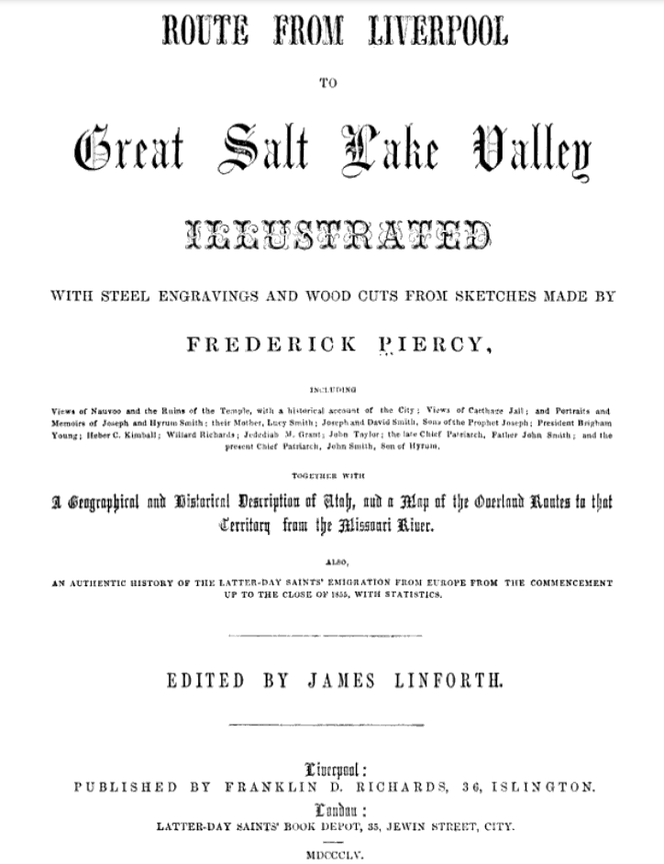
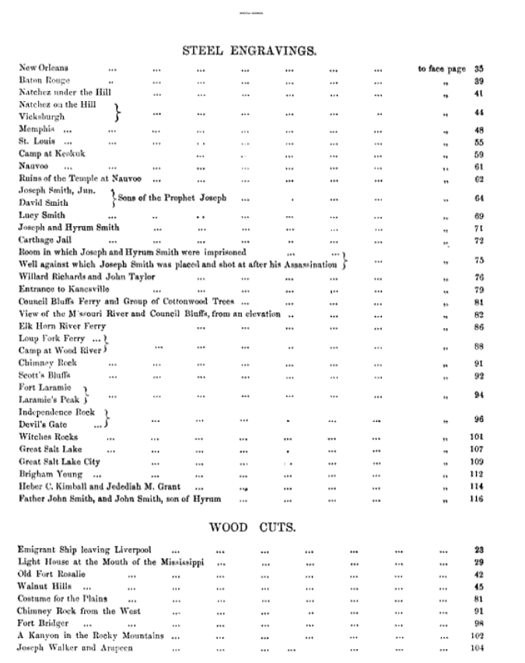

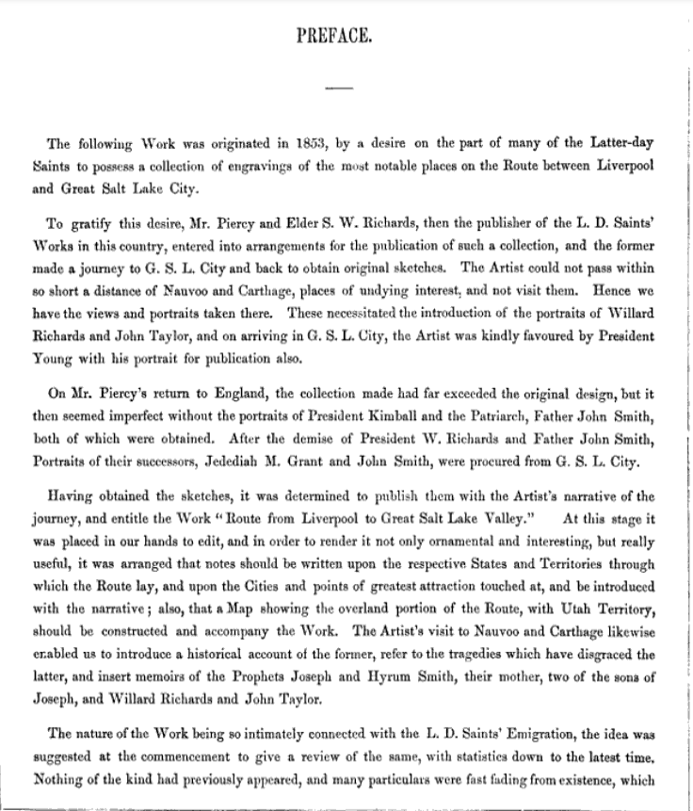

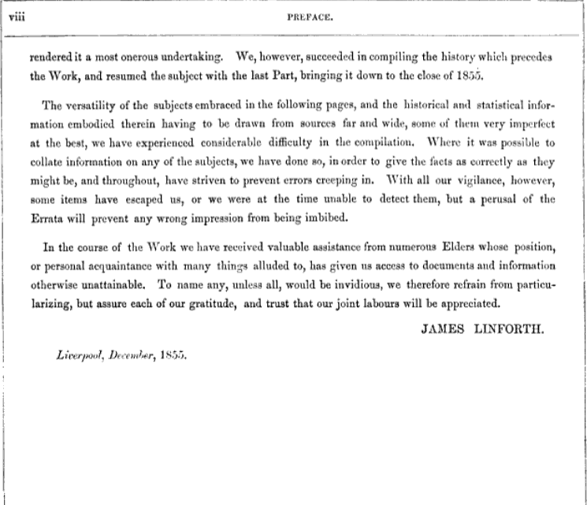

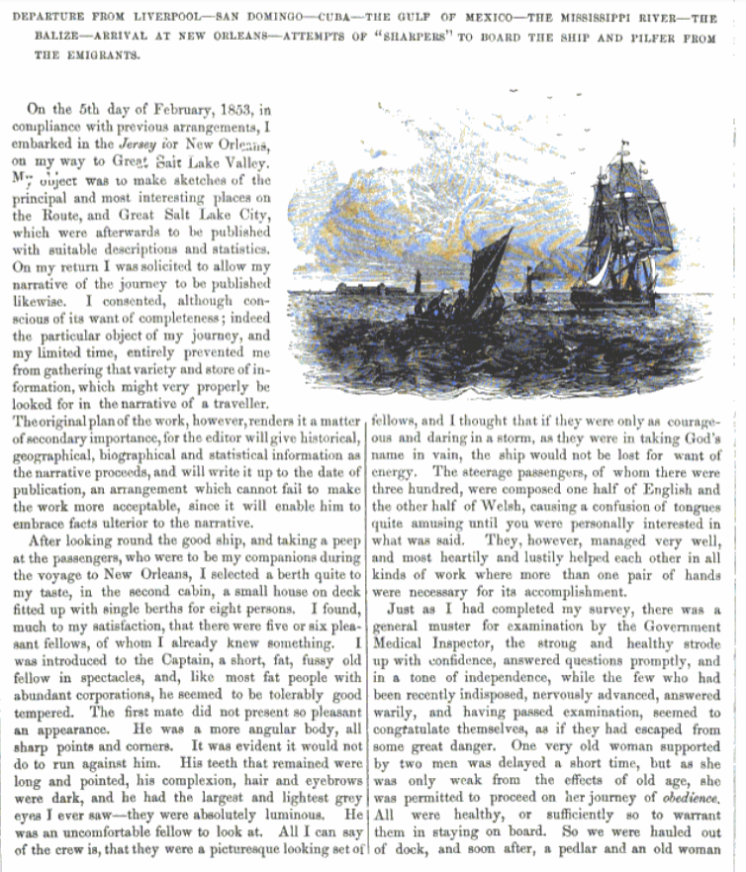

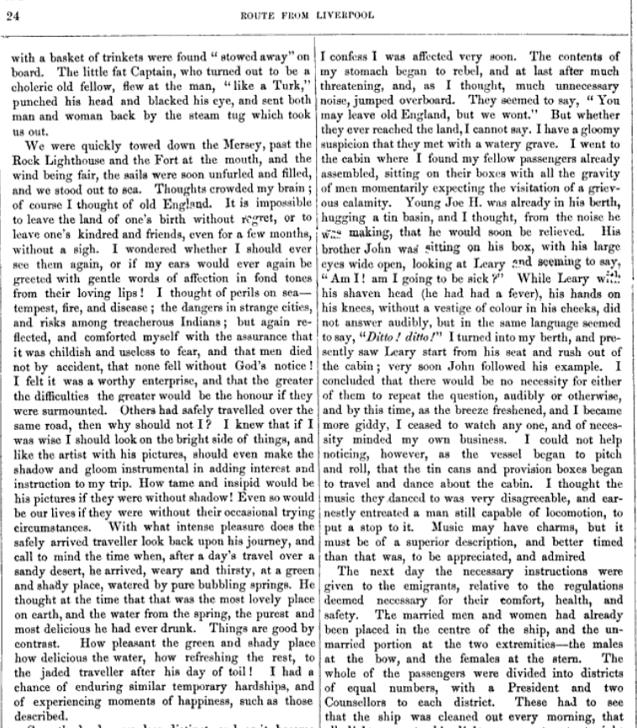

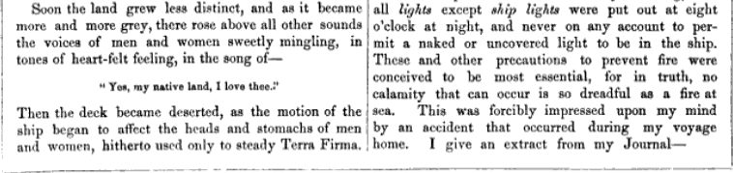

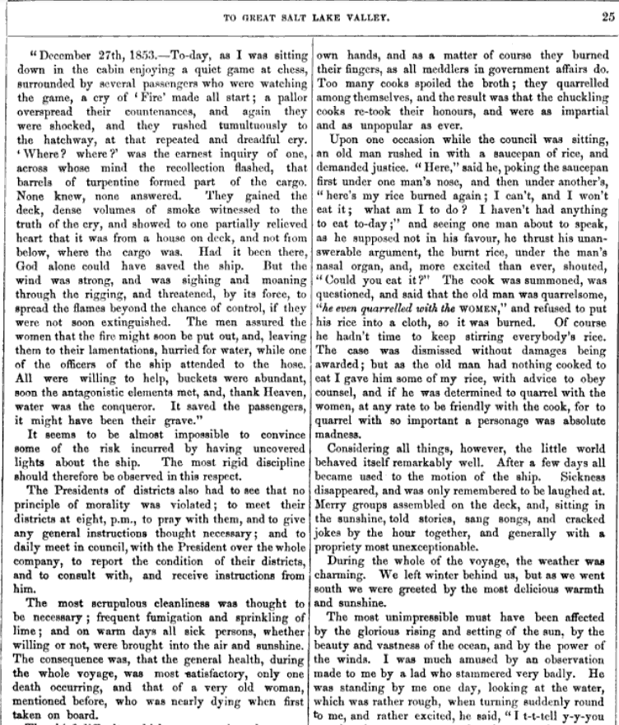

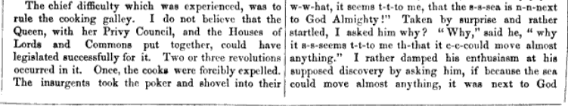
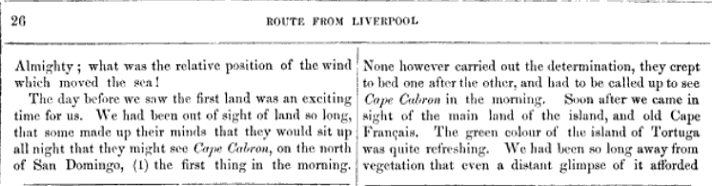

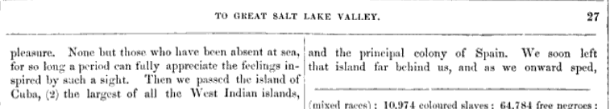

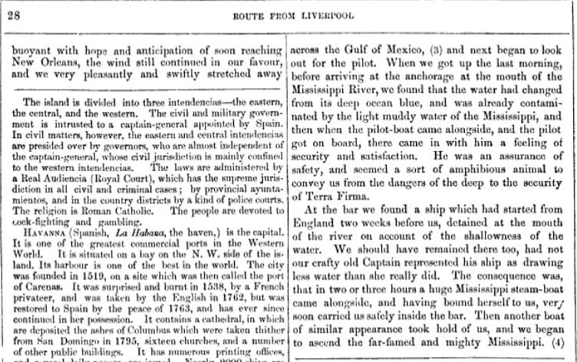

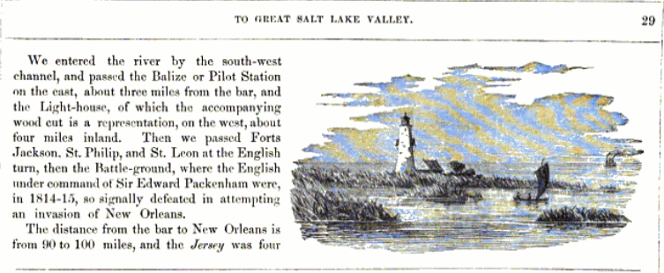

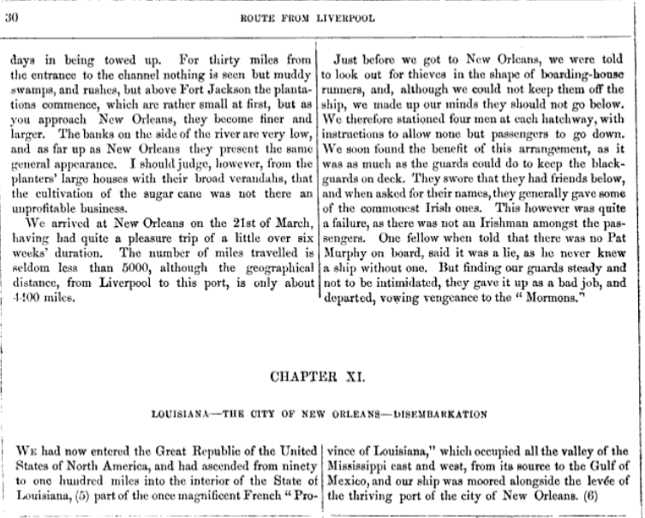

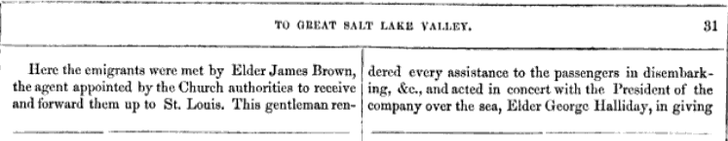
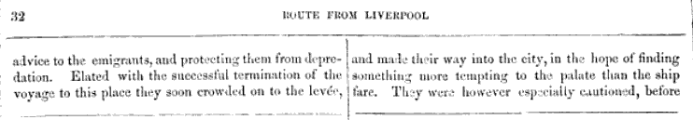

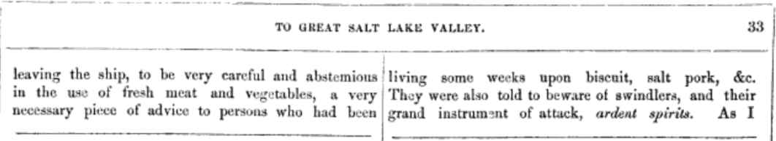

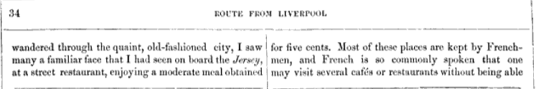
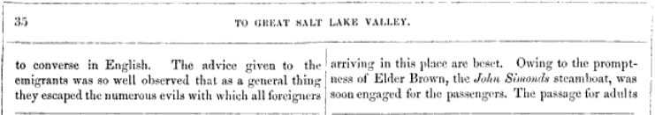

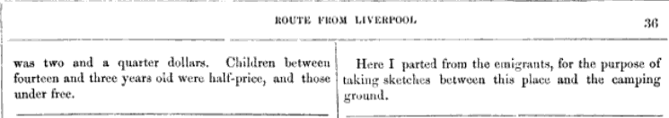

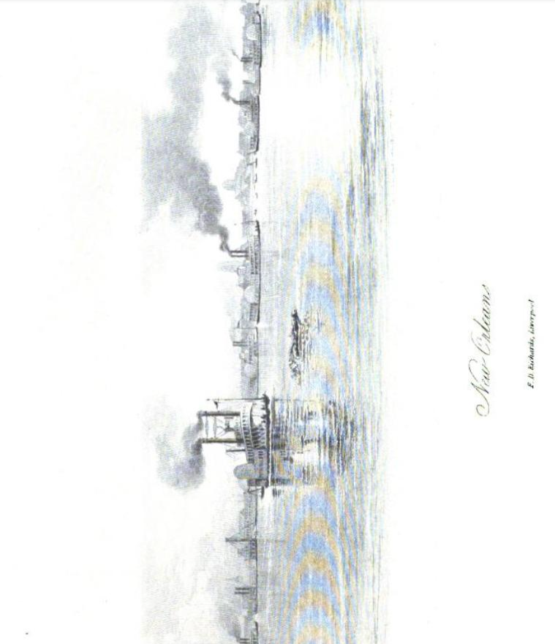

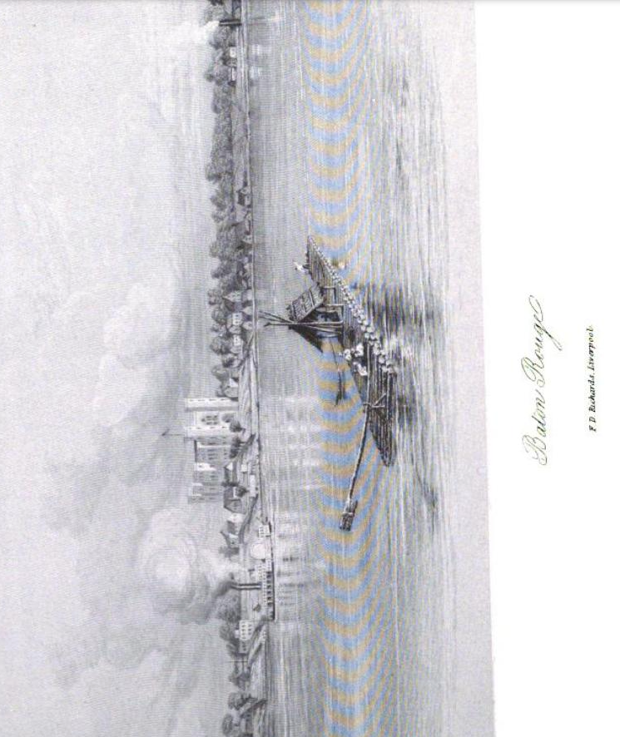
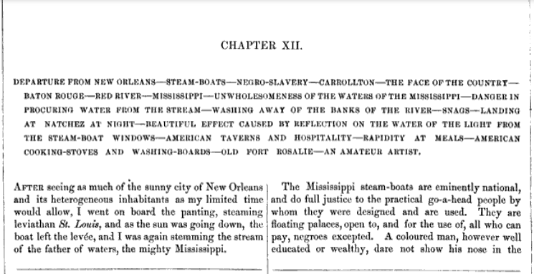

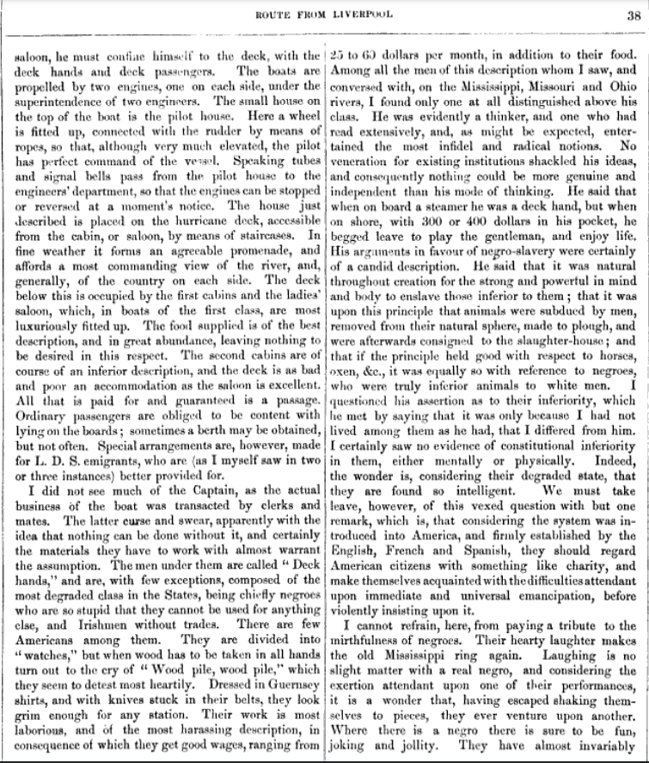

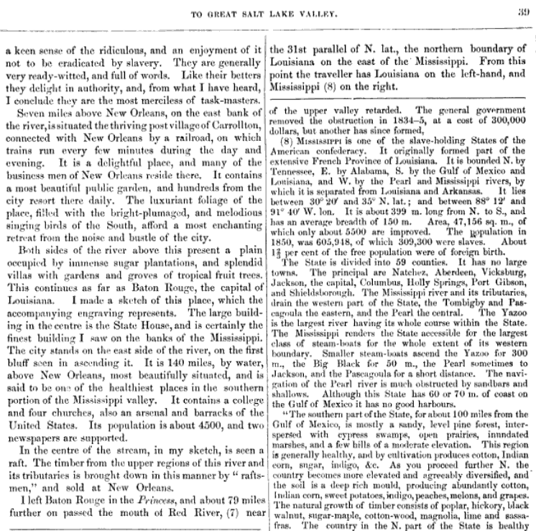

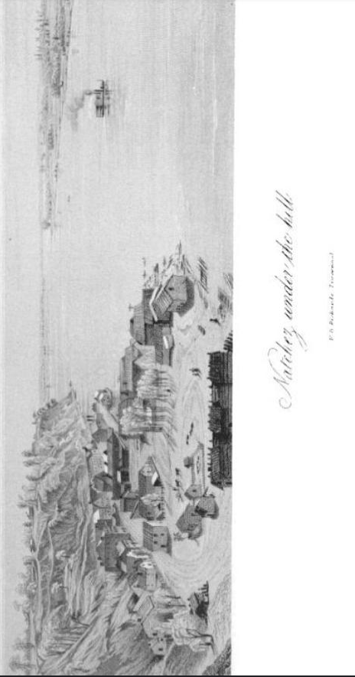
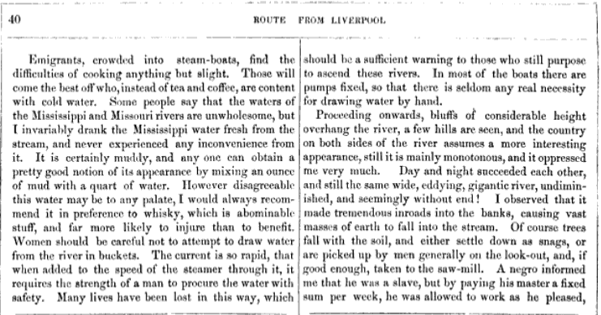

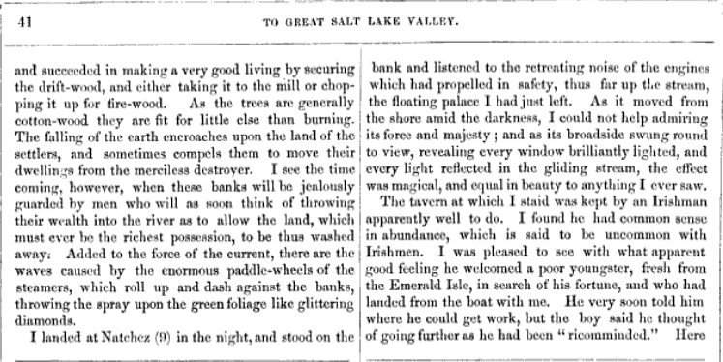
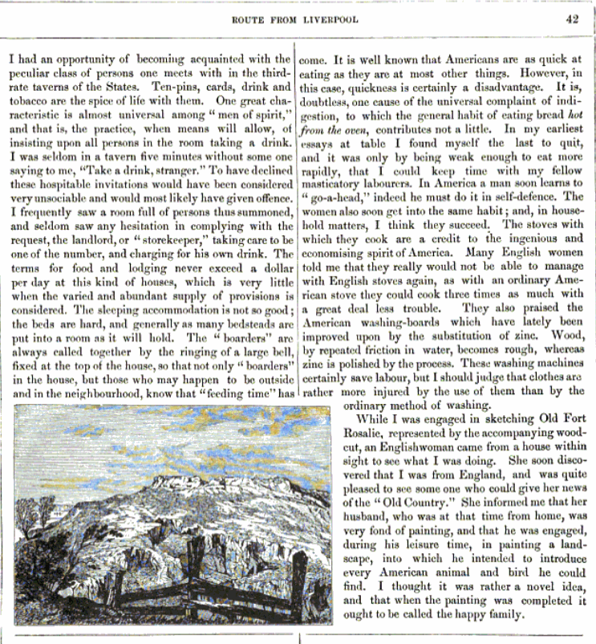

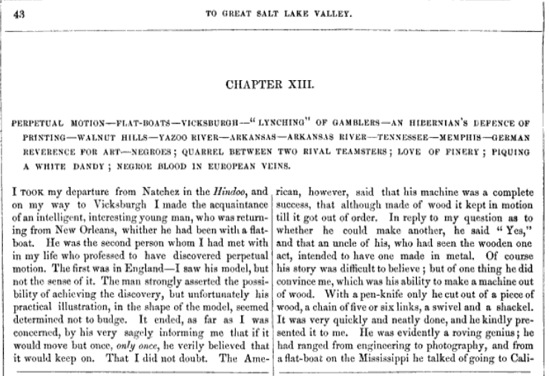

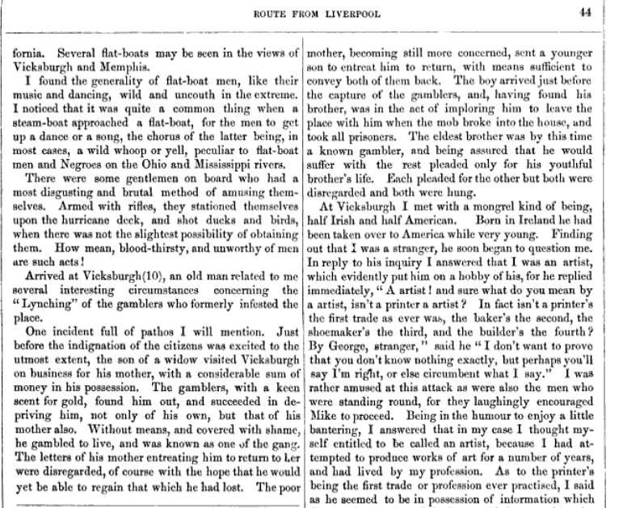

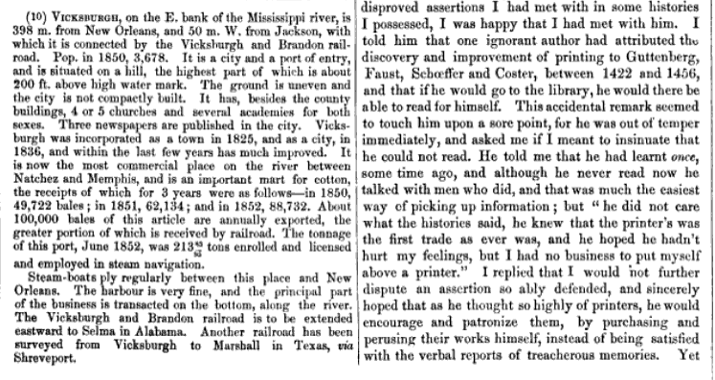

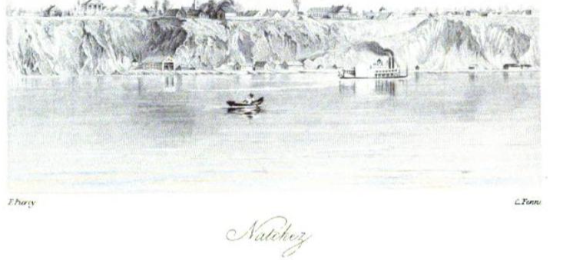

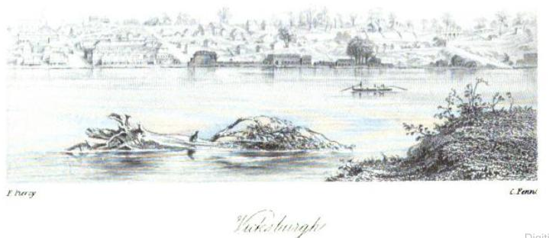

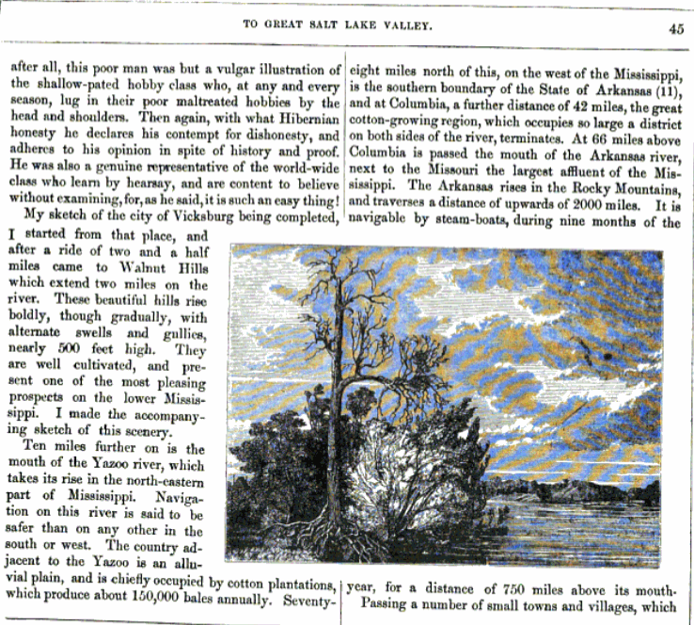
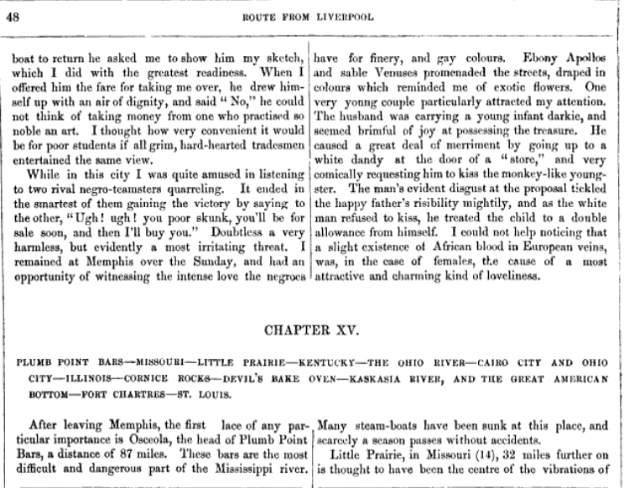
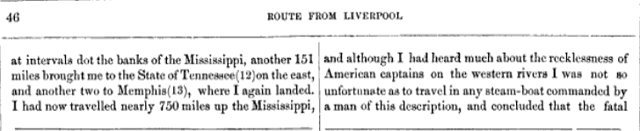
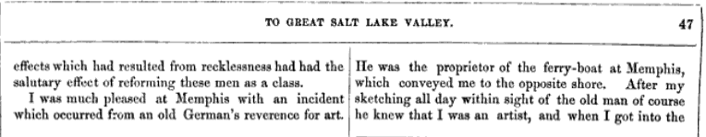

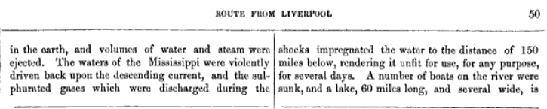
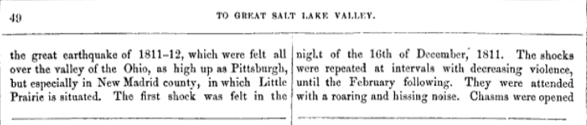
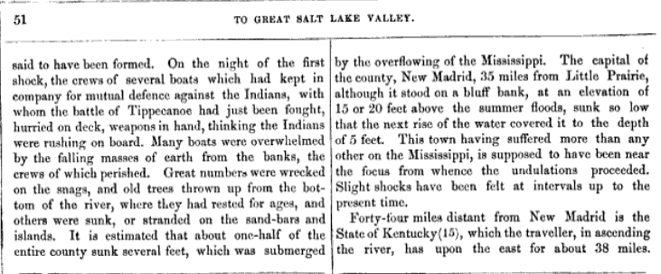

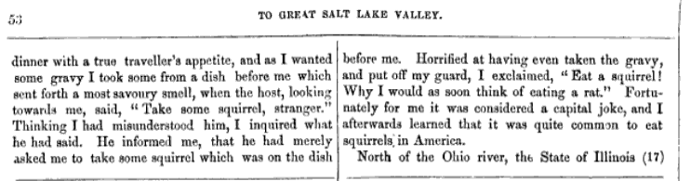
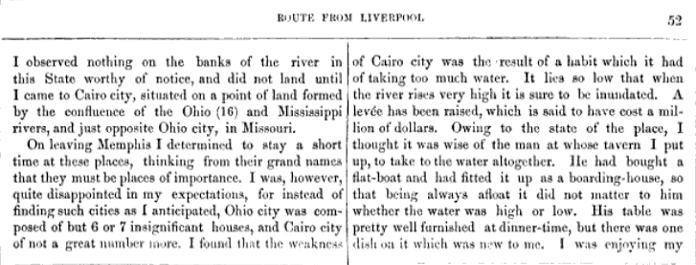

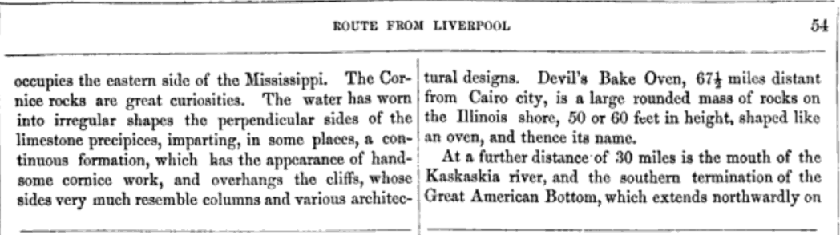
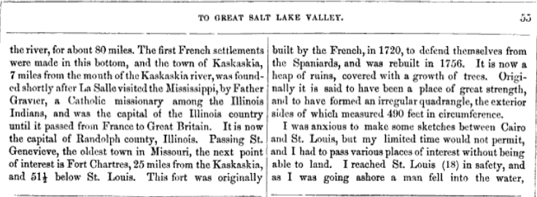

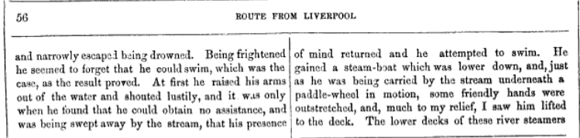
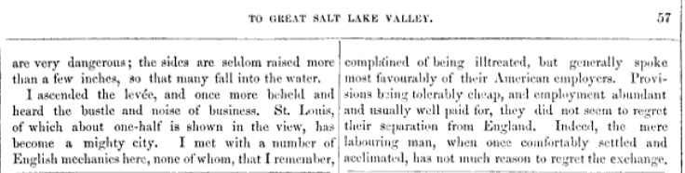

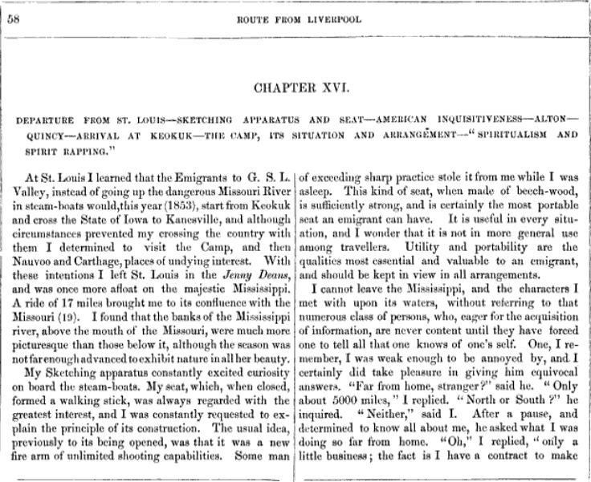


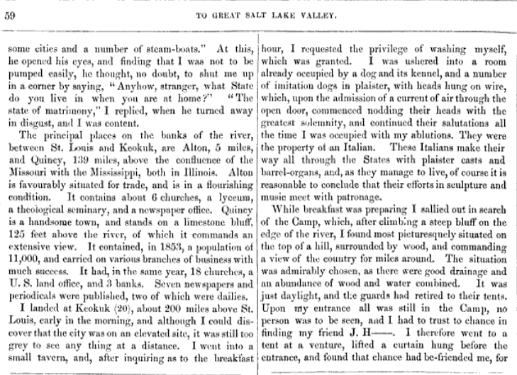

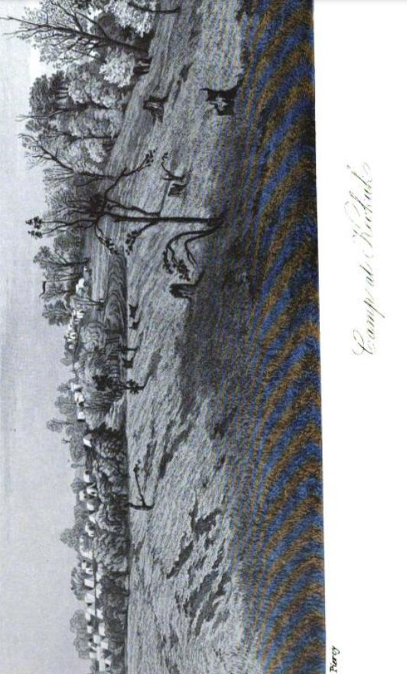
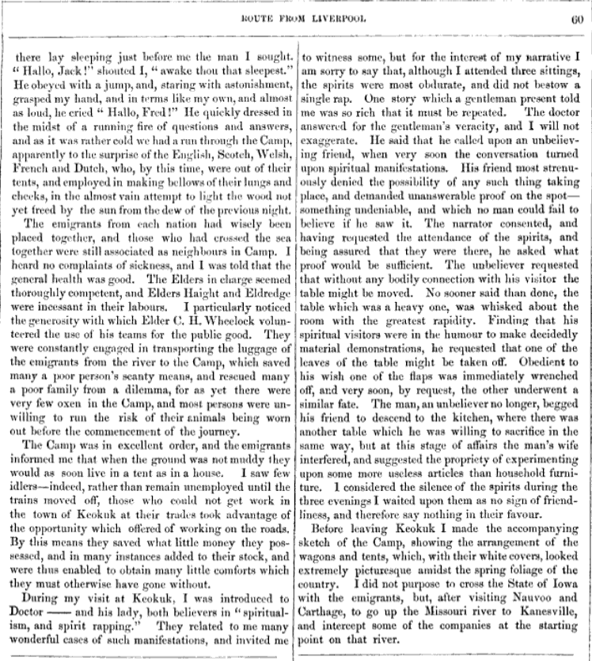

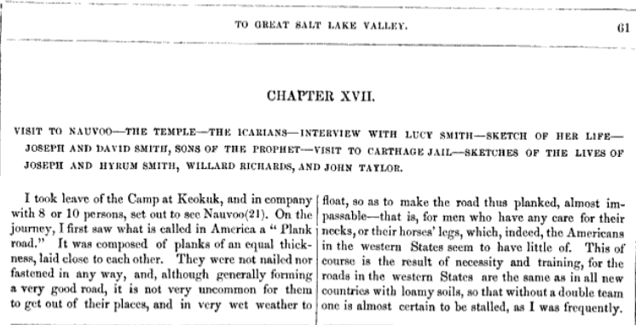
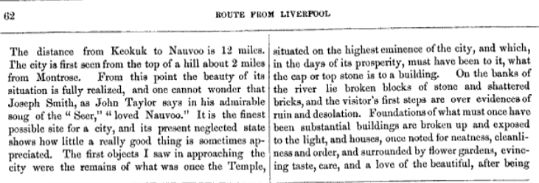

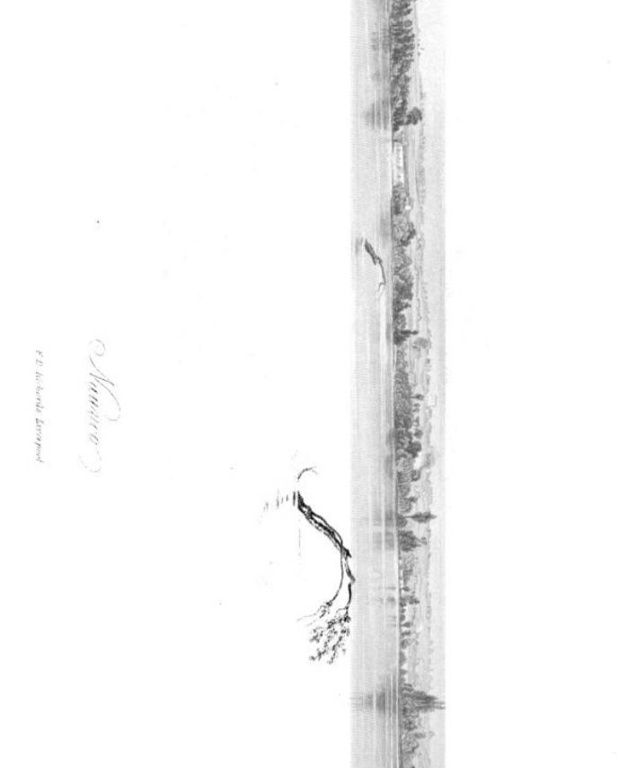

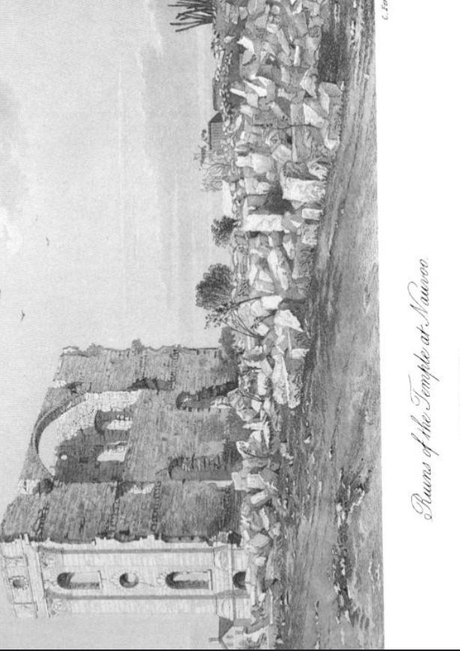

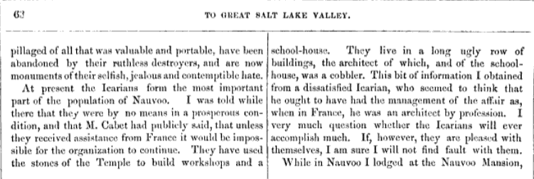

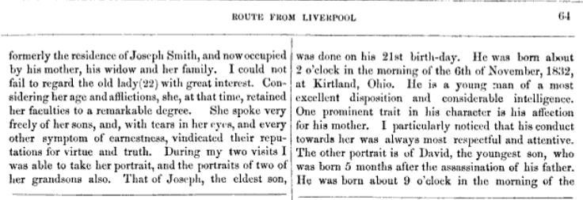
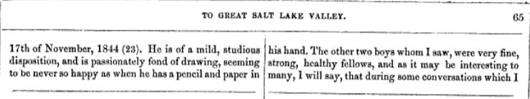
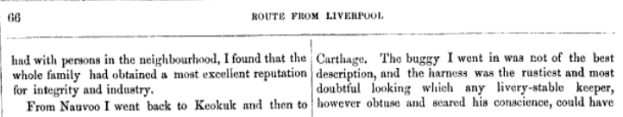

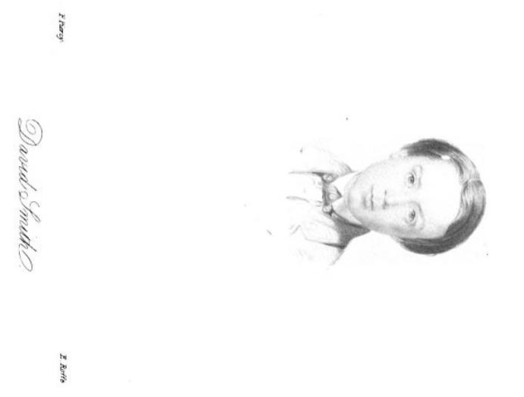
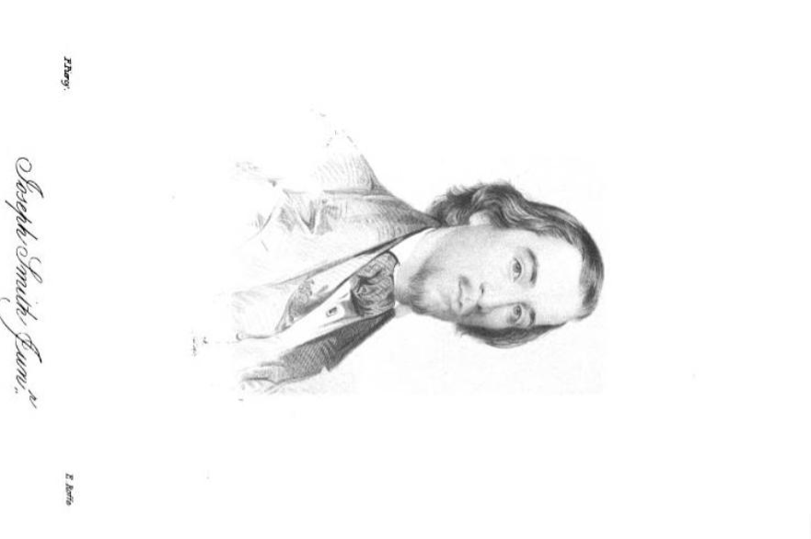

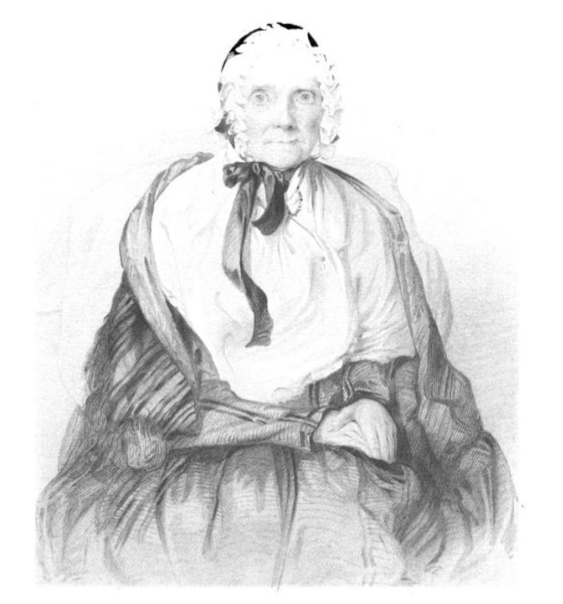

Lucy Mack Smith, the mother of Joseph Smith Jr. the Prophet

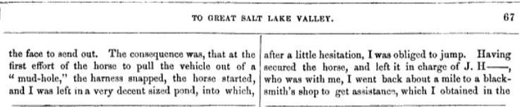

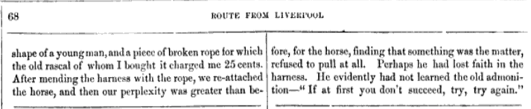

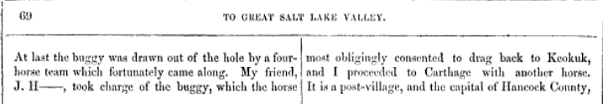

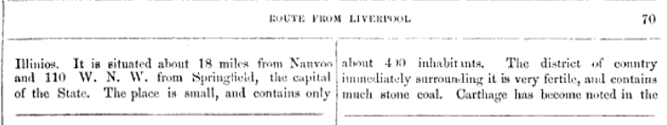

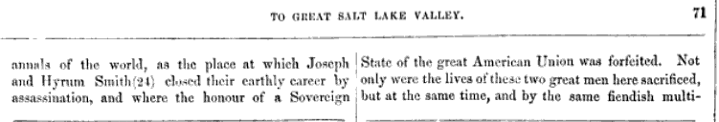

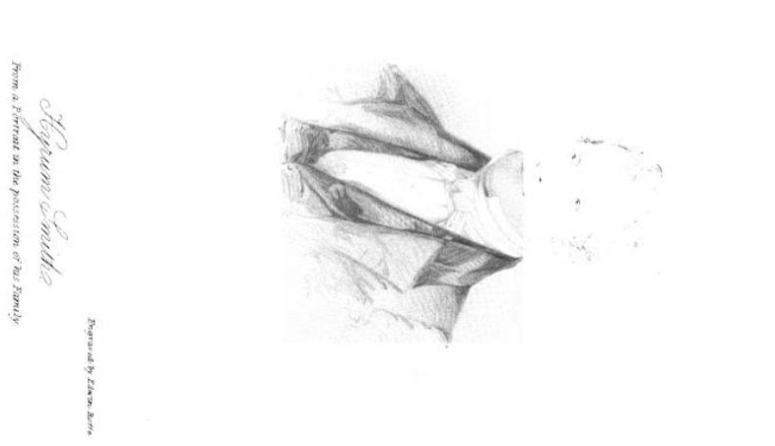

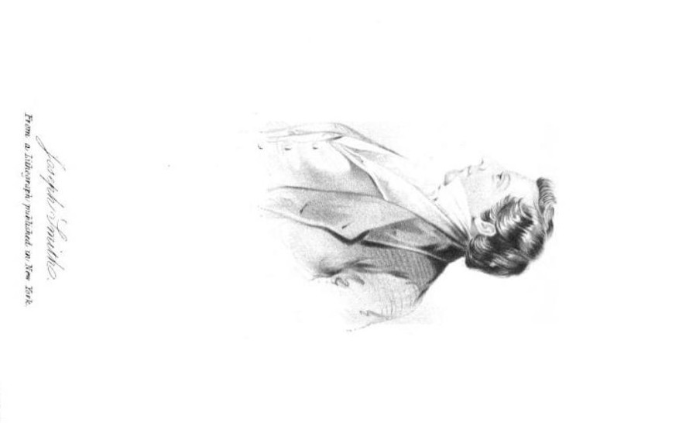

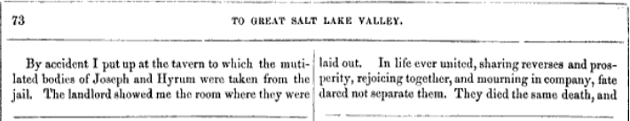
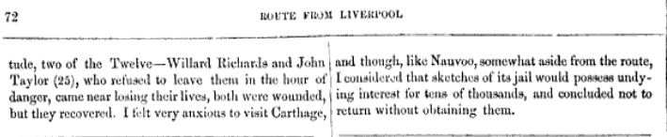

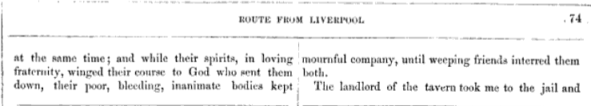
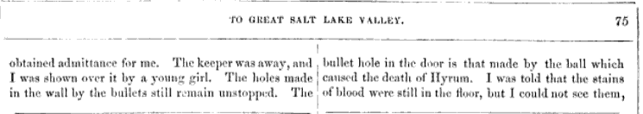

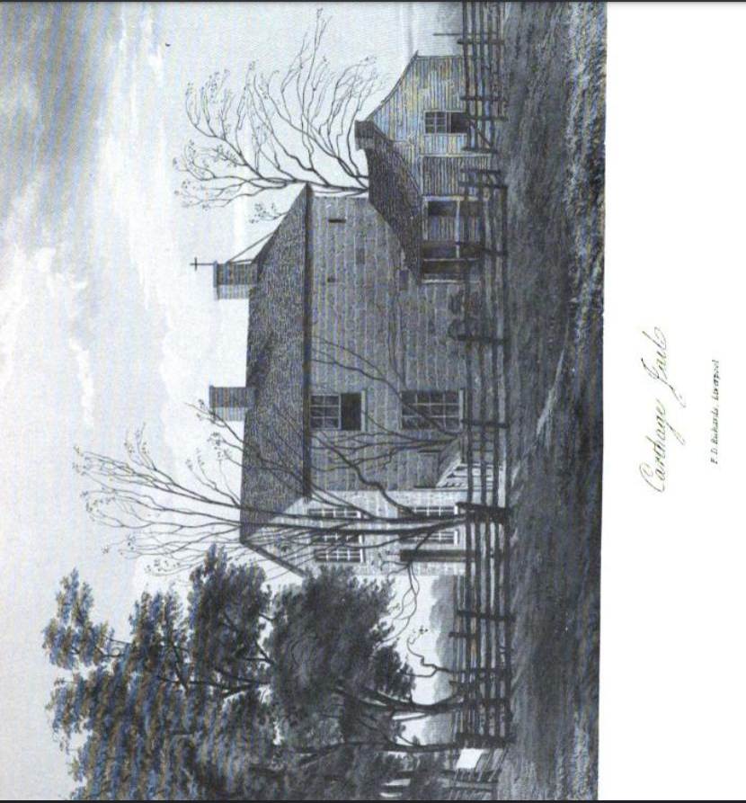

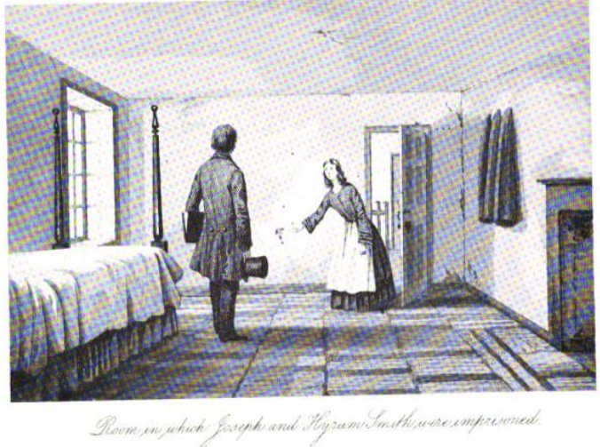

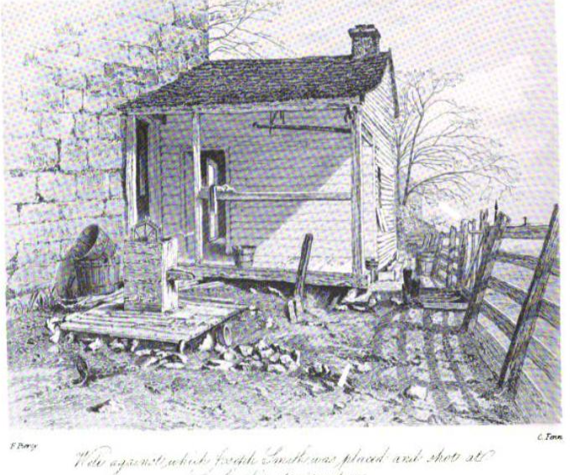

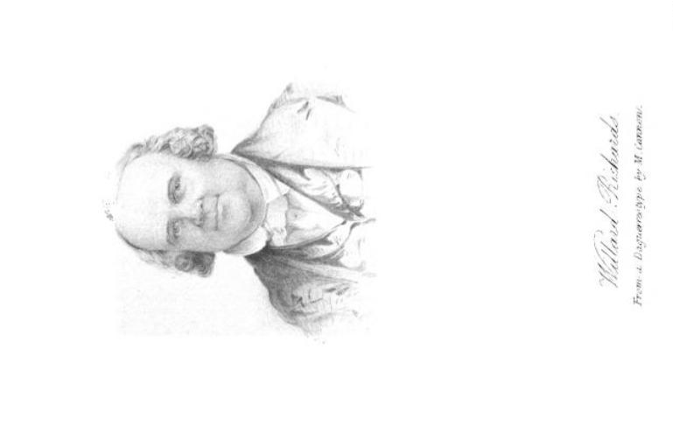
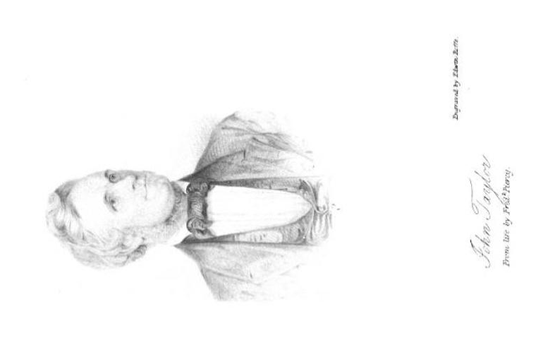

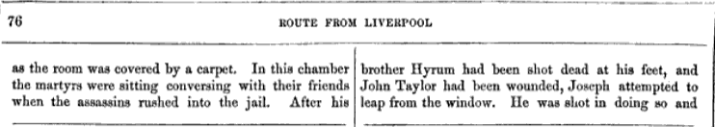

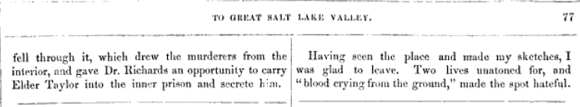
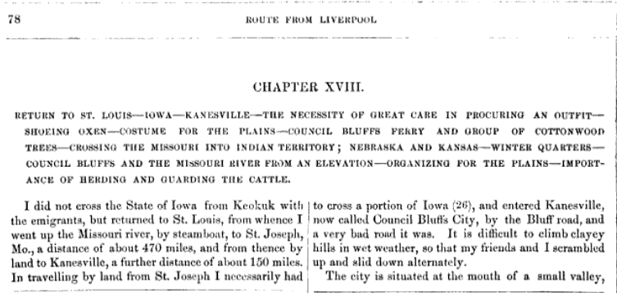

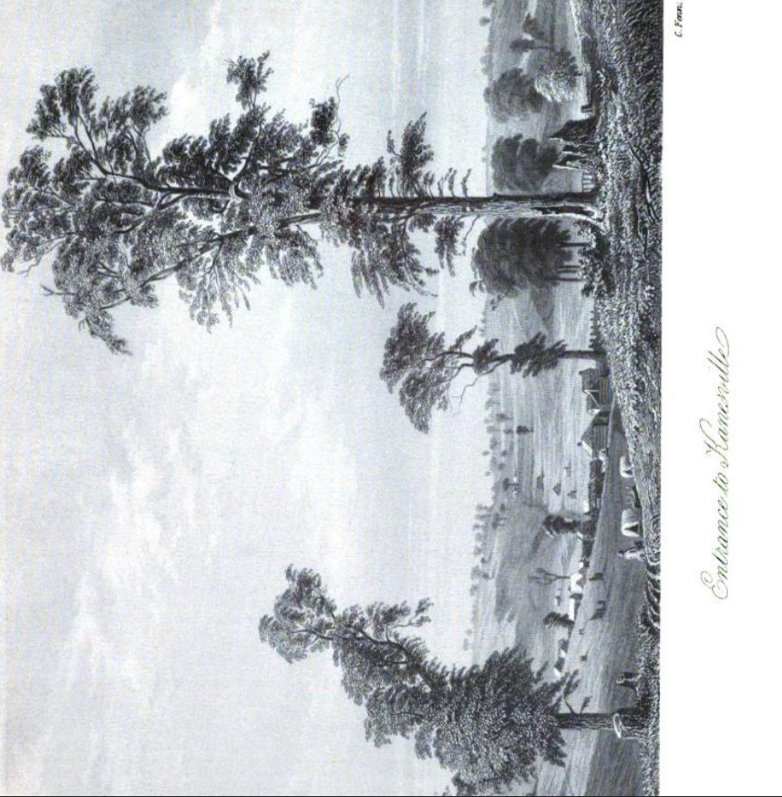
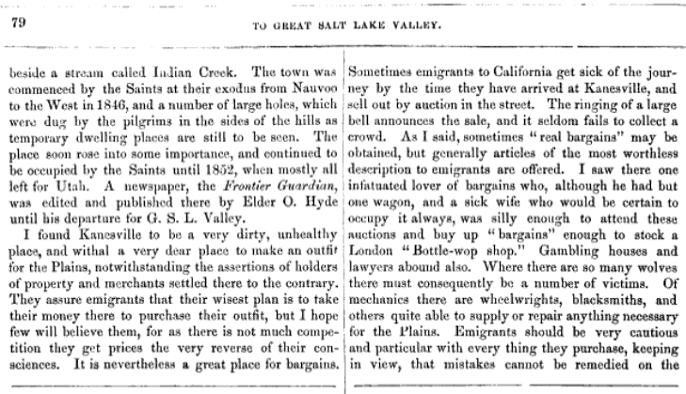

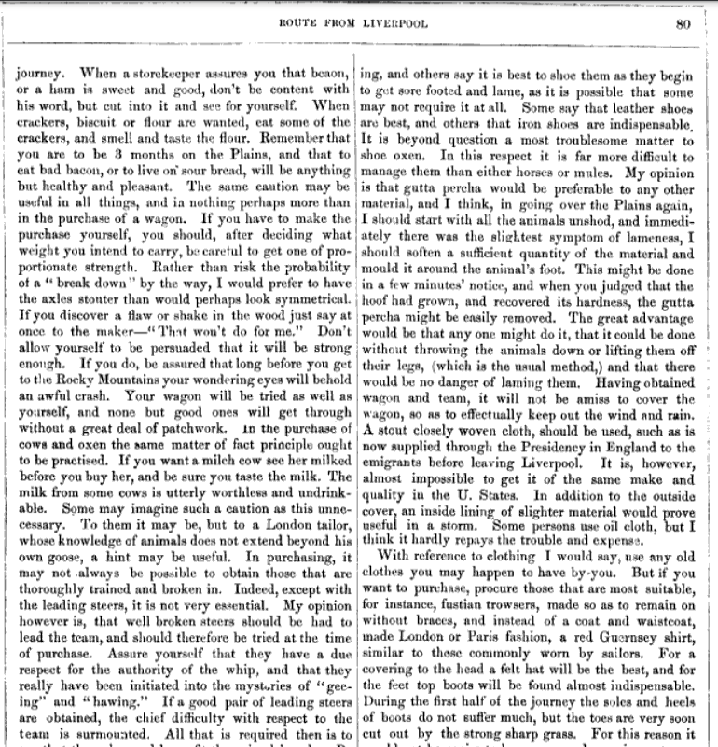

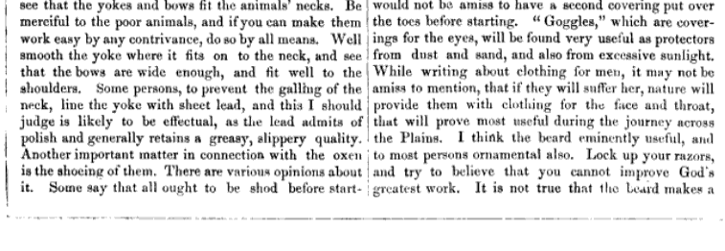

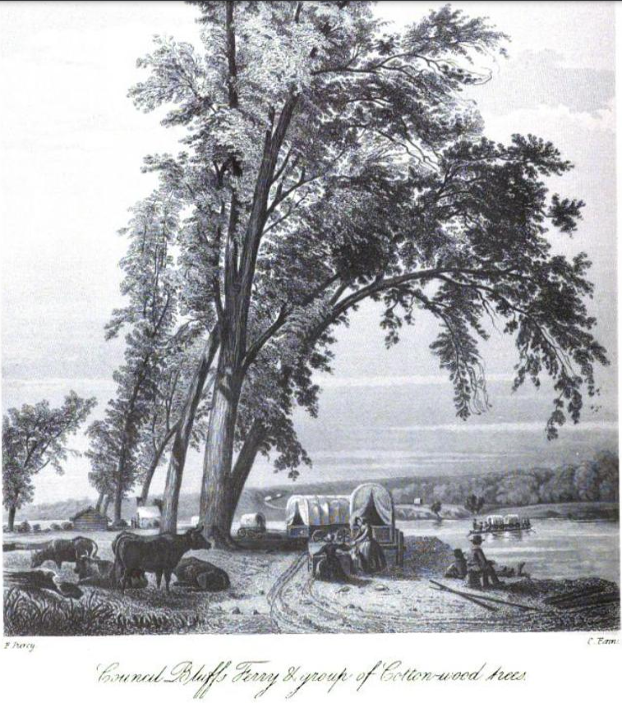

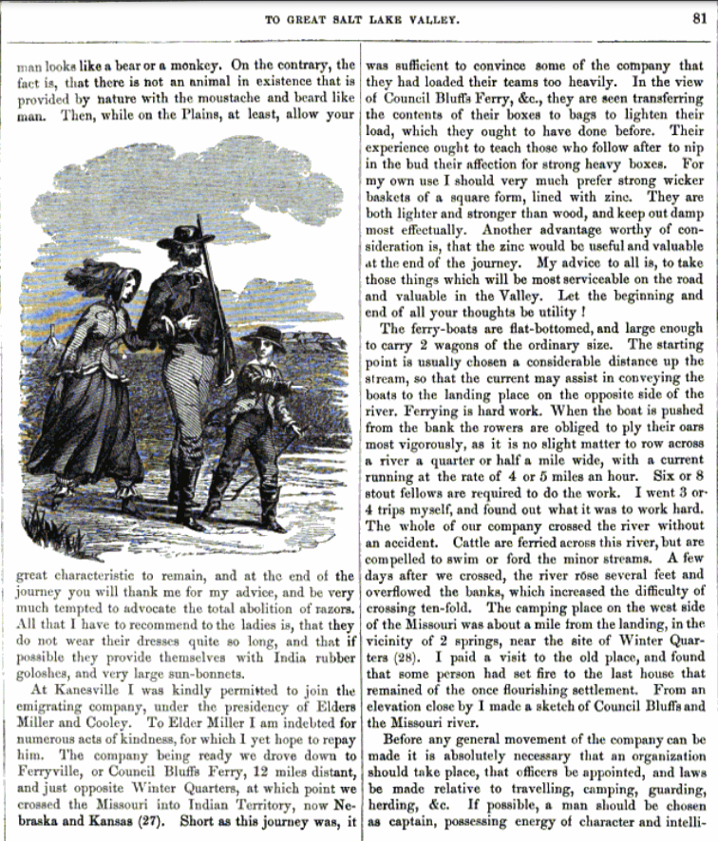

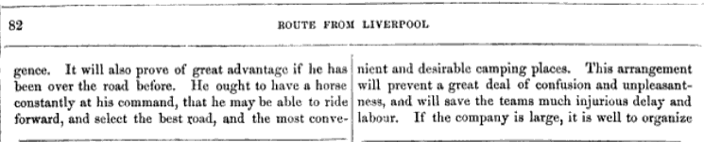

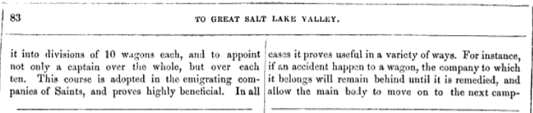

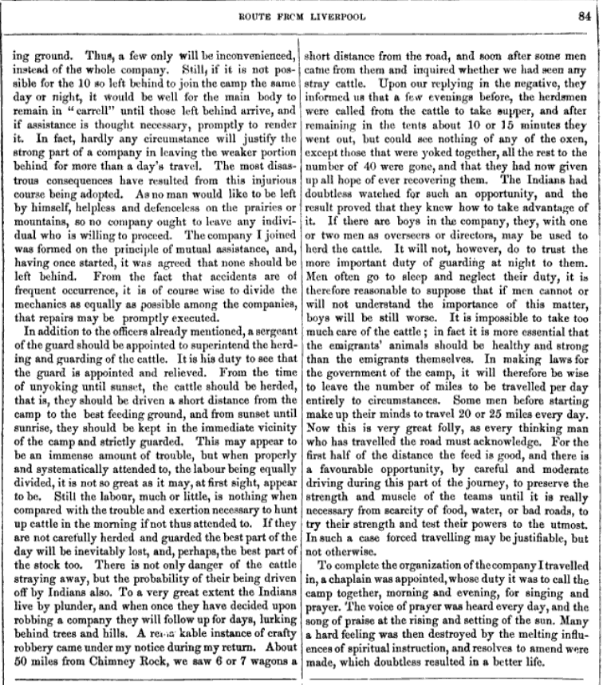

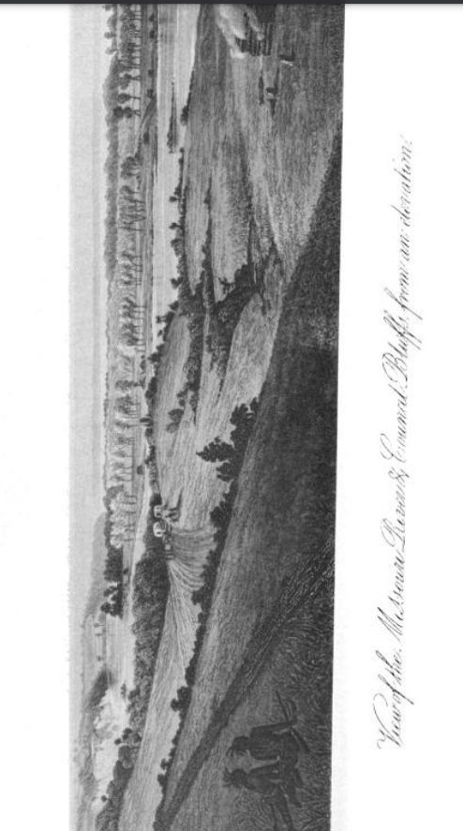

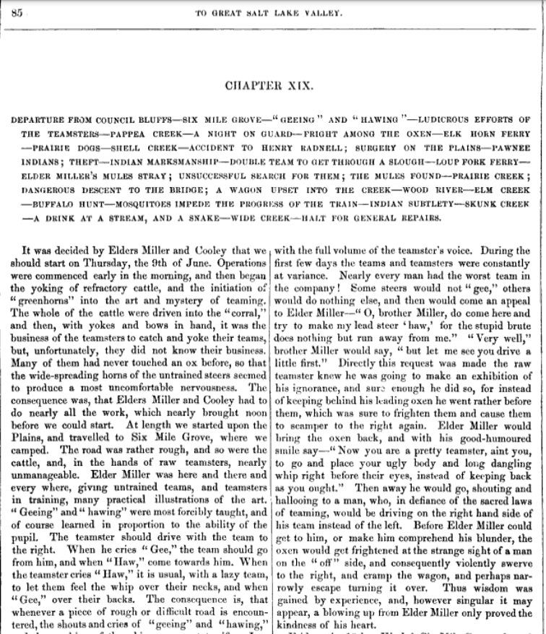

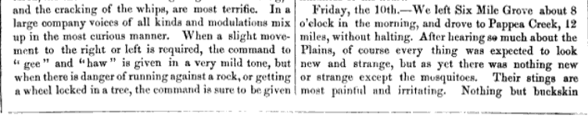

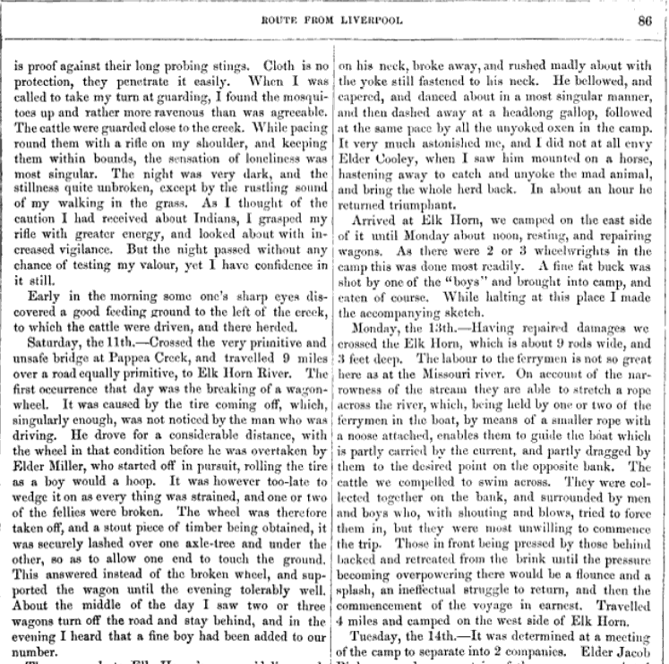

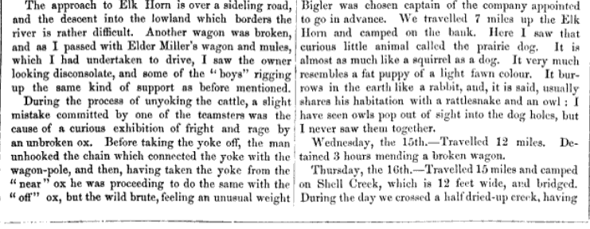

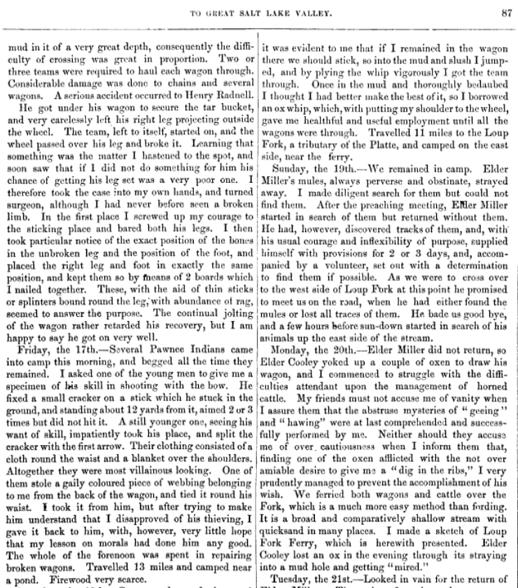

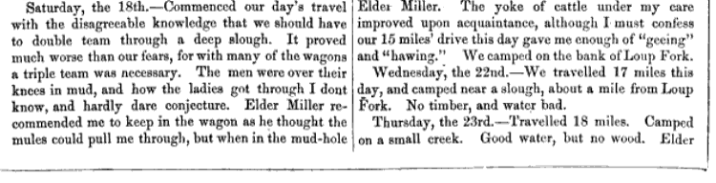

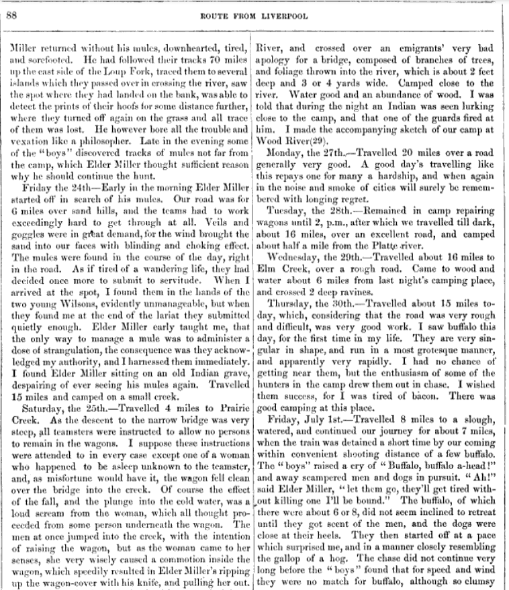

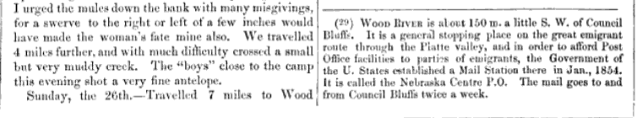

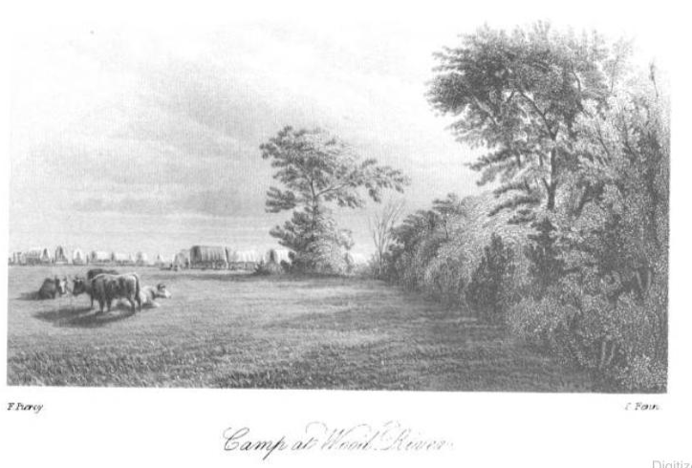
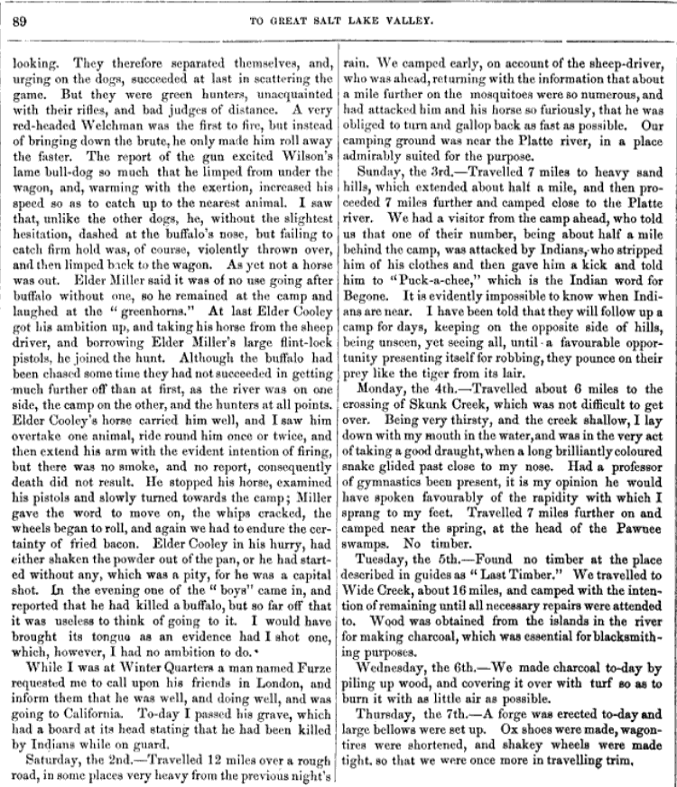

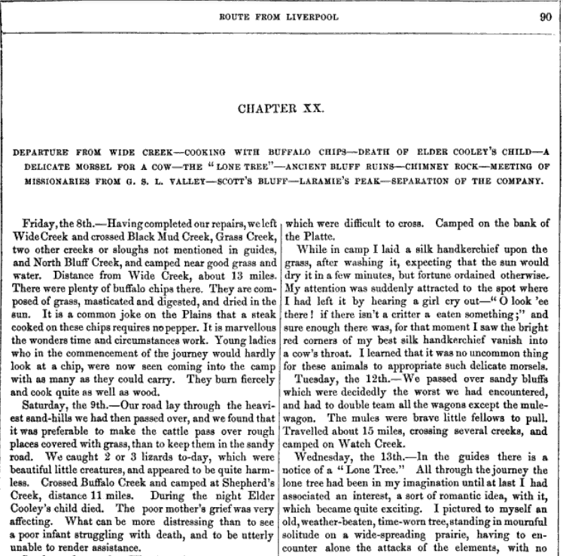

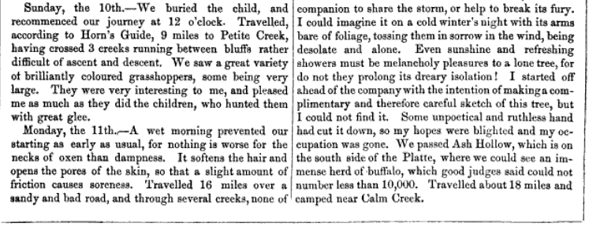

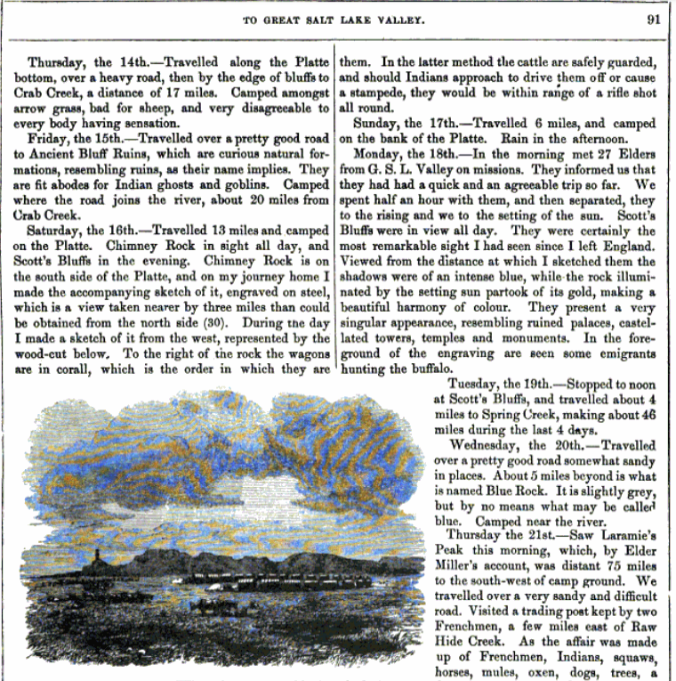
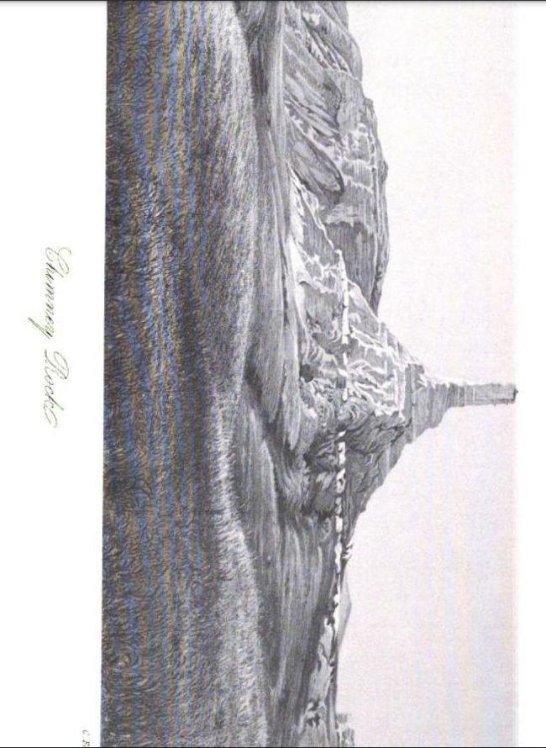
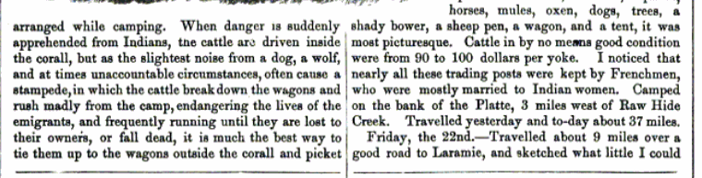

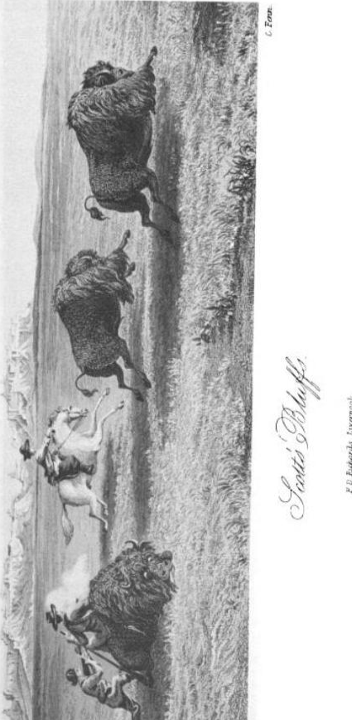
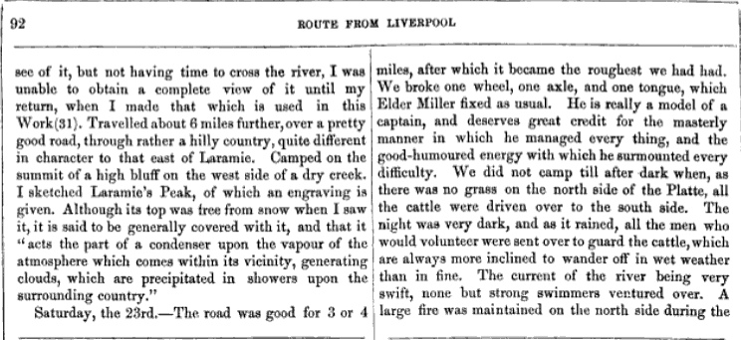

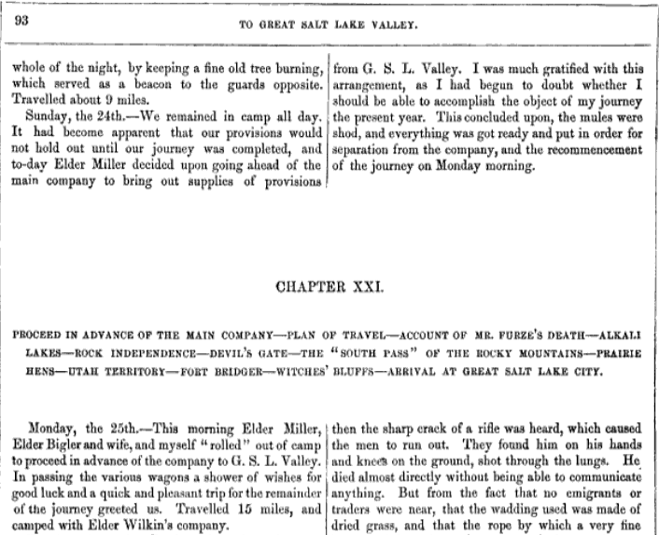

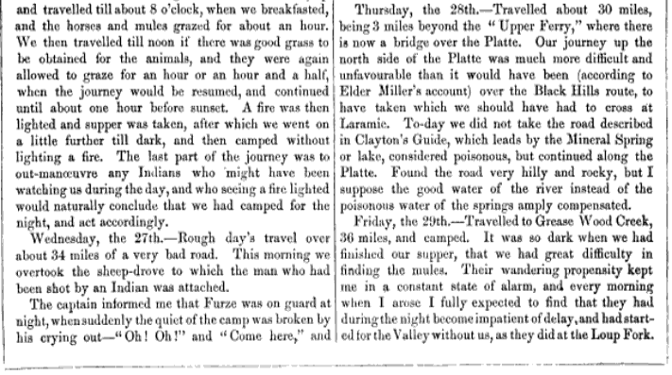

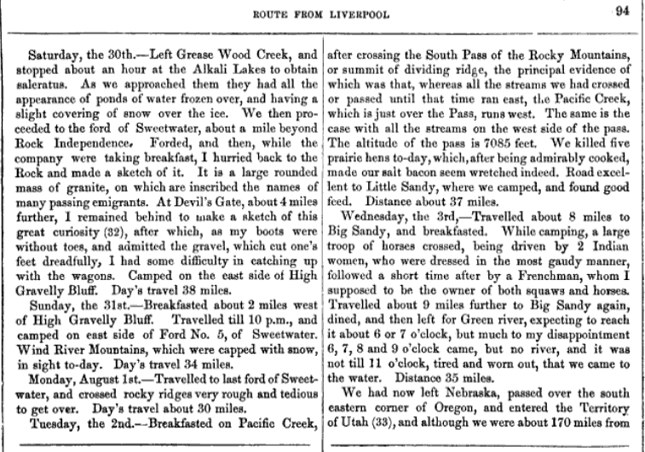

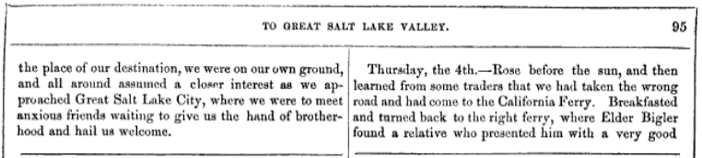
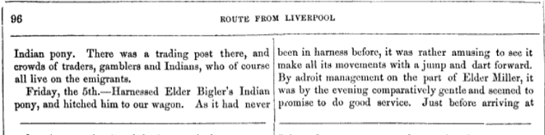
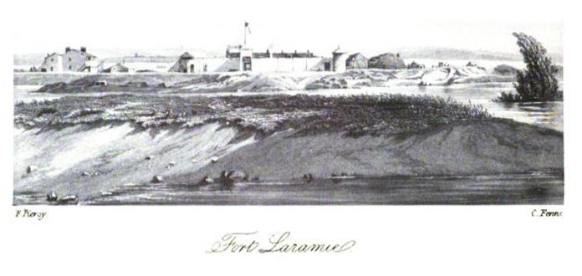
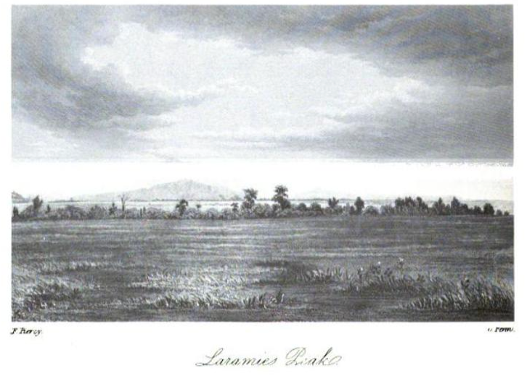

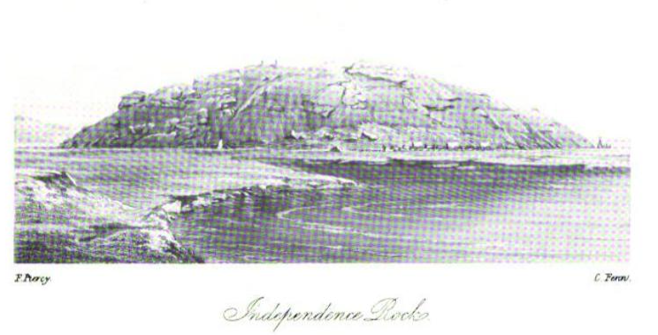
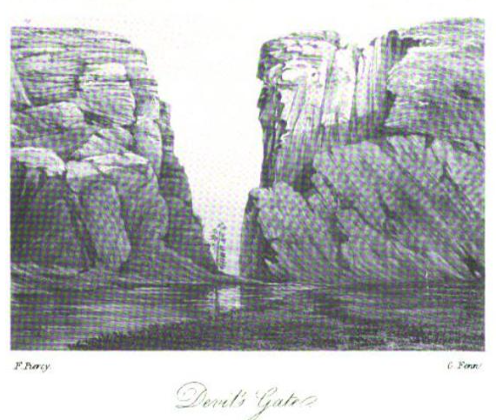

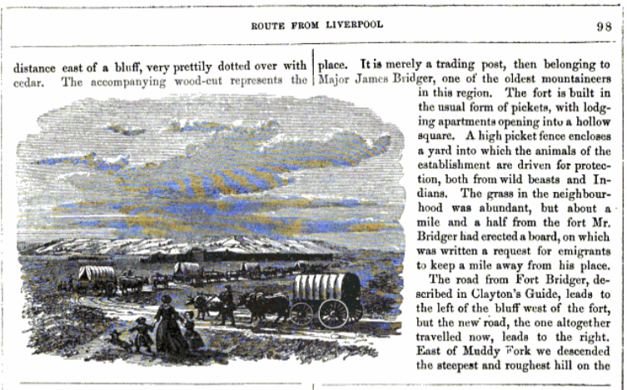
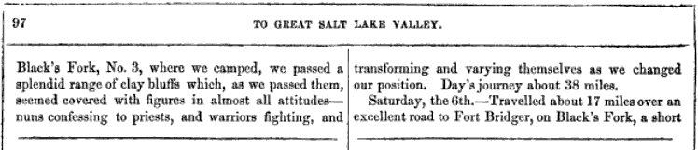

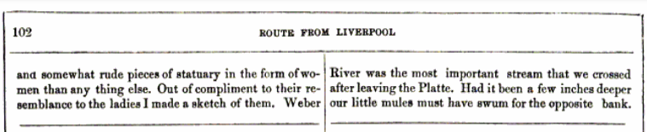
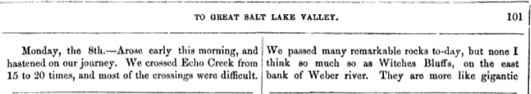
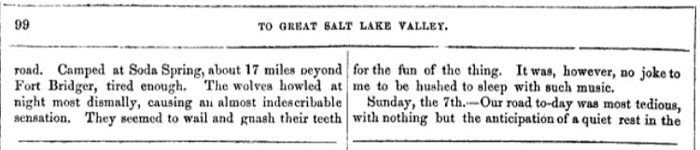
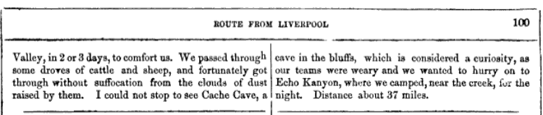

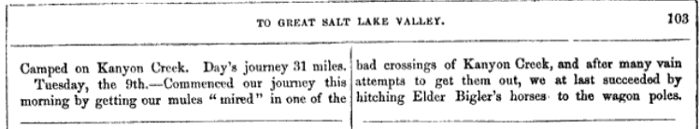
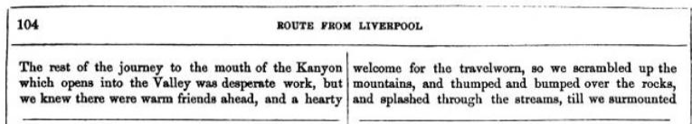

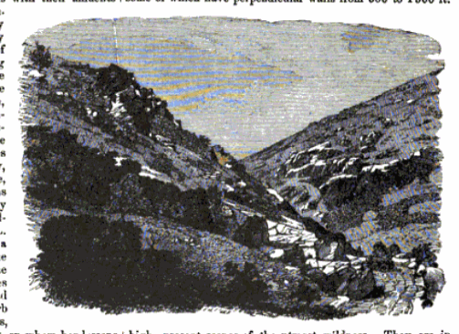

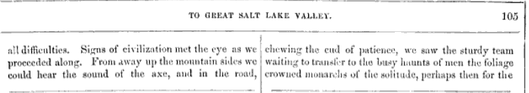
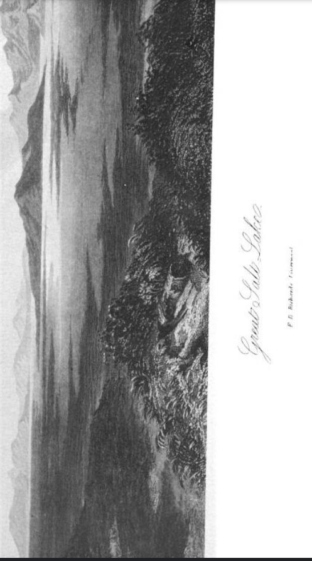
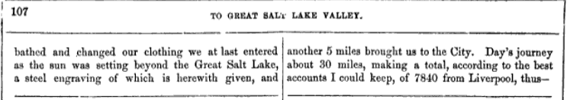
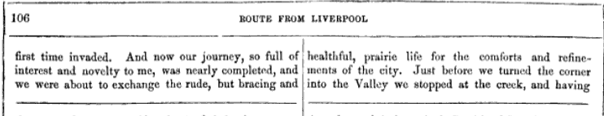

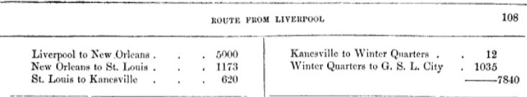

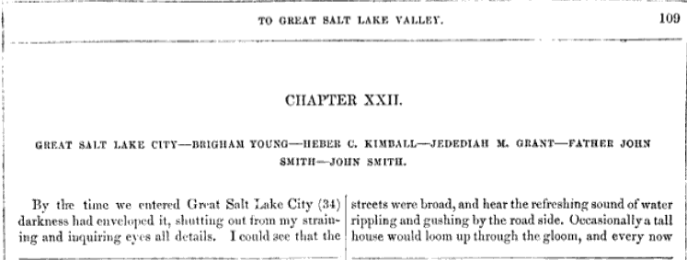
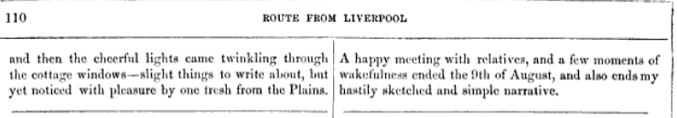

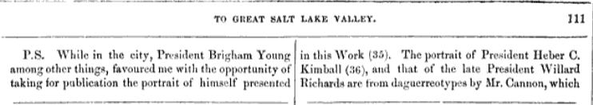

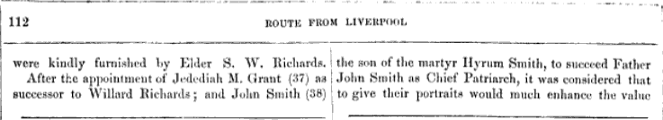
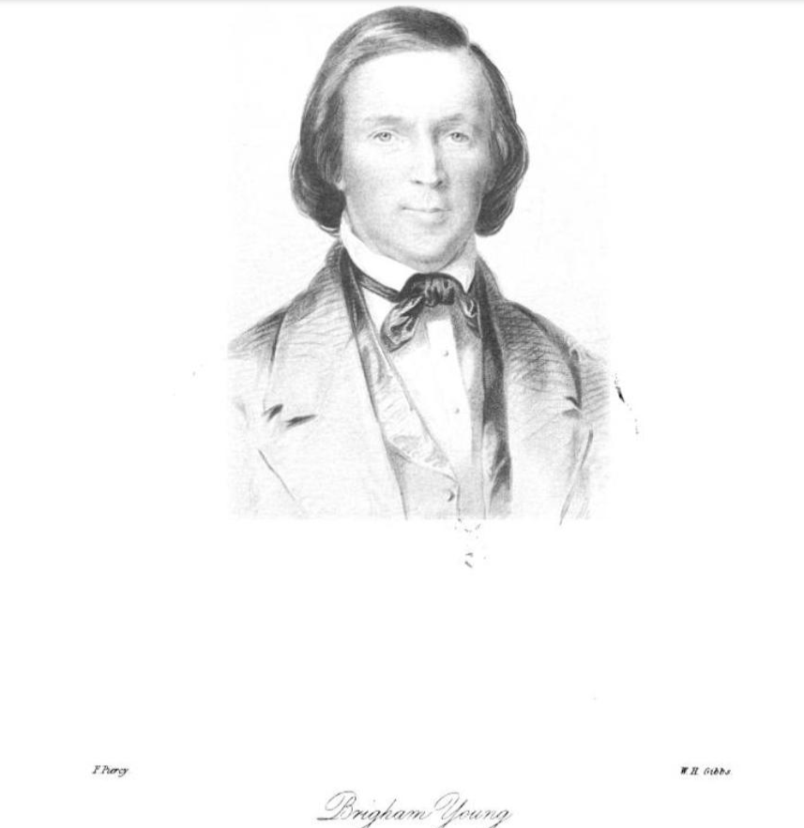

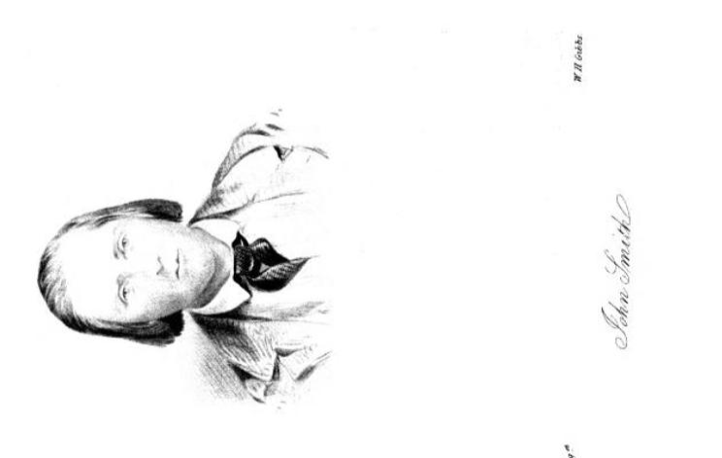


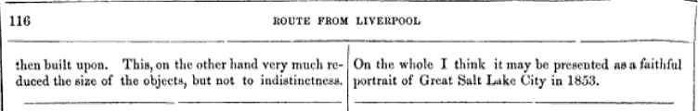
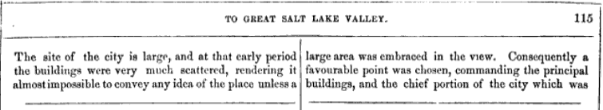
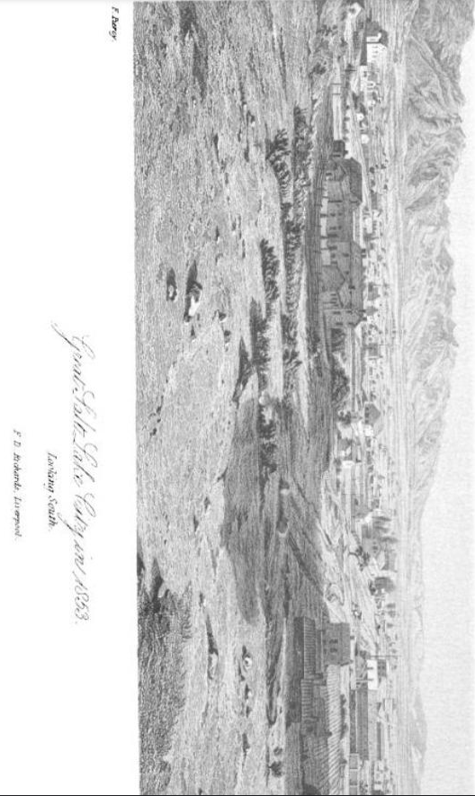

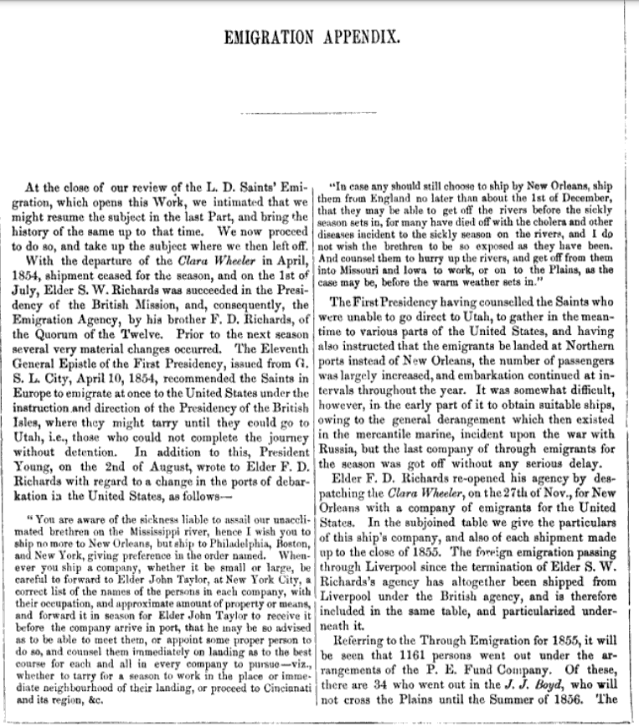

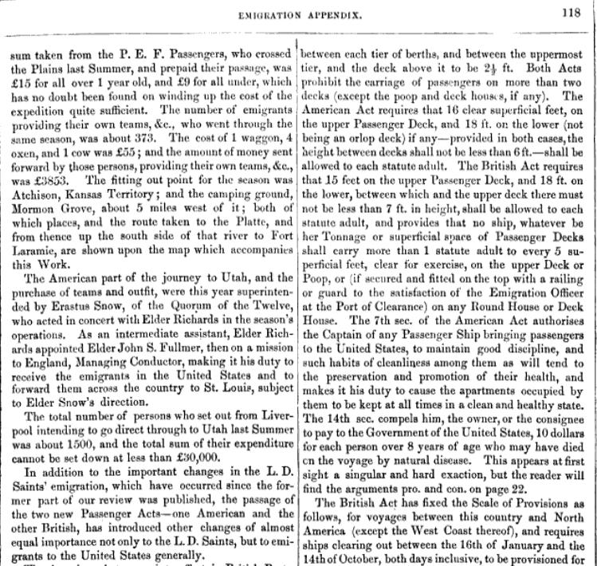

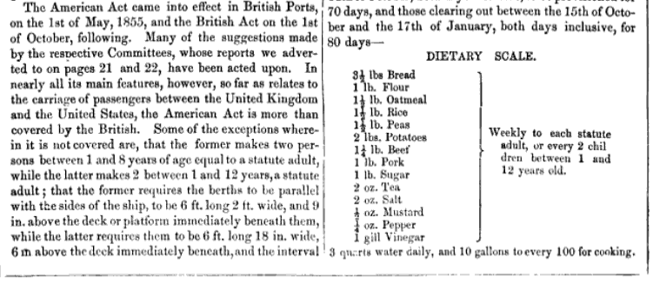

Appendix F Photographs, Sketches, and other stuff

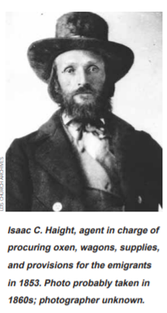
Isaac C. Haight was the Emigration agent in charge of organizing the Saints gathering at Keokuk in 1853. Thomas and family were among those Saints he would have helped outfit for their trek across the plains in the Appleton Harmon Emigrating Company.
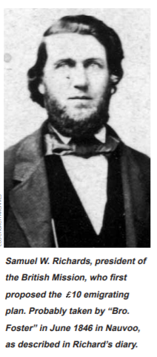
Samuel W. Richards was President of the British Mission and, thus, the Emigration Agent for the Church in Liverpool during the years Thomas and George and their families departed Liverpool for New Orleans (1853-1854).

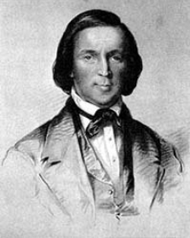
Brigham Young 1853 Portrait by Frederick Piercy. When Piercy entered the Great Salt Lake Valley in 1853 after making his long Journey from Liverpool he was given permission to sketch this portrait of the prophet. Brigham Young was 52 years old at the time of this sitting.

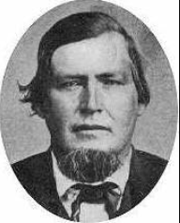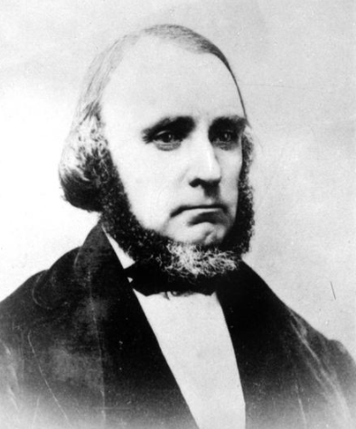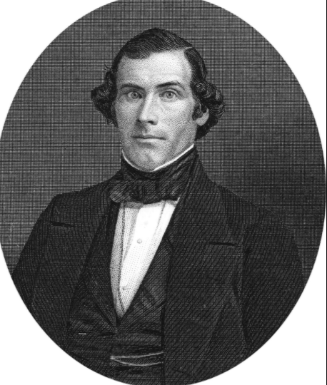
Appleton Harmon William Clayton Orson Pratt

This is a Photograph of an Odometer or Roadometer (not the original). The Odometer was thought up by William Clayton while traveling with the Brigham Young Emigration Company in 1847. William wanted to measure the distance they traveled each day across the plains. He tied a piece of string or yarn on a wagon spoke at the outer circumference of the wheel and then counted the revolutions of the wheel throughout the entire day. Knowing the circumference of his wagon wheel (measured in feet) he multiplied that number by the number of revolutions the wagon wheel made and, thus, determined the number of miles they traveled. Sharing his thoughts with Orson Pratt a system of cogs and gears was drawn up my Orson. The design was given to Appleton Harmon who, being a craftsman and mechanic, built the odometer and attached it to a wagon on May 10, 1847 while the three of them were still on the plains.
Appleton Harmon was the wagon master of his company that brought Thomas and family to the Great Salt Lake Valley in 1853.
William Clayton penned the words to one of our favorite Pioneer hymns, “Come, Come Ye Saint”.
Orson Pratt was one of the original 12 apostles in this last dispensation.

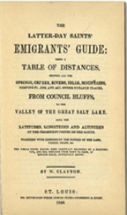

William Clayton, after arriving in the Great Salt Lake Valley with Brigham Young in 1847 petitioned Brigham to let him return to Winter Quarter and document the route taken coming to the Valley. With the Odometer attached to his wagon he accurate calculated distanced between every landmark and the distance back to the Valley. The result was the guide book shown above, “The Emigrants Guide with a Table of Distances from Council Bluffs to the Valley of the Great Salt Lake”, published in 1848. Every wagon master coming west thereafter benefited from Elder Clayton’s Guide.

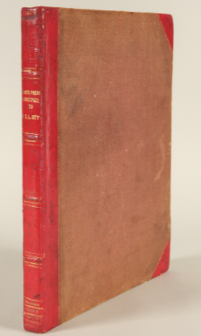
This is a photograph of Frederick Piercy an English Artist who joined the Church around the time our Smith’s joined (1848). He was commissioned to travel from Liverpool to the Great Salt Lake Valley and document his travels with sketches and Commentary. The result of his 1853 journey was the book depicted here. The “Route from Liverpool to Great Salt Lake Valley Illustrated” was meant to be read by Saints in England as encouragement to make the journey to Utah themselves. Unfortunately, Brigham Young changed the route to be traveled by the Saints from New Orleans to the Eastern Sea Ports of Boston, New York and Philadelphia the year after the book was published. The book did not sell well but it is a treasure of priceless sketches and I found his commentary to be refreshing and witty. During my research I found a original copy of his book for sale at a rare book store for $25,000.00. I believe the amount of money paid Piercy for the commission was £75 pounds.

